**IPPD Design Review Feedback App**

**Link to deployed app:** http://ippd.herokuapp.com/

**Credit for code borrowed for this project**: Bootstrap v. 0.13.4, CSS v. 3

**Project features implemented**:

* App landing page



* Registration view

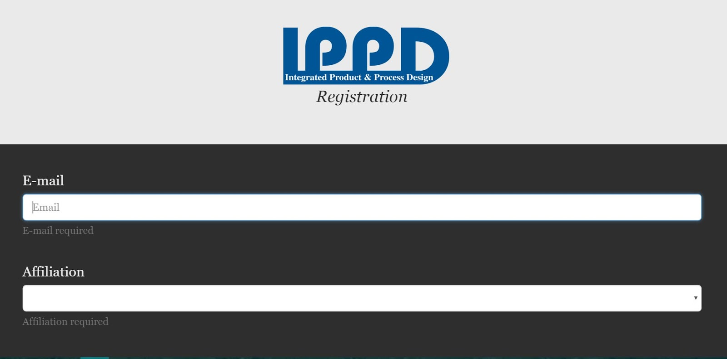

* Team & Presentation Selection view

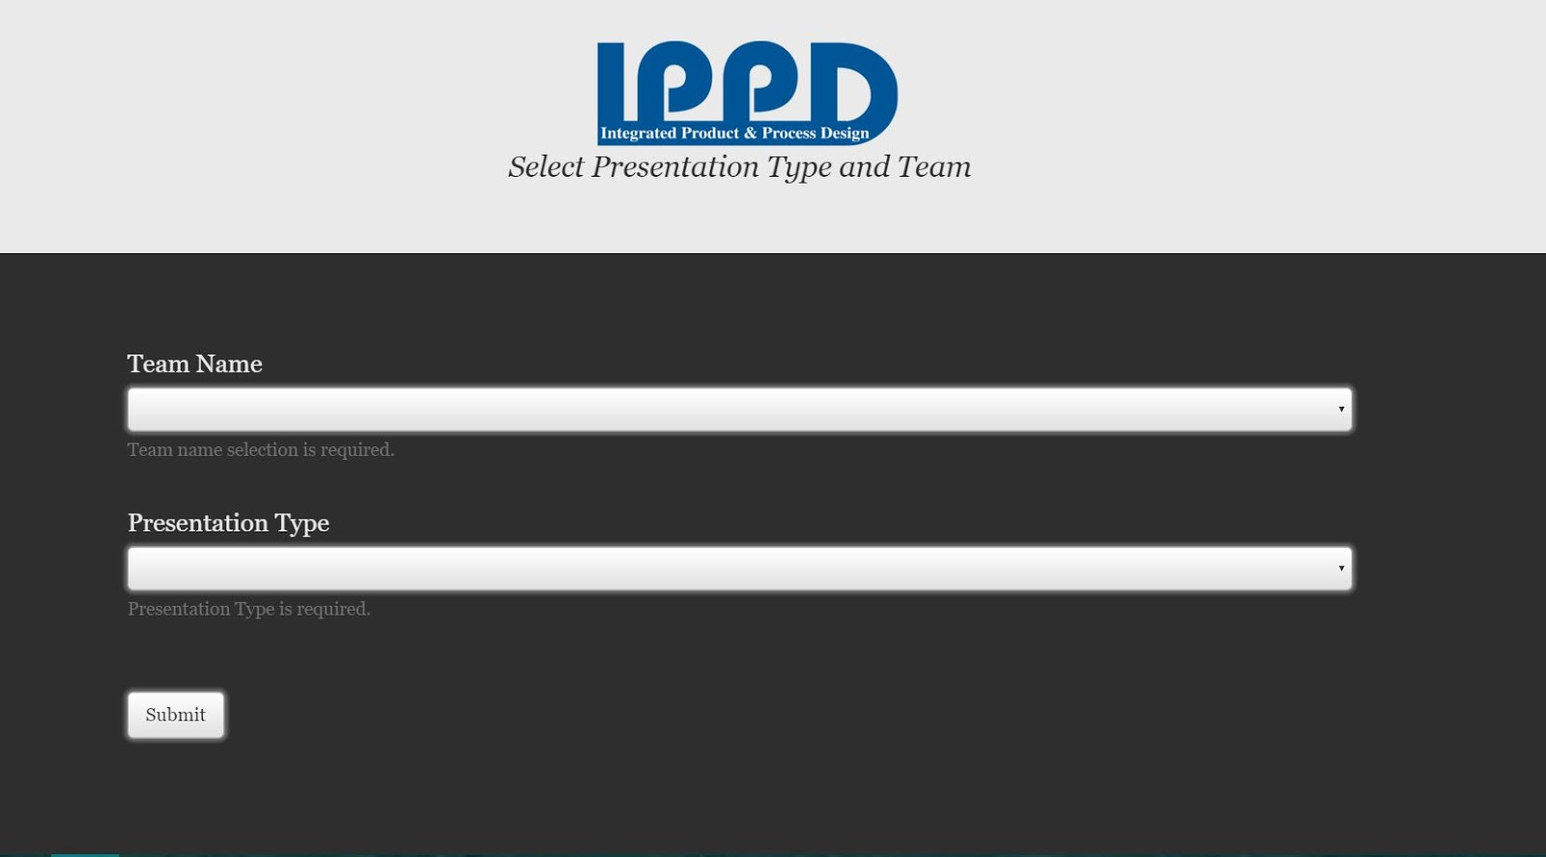

* Review View

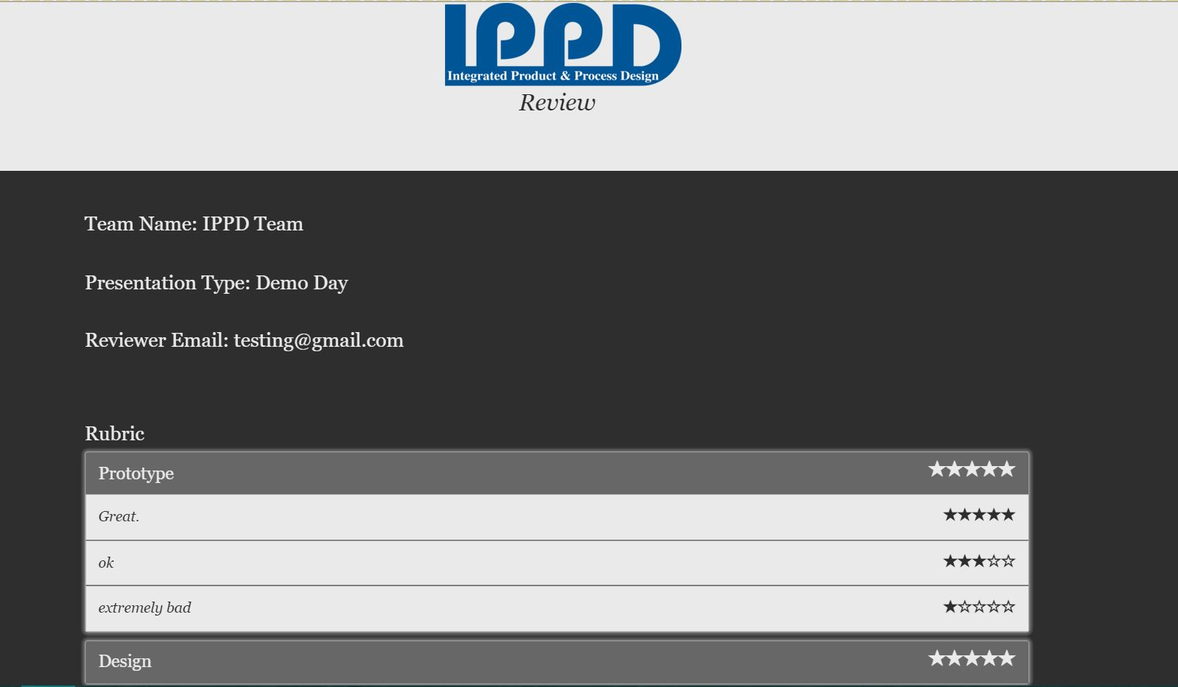

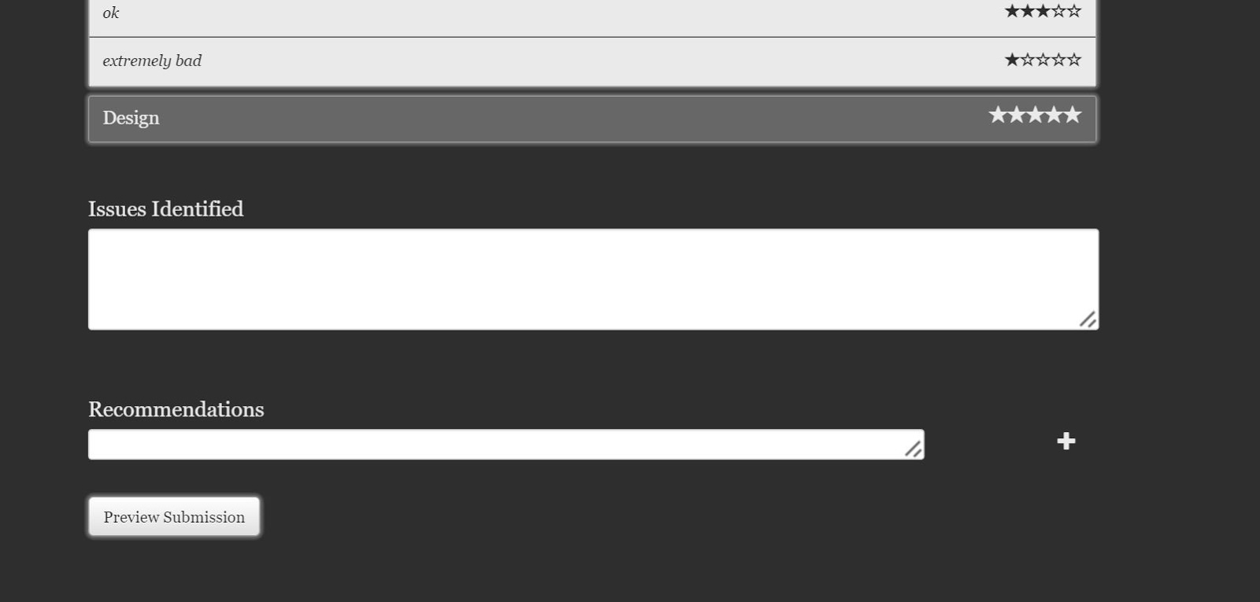

* Admin Login page

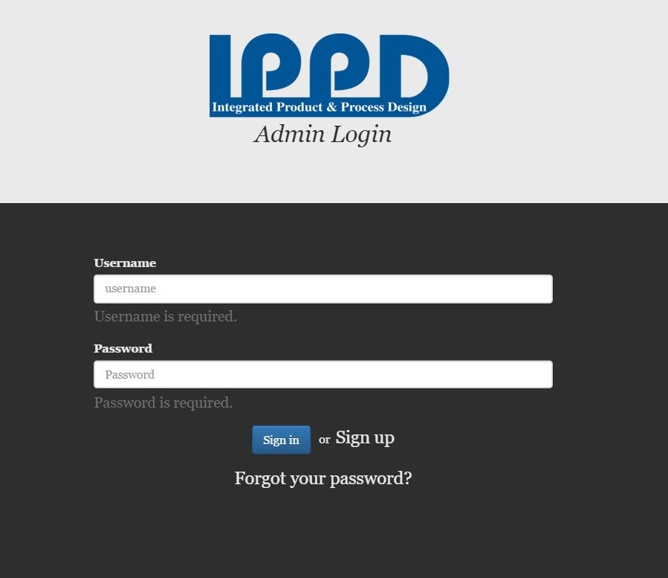

* Admin Home page

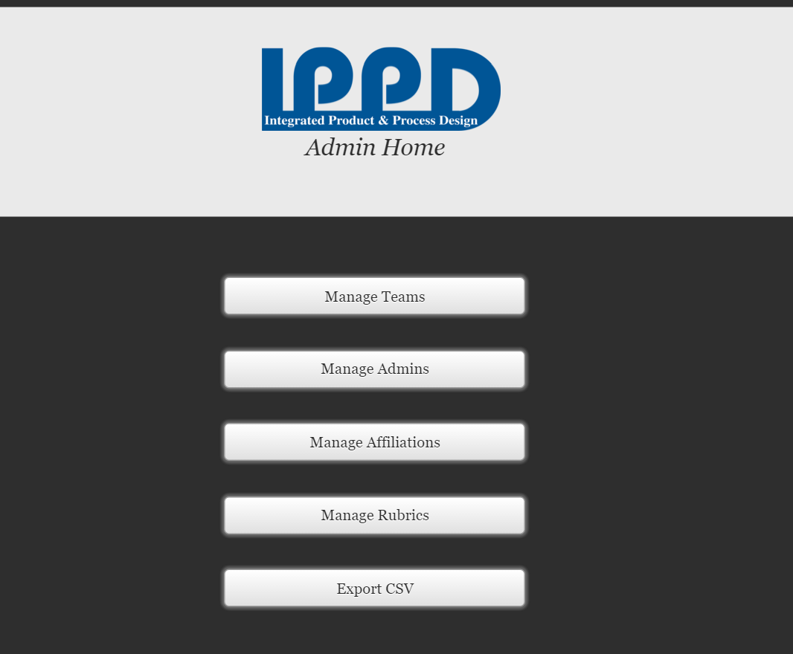

* Admin panel features
  + Manage teams, affiliations, and rubrics

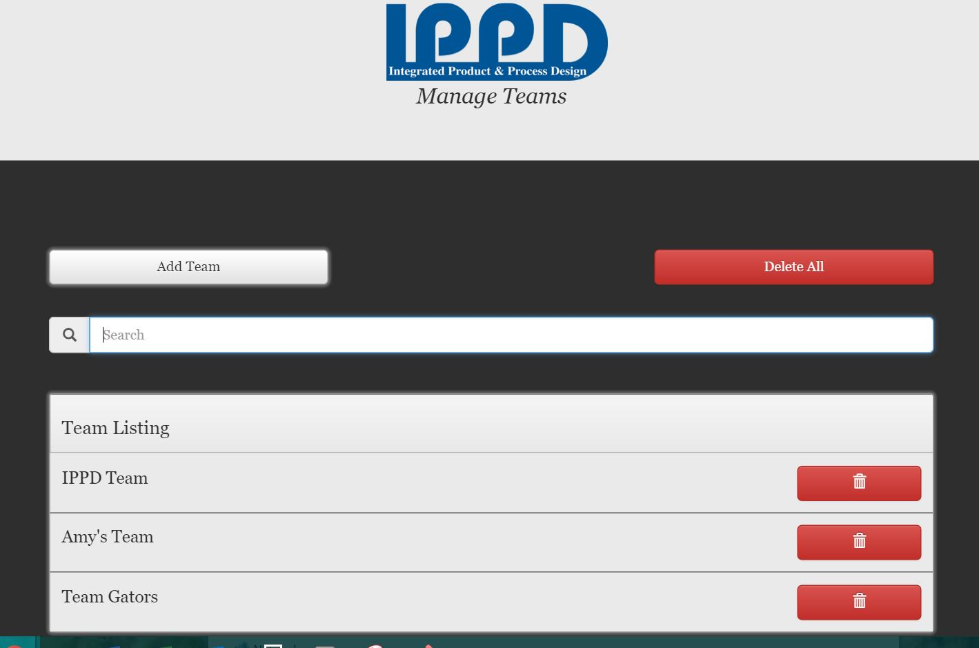

* + Add/Update teams, affiliations, and rubrics

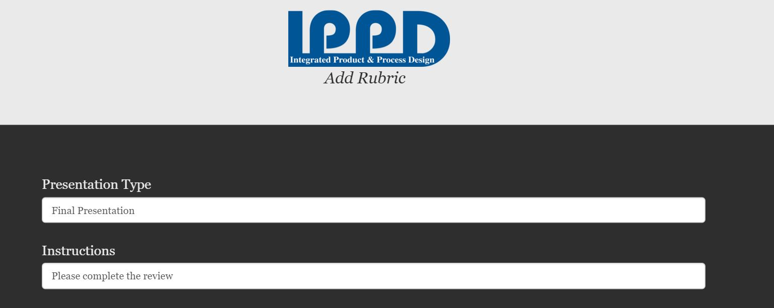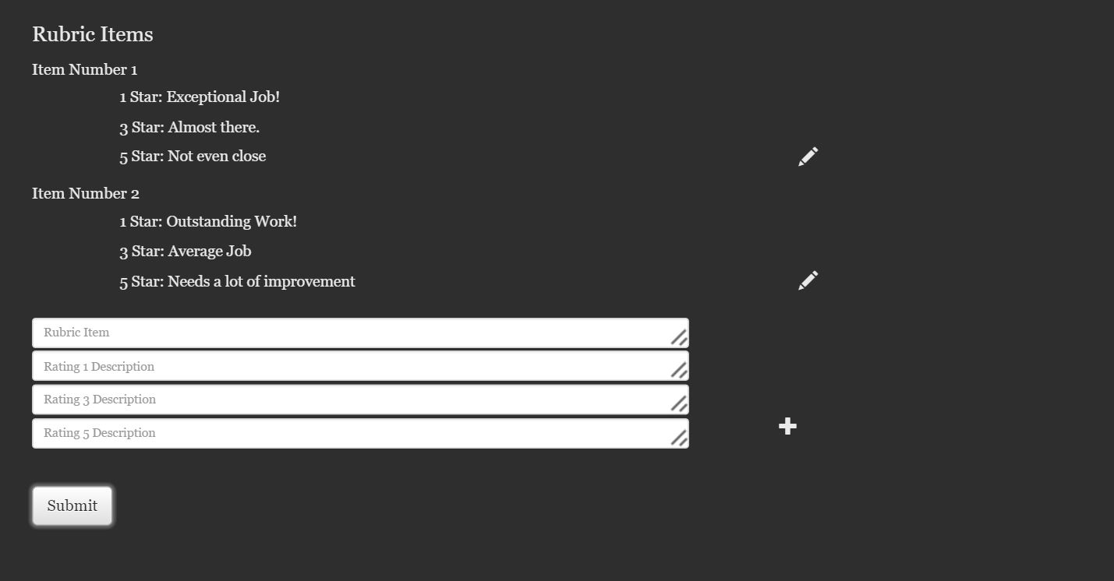

* + Delete teams, affiliations, and rubrics

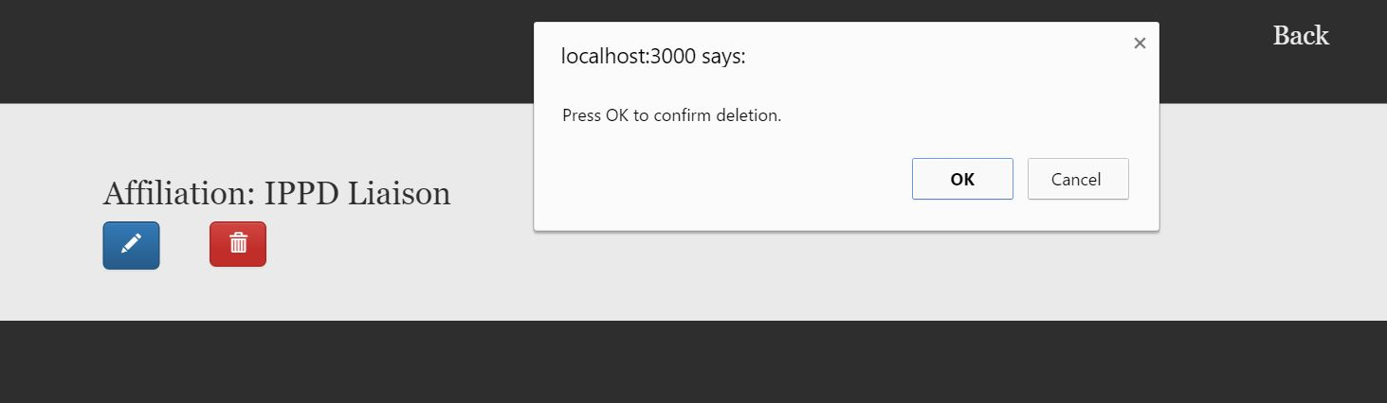

* + Export Completed Rubrics

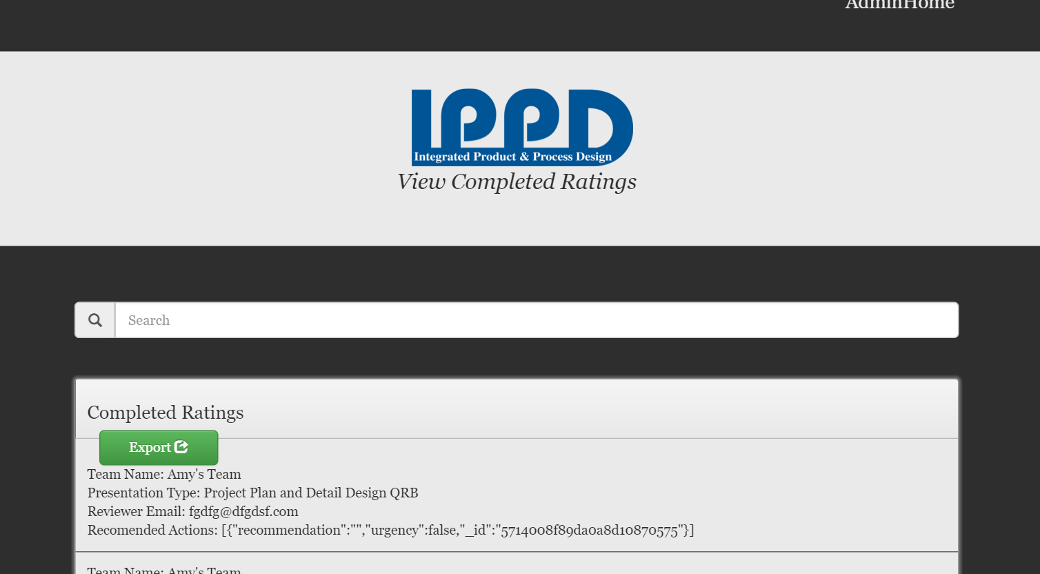

* + Theme Change Preview

**Instructions for how to run the project locally:**

1. Navigate the to the IPPD main folder directory.
2. Right click on the IPPD folder.
3. Click “git bash here.”
4. Type “grunt.”
5. Wait for a message similar to the one below:

  --

   MEAN.JS - Development Environment

   Environment:                        development

   Port:                               3000

   Database:

   App version:                        0.4.2

   MEAN.JS version:                    0.4.2

   --

1. On an internet browser, navigate to “localhost:3000,” or whichever port number is specified in the message.
2. You can now access the app locally.

**How to update database connection:**

1. Navigate to the IPPD main folder directory.
2. Navigate to the “config” folder.
3. Navigate to the “env” folder.
4. Open the “development.js” file.
5. Within the “module.exports” field, change the ‘uri’ to the desired mongo uri link.
6. Save the file.
7. Open the “production.js” file.
8. Within the “port” field, change the ‘uri’ to the same desired mongo uri link as in step 5.
9. Save the file.
10. The database connection is now updated.

**How to update server connection:**

1. Navigate to the IPPD main folder directory.
2. Navigate to the “config” folder.
3. Navigate to the “env” folder.
4. Open the “default.js” file.
5. Locate the “port: process.env.PORT” field.
6. After the “||”, change the port number to the desired number.
7. Save the file.
8. The server connection is now updated.

**How to permanently change site colors:**

1. Navigate to the IPPD main folder directory.
2. Navigate to the “modules” folder.
3. Navigate to the “core”  folder.
4. Navigate to the “client”  folder.
5. Navigate to the “css”  folder.
6. Open the “index.css” file
7. On line 27, change the body text color (#eaeaea) to the desired body text color
8. On line 28, change the body background-color (#2e2e2e) to the desired body color
9. On line 87, change the jumbotron (header) background-color (#eaeaea) to the desired color
10. On line 88, change the jumbotron (header) text color (#eaeaea) to the desired text color

**How to permanently change site logo:**

1. Navigate to the IPPD main folder directory.
2. Navigate to the “modules” folder.
3. Navigate to the “core”  folder.
4. Navigate to the “client”  folder.
5. Navigate to the “image”  folder.
6. Navigate to the “brand”  folder.
7. Delete the IPPD_COLOR.png file
8. Insert new logo image (make sure it’s named IPPD_COLOR.png) in the same folder