

Business Intelligence For FMCG Business Empowerment

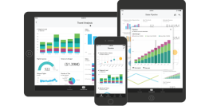

Date : 15/08/2019

Kara Data Framework General Overview of Data Hierarchy for KARA

SKU 

Material Group

Category (Product)

Customer

Customer Group Brand

Sales Category Sales Division Channel

State

Region (District) Month

• Drill down to specific item / SKU • Group by Channel & Sales Division

Channel



Domestic International Packaging

International

Key

Account C.Store GT Food

Service Industrial PC Office E-Comm

Sales Division

Int -

C.Store Cash

Packaging

IKA

FS-AD

GT-AD Pharmacy Sales Industrial

Commodity

LKA

Key

Dealer

GT-WS

FS-WS HORECAInt -F&B

Sales Category

International E-Comm

Local

E-Comm

Packaging

Data Mining In KARA Data Framework

Overview

Data Mining

Target

View

Division Customer

Brand

Salesperson

Performance

Sales Analysis

Return Analysis

Purchase Product Trend

Product Sales & Target

Return Analysis

Demand Trend Review

Inventory Snapshot

Definition of BI Report

1 Summary

• Visualization • Comparison

2 Analysis

• Visualization • Table Form

• Distribution • Year on Year

3 Details

• Visualization • Table Form

• Overall Details • Month on Month

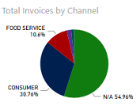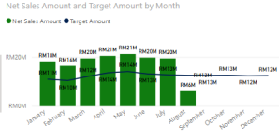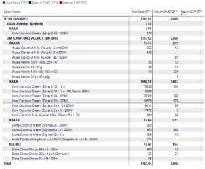

Overview of the KARA BI Reports

Daily DT

DT

DSR

Branch Summary

Division Summary

Monthly

DT

Sales

Summary DT

Branch Analysis

DT DT

Return

Analysis

DT

Brand

Analysis

Salesperson Analysis

DT

Details

DT

Customer Analysis

DT

Director View Key Management View Area Management View 

Sales Amount vs Sales Target

Sales Amount vs Sales Target

Sales Amount vs Sales Target

Sales vs Return Sales vs Return Sales vs Return

COGS & Gross Profit Net Profit without Cost

COGS & Limited Profit Net Profit with Cost

Data Views By Role In KARA Data Framework

Data Mapping Progress Bucket 1

1 Structure Table

2 ETL Process

• Dimension Table

• Hierarchy

• Relation

Product_D M

Employee_ DM

SalesOffice _DM

Customer_ DM

3 Data Behaviors

• Slowly Dimensional Changes

• Change Data

4 Data Handling 

• Data Cleansing • Error Event Handling

Capture System

Data Mapping Progress Bucket 2

1 ETL Process

• Fact Table

Sales_FT Target_FT

3 Data Handling

• Late Arriving

Dimension Handling

• Source Data

Handling

2 Data Behaviors 

• Change Data

Capture System

(New & Updated

Trans)

4 Others

• Additional Fact Tables

Power BI Enabling Progress Status

Prerequisite Items

1 SQL Server Integration Services (SSIS) DONE 2 Microsoft Access Database Engine 2010 Redistributable DONE 3 Installation of (.zip, .rar) File extension support apps & Notepad++ DONE 4 Intégration of SAP (Server Name : KMM_SAP\KMM_SAP_2014) DONE 5 Power BI Configuration and Setup DONE

6 *FTP folder for upload manual excel Pending *Required KARA IT team to create FTP folder access in server

KARA Target Excel File Integration Process Create a copy from original excel file using Excel Mirco technology Generate a copy of

Click Process button to post Target Excel to BI 

excel and place to BI FTP folder

Required FTP Folder access

Data Validation - Employee

Sales

Division ASM If -, group into N/A

If null, group into N/A If consumer, group into GT

Region Group by State1

Data Validation – Region Region Column

State Data

(U_Region/Sales Person) 

(State1/Customer)



Relationship between customer &

salesperson based on State1

Data Validation – Region

BI group state1 in to 5 regions

Region

North Malaysia

East Coast

Central Malaysia

South Malaysia

East Malaysia

Perlis

Kedah Penang Perak

Kelantan

Terengganu Pahang

Selangor

Kuala Lumpur

Negeri Sembilan Malacca

Johor

Sarawak Sabah

Data Validation – Region Region If null, group into Other 

Missing coordination 

in BI Map

Data Validation – Return Type Return Type Code 

Return

Normal

Damage

HQ-GOOD

HQ-RSV

PA-DIS

Savage

HQ-DMG

PA-DMG

PA-SVG HQ-SVG

BI group into 3 Return Types • Normal

• Damage

• Savage

Alert for Return exceed 1.1%

PA-Good

Data Validation - Item Brand If null , group into N/A



BI group into N/A if found null in data

Thank you.

Q & A

People drive performance . We empower potential 