CSCI 1010 Algorithmic Problem Solving Assignment 2

1. What is a compiler?

**A complier converts high level code to machine code.**

1. Use your own words to tell the difference between a compiler and an interpreter.

**A complier converts an entire program at once, while a interpreter can execute code line by line.**

1. For the compiling command showing bellow, please explain the meaning of each part in the command:



**The ‘g++’ part is the program we use to compile our program.**

**The ‘-o test’ part signifies that we want to put the output in a file called ‘test’**

**The hello.cpp is the c++ file we are translating to machine code.**

1. Use your own words to briefly explain the three steps when compiling a C++ program.

**The three steps are preprocessing, compiling, and linking.**

**Preprocessing handles directives, directives start with a #.**

**Next is compiling which complies all of the actual code. Finally the Linker links the code.**

1. Write a program that allows user to enter a number of miles and output the equivalent distance in kilometers.

**Algorithm:**

1. **Get the number of miles from the user**
2. **Convert miles to kilometers by multiplying by 1.6**
3. **Display the kilometers**

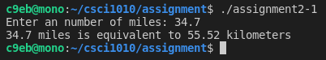

1. Write a program that allows user to enter a number of quarters, dimes, and nickels and then outputs the monetary value of coins in cents.

**Algorithm:**

1. **Get number of quarters from user.**
2. **Get number of dimes from user.**
3. **Get number of nickels from user.**
4. **Multiply quarters by 25**
5. **Multiply dimes by 10**
6. **Multiply nickels by 5**
7. **Add quarters, dimes, and nickels together.**
8. **Display Total**

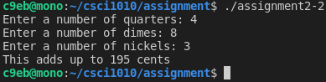

1. Write a program to let the user to enter two integers, then display the whole addition of two numbers and the result.

**Algorithm:**

1. **Get 2 integers from user.**
2. **Add numbers together.**
3. **Display the addition.**

