CSCI 1010 Algorithmic Problem Solving Assignment 3

1. Show the output produced by each of the following program fragments. Assume i, j, and k are int variables.

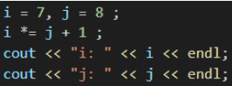

i: 63, j: 8

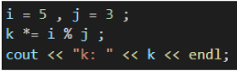

k: 0



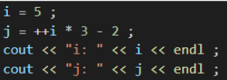

i: 6, j: 16



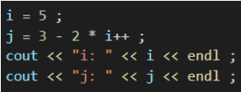

i: 6, j: -7

A attached the cpp files for the rest of the questions.