1. Printing my name and favorite color on one line 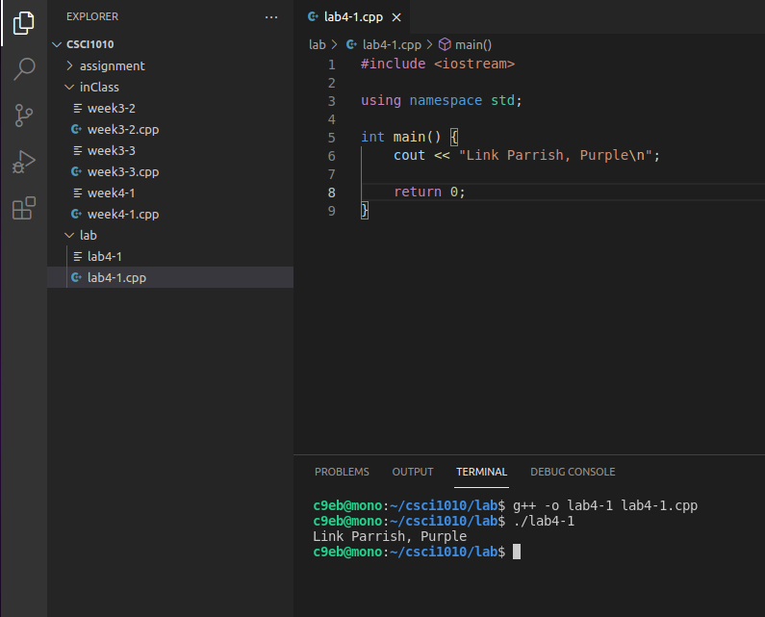2. Printing my name and favorite color on 2 lines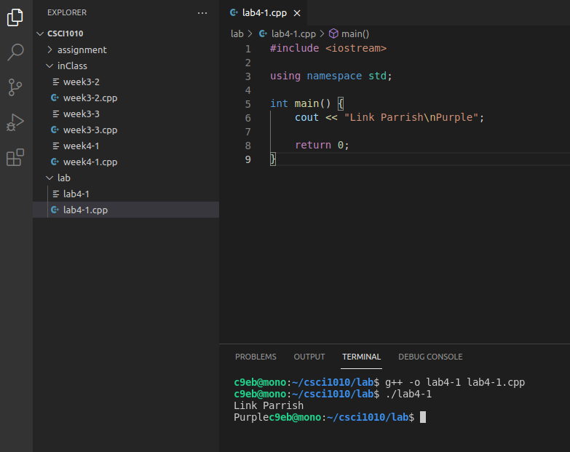
2. Printing my name and favorite on 2 lines with an extra ‘\n’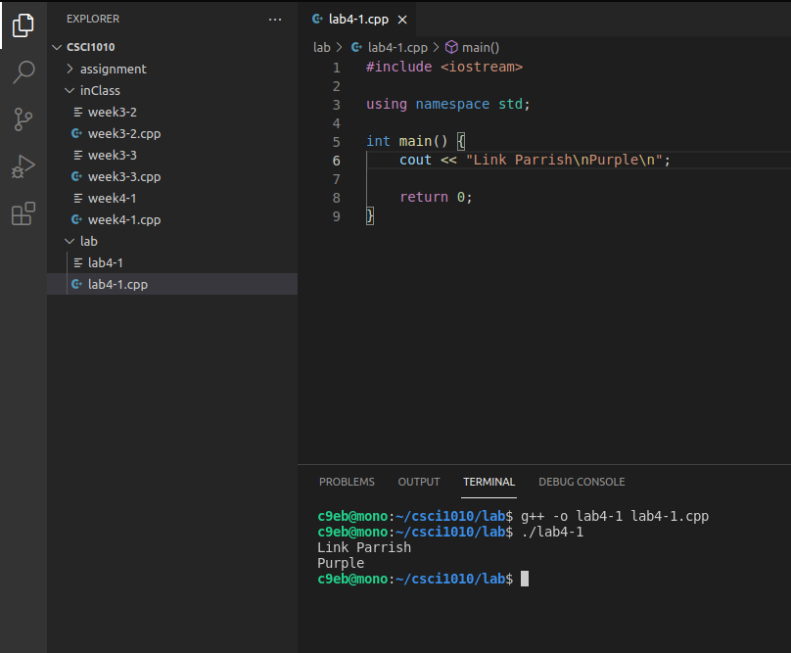
3. Printing a poem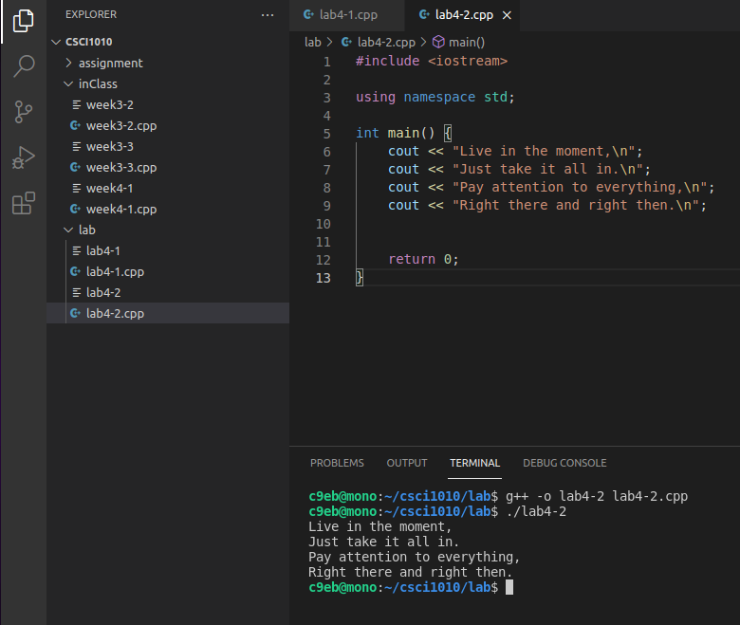
4. Printing the poem with spaces between every 2 words