CSCI 1011 Algorithmic Problem Solving LabWeek 5

1. Algorithm:
2. Get the radius from the user
3. Get the height from the user
4. Calculate the volume with the equation:

3.14 \* raidus \* radius \* height

4. Display the volume

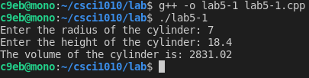

1. Algorithm:
2. Get the number of cheeseburgers from the user
3. Get the number of cups of coffee from the user
4. Calculate the total with the equation:

(burgers \* 5.89 + coffees \* 3.99) \* 1.07

1. Display the total

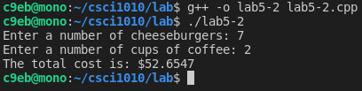

1. Algorithm:
2. Get the number of hours worked from the user
3. Calculate the gross pay with the following equation:

(40 \* 16.78) + (hours - 40) \* 16.78 \* 1.5

1. Display the gross pay
2. Calculate the Social security tax with the following equation:

gross \* 0.06

1. Display the social security tax
2. Calculate the Federal tax with the following equation:

gross \* 0.14

1. Display the federal tax
2. Calculate the state tax with the following equation:

Gross \* 0.05

1. Display the state tax
2. Display the union dues of $10
3. Calculate the net income by subtracting all of the taxes from the gross income.
4. Display the net income

