CSCI 1011 Algorithmic Problem Solving Lab Week 6

1. Algorithm:
2. Get the temperature from the user
3. Get the velocity from the user
4. Calculate the effective temperature
5. Display the effective temperature

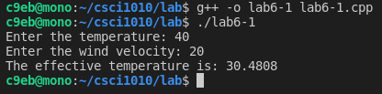

1. Algorithm:
2. Get the number of dollars from the user
3. Calculate the number of 20s
4. Calculate the number of 10s
5. Calculate the number of 5s
6. The amount left is the number of 1s
7. Display the number of each bills

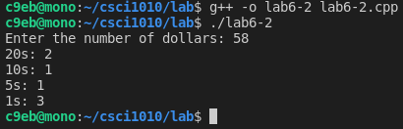

1. Algorithm:
2. Get x and y from the user
3. Use the Pythagorean theorem to calculate the distance from the origin to the point
4. Display the distance to the point

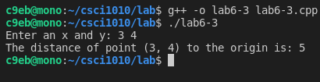

1. Algorithm:
2. Get the year, month, and day from the user
3. Use the provided formula to calculate the day of the week
4. Display the day of the week

