CSCI 1010 002 Project 1

By: Link Parrish, Amelia Moore

1. Flowchart

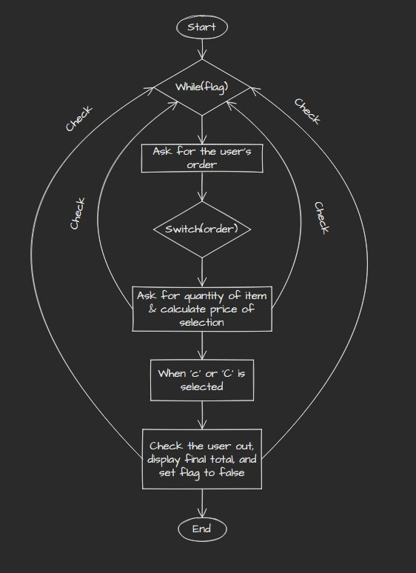

1. Instructions
2. Enter the id of the item you want.

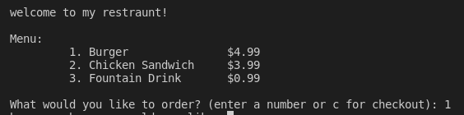

1. Enter the quantity of the selected item. 
2. Repeat steps 1 and 2 until you have everything you want. 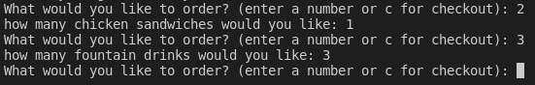
3. Enter c to checkout.



1. Teamwork

Amelia wrote the flowchat.

Link wrote the first draft of the code.

We both went over the code and improved it.

Link wrote the instructions.