

Document control
This report describes the TM ANTOINE Portal as it exists in the product source code and supporting project documentation on 6 September 2026. It is written for TM ANTOINE Partners & Advisors as a professional record of what has been built, how it is constructed, how it is protected, which platforms it supports, what is required to keep it operating, and what a comparable system would cost to commission again today.
Item | Detail
Document title | Application & Technology Overview
Subtitle | Product Documentation, Technical Specifications, Security Architecture & Market Valuation
Organisation | TM ANTOINE Partners & Advisors
Product name | TM ANTOINE Portal
Production host (code reference) | https://portal.tmantoinelaw.com
Version | 1.0
Date | 6 September 2026
Prepared by | iGraphix Marketing & Co., Castries, Saint Lucia
Prepared for | TM ANTOINE Partners & Advisors
Classification | Confidential — intended recipients only
Document type | Technology assessment and market valuation (not a proposal or quotation)
Evidence basis | Inspection of the application repository, configuration, desktop shell, and internal technical notes

How to read status labels
Where a capability could be misunderstood, this report uses the following labels. They are used consistently and are not marketing language.
Label | Meaning
Implemented | Present in the product codebase and described from that evidence.
Configured | Behaviour depends on environment variables, feature flags, or administrator policy.
Supported | The product is designed to run in this environment when that environment is provided.
Recommended Enhancement | Not currently implemented, or not verified as operational. Not included in the product valuation.
Planned | Documented as intended future work. Not included in the current product valuation.
To Be Confirmed | Cannot be verified from the repository alone (for example a live production setting).
Not included | Not part of the current product.

Confidentiality
This document contains a technical description of a private business system, including security architecture and an estimate of replacement value. It should be shared only with people who need it for internal discussion or authorised negotiation. It does not grant any licence, transfer any intellectual property, or constitute an offer to sell.

Purpose of this report
6 September 2026
TM ANTOINE Partners & Advisors
Saint Lucia
Dear Partners,
Re: Application & Technology Overview of the TM ANTOINE Portal, including security architecture and estimated replacement value
iGraphix Marketing & Co. has prepared this report so that the firm can discuss the TM ANTOINE Portal as a complete technology product. It is not a sales proposal, not a quotation, and not a terms-and-conditions document. The purpose is to state, with as much accuracy as the codebase allows, what has been developed, what the application consists of, the technology behind it, the features that are present, the security and data-protection measures that are implemented, the platforms that are supported, the maintenance the system requires, and a defensible estimate of current replacement value.
The portal is a custom operations platform for an advisory practice that handles client work, sensitive identity documents, internal collaboration, and connected professional mail and calendars. It is not a brochure website and it is not a generic content-management system. The web application, the macOS desktop application, and the Windows desktop application are clients of one hosted backend. There is no Android application in the current product.
Figures in the valuation section are replacement-cost estimates for commissioning a comparable system from a professional software team in 2026. They are not historical development cost, not a purchase price, and not a negotiated commercial value. Maintenance pricing has not been supplied by the project owner and is shown as a placeholder.
I am an authorised officer of iGraphix Marketing & Co. and I am pleased to present this report on the company’s behalf.
Yours sincerely,
Vernon Francis
Founder & Creative Director
iGraphix Marketing & Co. | Castries, Saint Lucia | igraphixmarketingco@gmail.com | +1 (758) 726-6532

Contents
1. Executive overview
2. Product overview
3. Application features
4. Workspaces and modules
5. User roles and access control
6. Data and identity protection
7. Technical architecture
8. Application architecture diagram
9. Security architecture
10. Data protection
11. Offline and synchronisation capabilities
12. Cross-platform capability
13. Performance and scalability
14. Backup and disaster recovery
15. Maintenance requirements
16. Maintenance cost model
17. Product development value
18. Market value assessment
19. Value breakdown
20. Replacement cost
21. Intangible product value
22. Future development roadmap
23. Current product versus future enhancements
24. Technical specifications
25. Documentation of deliverables
26. Conclusion

1. Executive overview
The TM ANTOINE Portal is a custom-built practice system for TM ANTOINE Partners & Advisors. It gives the firm a single place to manage clients, citizenship-investment casework, documents, signatures, internal communication, connected professional email, calendars, and administration — with role-based access and technical safeguards for sensitive personal information.
What business problem it solves
An advisory firm that handles client files, identity documents, and confidential correspondence cannot run those workflows on a public website, a shared drive, and a consumer mailbox without losing control of access, auditability, and continuity. The portal concentrates those workflows in one authenticated system: staff work in a shared client hub and file vault; officers review CIP files; clients and service-provider contacts see only what their relationship permits; and mail, calendar, and chat stay attached to the same identity.
Who it is designed for
• Administrators who approve accounts, set security policy, and configure the firm.
• CRO / Reviewing officers who work CIP applications, documents, and decisions.
• Staff who use mail, files, messaging, calendar, signatures, and the client hub.
• Clients and service-provider contacts who are invited into a scoped view of their own work.
• External signers and uploaders who receive a public token link for a specific request.
Major workflows
The system supports client intake and assignment; CIP application lifecycle (when the module is enabled); document collection, review, versioning, and sharing; electronic signature requests; staff mailbox and calendar synchronisation with Microsoft and Google; internal messaging and live voice or video calls; call-recording storage for staff; an internal feed; reporting; and firm-wide user and security administration.
Why this is a technology product rather than a website
The public face of the product is a web interface, but the substance is an application backend: 191 database migrations, more than one hundred domain models, queued background work, a realtime event server, encrypted identity fields, a document vault with envelope encryption, capability-based authorisation, desktop shells for macOS and Windows, and an automated test suite covering access control and core modules. Those are the characteristics of a multi-user operations platform, not of a marketing site.
Platforms
The product supports a responsive web application in a current desktop or mobile browser; a macOS desktop application (Electron 0.8.51, macOS 11 or later); and a Windows desktop application from the same codebase (NSIS installer, Windows 10 or later as stated in the download metadata). An Android application is not part of the current product.
Evolution, security, scalability, and desktop capability
• The architecture is modular. CIP and CBI can be switched with feature flags. Integrations with Microsoft, Google, SharePoint, and Smartsheet are similarly environment-gated.
• Security is layered: authentication is separate from authorisation; sensitive identity fields are encrypted; vault writes can be envelope-encrypted; sessions are stored in the database and encrypted.
• Growth is supported by indexed PostgreSQL, pagination and scoped queries, background jobs, Redis locks, and a production topology that can scale queue workers. This is not a claim of unlimited capacity.
• The desktop applications cache the last portal shell, static assets, and document previews, and they keep an IndexedDB replica for offline reading of clients, files, and CIP applications. Offline writes are implemented for CIP applications. The browser web application is online-first.
Central point
The TM ANTOINE Portal is a complete, custom-built technology product with measurable development, infrastructure, security, platform, and ongoing maintenance value. It should be assessed as such, not as a website or a simple database front end.

2. Product overview
The product is one hosted application with three supported clients. All three clients authenticate to the same backend. Desktop does not contain a second copy of the business logic.
2.1 Core application (web)
The core application is a Laravel 13 system. Authenticated work happens in a single-page portal shell (dashboard HTML plus JavaScript modules) talking to JSON endpoints under /portal/*, with Blade used for authentication, onboarding, and related account flows. The interface is responsive. Realtime updates use Laravel Reverb. Background work uses a database queue and a process scheduler.
Major capabilities of the core application are described in sections 3 and 4. In summary they include the client hub, CIP and CBI modules (feature-flagged), the file vault, signatures, mail, calendar, messaging and calls, the internal feed, people and users, templates, reporting, and administrator settings.
2.2 Android application
Not included in the current product
The repository does not contain an Android project, APK, Capacitor or Cordova wrapper, Trusted Web Activity, or native Kotlin/Java client. Mobile use today is the responsive web application in a mobile browser. An Android application is listed later as a potential future enhancement and is excluded from the current valuation.

2.3 macOS application
The macOS client is TM ANTOINE Portal, version 0.8.51, an Electron desktop shell around the hosted portal. It is distributed as .dmg, .pkg, and .zip. The stated minimum system is macOS 11.0. Current Apple-silicon builds produce arm64 binaries. The app identifier is com.tmantoinelaw.portal.
Topic | Implementation
Environment | macOS 11 or later. Camera and microphone usage strings are declared for portal calls.
Native capability | Dock badge, incoming-call panel that can appear over other spaces, menu navigation, tray/close-to-background, custom title bar, context menu with spelling suggestions, auto-update, protocol handler tmaportal://.
Installation / distribution | Download from /desktop/download/mac; updates from https://portal.tmantoinelaw.com/desktop/.
Authentication | Session cookies against the hosted portal. Google OAuth is completed in the system browser and returned over PKCE-style tmaportal:// handoff. Connecting a mailbox or calendar still runs in-app so it attaches to the signed-in portal user.
Local data | Shell cache (last HTML shell), asset cache, file preview cache (network-first, about 512 MB LRU), IndexedDB replica of clients/files/CIP on the desktop store.
Synchronisation | Replica walk of CIP, files, and clients; CIP offline write queue; caches revalidate against deploy identity so a stale shell is dropped after a new release.
Security | No portal session is served from disk without a session cookie. Account change or a dead session drops local shell and file caches. Vault bytes remain authorised by the server when the network is available.
Updates | Custom updater (not Squirrel). Checks shortly after launch and hourly. User is shown release notes and can update; the app verifies the download hash, swaps the bundle, and relaunches.
Code signing | Currently ad-hoc signed (identity null in the build). A Developer ID certificate and notarisation are required to remove the macOS 15+ Open Anyway step. Recommended Enhancement — not claimed as a completed store-grade signature.

2.4 Windows application
Windows uses the same Electron codebase. Differences are platform behaviour, not a second product. Distribution is an NSIS installer (x64). Unsigned builds show SmartScreen on first run.
Topic | Implementation
Environment | Windows 10 or later (download metadata). x64 installer; arm64 Windows would run it under emulation.
Installation / distribution | NSIS setup executable from /desktop/download/windows when latest.yml has been published.
Authentication | Same hosted session as the web and macOS clients, including tmaportal:// deep links via process arguments.
Local data and sync | Same shell, asset, file, and IndexedDB replica behaviour as macOS.
Native capability | Tray icon is required when the window is closed; taskbar overlay badge; taskbar flash on ringing calls; Windows-themed update surfaces.
Updates | Downloads the NSIS installer and runs it silently with update flags so shortcuts are kept.
Code signing | No Authenticode certificate is present. SmartScreen “More info → Run anyway” is the current first-run path. Recommended Enhancement.

2.5 Distinction between clients
The web application is the full product in a browser. It does not install, does not keep a durable client replica on disk, and does not boot if the network is absent after a reload. The macOS and Windows applications are native installers around that same product. They add OS integration, a warm offline shell, a local replica, and self-update. They are not independent backends.
3. Application features
The inventory below includes only features evidenced in the application. Each row states what the feature does, why it exists, who uses it, and why it matters to product value. Feature-flagged modules are marked Configured.
3.1 Access, identity, and administration
Feature | What it does | Business purpose | Who uses it | Product value
Dashboard | Home metrics, work tiles, and staff presence after sign-in. | Gives each role a starting picture of work. | All approved accounts. | Turns the system into a daily workplace rather than a file dump.
Overview | Firm activity, recent files, sign-ins, week framing. | Lets staff see the practice, not only their own queue. | Staff with overview.view. | Management visibility without a separate BI tool.
Account approval | Pending / approved / suspended states; administrators approve access. | Stops unknown registrations reaching client data. | Administrators. | Access is a controlled process, not an open register.
Password authentication | Fortify login with hashed passwords and compromise checks. | Proves identity for a staff or client account. | Every account with a password. | Baseline credential security.
Authenticator 2FA | TOTP setup, challenge, recovery; can be required by policy. | Stops a stolen password being enough. | Users; administrators can enforce. | MFA is in the product, not an add-on slogan.
Email login codes | Six-digit codes for unusual sign-ins. | Confirms the person on a new or unusual attempt. | All users when the challenge fires. | Additional factor without a phone app.
Google / Microsoft sign-in | OAuth login and account linking. | Uses the firm’s existing identity providers. | Staff and invited users as configured. | Fewer passwords; aligned with Microsoft 365 / Google.
Trusted devices | Remembered devices can skip the authenticator challenge. | Reduces friction on known hardware. | End users; revocable in settings. | Usable MFA rather than MFA that is switched off.
Stay signed in | Absolute session lifetime from policy (default 7 days). | Keeps a working day from dying every two hours while still expiring. | End users after login. | Session policy is explicit.
Turnstile | Cloudflare challenge on selected auth POSTs when keys are set. | Slows automated account attacks. | Public auth forms. | Configured — requires live keys.
Users administration | Approve, suspend, reset password or 2FA, delete, re-type roles. | Keeps the firm’s account list under control. | Administrators. | Operational HR/IT control inside the product.
Roles and permissions | Server-side capability matrix plus CIP and client scoping. | Different people must see different files. | All users, enforced on the server. | Authorisation is a designed subsystem.
Security policies | Password length, MFA require flags, session days, alerts, recording retention. | Lets the firm set its own bar. | Administrators. | Policy is data, not a one-off config file only a developer can change.
Auth event log | Records login, failure, lockout, and related events. | Supports investigation of access issues. | Administrators / security review. | Evidence trail for access.

3.2 Clients, people, and casework
Feature | What it does | Business purpose | Who uses it | Product value
Client hub | Directory of clients and companies, assignments, invites, search. | The firm’s book of work in one place. | Staff with clients.view; scoped for employees. | Replaces scattered spreadsheets as the client system of record.
Company records | Companies, members, staff assignments. | Holds corporate clients as well as individuals. | Staff in the hub. | Fits an advisory practice, not only consumer CRM.
Invitations | Token links for a client to create an account. | Brings the client into the portal without a shared password. | Staff who may invite; the invited person. | Controlled onboarding.
People / directory | Employees, client contacts, prospects, groups, welcome mail. | Address book and internal directory. | directory.view (admin by default; grantable). | Staff can find people without exporting a list.
Groups | Teams, departments, projects, membership. | Organises collaboration and calendar reach. | Staff view; admin manage. | Structure for a growing firm.
Native CIP | Application lifecycle, people, documents, letters, threads, decisions. | Runs citizenship-investment files inside the portal. | Officers and admins; providers/clients via CipAccess. | Implemented; Configured by FEATURE_CIP.
Encrypted CIP identity | Passport number and date of birth stored with EncryptedIdentity. | Protects high-sensitivity PII at rest in the database. | System; visible only to authorised CIP users. | Identity protection is in the data model.
CBI mirror | Smartsheet-synced CBI applications, comments, attachments. | Keeps an existing Smartsheet process visible to admins. | Administrators when FEATURE_CBI is on. | Implemented; Configured; admin-only.

3.3 Documents, signatures, and files
Feature | What it does | Business purpose | Who uses it | Product value
File library / vault | Folders, uploads, browse, organisation and personal trees. | Authoritative document store for the firm. | All users, scoped by access rules. | Document management is a first-class module.
Versions | Append-only history, restore, preview, download. | Keeps an audit of what was filed. | People with file access. | Replaces “final_v7.pdf” on the desktop.
Sharing | User, email, company, and link shares; optional passwords. | Sends a file without copying it into email. | Staff; client re-share is separately gated. | Controlled distribution.
Identity-link passwords | Public links to passport/ID type folders require a password. | Stops a leaked URL exposing identity documents. | Anyone given such a link. | Specific control for high-risk files.
Malware scan | Post-upload scan; infected files cannot be shared. | Reduces malware moving through the vault. | System job. | Implemented in code; Configured (default scanner none).
File requests | Staff create a public upload slot /r/{token}. | Collects documents without an account. | Staff and the uploader. | Intake without extra licences.
Workflows | Review, approval, acknowledgement on a pinned version. | Makes “please check this file” a tracked action. | Staff; provider contacts via CIP. | Accountability on documents.
Comments and presence | File comments, mentions, resolve; presence on open files. | Discussion stays on the document. | People with file access. | Reduces parallel email threads.
Recycle bin | Soft-delete recovery; firm-wide bin for admins. | Mistakes are reversible. | Users; recyclebin.admin for firm-wide. | Operational safety.
SharePoint / OneDrive | Sync connections into the library. | Works with the firm’s Microsoft estate. | Configured staff / admin. | Configured by Microsoft sync flags and connections.
E-signatures | Author fields, send, remind; public /sign/{token}. | Gets a signed PDF without printing. | Staff create; recipients sign. | Closes the paper gap on engagement letters and packs.
Call recordings | Stores authorised client-call audio with access logs and retention. | Keeps a record of client calls for the firm. | Staff with callRecordings.view; scoped. | Sensitive media with an access trail.

3.4 Communication, time, and insight
Feature | What it does | Business purpose | Who uses it | Product value
Connected mailbox | Sync, read, send, drafts, labels, templates, signature import. | Professional email inside the portal. | Staff with mail.use. | Mail stays next to the client file.
Messages | DM and group chat, attachments, search, receipts. | Internal and client messaging with access rules. | Approved accounts (clients scoped). | A controlled alternative to WhatsApp for firm work.
Voice / video calls | WebRTC signalling; desktop call panel; camera/mic. | Speak without leaving the file. | Messaging users on a secure context (HTTPS or localhost). | Realtime collaboration in-product.
Notifications | In-app and OS banners via realtime events. | People see what needs them. | Signed-in users; desktop can run in background. | Not mobile push (FCM/APNs are Not included).
Internal feed | Channels, posts, polls, reactions, analytics. | Firm-wide communication. | Staff; moderation is admin. | Internal comms without a second product.
Calendar | Events, RSVP, members, ICS, Google/Microsoft two-way sync. | Scheduling attached to the same identity. | All users (staff extras gated). | Reduces double booking across personal and firm calendars.
Templates | System emails, compose templates, CIP letters and requirements. | Keeps outbound language consistent. | Admin / templates.email. | Quality control on official text.
Reporting | Usage, access, messaging, storage, CIP reports. | Shows how the system is used. | settings.reporting. | Oversight without exporting the database.
Search and filters | Global search plus per-area search and listing filters. | Finds a person, file, or message quickly. | All portal users within their reach. | Usable at firm scale.
Data exports | Message export and similar per-module exports where coded. | Lets a user take a thread or listing with them. | The user who holds that data. | Portability of selected records — not a general warehouse dump.

3.5 Explicitly not claimed
Item | Status
Android application / APK | Not included
PWA / service worker | Not included
FCM / APNs push notifications | Not included
Event QR codes or printed attendee badges | Not included (authenticator setup QR only)
Stripe or other card capture as a billing engine | To Be Confirmed — billing HTML exists; no charge API found in app/
Formal GDPR / ISO certification | Not included — technical safeguards are described; no compliance assessment is claimed

4. Workspaces and modules
The portal is one application with named workspaces. Navigation is pruned in the browser as a courtesy; every capability is still enforced on the server. CIP and CBI are implemented in code and remain dark unless their feature flags are enabled.
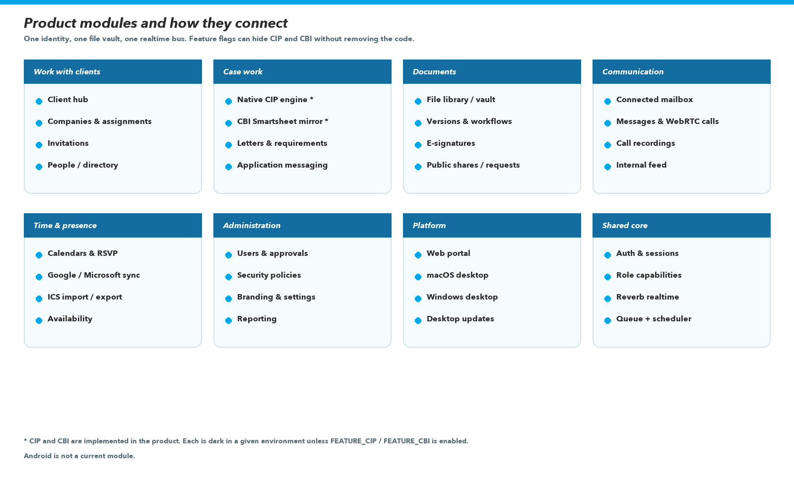
Figure 1. How the product modules sit on a shared identity, vault, and realtime bus.
Dashboard and Overview
Purpose | Starting point and firm picture.
Target users | All approved users (dashboard); staff with overview.view (overview).
Data handled | Metrics, tiles, presence, recent files, sign-in activity.
Workflow | Operational pulse — not a data warehouse.
Relationship | Uses the same identity and activity logs as the rest of the system.

Client hub
Purpose | Client and company system of record, assignments, invitations.
Target users | Staff with client-hub capabilities; employees are assignment-scoped unless granted view-all.
Data handled | Clients, companies, assignments, profile data, related conversations.
Workflow | Create and maintain the book of clients; invite portal accounts.
Relationship | Drives folder access and messaging reach for those relationships.

CIP applications
Purpose | Native citizenship-investment file management.
Target users | CRO / Reviewing officers and administrators; service-provider contacts and private clients through CipAccess.
Data handled | Applications, people (including encrypted passport and DOB), documents, letters, events, threads.
Workflow | Intake → review → assessment → submission → decision → post-approval documents → closed/denied.
Relationship | Configured by FEATURE_CIP. Uses the vault for documents and Role for officer capabilities.

CBI
Purpose | Administrator view of Smartsheet-mirrored CBI work.
Target users | Administrators only, and only when FEATURE_CBI is on.
Data handled | Mirrored applications, comments, attachments, sync log.
Workflow | Sync and inspect; not a public workspace.
Relationship | Configured by FEATURE_CBI and a Smartsheet token.

File library
Purpose | Vaulted document store.
Target users | Everyone with file reach; organisation tree is staff-gated.
Data handled | Folders, files, versions, shares, workflows, requests, activity.
Workflow | Upload, review, share, request, recycle.
Relationship | Optional SharePoint sync; envelope encryption; malware job.

Signatures
Purpose | Electronic signature requests.
Target users | Staff create; any addressed recipient can sign on a public token page.
Data handled | Requests, recipients, fields, events; signed artefacts in the vault.
Workflow | Author, send, remind, complete.
Relationship | Signing tokens are hashed and stored encrypted.

Email
Purpose | Connected Gmail or Microsoft mailbox inside the portal.
Target users | Staff with mail.use.
Data handled | Messages, drafts, labels, attachments, correspondents.
Workflow | Sync, read, send, template, import signature.
Relationship | Configured by GOOGLE_SYNC_ENABLED / MICROSOFT_SYNC_ENABLED.

Messages and calls
Purpose | Chat, groups, WebRTC calls, optional recording.
Target users | Approved accounts; clients are limited unless messaging.contactAll applies.
Data handled | Conversations, attachments, recordings, presence.
Workflow | Message, call, record when the server starts capture.
Relationship | Reverb channels; recordings live in the vault with access logs.

Feed
Purpose | Internal social/intranet channel.
Target users | Staff with feed.view; moderation is administrative.
Data handled | Channels, posts, polls, reactions.
Workflow | Publish, discuss, moderate.
Relationship | Separate from client messaging on purpose.

Calendar
Purpose | Personal, shared, and organisation calendars.
Target users | All users for their own events; staff extras via calendar.staff / admin.
Data handled | Calendars, events, attendees, subscriptions, audit events.
Workflow | Create, RSVP, sync, import ICS.
Relationship | Google and Microsoft providers with conflict handling in the sync layer.

People and Users
Purpose | Directory versus account administration.
Target users | directory.view versus users.view / users.manage (admin by default).
Data handled | User accounts, contacts, groups, status.
Workflow | Find people; approve and discipline accounts.
Relationship | Split deliberately so a directory grant does not open the Users table.

Templates and Reporting
Purpose | Official wording and firm reports.
Target users | Administrators and staff with the matching capabilities.
Data handled | Template records; Report output.
Workflow | Edit copy; run usage, access, messaging, storage, CIP reports.
Relationship | CIP reporting is meaningful only when CIP is enabled.

Account settings
Purpose | Personal preferences and administrator rails.
Target users | All users for their own settings; admin capabilities for firm rails.
Data handled | Profile, security, connectors, branding, CIP console, operations.
Workflow | Configure rather than code.
Relationship | SecurityPolicies live here.

Security consideration across modules
Workspace visibility is not a substitute for row-level rules. Client hub employees see assigned clients; CIP rows go through ApplicationScope; files go through FileAccess; clients cannot open the call-recording library. Administrators bypass most capability rows but CIP/CBI still vanish entirely when their feature flags are off.

5. User roles and access control
Authentication answers “is this the right person?” Authorisation answers “may this person do this action on this record?” The portal treats those as separate problems. A valid login does not grant every workspace, and a capability name in the browser is only a courtesy — the server repeats the check.
5.1 Authentication (identity)
Identity is established with Laravel Fortify (password), optional authenticator TOTP, email login codes on unusual sign-ins, Google or Microsoft OAuth, and a desktop PKCE handoff. Sessions live in the database, are encrypted at rest in the session store, and carry an absolute lifetime from Stay signed in / SecurityPolicies (default seven days) in addition to idle expiry. Account status must be approved; email verification, profile completion, onboarding, and optional enforced MFA are further gates on the portal group of routes.
5.2 Account types
Account type | Role in the firm | Notes
Administrator | Full capability set (except feature-flagged modules when those flags are off). | Only type, with CRO / Reviewing officer, that the Users page may assign.
CRO / Reviewing officer | Staff baseline plus CIP officer capabilities (view, create, review, compliance, decide). | Aliases still recognised: Reviewing Officer, Compliance Officer.
Employee | Parked / legacy staff type. Holds employee-matrix grants if an old row still exists, but new assignment is disabled and role-pending blocks the portal until the person is retyped. | Not assignable.
Client | No matrix capabilities. Reach comes from hub relationships and CIP access rules. | Created through invitations, not typed by hand on the Users page.

5.3 Capability matrix (authorisation)
Non-administrator grants live in App\Support\Access\Role. Empty rows are administrators only. Unknown capability names are denied. Officers inherit the employee baseline through Role::can() so CIP officer rights sit on top of mail, files, and the client hub.
Area | Employee / officer (typical) | Administrator only (typical)
Client hub | view, manage, invite (employees assignment-scoped) | view all, assign; overlay grants from Client hub access settings
CIP | officer: view, create, review, compliance, decide | assign, configure, report; entire module dark if FEATURE_CIP is off
CBI | none | view; dark if FEATURE_CBI is off
Users / directory | none by default | users.view/manage; directory.view grantable via Advanced Preferences
Mail, feed, messaging | mail.use, feed.view/createChannel, messaging.contactAll | feed moderate and analytics
Files | view organisation tree | files.admin, files.settings
Signatures, workflows, recordings, overview | create signatures, email templates, workflows, own recordings, overview | templates.view, activity.viewAll
Calendar / groups | calendar.staff, groups.view | calendar.admin, groups.manage
Settings | personal settings only | security, operations, reporting, branding, client hub, storage, advanced, recycle bin

5.4 Workspace and row visibility
• Employees in the client hub see assigned clients unless clients.viewAll is granted.
• CIP visibility is ApplicationScope plus CipAccess for external people — not a matrix grant on Client accounts.
• Clients message staff assigned to them unless messaging.contactAll applies to the staff side of the policy.
• Call recordings: employees see recordings they captured; administrators see the library; clients do not hold the capability.
• Public signature, share, and file-request links are tokenised and sit outside the logged-in portal, with extra password rules on identity documents.
5.5 Action-level controls
Beyond workspace entry, individual routes use capability middleware and module access classes (file shares, CIP document decisions, feed moderation, user suspend/reset). Administrative privileges (approve accounts, reset 2FA, change security policy) are not available to officers or clients.
6. Data and identity protection
The portal stores ordinary business data and, in CIP/CBI, high-sensitivity identity data. This section states the controls that are actually present. Recommended items are labelled as such and are not treated as live controls.
6.1 Categories of personal information
Category | Where it appears | Protection observed in code
Names, email addresses, telephone numbers | User, client, company, mail, messaging | Access control; not field-encrypted
Addresses | Company and related profile fields | Access control; not field-encrypted
Photographs / avatars / passport likeness | Avatar disk; CIP person photo; vault documents | Disk access rules; vault envelope when enabled; avatars are not EncryptedIdentity
Dates of birth, passport numbers | CipPerson, CbiApplication | EncryptedIdentity plus HMAC lookup hashes — Implemented
Uploaded identity documents | Vault, CIP document slots, identity folders | Vault paths, envelope encryption (default on), password on public identity links
Call audio | CallRecording in the vault | Envelope path, access log, retention / legal hold
Mailbox contents and OAuth tokens | Mail models; ConnectedAccount.token | Staff mail capability; token cast encrypted
Payment card capture | — | Not verified as a charging integration in app/

6.2 Implemented technical safeguards
Control | Status | Notes
Password hashing (bcrypt via Laravel hashed cast) | Implemented | Minimum length from policy, floor 8; uncompromised() check
Authenticator 2FA (Fortify TOTP) | Implemented | Enforceable by policy (default off)
Email login codes | Implemented | Always on in SecurityPolicies comments
Session encryption, HTTP-only cookies, production Secure flag | Implemented | Database session driver; cookie driver refused
Session lifetime / stay signed in | Implemented | Idle 120 minutes plus absolute days from policy
Role-based authorisation | Implemented | Server-side matrix
HTTPS/TLS in production | Supported | Terminated at proxy / Laravel Cloud; app trusts forwarded proto
Encrypted OAuth tokens | Implemented | ConnectedAccount.token
Encrypted passport and DOB | Implemented | EncryptedIdentity
Vault envelope encryption | Implemented | Default on; APP_KEY or FILES_ENVELOPE_KEY
CSRF protection | Implemented | Exception: Microsoft Graph webhook
SQL injection protection | Implemented | Eloquent / bindings — standard Laravel
XSS / clickjacking headers | Implemented | CSP allows 'unsafe-inline' scripts and styles
Rate limiting (login, 2FA, uploads, invitations, signing) | Implemented | Fortify 5/minute on login and 2FA
Turnstile | Configured | No-op if keys are empty
Upload allow-list, MIME sniff, 2 GB cap, blocked executables | Implemented | FileType / ChunkedUpload
Malware scanning | Configured | ClamAV when MALWARE_SCANNER=clamav; default none
Identity public-link passwords | Implemented | Required for passport/ID class folders
Audit: auth events, file activity, call-recording access, security log | Implemented
Security alert detectors | Implemented | Alert / auto-remediation flags; detectors do not lock accounts
Database engine TDE / volume encryption | To Be Confirmed | Not implemented in application code
Address field encryption | Recommended Enhancement | Currently access-controlled plaintext in reviewed models
Strict CSP without unsafe-inline | Recommended Enhancement | Current CSP matches inline Blade/JS
Progressive account lockout (multi-hour freeze) | Recommended Enhancement | Actual control is per-minute throttle plus alerts
Device “self-destruct after N days offline” | To Be Confirmed | Stored as an admin setting; runtime enforcement not verified

7. Technical architecture
7.1 Frontend
Item | As implemented
UI composition | Blade for auth/onboarding; portal shell is static HTML (dashboard.html) plus vanilla JavaScript modules in public/js
CSS | Hand-authored stylesheets and design tokens (primary #03a5e9). Tailwind and Vite are listed in package.json but are not the runtime pipeline
Bundling | esbuild concatenation into public/build
Component architecture | Server-rendered shell + TMA* JavaScript namespaces; no Livewire, no Alpine, no React SPA framework
Responsive design | Implemented in portal CSS, including compact/mobile navigation
State / cache | portal-store.js: in-memory SWR everywhere; IndexedDB replica on desktop

7.2 Backend
Item | As implemented
Language / framework | PHP 8.4.1+ (containers on 8.5); Laravel 13
Auth | laravel/fortify, laravel/socialite, Microsoft Socialite provider
Realtime | laravel/reverb
API architecture | Session-authenticated JSON on the web stack (/portal/*). No Laravel Sanctum, no public token API
Business logic | app/Support/* domain services, HTTP controllers, Eloquent models
Background processing | Database queue; dedicated mail-photos queue; scheduler in routes/console.php

7.3 Database
Item | As implemented
Engine | PostgreSQL 18 in Docker / intended production; PHPUnit uses in-memory SQLite
Structure | 191 forward migrations; 111 Eloquent models
Integrity | Foreign keys and application-level scopes; soft deletes on files/folders with tombstones on sync
Indexing | Present on high-traffic tables (files, mail, CIP, lookup hashes)
Backups | Operational concern — see section 14. Not automated inside compose.prod.yaml

7.4 Storage
Uploaded documents, versions, messaging attachments, generated thumbnails, and call recordings use the files disk (local or S3-compatible, including Cloudflare R2). Avatars use a separate public disk. Vault paths are opaque (vault/{year}/{month}/{uuid}.ext). When envelope encryption is on, new writes are wrapped (magic TMAENC1) and ciphertext is not exposed as a browser source URL. Identity documents follow the same vault, with extra public-link rules.
7.5 Infrastructure
Item | As implemented
Hosting | Documented for Laravel Cloud and for Docker production compose (nginx + php-fpm, postgres, redis, queue, scheduler, reverb)
TLS | Reverse proxy or cloud load balancer; application forces HTTPS URLs when APP_ENV=production
Domain | Code and desktop default to portal.tmantoinelaw.com
Deployment | Cloud: composer install and migrate. Docker prod: baked image, config/route/view cache at start
Environment | .env on Cloud; .env.production for compose. Feature flags and disk names are configuration
Monitoring | Logs to stderr in Docker; security channel; queue failed jobs. External APM is To Be Confirmed

7.6 Integrations (coded)
Integration | Role | Status
Microsoft Graph | OAuth login; mail, calendar, OneDrive/SharePoint; webhook; app-only system mail | Implemented; sync Configured
Google | OAuth; Gmail and Calendar sync | Implemented; Configured by GOOGLE_SYNC_ENABLED
SharePoint / OneDrive | Library sync | Implemented; Configured
Smartsheet | CBI mirror | Implemented; Configured by FEATURE_CBI
Resend | Mail transport option | Implemented as a configured mailer
Cloudflare Turnstile | Auth form bot resistance | Configured
ICS | Calendar import, export, subscribe | Implemented
ClamAV | Optional malware scan | Configured
Stripe charges | — | Not verified in app/

8. Application architecture diagram
The diagram shows the system that exists: three clients, one authenticated backend, PostgreSQL, file storage, Redis, Reverb, and the external services that are actually coded. Android is omitted because it is not a current client.
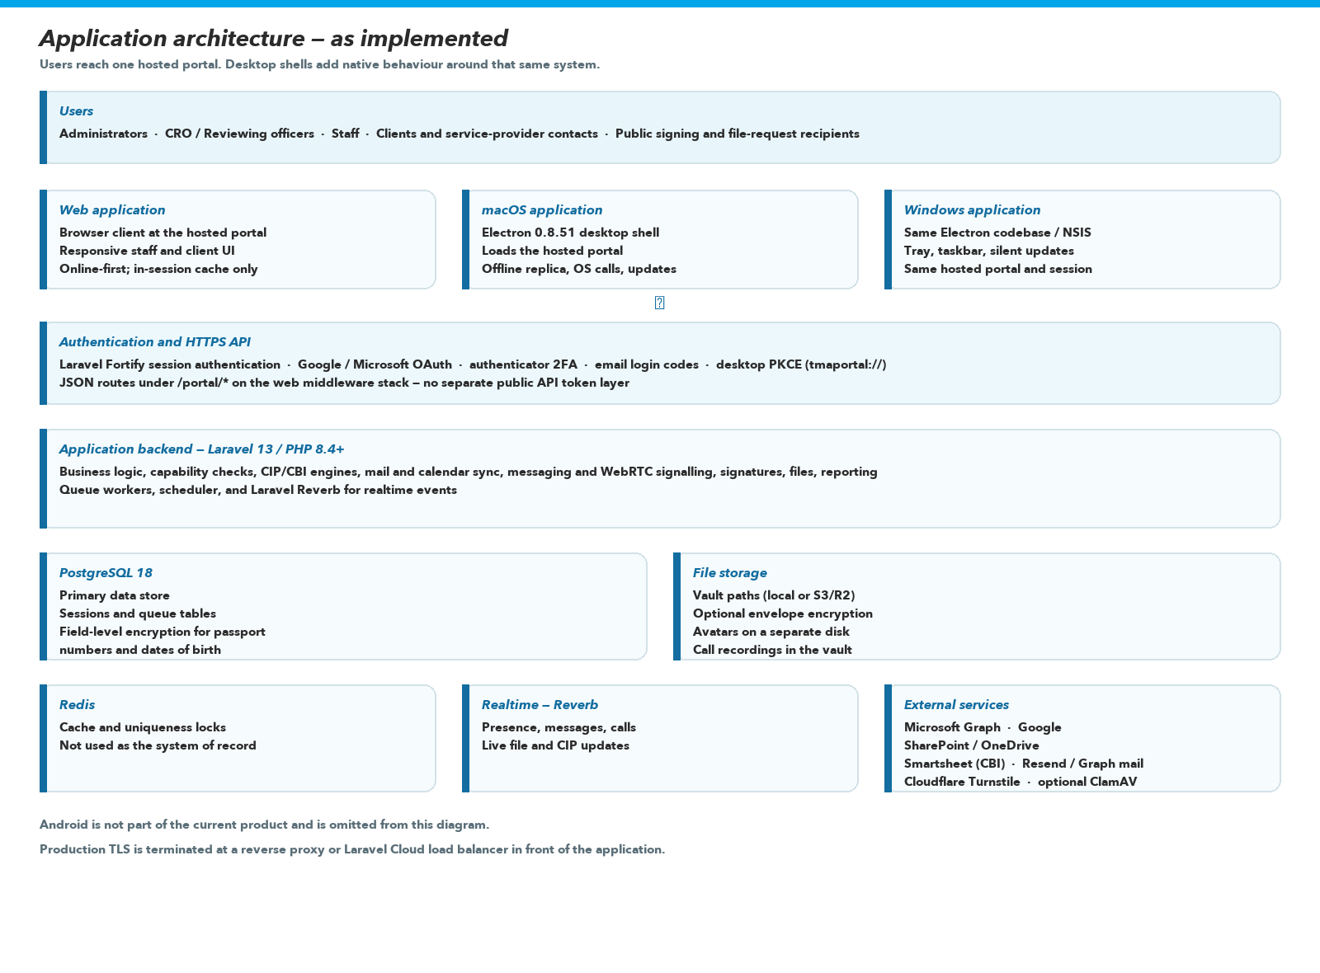
Figure 2. Runtime architecture of the TM ANTOINE Portal.
9. Security architecture
Security is a stack of controls, not a single product feature. The diagram lists implemented layers. Backup automation and host-level disk encryption sit in operations and are not drawn as application features.
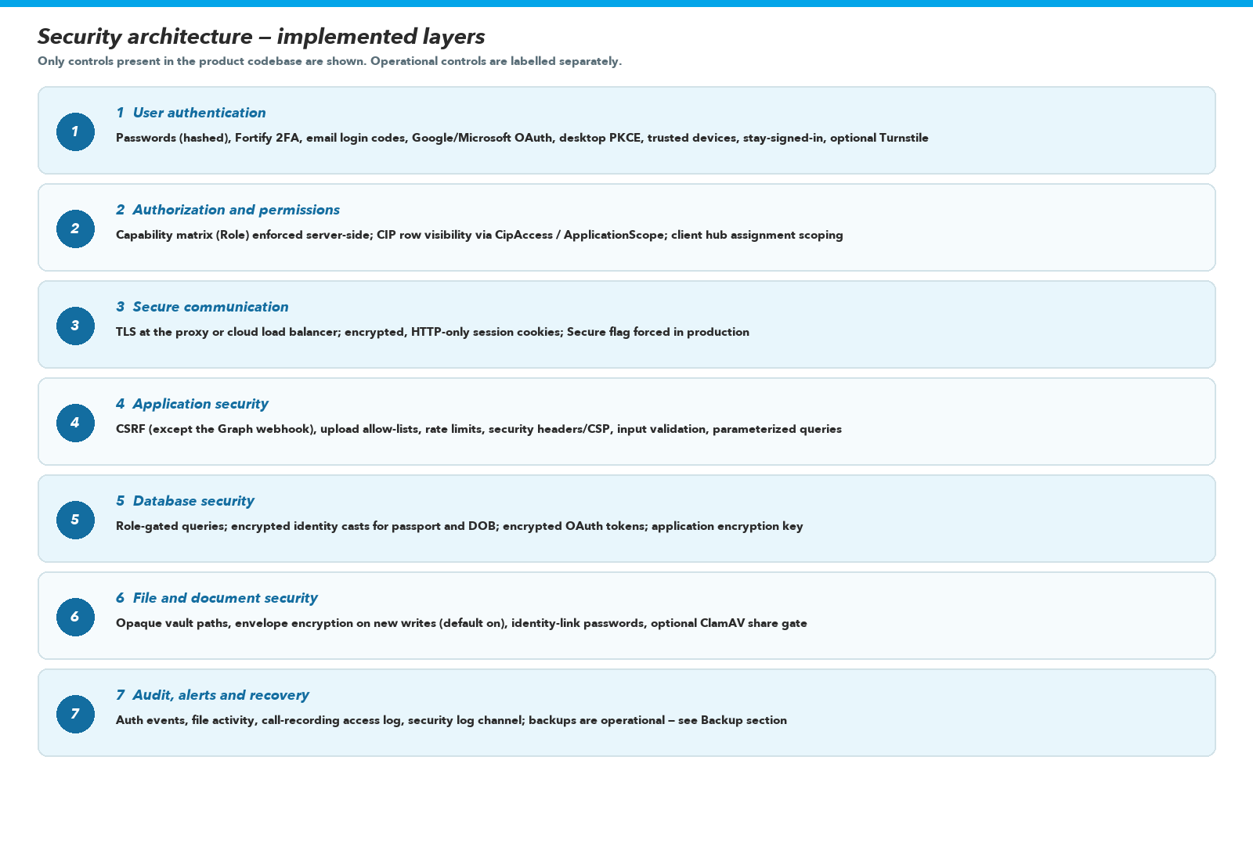
Figure 3. Implemented security layers.
9.1 Implemented versus recommended
Layer | Current status | Included in current product
Password authentication and hashing | Implemented | Yes
Authenticator 2FA and email codes | Implemented | Yes
OAuth (Google, Microsoft) and desktop PKCE | Implemented | Yes
Capability-based authorisation | Implemented | Yes
TLS at the edge | Supported / To Be Confirmed per host | Yes — required for production
Vault envelope encryption | Implemented (default on) | Yes
Field encryption of passport and DOB | Implemented | Yes
Malware scanning | Configured | Yes — when ClamAV is enabled
Turnstile | Configured | Yes — when keys are set
Apple Developer ID + notarisation | Recommended Enhancement | No
Windows Authenticode signing | Recommended Enhancement | No
Automated compose backups | Recommended Enhancement | No
Host/volume encryption at rest | To Be Confirmed | No — not in application code
Formal privacy certification | Recommended Enhancement | No

10. Data protection
The application incorporates technical safeguards designed to support data protection and privacy requirements. This report does not claim that a formal legal assessment (for example GDPR certification) has been completed.
What is stored, and where
Relational business data lives in PostgreSQL. Files live on the configured files disk (local volume or S3/R2). Avatars live on the avatar disk. Sessions and jobs live in the database. Redis holds cache and locks, not the client book. Desktop machines that run the official app may hold a replica of clients, files, and CIP applications in IndexedDB, plus shell HTML and preview bytes. Browsers are limited to an in-memory cache that is not the firm’s offline store.
Who can access it, and how that is controlled
Access is decided by authentication plus the Role matrix, client assignment scope, CIP access rules, and file share records. Administrators can reach firm-wide administrative data (users, security policy, operations) but still cannot turn on CIP/CBI without the feature flags. Clients do not receive staff mailboxes or the call-recording library. Public links are unauthenticated by design and are therefore constrained (token, optional password, identity-folder password).
Transmission
Production is expected to run behind TLS. The application trusts X-Forwarded-Proto from its proxy and, when APP_ENV=production, generates HTTPS URLs. Desktop traffic is ordinary HTTPS to the portal host. WebRTC media is browser-to-browser after signalling through the portal; signalling is authenticated.
Documents and administrators
Administrators are powerful inside the product. Envelope encryption is firm-held (derived from APP_KEY), not zero-knowledge: the server can decrypt in order to preview, virus-scan, stamp signatures, and sync. That is a deliberate design. Protection against a dishonest administrator is therefore organisational (who is granted Administrator) as well as technical. Unauthorised external access is mitigated by MFA options, rate limits, Turnstile when configured, scoped queries, and audit logs.
11. Offline and synchronisation capabilities
Offline behaviour was scoped with the firm: durable client data belongs on the desktop application, not on a shared browser. The web application is therefore not described as an offline product.
Desktop (macOS and Windows) — offline-capable native applications
Capability | Status
Warm boot from cached shell and assets | Implemented
IndexedDB replica of clients, files, CIP applications (everything the account may see, walked on sign-in) | Implemented
Browse cached client profiles and file listings without a network | Implemented (with documented limits on filtered/shared views)
Document preview bytes on disk (network-first, LRU) | Implemented
CIP application edits queued until reconnect | Implemented
Offline writes for mail, messaging, generic file upload, signatures | Planned / not the current write queue
Conflict versions beyond CIP queue semantics | Planned
Local replica encrypted with a user-held key | Not claimed

Web / PWA
There is no web manifest and no service worker. The browser keeps an in-memory SWR cache for speed during a session. A reload with no network shows an error page. CIP has a write queue in IndexedDB that can also run in a browser, but the full replica walk is desktop-only. This is not a PWA.
Synchronisation and integrity
CIP, files, and clients expose cursor APIs (updated_at plus id) so the replica pages without losing rows that share a timestamp. File deletions arrive as tombstones. A purged recycle-bin row and a revoked share are documented limitations of the cursor. Mail and calendar synchronisation with Google/Microsoft is a separate, online server-side process with provider conflict handling — it is not the desktop offline replica.
What still needs a network
• First sign-in, OAuth, and any action against a live mailbox or calendar provider.
• Live calls, realtime presence, and sending mail.
• Non-CIP writes that have not been queued.
• A browser reload when offline.
• Malware scan, SharePoint push, and Smartsheet sync (server-side).
12. Cross-platform capability
Platform | Application | Installation | Offline | Updates | Primary use
Web | Hosted portal | Browser — no install | In-session cache only; reload requires network | Server-side deploy | Full product on any current browser; day-to-day staff and client access
Android | Not included | — | — | — | Use the web application in a mobile browser
macOS | TM ANTOINE Portal 0.8.51 | DMG / PKG / ZIP | Shell, assets, file previews, replica; CIP queue | In-app updater from /desktop/ | Native shell, calls, warm start, offline read
Windows | TM ANTOINE Portal 0.8.51 | NSIS installer | Same as macOS | Silent NSIS update | Same product on Windows desktops

13. Performance and scalability
The product is built to support a professional firm growing its user and file counts. It does not promise unlimited capacity. The mechanisms below are the ones actually present.
• PostgreSQL with indexes on hot paths and HMAC lookup columns for encrypted identity search.
• Scoped queries (client assignment, CIP application scope, file access) so listings are not “select all rows”.
• Pagination and cursor sync pages (for example CIP sync pages of 50).
• SWR caching in the client; desktop replica so repeat screens do not wait on Cloud round-trips.
• Background jobs for mail sync, SharePoint, thumbnails, malware scan, reports, pruning.
• Redis-backed unique job locks so web and worker processes do not double-run work.
• Chunked uploads and a 2 GB cap; envelope encryption in chunks.
• Asset bundling (esbuild) and desktop asset cache.
• Production compose can scale queue workers; scheduler and Reverb are documented as single-replica.
Further scale (read replicas, extra Reverb backplane, CDN in front of public assets) would be infrastructure work and is not claimed as already configured unless the host provides it. To Be Confirmed for the live Laravel Cloud plan size.
14. Backup and disaster recovery
Operational — not fully encoded as an application feature
The repository documents how to dump PostgreSQL and how to tar storage volumes. compose.prod.yaml does not run a backup service. Redis is configured without persistence by design. Live Laravel Cloud backup schedules are To Be Confirmed.

Topic | What can be stated
Database backups | Supported via pg_dump / managed Postgres. Frequency and retention: To Be Confirmed on the live host.
File storage | Must be backed up if FILES_DISK=local. If FILES_DISK=s3/R2, durability follows that bucket’s configuration — To Be Confirmed.
Envelope key / APP_KEY | Loss of APP_KEY without APP_PREVIOUS_KEYS makes encrypted tokens and envelope bytes unreadable. Key management is part of recovery.
Restoration | Documented restore path for Docker: pg_restore into a running database; extract storage volumes. Cloud restore: To Be Confirmed with the host.
Desktop caches | Rebuildable from the server; not a backup of the firm’s data.
Monitoring | Application logs, security log channel, failed jobs. Uptime monitoring vendor: To Be Confirmed.

Recommended Enhancement: a documented, tested restore drill with named RPO/RTO, off-site database snapshots, and bucket versioning — owned by whoever operates production.
15. Maintenance requirements
A system of this type remains safe and usable only if it is maintained. The items below are what the architecture requires, not a priced retainer (see section 16).
Routine maintenance
• Security updates for PHP, Laravel, Electron, nginx, PostgreSQL, Redis, and OS images.
• Composer and npm dependency updates, with regression tests.
• Framework and Fortify/Reverb upgrades within supported ranges.
• Database maintenance (vacuum/analyse on self-hosted Postgres; watching managed-plan limits).
• Queue health, failed-job retry, scheduler liveness (one replica).
• Backup verification and occasional restore tests.
• Certificate and TLS proxy health; Reverb websocket path.
• Review of security alerts, malware scanner status, and auth event noise.
• Desktop release signing (when certificates exist) and publishing latest-mac.yml / latest.yml together so platforms do not drift.
Content and configuration changes
These are normally administrator or light-support tasks: adding users, changing roles and Client hub overlays, branding, security policy, templates, CIP requirement text (when enabled), file-library defaults, and report runs. They do not require a full development project if they stay within existing screens.
Development changes
New modules, additional platforms (including Android), additional integrations, substantial UI redesign, changes to CIP legal workflow, and new offline write surfaces are development work. They should be scoped and quoted separately from routine maintenance.
16. Maintenance cost model
No monthly or annual maintenance price has been provided by the project owner for this report. Figures are therefore placeholders. They should be replaced with agreed rates before the document is used in a priced negotiation. The structure is the commercially important part.
Item | Amount | What it is for
Monthly maintenance | [INSERT VALUE] | Infrastructure watching, security updates, routine dependency patches, backup verification, minor defect fixes, general technical support within an agreed response time.
Annual maintenance | [INSERT VALUE] | Twelve times the monthly amount, or a distinct annual package if that is how the parties contract. Same scope as monthly unless a statement of work says otherwise.
Major development / change requests | Quoted separately | New modules, new integrations, substantial UI work, new platform clients, CIP/CBI workflow redesign, additional offline write modules.

Note on analogue pricing
A brochure-website care plan is not an appropriate analogue. This product includes a Laravel backend, a document vault, realtime communication, identity encryption, and two desktop clients. Any inserted maintenance value should reflect that scope.

17. Product development value
The value of the portal is not a line-count. It is the accumulation of discovery, design, architecture, engineering, security, tests, and operational wiring that would have to be repeated to arrive at a comparable working system.
The product represents work across:
• Requirements analysis for an advisory practice and CIP-style casework
• UX/UI design against a Figma portal design system
• System and database architecture
• Backend, frontend, and JSON API development
• Security implementation (authn, authz, encryption, headers, audit)
• Cross-platform desktop development (macOS and Windows)
• Integrations (Microsoft Graph, Google, SharePoint, Smartsheet, Turnstile)
• Testing and quality assurance
• Deployment topology (Docker and Laravel Cloud documentation)
• Maintenance infrastructure (queues, scheduler, logging, desktop update feed)
• Future extensibility (feature flags, capability matrix, vault, replica cursors)
Four numbers that must not be confused
Term | What it means | Used in this report?
Development cost | What was actually spent historically (time, invoices, opportunity cost). | No — not available and not inferred.
Replacement cost | What a professional team would likely charge to commission a comparable system today. | Yes — sections 18–20.
Market value | What a willing buyer and seller might agree, which can sit below or above replacement cost. | Discussed qualitatively; no single sale price is asserted.
Ongoing maintenance cost | What it costs to keep the existing system running. | Structure only; amounts are placeholders.

18. Market value assessment
The objective of this section is to estimate what it would realistically cost, in 2026, to commission a comparable system from a professional software company — not to invent a headline number from the length of the feature list.
Methodology
The estimate is a component-based replacement cost:
• Scope was taken from the inspected codebase (modules, platforms, security, integrations), not from a wish list.
• Effort is expressed as replacement hours for a team that does not already know this repository, including design, engineering, QA, and deployment — not coding speed in isolation.
• Android is excluded. Unsigned desktop distribution is included as software, not as App Store / Developer ID completion.
• CIP and CBI code is included because it exists in the product, even though each module is environment-flagged.
• Rates are blended professional-company rates (design + senior engineering + QA + project leadership), not junior freelance website rates.
Rate basis (2026)
Published Caribbean freelance web-developer bands in 2026 commonly sit around USD 38–95 per hour depending on seniority, with technical leads higher. Nearshore Latin American blended agency bands for professional product work commonly sit around USD 40–85 per hour at mid/senior, while a US or UK software firm quoting a full custom build typically sits well above USD 120 per hour blended. A professional replacement of this portal is not a WordPress brochure quote (the iGraphix LUCELEC proposal used EC$150 per hour for website change requests — a different class of work).
This report therefore uses a blended replacement rate of XCD $190–$310 per hour (approximately USD $70–$115), with an international-equivalent sensitivity at about XCD $400 per hour (approximately USD $150). The East Caribbean dollar is treated at the ECCU peg of USD 1.00 = XCD 2.70.
Effort basis
Typical replacement effort used here is about 4,290 professional hours across design, frontend, backend, database, security, CIP/CBI, vault, integrations, messaging/calls, two desktop clients, QA, deployment, and documentation. That is approximately a two-to-three person product team working for a year, which is conservative relative to an 18-month rebuild of the same surface area. Low range uses fewer hours at the lower rate. High range uses more hours at an international blended rate.
Estimated replacement / development market value
Band | XCD | Approximate USD | How to read it
Low range | XCD $680,000 | USD $252,000 | Efficient regional professional team; tighter hours; less ceremony in QA and documentation.
Typical professional development range | XCD $780,000 – $1,080,000 | USD $289,000 – $400,000 | The defensible commissioning band for a comparable custom system.
Mid-point used in the component table | XCD $945,000 | USD $350,000 | 4,290 hours × about XCD $220/hour blended.
High / international-equivalent | XCD $1,450,000+ | USD $537,000+ | US/UK-adjacent firm, heavier QA, signed desktop distribution, more operational polish.

What this number is not
It is not an asking price. It is not historical cost. It is not a licence fee. A negotiated commercial value may reasonably sit anywhere in or below the typical band depending on exclusivity, support commitments, and who owns ongoing development. Future enhancements in section 22 are not included.

19. Value breakdown
Component values below are the typical mid-point (XCD $945,000). They are allocation of replacement cost, not separate products that can be purchased in isolation for those amounts.
Component | Hours (typical) | Estimated market value (XCD)
UX/UI and product design | 250 | 55,000
Frontend development (portal UI) | 700 | 154,000
Backend development (domain, APIs, jobs) | 850 | 187,000
Database architecture | 140 | 31,000
Security implementation | 240 | 53,000
CIP / CBI case management | 360 | 79,000
File vault, versions, workflows | 300 | 66,000
Mail, calendar, Microsoft/Google/SharePoint integrations | 280 | 62,000
Messaging, WebRTC calls, recordings | 250 | 55,000
macOS desktop application | 260 | 57,000
Windows desktop application | 150 | 33,000
Testing and QA | 350 | 77,000
Deployment and infrastructure | 110 | 24,000
Documentation | 50 | 12,000
Android application | — | Not included
Estimated typical replacement value | 4,290 | XCD $945,000

20. Replacement cost
If the application had to be commissioned from the beginning today, a comparable professional development team would likely quote in the typical band of XCD $780,000 to $1,080,000, with XCD $945,000 as a reasoned mid-point, assuming the same modules and the same two desktop platforms, and assuming CIP/CBI are in scope as they exist in the codebase.
That figure should be kept separate from historical development cost (unknown here), current maintenance cost (placeholders), a purchase price (a commercial negotiation), and any discount for incomplete operational items such as platform code-signing certificates or unverified backup schedules.
21. Intangible product value
Acquiring or continuing an already-developed system avoids a year or more of design and delivery risk. The intangible assets that travel with the code include:
• An existing information architecture and Figma-aligned interface language the firm already knows.
• A working database shape covering clients, CIP, files, mail, calendar, messaging, and audit.
• Security decisions already made (capability model, identity encryption, vault envelope, session rules).
• A deployment story (Docker, Laravel Cloud notes, desktop update feed).
• A substantial automated test suite around access control and core modules.
• Extensibility: flags for CIP/CBI, a Role matrix that can gain capabilities without rewriting every gate, replica cursors that can admit more modules.
Those items do not add a second currency amount on top of replacement cost. They explain why replacement cost is the right comparison, and why a from-zero project would also consume calendar time the firm would not get back.
22. Future development roadmap
The following items are potential future enhancements. They are not included in the current product valuation.
Potential future enhancement | Why it might be considered
Android application | A true mobile client; currently Not included.
Apple Developer ID, notarisation, and Windows Authenticode | Removes Gatekeeper / SmartScreen friction.
Production ClamAV (if not already enabled) | Turns the coded scanner on in operations.
Automated, tested backups with stated retention | Closes the operational gap in section 14.
Broader offline write queue (files, mail, messaging) | Extends desktop offline beyond CIP.
Conflict-version UX | Honest handling when two officers edit offline.
Mobile push (FCM/APNs) or a web push service worker | Alerts when the app is fully quit / no tab is open.
Stricter CSP (no unsafe-inline) and field encryption of addresses | Defence in depth.
Progressive account lockout beyond Fortify’s per-minute throttle | Matches a harsher threat model if the firm wants it.
Advanced analytics / AI-assisted document checks | Only if the firm wants them; nothing like this is claimed as built.
Additional integrations | Whatever the practice adds next (accounting, SMS, payment capture) — quoted separately.

23. Current product versus future enhancements
Capability | Current status | Included in current product
Web application | Implemented | Yes
macOS desktop application | Implemented | Yes
Windows desktop application | Implemented | Yes
Android application | Not included | No
Client hub, files, signatures, mail, calendar, messaging, calls | Implemented | Yes
Native CIP engine | Implemented / Configured (FEATURE_CIP) | Yes — in the codebase
CBI Smartsheet mirror | Implemented / Configured (FEATURE_CBI) | Yes — in the codebase
Desktop offline replica + CIP write queue | Implemented | Yes
Browser PWA offline | Not included | No
Envelope encryption and identity field encryption | Implemented | Yes
Malware scanner wiring | Implemented / Configured | Yes
Store-grade OS code signing | Recommended Enhancement | No
Automated production backups | To Be Confirmed / Recommended | No
FCM/APNs push | Not included | No
Card payment engine | To Be Confirmed | No

24. Technical specifications
Item | Specification
Application type | Custom multi-user practice portal with document vault, realtime collaboration, and desktop shells
Supported platforms | Web (modern browsers), macOS 11+ (app 0.8.51), Windows 10+ (app 0.8.51). Android: not included
Frontend | Blade + HTML/CSS + vanilla JavaScript; esbuild asset pipeline; design tokens
Backend | PHP 8.4+ / Laravel 13; Fortify; Socialite; Reverb
Database | PostgreSQL 18 (production intent); SQLite in-memory for PHPUnit
Cache / locks | Redis 8
Hosting | Laravel Cloud (documented) or Docker production compose behind a TLS proxy
Authentication | Session cookies; passwords; TOTP; email codes; Google/Microsoft OAuth; desktop PKCE
API architecture | Session-authenticated JSON on the web middleware stack
File storage | Local or S3-compatible; vault layout; optional envelope encryption
Security (summary) | RBAC, encrypted PII fields, encrypted sessions and OAuth tokens, CSRF, headers, rate limits, optional Turnstile and ClamAV
Backup | Operational — To Be Confirmed on the live host
Deployment | Git-connected Cloud deploy and/or Docker prod image; desktop artifacts via /desktop/
Versioning | Application deploy hash for shells; desktop semver 0.8.51 at inspection
Realtime | Laravel Reverb (websocket), WebRTC signalling for calls
Browser requirements | A current Chromium, Safari, or Firefox release with JavaScript. Camera/mic/screen share require a secure context (HTTPS or localhost)

25. Documentation of deliverables
The completed technology product, as inspected, consists of:
• The web application (portal shell, auth/onboarding, JSON APIs, Blade views, public assets).
• The Laravel backend, domain services, jobs, scheduler, and Reverb realtime server.
• The PostgreSQL schema (forward migrations) and Eloquent model layer.
• The file vault, signature subsystem, mail and calendar sync, messaging and calling, feed, client hub, people/users, templates, reporting, and administrator settings.
• The native CIP engine and the CBI Smartsheet mirror (both feature-flagged).
• The macOS desktop application and the Windows desktop application, including the update feed controllers.
• Security infrastructure in code: Fortify pipeline, Role matrix, encryption casts, envelope wrapper, headers, audit events.
• Docker development and production compose files, and Laravel Cloud deployment notes in the project README.
• Automated tests (PHPUnit and desktop Electron tests) and internal technical notes under docs/.
• This report.
Not among the current deliverables: an Android application; store-signed desktop binaries; a priced maintenance contract; a legal compliance certificate.
26. Conclusion
TM ANTOINE Partners & Advisors has a custom-built portal that concentrates client work, case files, documents, signatures, professional mail and calendars, internal communication, and administration on one authenticated platform. The web application is the core product. The macOS and Windows applications are native shells of that product, with offline replica behaviour the browser does not attempt. There is no Android client in the current estate.
The complexity is in the combination: a capability-based authorisation model, a document vault with envelope encryption, field-level protection for passport numbers and dates of birth, queued integrations with Microsoft and Google, realtime messaging and calling, and a CIP engine that can be enabled without rewriting the rest of the system. Those are not properties of a brochure website.
Security is real and also incomplete in the way live systems usually are. Authentication, authorisation, encryption, headers, and audit exist in code. Malware scanning and Turnstile depend on configuration. Desktop installers are not yet store-signed. Backups depend on whoever operates PostgreSQL and object storage. Those gaps are named so they are not mistaken for features.
Keeping the product operational requires routine platform maintenance, dependency hygiene, and operational backup practice. Larger functional change remains project work. Maintenance prices are left blank until the owner supplies them.
On a replacement-cost basis, using 2026 professional blended rates and the inspected scope, a comparable system would likely be commissioned in the typical range of XCD $780,000 to $1,080,000, with a reasoned mid-point of XCD $945,000 (approximately USD $350,000). A lower regional outcome around XCD $680,000 and an international-equivalent outcome of XCD $1,450,000 or more are recorded as the edges of the same method. That range is an estimate of what it would cost to build again, not a price at which the system must be bought or sold.
The practical fact for any discussion of value is that the system already exists, is structured to be extended, and already encodes the firm’s workflows and security decisions. Replacing it would cost both money and time. Treating it as “a website” would misstate both the asset and the work required to recreate it.


iGraphix Marketing & Co. · Castries, Saint Lucia
Application & Technology Overview · TM ANTOINE Portal · Version 1.0 · 6 September 2026

