Arduino project.

Linux Mint 19.1 (Ubuntu 18.04 Bionic Beaver)
Install Arduino IDE using Software manager.
(Arduino 2:1.0.5+dfsg2-4.1)
Let the IDE add you to the dialout group and re-login.
Attach OSEPP Nano
Getting java.lang.NullPointerException thrown while loading gnu.io.RXTXCommDriver
So it seems, I only have the jre installed … installing OpenJDK-11 using Software Manager
Installing oracle java 11 also
https://linuxconfig.org/how-to-install-java-on-ubuntu-18-04-bionic-beaver-linux#h6-instructions

OK – need to install java 8

sudo add-apt-repository ppa:webupd8team/java
sudo apt update
sudo apt install oracle-java8-set-default
Working! Now I can select Tools→Serial Port → /dev/ttyUSB0
Test the action File→Examples→Basic→Blink

problems:

avrdude: Version 6.3
Copyright (c) 2000-2005 Brian Dean, http://www.bdmicro.com/
Copyright (c) 2007-2014 Joerg Wunsch

System wide configuration file is "/usr/share/arduino/hardware/tools/avrdude.conf"
User configuration file is "/home/rich/.avrduderc"
User configuration file does not exist or is not a regular file, skipping

Using Port : /dev/ttyUSB0
Using Programmer : arduino
Overriding Baud Rate : 57600
avrdude: Send: 0 [30] [20]
avrdude: Send: 0 [30] [20]
avrdude: Send: 0 [30] [20]
avrdude: ser_recv(): programmer is not responding
avrdude: stk500_recv(): programmer is not responding
avrdude: stk500_getsync() attempt 1 of 10: not in sync: resp=0x00
avrdude: Send: 0 [30] [20]
avrdude: ser_recv(): programmer is not responding
avrdude: stk500_recv(): programmer is not responding
avrdude: stk500_getsync() attempt 2 of 10: not in sync: resp=0x00
avrdude: Send: 0 [30] [20]
avrdude: ser_recv(): programmer is not responding
avrdude: stk500_recv(): programmer is not responding
avrdude: stk500_getsync() attempt 3 of 10: not in sync: resp=0x00
avrdude: Send: 0 [30] [20]
avrdude: ser_recv(): programmer is not responding
avrdude: stk500_recv(): programmer is not responding
avrdude: stk500_getsync() attempt 4 of 10: not in sync: resp=0x00
avrdude: Send: 0 [30] [20]
avrdude: ser_recv(): programmer is not responding
avrdude: stk500_recv(): programmer is not responding
avrdude: stk500_getsync() attempt 5 of 10: not in sync: resp=0x00
avrdude: Send: 0 [30] [20]
avrdude: ser_recv(): programmer is not responding
avrdude: stk500_recv(): programmer is not responding
avrdude: stk500_getsync() attempt 6 of 10: not in sync: resp=0x00
avrdude: Send: 0 [30] [20]
avrdude: ser_recv(): programmer is not responding
avrdude: stk500_recv(): programmer is not responding
avrdude: stk500_getsync() attempt 7 of 10: not in sync: resp=0x00
avrdude: Send: 0 [30] [20]
avrdude: ser_recv(): programmer is not responding
avrdude: stk500_recv(): programmer is not responding
avrdude: stk500_getsync() attempt 8 of 10: not in sync: resp=0x00
avrdude: Send: 0 [30] [20]
avrdude: ser_recv(): programmer is not responding
avrdude: stk500_recv(): programmer is not responding
avrdude: stk500_getsync() attempt 9 of 10: not in sync: resp=0x00
avrdude: Send: 0 [30] [20]
avrdude: ser_recv(): programmer is not responding
avrdude: stk500_recv(): programmer is not responding
avrdude: stk500_getsync() attempt 10 of 10: not in sync: resp=0x00

avrdude done. Thank you.

No Luck.

Install from main site.

Yeah! Now it works.
Use Oracle Java8 JDK
Arduino IDE 1.8.8
Board is almost automatically detected.
Selected Arduino Nano. ATmega328P is automatically shown (the P suffix was not even a dropdown option before)

Experiment 1
Select “/dev/ttyUSB0” and blink uploads.

Experiment 2

Hello World -
Nano LCD GND +5V POT (substituted 5k for 10k)
D12 → 4 (RS)
D11 → 6 (Enable)
D5 → 11 (DB4)
D4 → 12 (DB5)
D3 → 13 (DB6)
D2 → 14 (DB7)
5 (R/W) → *
1 (VSS) → *
2 (VCC) → *
*----→ 1 (high)
3 (VEE) ------------------------- → 2 (sweep)
*--------------→ 3 (low)

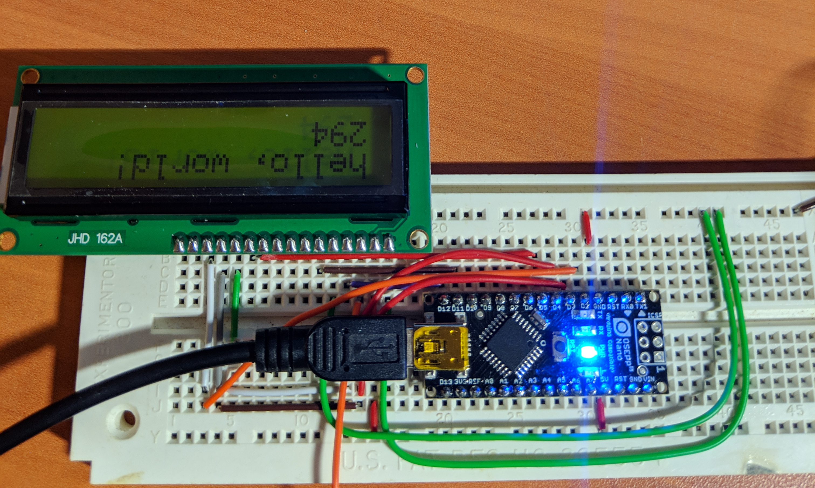

much better article.
https://simple-circuit.com/arduino-lm35-temperature-sensor/

