**Industrial Training Report**

**ON**

**“Scrappad”**

***Submitted to Punjab Technical University, Jalandhar***

***In partial fulfillment of the requirements for six to eight weeks***

***industrial training.***

***At***

**CS INFOTECH**

**(From 1 January 2018 to 7 July 2018)**

**Submitted By:-**

**Master of Computer Applications**

**(2016-2018) 1632183**



**Department of Computer Science**

**Punjab College of Technical Education,Baddowal (Ludhiana)**

**Industrial Training Report**

**ON**

**“Scrappad”**

***Submitted to Punjab Technical University, Jalandhar***

***In partial fulfillment of the requirements for six to eight weeks***

***industrial training.***

***At***

**CS INFOTECH**

**(From 5 June 2017 to 7 July 2017)**

**Submitted By:-**

**ChahatAggarwal**

**Master of Computer Applications**

**(2016-2018) 1632183**



**Department of Computer Science**

**Punjab College of Technical Education,Baddowal (Ludhiana)**

**CERTIFICATE**

**Cs Infotech, Chandigarh**

**TO WHOM IT MAY CONCERN**

I are here by certify thatChahatAggarwal(1632183) Punjab College of Technical Education,Baddowal,Ludhiana has undergone 6 weeks Industrial training from **June,2017** to **July, 2017**

At Cs Infotech to fulfill the requirements for the award of degree of Master of Computer Applications.she has worked on SCRAPPAD project during the training under the supervision of Mrs. Shalini Sharma During his/her tenure with us we found him/her sincere and hard working. Wishing him/her a great success in the future.

Signature of the Student

Signature of the SUPERVISOR (S)

(Seal of Organization)

**ACKNOWLEDGEMENT**

Iam highly grateful to **Mr.BalrajS.Grewal, Head,Dept. of Computer Science**, Punjab College of Technical Education ,Baddowal, Ludhiana for providing me this opportunity to carry out Industrial training at CS infotech-soft solution.

The constant guidance and encouragement received from **Mr. Harinder Singh** and training incharge**MrChhotu Sharma**has been of great help in carrying out the project work and is acknowledged with reverential thanks.

I would like to express a deep sense of gratitude and thanks profusely **to Mrs.Shalini Sharma** Director/CEO of Company. Without the wise counsel and able guidance, it would have been impossible to complete the report in this manner.

The help rendered by (Mrs.Shalinisharma) for experimentation is greatly acknowledged.

I also express gratitude to other faculty members of the Department of Computer Science, Punjab College of Technical Education, Baddowal, Ludhiana for their intellectual support throughout the course of this work.

Finally, we are indebted to all whosoever have contributed in this report work and friendly stay at **CS infotech- soft solution , Chandigarh**.

**Name of Student**

**­**

**Table Of Content**

***Chapter 1.Introduction to the Organization***

*Company Profile

*CS Group

*Founders

***Chapter 2.Project Review***

*Introduction of project

*Statement About Problem

*Objective Of Project

*Modules

***Chapter 3.SDLC***

*Requirement Analysis

***Chapter 4.Feasibility Study***

1. **System Analysis**

*Identification Of Need

*Preliminary Investigation

*Objective

***Chapter 5.Project Work***

**1.Introduction to php**

*Front end used

*Back end Used

**2.Architecture of project- 3 Tiers**

**\***Database Tier

*Business tier

*Presentation Tier

**3. System Design& Database Design**

**4. Implementation**

*Introduction

*Maintenance

*Platform Used

*Testing

**5.Relations in Project**

* Project Screen Short

***Chapter 6.Conclusion and Future Scope***

**Chapter-1Introductionto Organization**

**Company Profile**

**CS Group**

CS Group founded by Mr. Chhotu Sharma is an amalgam of CS Soft Solutions Pvt. Ltd and CS Infotech. CS Soft Solutions is a complete IT solutions providing company with huge clientele all over the world. CS Infotech is a pioneer institution which is engaged in providing computer education in software technologies, to students as well as professional executives.

**CS Soft Solutions Pvt. Ltd.**

CS Soft Solutions is a complete IT solutions providing company based in Mohali. CS Soft Solutions was created to achieve the goal of providing its clients state-of-art web development services comparable with best in the world. The services provided by CS Soft Solutions Pvt. Ltd. Are

* Web Development
* Web Designing
* Online Marketing
* Mobile Application Development

CS Soft Solutions Pvt. Ltd. was conceptualized in October 2009 by Mr. Chhotu Sharma and Mrs. Shalini Sharma. The goal was to build a company that worked on solid principals, to develop world class IT products and provide a congenial environment and adequately encouraging work culture for all the team members at CS Soft Solutions Pvt. Ltd. Consequently, there is a huge clientele from all across the world. For assistance please refer to our website <http://www.cssoftsolutions.com>

One of the methods of paying back to the industry that has been adopted by the CS Group is to recruit students from CS Infotech into CS Soft Solutions Pvt. Ltd. on the basis of their performance and ability to perform in the industry.

**Founders**

Mr. Chhotu Sharma is the founder of the CS Group. He is a Microsoft Certified Software Developer and has been training IT professionals in different Microsoft Technologies since last 13 years. He is recognized as “The Guru of Microsoft Technologies”. For his excellent work in field of education, he has been conferred with title of “Himachal Gaurav” by the Chief Minister, Sh. Prem Kumar Dhumalin the year 2007.His students have been picked up by Fortune 500 companies including Microsoft, Accenture, TCS, Infosys and others. In the year 2009, he established CS Soft Solutions Pvt. Ltd, a company offering complete IT services in multifarious IT applications. He has been instrumental in shaping the goals and evolving values of CS Soft Solutions Pvt. Ltd. His strong penchant for excellence at professional as well as personal front, backed by a sincere and an honest approach towards life are the basic reasons for the success of the ventures he has launched and actively developed. These qualities of sincerity and honesty easily percolate among students, ensuring their success in future lives too.

Mrs. Shalini Sharma is Director of CS Soft Solutions Pvt. Ltd. and an adept teacher at CS Infotech. She bears a sharp analytical acumen coupled with excellent People Management skills. She has received Bachelor’s Degree from Guru Nanak Dev University, Amritsar. She has trained thousands of students during last decade. She has expertise in a wide array of languages and she meticulously imparts technical training to her wards with endeavor to make them fully equipped in dealing with various requirements of the IT industry, in their careers.

**Chapter-2Project Review**

**Introduction Of Project**

**Project Title:** SCRAPPAD

**Project Manager:** Mrs. Shalini Sharma

**Project Advisor:** Mr. Harinder Singh

**Project category:** Web Application

**SCRAPPAD**is an online solution for creating groups and passing messages to users or groups. When a user logins, inbox is displayed which contained scraps, we can reply or delete these scraps. In basic system, people who want to pass messages to their friends had to contact through phone or sms. Passing of long messages is difficult. It is not that no effort has been made towards this end. An attempt to get the complete working automated failed as the system could not be integrated into a functional whole.

**Objectives of Project:**

After thoroughly analyzing the existing system the following objectives have been set:

* Providing user friendly interface
* Keeping project records online
* Easy access of data
* Easy maintenance
* Maintaining data consistency
* Providing better performance
* Increasing the efficiency through automation
* Adequate validation checks for data entry
* Facility to update the data time to time
* Adequate security of the database

**Statement about problem**

In basic system, people who want to pass messages to their friends or group of friends had to contact through phone or sms. Passing of long messages is difficult. It is not that no effort has been made towards this end. An attempt to get the complete working automated failed as the system could not be integrated into a functional whole. I felt this shortcoming becoming glaringly evident. A discussion with my project guide produced enthusiastic response and I decided to take the challenge.

**Module**

The modules for project are

* User Account Maintenance
* Admin
* User
* Posts Module
* Voting Module
* Discussion Module

**Chapter- 3 SDLC**

The Systems Development Life Cycle (SDLC) is a conceptual model used in project management that describes the stages involved in an information system development project from an initial feasibility study through maintenance of the completed application. Various SDLC methodologies have been developed to guide the processes involved including the waterfall model (the original SDLC method), rapid application development(RAD), joint application development (JAD), the fountain model and the spiral model. Mostly, several models are combined into some sort of hybrid methodology. Documentation is crucial regardless of the type of model chosen or devised for any application, and is usually done in parallel with the development process. Some methods work better for specific types of projects, but in the final analysis, the most important factor for the success of a project may be how closely particular plan was followed. The following figure shows a general life cycle Process in software development:

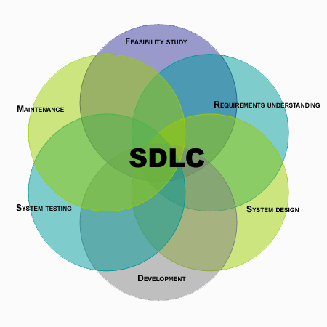

The most common steps in all the development methodologies are as follows:

1. **System/Information Engineering and Modeling:** As software is always of a large system (or business), work begins by establishing the requirements for all system elements and then allocating some subset of these requirements to software. This system view is essential when the software must interface with other elements such as hardware, people and other resources. System is the basic and very critical requirement for the existence of software in any entity. So if the system is not in place, the system should be engineered and put in place. In some cases, to extract the maximum output, the system should be re-engineered and spruced up. Once the ideal system is engineered or tuned, the development team studies the software requirement for the system.
2. **Software Requirement Analysis:** This process is also known as feasibility study. In this phase, the development team visits the customer and studies their system. They investigate the need for possible software automation in the given system. By the end of the feasibility study, the team furnishes a document that holds the different specific recommendations for the candidate system. To understand the nature of the program(s) to be built, the system engineer or "Analyst" must understand the information domain for the software, as well as required function, behavior, performance and interfacing. The essential purpose of this phase is to find the need and to define the problem that needs to be solved.

### Server Side:

* **Software Requirements (Recommended):**
* Developing Language:
* PHP 5.4 With html,css
  + - * Database:
* My SQL 5.5
  + Operating System:
* Any operating system
* **Hardware Requirements (Recommended):**
  + - * Processor:
* Pentium 3 or above.
  + - * Processor speed:
* Greater than 400MHz**.**
  + - * Ram:
* Greater than 512MB**.**
  + - * Hard Disk:
* Minimum 40GB.

### User Side (Recommended):

* **Software Requirements:**
* Browser
* Internet Connection
* **Hardware Requirements:**
  + Processor:
    - Pentium 3 or above.
  + Video Device:
    - Monitor or any other video screen
  + Processor speed:
    - Greater than 500MHz**.**
  + Ram:
    - Greater than 128MB**.**
  + Hard Disk:
    - Minimum 20GB.
* Modem:
* For Internet Connection

1. **System Analysis and Design:** In this phase, the software development process, the software's overall structure and its nuances are defined. A software development model is thus created. Analysis and Design are very crucial in the whole development cycle. Any glitch in the design phase could be very expensive to solve in the later stage of the software development. Much care is taken during this phase. The logical system of the product is developed in this phase.
2. **Code Generation:** The design must be translated into a machine-readable form. The code generation step performs this task. If the design is performed in a detailed manner, code generation can be accomplished without much complication. Programming tools like compilers, interpreters, debuggersetc are used to generate the code. Different high level programming languages likeare used for coding. With respect to the type of application, the right programming language is chosen.
3. **Testing:** Once the code is generated, the software program testing begins. Different testing methodologies are available to unravel the bugs that were committed during the previous phases. Different testing tools and methodologies are already available.
4. **Maintenance:** The software will definitely undergo change once it is delivered to the customer. There can be many reasons for this. Change could happen because of some unexpected input values into the system. In addition, the changes in the system could directly affect the software operations. The software should be developed to accommodate changes that could happen during the post implementation period.

**REQUIREMENT ANALYSIS:**

This phase define the requirement of the software i.e. it defines the tools and equipments which are used for the development of the software.. Following are the hardware and software requirements for building this Application:

**Hardware and Software Used**

* Client machine accessing PHP application
  + Any machine that can access a webpage
* Development machine for PHP MySql application
  + Operating System: Any
  + Software: WAMP Server, NetBeans Editor
  + Hardware: 160GB HardDisk, 2GB RAM

**Chapter -4 Feasibility Study**

Feasibility study is carried out to test if the proposed system is worth being implemented. Given unlimited resources and infinite time, all projects are feasible. Unfortunately, such situations are not possible in real time. It is usually carried out by a small group of people who are familiar with the information system techniques, understand the part of business that will be involved and affective by the people that are skilled in analysis and design.

A feasibility study is conducted to select the best system that meets the performance requirements. This entails an identification description, and emulation of candidate systems and selection of best system for the job.

Economic Feasibility

Economic analysis is the most frequently used method for evaluating the effectiveness of a candidate system. More commonly known as cost/benefits and saving that are expected from a candidate system and compare them with cost. If benefits outweigh costs, then the decision is made to design and implement the system.

Usually cost benefits analysis is made to find the savings or extra overheads that would arise new development.

Technical Feasibility

Technical feasibility centers on existing computer system and to what extent it can support the proposed addition. This involves financial consideration to accumulate technical enhancement

Operational Feasibility

The operational feasibility refers to the assessment of proposed system in the manner that how much this system is feasible for the end users. The system should have capabilities in it. That person with a simple knowledge can also use the system. Our proposed system is user-friendly interface. The user just have to click on the choice with the help of menu. Therefore the system is feasible on operational front too.

**TimeFeasibilty**

Time feasibility determines whether system is implemented within stipulated time.

**Requirement Specifications**

Requirement analysis is a software engineering task that bridges the gap between system level software analysis and software design.

There are four basic elements in system requirements analysis:

**Output** First of all, we must determine what the objectives or goals are, what do we intend to achieve, what is the purpose of our work; in other words what is the main aim behind the system. Defining aim is very vital in system work. If we do not know where we want to go, we will not know when we have reached there; we shall be unnecessarily wasting our time and energy in the system.

**Input**

Once we know the output, we can easily determine when the inputs should be sometimes, it may happen that the required information may not be readily available in the proper form.

**Accuracy**

If the data is not accurate the output will be also not be correct.

**Timeliness**

If data is not obtained in time, the entire system is considered to be a bad system.

**System Analysis**

Analysis is a detailed study of the various operations performed by a system and their relationship within and outside of the system. In general view system is collection of people, procedures and equipments. People are not the only important component of any information system. Information is produced and used by people in an organization in their everyday activities to make decisions. Information system establishes procedures ensuring that right people receive right data at right time. These procedures determine what is to be done at it enter and passed through the system. System analysis is the method that is used to analyze the system, design them and build them. Analysis is used to gain an understanding of existing and what is required in system. The analysis phase ends with the system description and a set of requirement of the new system. Analysis is a process of diagnosis the situation with the boundaries of system kept in mind to produce a report based own findings.

Identification of need

Detailed information requirement analysis of organization is collected from present system. As a person has to be changed with the prevailing conditions of society, in the same a system has to be changed accordingly. Computerized organization is the today’s demand. In comparison to the old system, the computerized system is more reliable and cost effective. In the present organization, the data is scattered whereas the data should be integrated at one place so that the modifications can be made easily and it becomes easy for any authorized person to get information from these files.

Preliminary investigation

To meet the above-mentioned requirement, we need a system that has the tools of PHP. It should be a simple system because the user going to use it are not much familiar with these kind of systems so it should be a simple, easy to use an understandable to all persons.

Objectives

1. Efficiency: when all the work is done by computer then it will increase the efficiency, so all the activities will be done fastely.
2. This system also save time for making test result

**DATA FLOW DIAGRAMS (DFDs)**

A data flow diagram, in the simple words, is a hierarchical graphical modal of a system that shows the different processing activities or functions that system performs and the data interchange in this function. In the DFD terminology, it is useful to consider each function as process that consumes some input data & produces some output data.

The DFD (also known as the bubble chart) is a simple graphical formalism that can be used to represent a system in terms of the input data to the system, various processing carried out on this data & output data generated by the system. DFD is very simple formalism. It is simple to understand & use. A is use very limited number of primitive symbols to represent the functions performed by a system & the data flow among these functions.

Human mind is such that it can easily understand any hierarchical model of a system, because in a hierarchical model, starting with a very simple & abstract model of a system; different details of the system can be slowly introduced through different hierarchies

**Primitive symbols Used For Constructing DFD’s:**

**1. Function symbol:-**

A function symbol is representing as circle. This symbol is called a PROCESS or a BUBBLE. Bubbles are annotated with the names of corresponding Functions. It represents a process that transforms incoming data flow into the outgoing data flow.

**2. External entity Symbol:-**

**External Entity**

An external entity such as a manager, customer etc. is represented by a rectangle. The external entities are essentially those physical entities external to the software, which interact with the system by inputting data to the system or by consuming the data produced by the system. In other words, it defines the source or destination of the system data.

**3. Data Flow Symbol:-**

An arrow identifies data flow in the motion. A arrow represent the data flow occurring between two processes, in which direction of the data flow arrow.

**4. Data Store Symbol:-**

An open rectangle is a data store – data at rest, or a temporary repository of data.

**ER Diagram**

* The constructs used in the ER modal can easily be transformed into relational tables.
* This modal can be used by the database designer to communicate the design to the end user.

**BASIC CONSTRUCTS OF ER DIAGRAM**

1. **ENTITIES:-**

Entities are usually recognizable concepts, either concrete or abstract such as person, places, things or events, which have relevance to the database

**ENTITY**

1. **RELATIONSHIPS:-**

A relationship represents an association among two or more entitles.

**Relationship**

1. **ATTRIBUTE:-**

Attribute describe the properties of the entity of which they are associated. A particular instance of an attribute is a value.

1. **KEY ATTRIBUTE:-**

A key attribute is the UNIQUE, distinguishing characteristic of the entity.

Scrapped ER

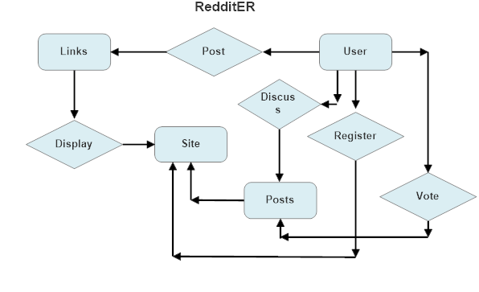

**Methodology Adopted**

Prototyping Model has been used for software development according to which a throwaway prototype of the proposed system, based on the currently known requirements, is given to the user so that he has a fair idea about how the proposed system is going to be like. This will help him in deciding the interface, input and output requirements.

It can be easily adjudged that inputs and outputs are big in number, can increase exponentially and may create a big chaos if not restricted properly. As the user spends some time on the prototype, he will become more precise about his own input and output requirements. This prototype will provide him with an environment analogous to the proposed system’s environment.

Because of object oriented support in PHP, various concepts (like reusability, polymorphism, isolation etc.) are already there but for the efficient management of system components, Component based Software Engineering will also be exercised which will help in a resultant library of components, the benefit of which will be reusability and fast development.

Because of lack of hierarchical structure in object oriented approach, there is no meaning of Bottom-up or Top-down testing. Testing will begin from the most rudimentary levels of the system and will move towards higher level components which will be based on design phase rather than coding phase. In little words, it can be said that ‘CLUSTER Testing’ will be exercised to scrutinize all the parts and their associative functionality.

**Chapter-3ProjectWork**

**Introduction To PHP**

**PHP** is a general-purposeserver-side scripting language originally designed for Web development to produce dynamic Web pages. It is one of the first developed server-side scripting languages to be embedded into an HTML source document rather than calling an external file to process data. The code is interpreted by a Web server with a PHP processor module which generates the resulting Web page. It also has evolved to include a command-line interface capability and can be used in standalonegraphical applications. PHP can be deployed on most Web servers and also as a standalone shell on almost every operating system and platform free of charge, PHP is installed on more than 20 million Web sites and 1 million Web servers.

Server-side scripting. This is the most traditional and main target field for PHP. You need three things to make this work. The PHP parser (CGI or server module), a web server and a web browser. You need to run the web server, with a connected PHP installation. You can access the PHP program output with a web browser, viewing the PHP page through the server. All these can run on your home machine if you are just experimenting with PHP programming.

**Why PHP?**

* Php run perfectly on different operating system such as window,linux,unix and so on.
* Php is compatible with almost all web servers used today(apache ).
* Php is free to download from the official php resource: http://www.php.net.
* Php is easy to learn and runs efficiently and swiftly on any compatible web server.

**FRONT END USED**

PHP is a server-side scripting language designed for web development but also used as a general-purpose programming language. PHP is now installed on more than 244 million websites and 2.1 million web servers. Originally created by RasmusLerdorf in 1995, the reference implementation of PHP is now produced by The PHP Group. While PHP originally stood for Personal Home Page, **it now stands for PHP: Hypertext Preprocessor, a recursive acronym.**

PHP code is interpreted by a web server with a PHP processor module which generates the resulting web page: PHP commands can be embedded directly into an HTML source document rather than calling an external file to process data. It has also evolved to include a command-line interface capability and can be used in standalone graphical applications.

PHP is free software released under the PHP License, which is incompatible with the GNU General Public License (GPL) due to restrictions on the usage of the term PHP.

PHP can be deployed on most web servers and also as a standalone shell on almost every operating system and platform, free of charge.

**BACK END USED:**

**MySql**

MySQL is the world's most popular open source database software, with over 100 million copies of its software downloaded or distributed throughout it's history. With its superior speed, reliability, and ease of use, MySQL has become the preferred choice for Web, Web 2.0, SaaS, ISV, Telecom companies and forward-thinking corporate IT Managers because it eliminates the major problems associated with downtime, maintenance and administration for modern, online applications.

Many of the world's largest and fastest-growing organizations use MySQL to save time and money powering their high-volume Web sites, critical business systems, and packaged software — including industry leaders such as Yahoo!, Alcatel-Lucent, Google, Nokia, YouTube, Wikipedia, and Booking.com.

The flagship MySQL offering is MySQL Enterprise, a comprehensive set of production-tested software, proactive monitoring tools, and premium support services available in an affordable annual subscription.

MySQL is a key part of WAMP (Windows, Apache, MySQL, PHP / Perl / Python), the fast-growing open source enterprise software stack. More and more companies are using LAMP as an alternative to expensive proprietary software stacks because of its lower cost and freedom from platform lock-in.

MySQL was originally founded and developed in Sweden by two Swedes and a Finn: David Axmark, Allan Larsson and Michael "Monty" Widenius, who had worked together since the 1980's

**Introduction To MYSQL**

Itis the world's most used open source relational database management system (RDBMS) that runs as a server providing multi-user access to a number of databases.It is named after co-founder Michael Widenius' daughter, My. The SQL phrase stands for Structured Query Language.

The MySQL development project has made its source code available under the terms of the GNU General Public License, as well as under a variety of proprietary agreements. MySQL was owned and sponsored by a single for-profit firm, the Swedish company MySQL AB, now owned by Oracle Corporation.

MySQL is an open source database management system and is used in some of the most frequently visited websites on the Internet, including Flickr, Nokia.com, YouTube and as previously mentioned, Wikipedia, Google, Facebook and Twitter.

MySQL can be built and installed manually from source code, but this can be tedious so it is more commonly installed from a binary package unless special customizations are required. On most Linux distributions the package management system can download and install MySQL with minimal effort, though further configuration is often required to adjust security and optimization settings.

**MySQL is the most popular open-source database system.**

1. In MySQL, data is stored in database objects (These objects are often referred as tables.

2. MySQL is the de-facto standard databasefor web sites that support huge volumes of both data and end users (like Friendster, Yahoo, and Google).

**ARCHITECTURE OF PROJECT- 3 TIERS**

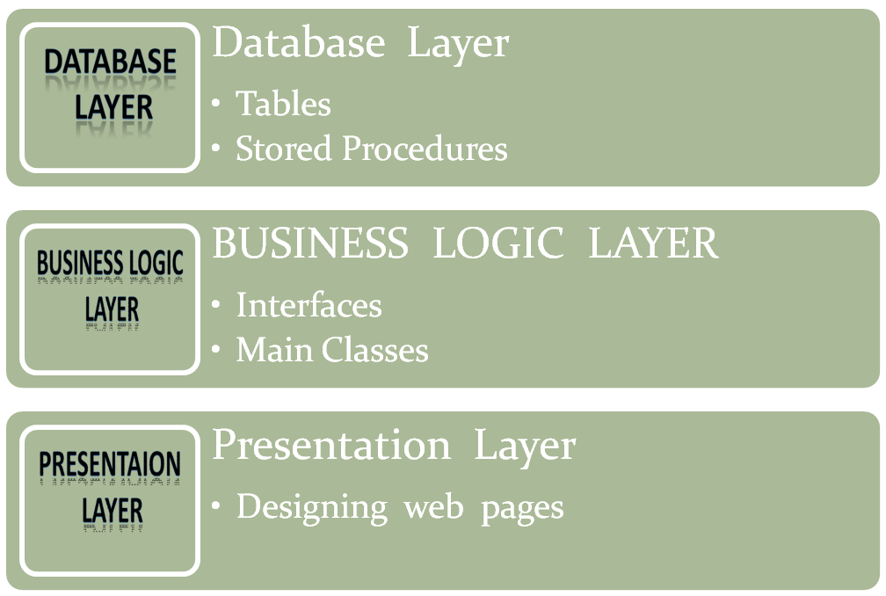

In web application development, we use three-tier architecture refers to separating the application process into three specific layers. What the user sees via a web browser is called the presentation tier and is content served from a web server. The middle tier performs the business logic processing that occurs, for example, when a user submits a form. The back end consists of the data tier which handles the database processing and access to the data. We'll take a simplistic look at each of these.

**1. Data Access Tier:** In php, the Data Access layer is where you define your typed datasets and table adapters.

* It is where you define your queries or stored procedures. The business tier may then make use of this functionality.
* In your classes, rather than defining ad hoc queries, you may use a Table Adapter to access the Data Access Layer.

**2.Business Logic or Application Tier:**The Business Logic, Functional Process Logic, Business Rules (all pertaining to the same thing), are kept in a separate layer.

* In php, this is where you define your classes and source code. This can be in the App_Code folder for your classes and methods.
* You would not use HTML or JavaScript in this layer. In this layer you typically define your classes, functions, sub procedures, properties,etc.

**3. Presentation Tier:**The Presentation Tier or User Interface is the portion the user sees when they open a web page in the browser.

* It is as simple as you reading this article all the way to searching a catalog and purchasing a product using a shopping cart.
* It is what is presented to the user on the client side within their web browser. Languages used in this layer are php, HTML, CSS and javascript.

**System Design:**

The design phase focuses on the detailed implementation for the system recommendation in the feasibility study. The design phase is a translation from a program-oriented-document to user-oriented-document. The design activity begins when the required document for the software to be developed is available. This may be SRS for the complete system, in case of waterfall model is being followed or the requirement for the next iteration, if the iterative enhancement is being followed or the requirement for the prototype if the prototyping is being followed. Design is essentially the bridge between requirement specification and the final solution for satisfying the requirements. The term “design” is used in two ways, when used as a verb it represents the process the designing while it represents the result of design process. The goal of design process is to produce some order, which can be later used to build that system. The produced model is called the design of the system.

The design of the system is essentially a blueprint or a plan for solution for the system. Here we consider a system to be asset of components which clearly defines the behavior that interacts with each other in a fixed define manner. A component of a system can be3 considered as a system with its own components. In a software system a component is a software module.

System design is the process of developing specifications for a candidate system that meet the criteria established in the system analysis. Major step in system design is the preparation of the input forms and the output reports in a form applicable to the user.The main objective of the system design is to make the system user friendly. System design involves various stages as:

* Data Entry
* Data Correction
* Data Deletion
* Processing
* Sorting and Indexing
* Report Generation

**Database Design**

The overall objective in the development of the database technology has been to treat data as an organizational resource and as an integrated whole. Database management system allows data to be protected and organize separately from other resources. Database is an integrated collection of data. The most significant of data as seen by the programs and data as stored on the direct storage access storage devices. This is the difference between logical and physical data. The organization of data in the database aims to achieve free major objectives:

## Data Integration

## Data Integrity

## Data Independence

## The databases are implemented using a DBMS package. Each particular DBMS has unique characteristics and general techniques for Database Design*.*

The proposed Management Information System stores the information relevant for processing in the Microsoft SQL Server Database. This MS SQL Server contains tables, where each table is called a field or column. A table also contains records which is a set of fields. All records, in a table the same set of fields with different information. Each table contains key fields that establish relationships in a MS SQL server database and how the records are stored. There are primary key fields that uniquely identify a record in a table. There are also fields that contain the primary key from another table called foreign keys.

It is a known fact that the program cannot be written until the data are defined, so the database must be defined. The starting point for this process is data dictionary. The records data structures and elements to be stored in each database are identified and extracted. Next the analyst codes the source statements library. Eventually, the programmer will incorporate the source code into the various programs, thus assuring consistency and simplifying the coding process. The databases have been designed in such a way that there is no duplication of information and loss of information.

**Verification:**

A verification check ensures that data is correctly transferred into a computer from the medium that it was originally stored on. Verification checks are usually used to check that a data entry worker has correctly typed information written on a data collection form into a computer.

## Methods of Verification:

**The two most common methods of verification are:**

## On-Screen prompts: After a user has entered some data it is redisplayed on the screen. The user is prompted to read the data and confirm that it has been entered correctly. If the user has entered any data incorrectly he should response that the data is inaccurate and retypes the incorrect parts*.*

* **Dual Inputs:** This method is used when data is entered through the keyboard. The data to be entered is typed in twice by two different operations. The two copies of data are been compared, any difference are detected, the operators will be prompted to retype the sections that differ until both copies agree/. When the two copies agree the computer assumes that the data has been entered correctly.

**Validation:**

## A validation check is an automatic check made by computer to ensure that any data entered into the computer is sensible. A validation check does not make sure that data has been entered correctly. It only ensures that data is sensible. For this reason validation checks are not usually as effective as verification checks. They can however be carried out automatically by the computer and therefore require less work by the computer operators making them cheaper to use.

**Data Dictionary**

In our DFD, we give names to data flows, processes, and data stores. Although the names are descriptive of the data, they do not give details. So the following the DFD, our interest is to build some structured place to keep details of the contents of data flow, processes, and data store. A data dictionary is a structured repository of data about data. It is a set of rigorous definition of all DFD data element and data structure. A data dictionary has many advantages. The most obvious is documentation; it is valuable reference in any organization. Another advantage is improving analyst/user communication by establishing consistent definition of various elements, terms and procedures. During implementation, it serves as a common base against which programmers who are working on the system compare data description. Also control information maintained for each data element is cross referenced in the data dictionary. E.g. program that use a given data element are cross referenced in a data dictionary, which makes it easy to identify them and make any necessary changes. Finally

## Input Design

## The input design is the link between the information system and the user. It comprises developing specification and procedure for data preparation and those steps that are necessary to put transaction data into a usable form for processing data entry. The activity of putting data into the computer for processing can be achieved by instructing the computer to read data from a written or printed document or it can occur by having people key data directly into the system. The design of inputs focuses on controlling the amount of inputs required, controlling errors, avoiding delay, avoiding extra steps and keeping the process simple.

## Output Design

In output design, emphasis is given on producing a hard copy of the information required as the output on the CRT screen in some predefined manner. Computer output is the most important and direct source of information to the use. Output design is a process that involves designing necessary outputs that should be given to various users according to their requirements. Efficient, intelligible output design should improve the system’s relationship with the user and help in decision making. Since the reports are directly referred by the management for taking the decisions and to draw conclusions,

**Implementation:**

Introduction:

It is one of the main modules of the project development stage. All the work done as earlier comes near to end when I am going to implementing the project. I tried my best to fulfill all the requirements of Online Human Resource Development. However, implementation can be taken finalize the testing procedure. But if we implement the project there is not any standardized procedure to check the testing while implementation give us chance to test if there is any problem, it can be taken remedies so we can finalise the project, using implementation and reviewing techniques. So far, this project is concerned; it is free from errors and can be implemented very effectively.

Testing:

Testing is a dynamic method for verification and validation, where the system to be tested is executed and behavior of the system is observed. Due to this, testing observes the failures of the system, for which the presence of faults can be deduced. However, separate activities have to be performed to identify the faults and then remove them.

There are two approaches to testing, functional and structural. In functional testing, the internal logic of the system under testing is not considered and the test cases are decided for the specifications or the requirements. It is often called black-box testing. In structural testing, the test cases are decided entirely on the internal logic of the program on module being tested. The external specifications are not considered. Mutation testing is another approach for structural testing that created mutants of the original program. The testing criterion is to kill all the mutants by having the mutant generate a different output from the original program.

Unit testing is used to test a module and the focus are combined into sub-systems which are then tested. The goal here is to test the system design.

Structural testing can be used for unit testing, while at higher level mostly functional testing is used.

During the test case, execution phase the test cases are executed and various reports are produced for evaluating testing. The main output of the execution phase is the test log, the test summary report and the error report.

Maintenance

Maintenance is a provision, which includes both the improvement of system functions and the correction of faults which arise during the operating of system. Maintenance activity may require the continuing involvement of a large proportion of computer resources. When we install the software, chances arise in two ways

1. As a part of normal running system where errors are found, user may ask for improvement or external requirements change.
2. As a result of specific investigation and review of system performance.

**Relations in Project:**

Total 4 tablesare there in our project

1. Tbtec(Specifies the technology)
2. Tbreg(Table for registration)
3. Tbpst(shows all the posts)
4. Tbrep(Reply Table)

**Tables with their Attributes:**

**1.tbtec**

|  |  |  |
| --- | --- | --- |
| **Attribute Name** | **DataType** | **Key** |
| Teccod | Int | Primary Key/AI |
| tecnam | varchar(100) |  |

**2.tbreg**

|  |  |  |
| --- | --- | --- |
| **Attribute Name** | **Data Type** | **Key** |
| Regcod | Int | Primary key/AI |
| Regeml | Varchar(100) | Unique |
| Regpwd | Varchar(50) |  |
| Regdat | Date/Time |  |

**3.tbpst**

|  |  |  |
| --- | --- | --- |
| **Attribute Name** | **Data Type** | **Key** |
| Pstcod | Int | Primary Key/AI |
| Pstdat | Date/Time |  |
| Pstregcod | Int | Foreign key |
| Pstteccod | Int | Foreign Key |
| Psttit | Varchar(100) |  |
| Pstdsc | Varchar(1000) |  |
| Pstatt | Varchar(50) |  |
| Pstrat | Int |  |

**4.tbrep**

|  |  |  |
| --- | --- | --- |
| **Attribute Name** | **Data Type** | **Key** |
| repcod | Int | Primary Key/AI |
| Repdat | Datetime |  |
| Reppstcod | Int | Foreign key |
| Repdsc | Varchar(1000) |  |
| Repatt | Varchar(200) |  |
| Repregcod | Int | Foreign Key |

**Screenshots**

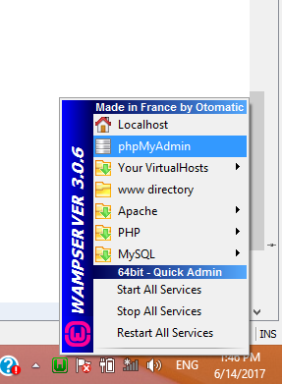

**How to create database**

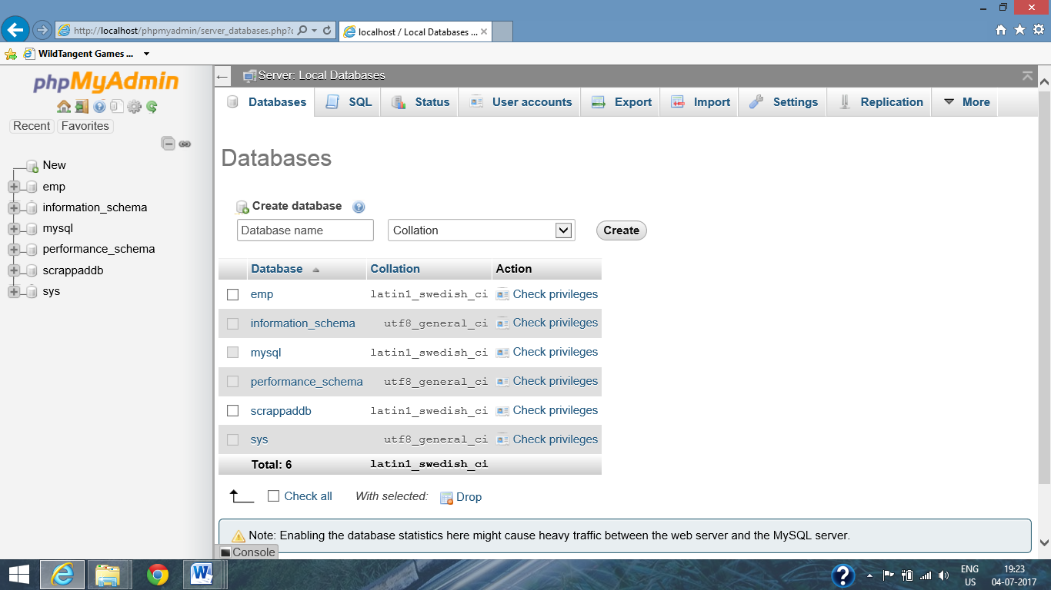

**Tables name**

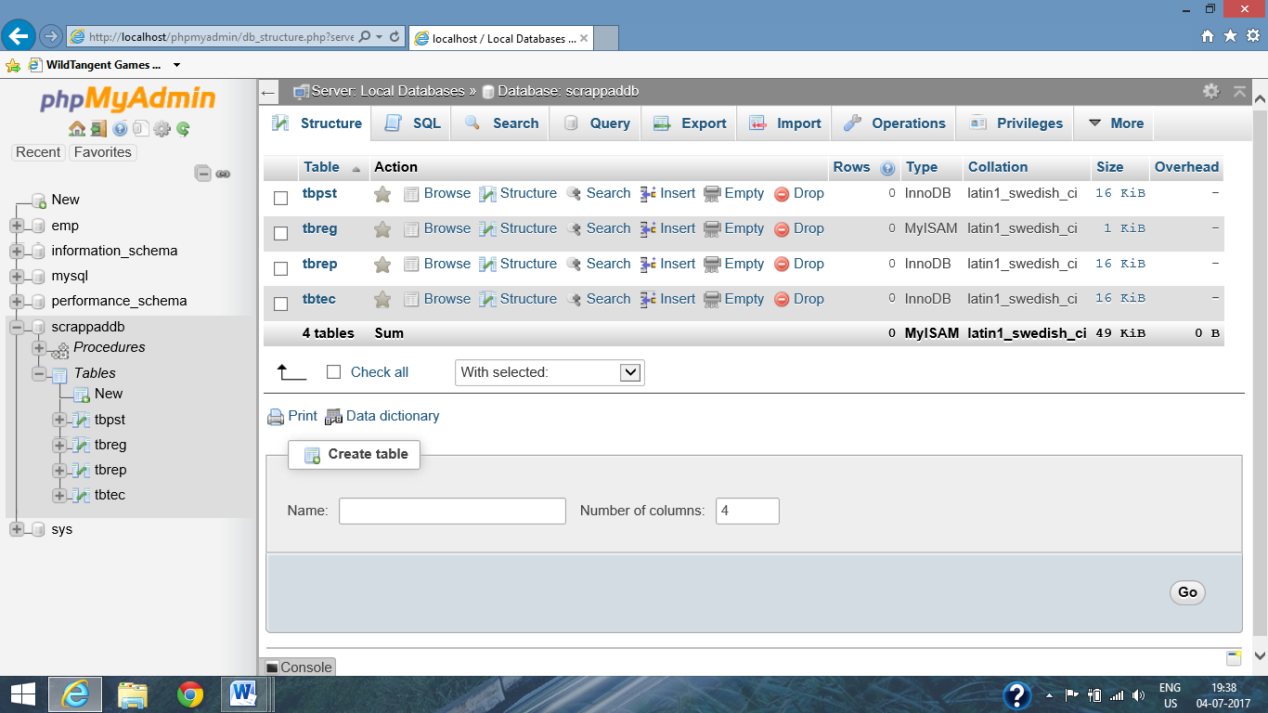

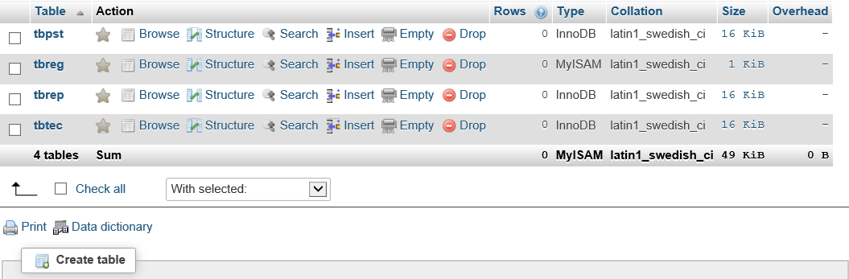

**Tbtec**

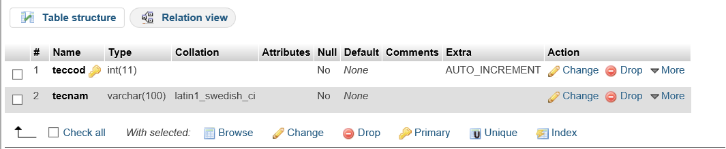

**Tbreg**

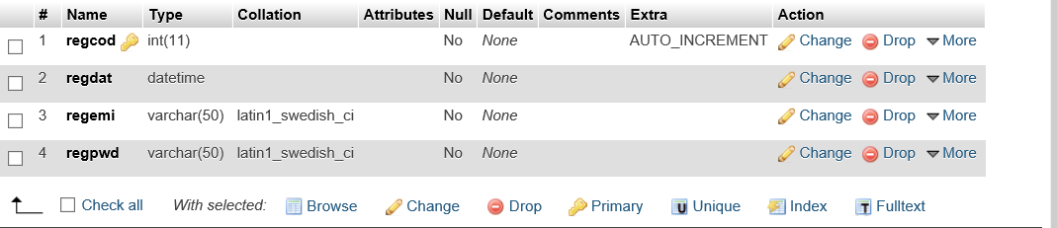

**Tbpst**

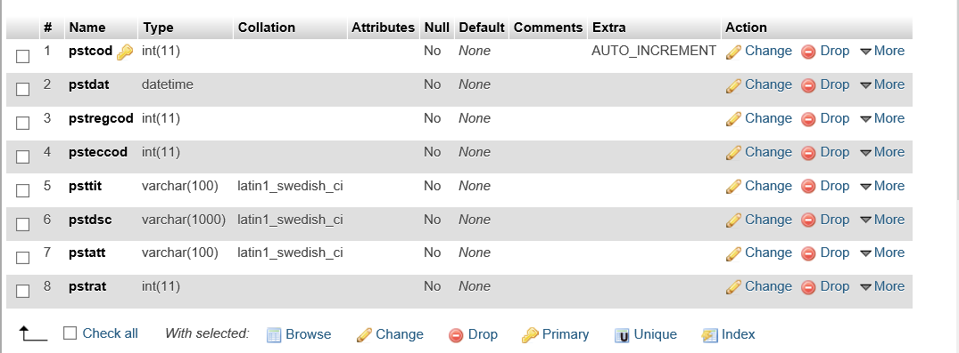

**Tbrep**

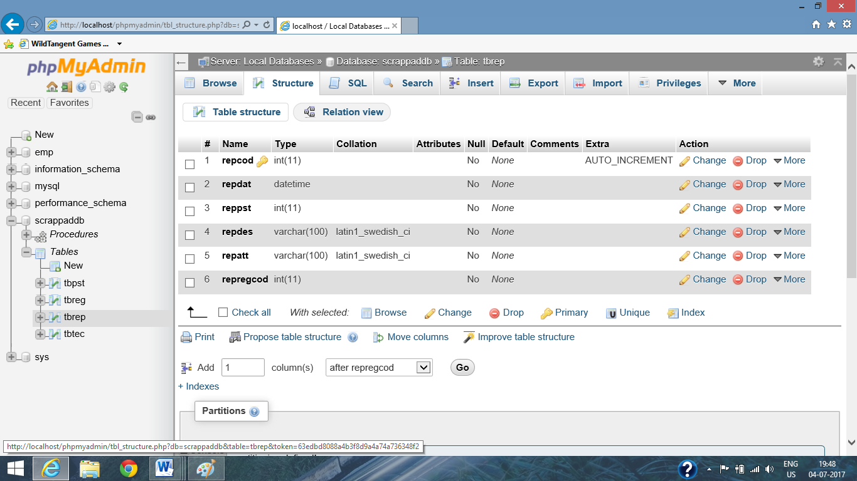

**Stored Procedures:**

20 Stored procedures are there in our project.

Each table has 5 stored procedure :

1. For insert
2. For delete
3. For update
4. For display
5. For find

Therefore 4tables are there in project so 20 stored procedures are there in table.

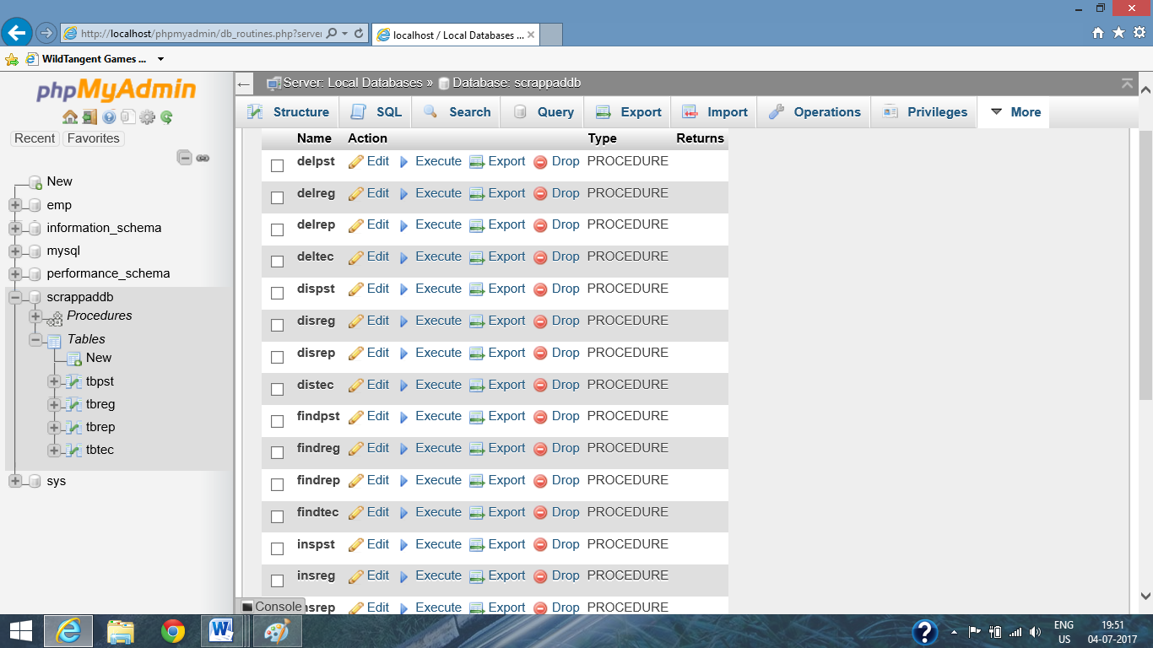

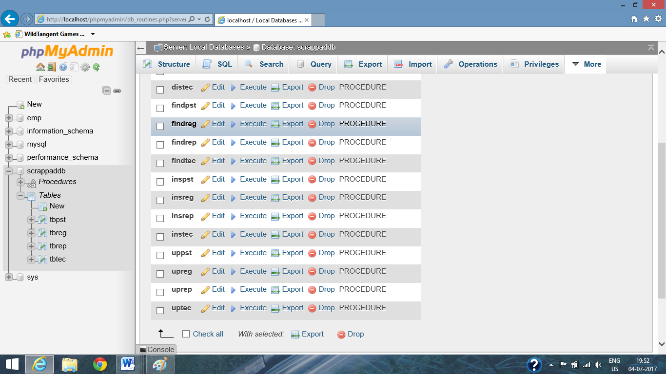

**Stored procedure for login check**

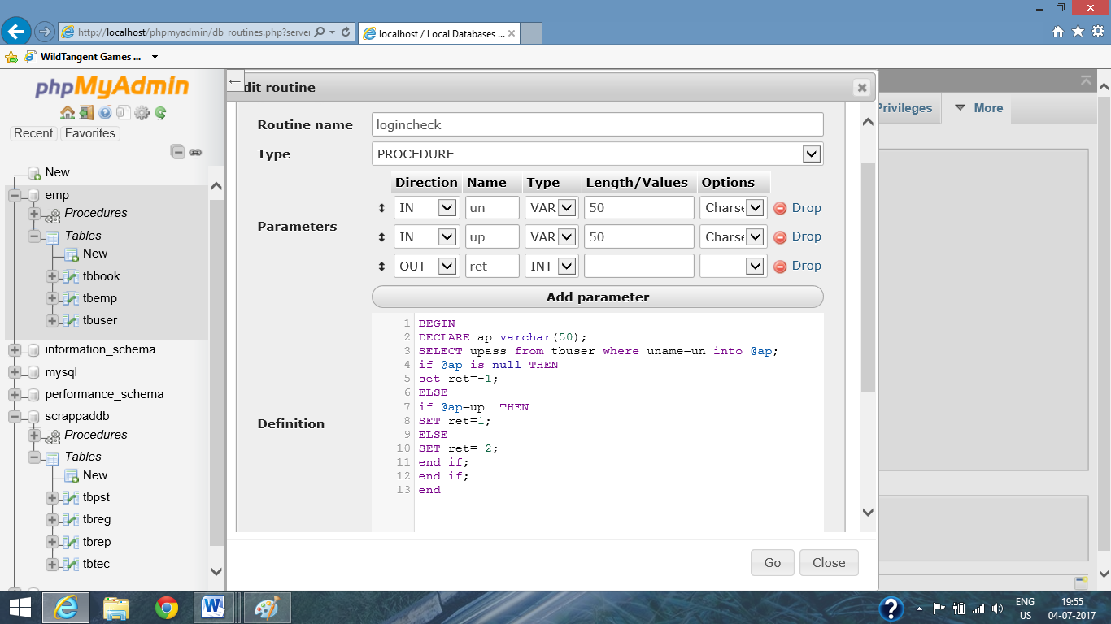

**Businesslogics:**

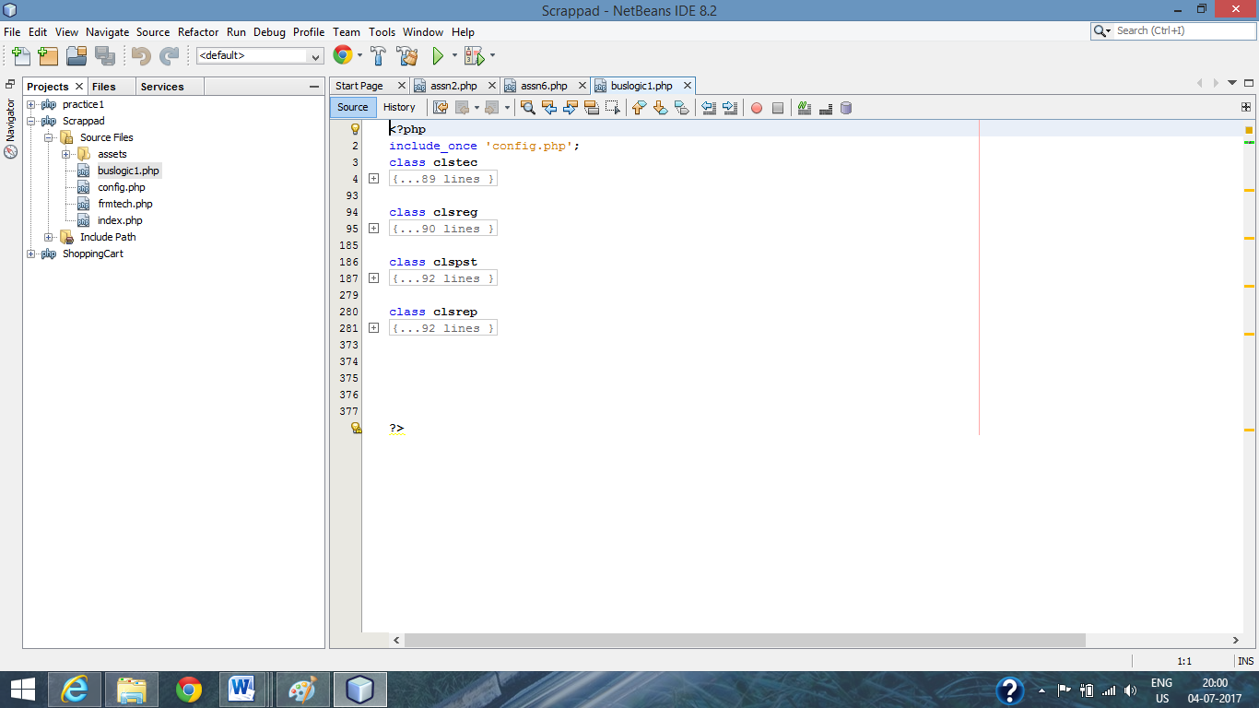

**SCREENSHOTS OF PROJECT**

**Chapter-6Conclusions and Future Scope**

**FUTURE SCOPE**

Completion of the development process will result in a software package that will provide user-friendly environment, which is very easy to work with, even for people with very little knowledge of computer.

Management of various tasks is incorporated in the package and will deliver the required information in a very easy to use and easy to access manner.

This package will provide accuracy, efficiency, speed and easiness to the end user. Since the system is verified with valid as well as invalid data and is run with an insight into the necessary modifications that may require in the future, it can be maintained successfully without much.

**CONCLUSION**

/This chapter provides me an opportunity to do self-introspection of what value I have added to my knowledge and skill set and to the project.

**What value I have added to my knowledge**

**Domain Experience**

CS Infotech is working on various technologies. Also the individual responsibilities are more. So, I have learnt a lot.

**Exposure to entirely different technology**

Working on ASP.NET for the first time was a very enriching experience. I had never worked on this platform earlier. So it added to my list of languages known to me.

**Database Implementation**

I had earlier made database but worked on SQL Server for the first time. I learnt many new things about database creation, concept of stored procedure etc. We learn many things theoretically as part of our curriculum but here I got a chance to apply my knowledge practically and enhance it also at the same time.

**Implementation of Business Logic Layer (BLL)**

I have implemented the classes for BLL, which provides the interface between UI Layer and Data Access Layer. This layer contains all the business logic, i.e. Programming Methodology to implement the functionality of the system.I had always read about N-Tier architecture but this was again the first time I got to implement 3-Tier logical architecture. So it was a very new and realistic experience.

**Implementation of User Interface Layer (UI Layer)**

I have also designed the UI layer that contains the web pages designed in Jsp and Java Script. Also it contains the Code Behind pages to implement the programming logic.

* **Books References:**

**To bring the system to verge of completion ,the following items have been referred:**

**BOOKS**:-

PHP, MYsql, Apache (all in one) By SAMS, Julie c, Meloni, pearson

Beginning: PHP6, Apache,MYSQL By Elizabeth naramore, Jason yerner,

Web development yann le Scouarnec, Jeremy stolz

PHP6 and MYSQL bible By tim converse, joyceepark,Michael k

**Web References:**

[www.php.net](http://www.php.net)

www.w3schools.com