3D City Model LOD-1

This folder contains 3D city LOD-1 model data. The zip file contains vector data of building footprint for part of Ahmedabad city with building height information (in meters). The vector data is in shapefile format (.shp) with corresponding supporting files and can be open in any GIS software or in python. Below in figure-1, the 3D city LOD-1 model data is shown. s
For visualisation of 3D city model for the entire Ahmedabad city, please visit https://vedas.sac.gov.in/vstatic/3D_CITY/index.html .
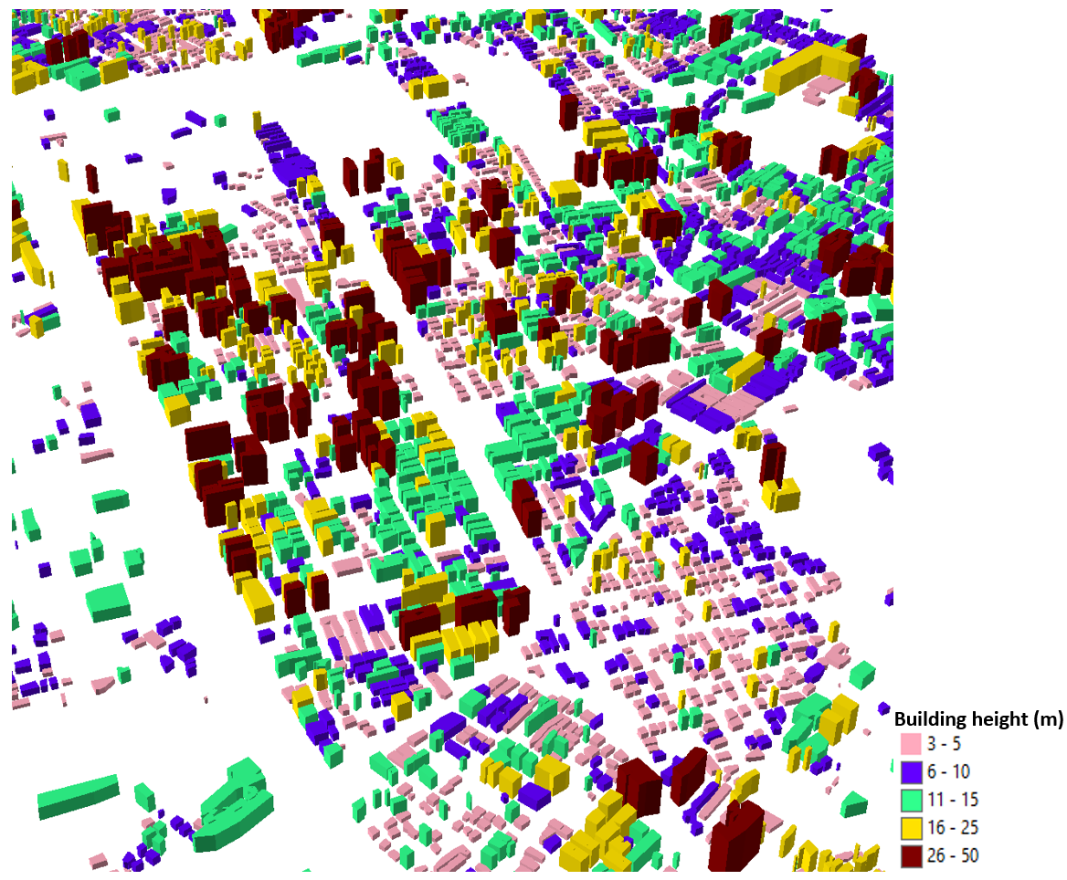
Figure-1: The 3D city LOD-1 model for part of Ahmedabad city.

