When Does Codebase Context Help? A Controlled Study of Dependency-Aware Retrieval-Augmented LLM Test Generation for Mutation Analysis
1st Given Name Surname  dept. of Computer Science  name of organization  City, Country  email / ORCID | 2nd Given Name Surname  dept. of Computer Science  name of organization  City, Country  email / ORCID | 3rd Given Name Surname  dept. of Computer Science  name of organization  City, Country  email / ORCID

Abstract—Mutation testing measures test-suite quality by injecting artificial faults; a mutant the suite fails to detect is a measured blind spot in behavioural coverage. Large language models (LLMs) can generate tests to kill surviving mutants, but existing methods prompt them closed-book, giving them only the unit under test. Real functions, however, often depend on constants, lookup tables, and helpers defined elsewhere, so the fact needed to write a discriminating assertion may be absent from the unit. We ask whether—and when—retrieval-augmented generation (RAG) helps. We present CodeKong, a fully local, reproducible pipeline that (i) generates four escalating mutant classes (operator swaps, statement deletion, LLM-authored semantic faults, and higher-order combinations), (ii) filters to survivors of the existing suite, (iii) indexes the codebase—including module-level constants—and retrieves the definitions of the symbols a unit references, and (iv) generates and validates tests under a strict two-sided kill criterion. We compare closed-book and RAG generation at retrieval depths k ∈ {3,5,8} on three subjects of differing information dependence. On a purpose-built context-dependent benchmark, dependency-aware RAG raises the kill rate from 12.5% to 77.8% and the valid-test rate from 25% to 88%, at a seven-fold lower token cost per kill; on self-contained algorithmic code it yields no benefit (a 22.2% tie); and a small local model floors on complex stateful code. An ablation shows both indexing constants and retrieving referenced symbols are necessary. RAG’s value for mutation-killing test generation is thus conditional on cross-module information dependence, not universal.
Index Terms—mutation testing, retrieval-augmented generation, large language models, automated test generation, software quality.
I. INTRODUCTION
A test suite is only as trustworthy as the faults it can detect. A suite that always passes is reassuring, yet it may be blind to precisely the defects that matter. Mutation testing [1], [2] operationalises this intuition: it seeds small artificial faults—mutants—into working code and measures how many the suite kills. Unlike line or branch coverage, the mutation score reflects a suite’s ability to distinguish correct from incorrect behaviour, and surviving mutants pinpoint concrete gaps [3]. Mutation analysis is a well-validated proxy for real-fault detection [4].
A growing body of work uses LLMs to strengthen suites by generating tests that kill surviving mutants. MuTAP [5] is emblematic: it prompts an LLM with the surviving mutant and the original function and requests a killing test. Industrial systems apply the idea at scale [6]. A shared assumption unites them: generation is closed-book—the model sees only the unit under test, not the surrounding codebase.
This assumption is at odds with how software is written. A function’s correct output frequently depends on values defined elsewhere—tax rates in a constants module, grade thresholds in a policy table, a helper that normalises inputs. To write an assertion that distinguishes a mutant from the original, a generator must often know such a value. Closed-book, it can only guess; and for domain-specific constants, it usually guesses wrong, producing a test that does not even run on the correct program.
We therefore ask a deliberately scoped question: does giving the model retrieved context from the codebase under test—retrieval-augmented generation (RAG) [7]—help it kill more mutants, and under what conditions? Our hypothesis is that retrieval helps exactly when killing a mutant requires a codebase-specific fact that is absent from the unit, and adds little when the unit is self-contained.
We study this with CodeKong, a fully local pipeline (Ollama, ChromaDB, sentence-transformers; no paid API) that makes the comparison controlled: the closed-book and RAG conditions share model, prompts, mutants, and decoding temperature, so retrieval is the only variable. Across three subjects of differing information dependence we find a sharp boundary. On a context-dependent benchmark, dependency-aware RAG lifts the kill rate from 12.5% to 77.8%; on self-contained sorting code it changes nothing; and a 7B model floors on a stateful OO library regardless of retrieval. This paper’s contributions are:
- A pipeline unifying four escalating mutant classes under one schema, providing a difficulty spectrum for per-class analysis.
- A dependency-aware retriever that (a) indexes module-level constants as first-class chunks and (b) explicitly fetches the definitions of the symbols a unit references. We show both are necessary for RAG to help.
- A controlled RAG-vs-closed-book study reported per subject, exposing the boundary condition rather than averaging it away.
- A released context-dependent benchmark and the complete pipeline for replication under the strict two-sided kill criterion.
- A quantitative and qualitative analysis, including a worked example and an ablation isolating the retriever’s two components.
Section II reviews background. Section III details the pipeline; Section IV the design; Section V the results; Section VI–VII discussion and threats; Section VIII concludes.
II. BACKGROUND AND RELATED WORK
A. Mutation testing
Mutation testing was proposed by DeMillo et al. [1] and surveyed by Jia and Harman [2] and Papadakis et al. [3]. A mutation operator transforms a program into a variant (mutant); a test strongly kills a mutant if its outcome differs on the mutant and the original. Surviving mutants indicate untested behaviour; equivalent mutants—semantically identical to the original—cannot be killed and deflate scores for all techniques. Higher-order mutants combine first-order mutations and can model interacting faults [2]. Empirical work links mutation kills to real-fault detection [4], motivating mutants as a generation target.
B. Automated and LLM-based test generation
Search-based generators such as EvoSuite [8] optimise coverage without natural-language understanding and often yield low-readability assertions. LLM-based generators instead exploit code semantics: MuTAP [5] prompts with surviving mutants; TestPilot [9] and related systems generate unit tests from signatures and docstrings; Meta’s deployment [6] uses mutation to guide LLM test generation at scale. These methods are closed-book with respect to the wider repository. Our study isolates what retrieved codebase context adds on top of a MuTAP-style baseline.
C. LLMs and retrieval for mutation
A parallel line uses LLMs to produce mutants: µBERT [10] and LLMorpheus [11] generate natural, realistic faults, and retrieval-boosted mutant generation [12] fetches historical bug-fix pairs. We use an LLM only for our semantic-mutant class; our retrieval operates on the opposite (test-generation) side to kill survivors. RAG [7] pairs a generator with a retriever over an external store; repository-level code assistants show that repo context improves code completion [13]. We bring dependency-aware repo retrieval to mutation-killing test generation and quantify when it pays off.
III. THE CODEKONG PIPELINE
CodeKong comprises five stages (Fig. 1). Provider and model are configuration, not code; every model call is logged with token counts for cost accounting; and generation temperature is fixed for determinism.
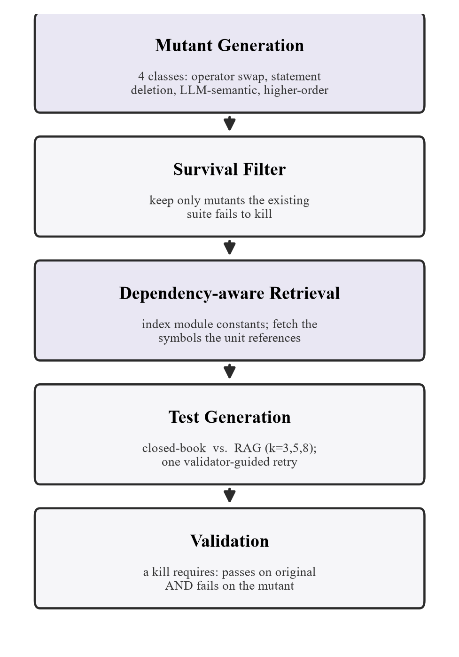
Fig. 1. The CodeKong pipeline. Shaded stages are contributions of this work.
A. Mutant generation
From each subject’s functions (parsed via the Python AST) we generate four classes of increasing subtlety. (i) Operator/constant swaps are produced mechanically by mutmut. (ii) Statement deletion (SDL) removes one statement while preserving parseability. (iii) Semantic mutants are single, realistic bugs injected by an LLM at temperature 0.7 (e.g., an off-by-one or a swapped key). (iv) Higher-order mutants combine two first-order mutants of the same function [2]. Every mutant is ast.parse-validated and normalised to one schema before use, so downstream stages are agnostic to its source.
B. Survival filtering
A mutant is worth attacking only if the subject’s existing suite fails to kill it. We copy the subject to an isolated scratch directory, apply the mutant in place, purge byte-code caches (a stale cache can silently execute pre-mutation code), run the suite, and retain only survivors. Survivors define the generation task and provide the denominator for all kill rates.
C. Indexing and dependency-aware retrieval
We embed each codebase into a local ChromaDB store with all-MiniLM-L6-v2 sentence embeddings [14]. Beyond the usual per-function and per-docstring chunks, we index every module-level constant as its own chunk, so a table such as BULK_BREAKS = […] becomes retrievable. This matters because a naive function/docstring index cannot surface a value a test needs. Retrieval (Algorithm 1) combines two signals: embedding similarity of a class-specific query, and an explicit dependency step that parses the unit under test for the free symbols it references (constants, tables, called helpers) and fetches their definitions directly. The dependency step guarantees that the definitions a unit depends on enter the candidate set, rather than relying on embedding similarity—which, for a code query, tends to surface sibling functions rather than a constants table.

Algorithm 1 Dependency-aware retrieval(m, k)
input mutant m, depth k; index I
output up to k context chunks
1 q <- class_specific_query(m)
2 C <- I.nearest(embed(q), k) # similarity
3 S <- free_symbols(m.original_code)
4 D <- { I.definition(s) : s in S } # dependencies
5 rank D before C; dedup; drop m itself
6 return first k of (D then C)
Algorithm 1. Retrieval fetches a unit's referenced definitions, not only embedding-similar code.
D. Prompting and generation
For each survivor we generate a test with a class-aware prompt at temperature 0. The closed-book (NO-RAG) condition receives the mutant diff, the original function, and the existing test—the MuTAP-style baseline. The RAG condition additionally receives the top-k retrieved chunks. An agentic layer permits exactly one retry, in which the model is shown structured validator feedback (e.g., that its test failed on the original). All other factors are held identical across conditions.
E. Validation
We adopt the strong-kill criterion and add a validity guard. Formally, for original program O, mutant M, and generated test t:
kill(t) ⇔ pass(t, O) ∧ ¬pass(t, M).
A test that fails on O is invalid—counted as a failure, never a kill—which discards plausible-looking but incorrect tests. We enforce this by executing each test against both O and M with a per-test timeout.
IV. EXPERIMENTAL DESIGN
We answer four research questions:
- RQ1: Does RAG beat closed-book generation on kill rate, and does the effect depend on the subject’s information dependence?
- RQ2: Does the benefit vary across mutant classes?
- RQ3: How does retrieval depth k affect the valid-test rate?
- RQ4: What is the token cost per mutant killed?
A. Subjects and dataset
Because our hypothesis concerns information dependence, we evaluate three deliberately different subjects and report each separately (Table I). ctxlib is a small billing/grading/shipping library we constructed so that each function references rates and thresholds defined in a separate constants module, with docstrings that describe behaviour but never state the specific values, which are non-standard and unguessable by design. It is the condition under which RAG should help, and we release it as a benchmark. sorts comprises classic sorting algorithms from The Algorithms/Python—self-contained code needing no outside facts, a control. schedule is dbader/schedule, an object-oriented scheduling library that stresses whether a small model can produce valid tests at all.
TABLE I. Subjects and surviving-mutant counts
Subject | Files | Funcs | Chunks | Muts
ctxlib (context-dep.) | 5 | 13 | 49 | 24
sorts (self-contained) | 10 | 12 | 27 | 9
schedule (complex OO) | 2 | 16 | 189 | 6

B. Model and retrieval configuration
All test generation uses qwen2.5-coder:7b served locally by Ollama at temperature 0 (semantic-mutant generation uses 0.7). Retrieval uses all-MiniLM-L6-v2 with a persistent ChromaDB store. The two conditions share model, prompts, mutants, and temperature; only retrieval differs. Using an open local model rather than a frontier API is a deliberate, disclosed threat to external validity (Section VII).
C. Metrics
Let survivors of a subject be the population. Kill rate is the fraction of generation attempts yielding a kill; because the RAG condition is run at three depths, its attempts are three times the number of mutants. Valid-test rate is the fraction of attempts producing a test that passes on the original program—a direct measure of whether the model knows the code’s expected behaviour. Tokens per kill divides total (prompt + generated) tokens by kills, the cost-equivalent unit for a free local model. We also report retry rate and first-attempt kill rate.
V. RESULTS
All figures are computed from the raw per-mutant records; RAG values aggregate over k ∈ {3,5,8} unless a depth is named.
A. RQ1: RAG vs. closed-book, per subject
Retrieval is transformative on context-dependent code and inert elsewhere (Fig. 2, Table II). On ctxlib the kill rate rises from 12.5% to 77.8%, a 65-point gap; on the self-contained control the conditions tie at 22.2%; and on the complex OO library both score 0%—the small model cannot write valid tests for its stateful API regardless of retrieval. The combined average (12.8% → 53.0%) is real but driven entirely by ctxlib; reporting the tie and the floor is what makes the win credible and localises the mechanism.
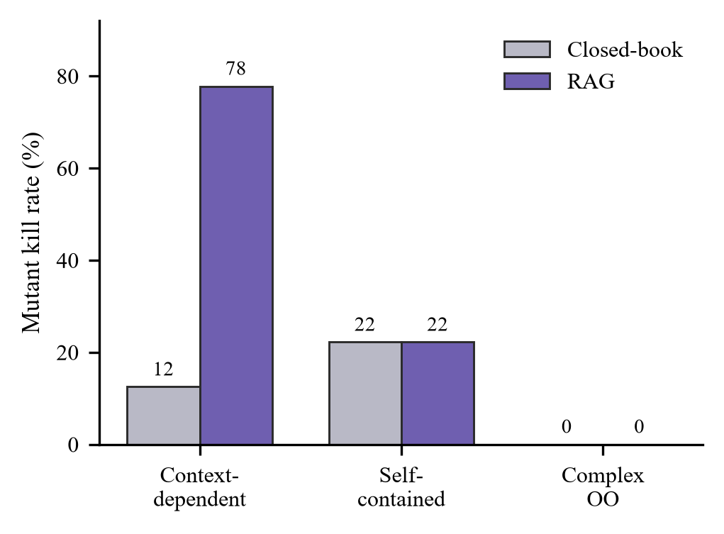
Fig. 2. Mutant kill rate by subject and condition.
TABLE II. Kill rate by subject (closed-book vs. RAG)
Subject | N | Closed-book | RAG | Δ
Context-dependent | 24 | 12.5% | 77.8% | +65.3
Self-contained | 9 | 22.2% | 22.2% | 0.0
Complex OO | 6 | 0.0% | 0.0% | 0.0
Combined | 39 | 12.8% | 53.0% | +40.2

B. RQ2: benefit by mutant class
On ctxlib, retrieval lifts every class (Table III), from statement deletion to the hardest higher-order faults. The strict “harder class, larger gain” gradient does not hold cleanly—semantic mutants gain less than statement-deletion mutants, in part because semantic mutants sometimes require multi-value arithmetic the 7B model still botches even when handed the values. We report this as an honest finding rather than shade it into a monotone trend.
TABLE III. Kill rate by mutant class (ctxlib)
Class | n | Closed-book | RAG | Δ
Statement deletion | 13 | 15.4% | 82.1% | +66.7
Semantic (LLM) | 7 | 14.3% | 61.9% | +47.6
Higher-order | 4 | 0.0% | 91.7% | +91.7

C. RQ3: retrieval depth and valid tests
The dominant effect of retrieval is on validity. Closed-book, only 25% of generated tests pass on the original program—the model guesses the codebase’s constants and guesses wrong. With retrieval, 83–88% of tests are valid (Table IV). Depth k = 3–5 is the sweet spot; k = 8 dips slightly, evidence that more context is not always better for a small model. Retrieval thus works less by making the model cleverer than by making it correct about the code.
TABLE IV. Valid-test rate by condition (ctxlib)
Condition | Valid-test rate
Closed-book | 25.0%
RAG, k = 3 | 87.5%
RAG, k = 5 | 87.5%
RAG, k = 8 | 83.3%

D. RQ4: cost per kill
Retrieval spends more tokens per call but is far cheaper per kill because it actually catches bugs (Table V): 2,246 tokens per kill with RAG versus 15,859 closed-book—a seven-fold gain in cost-effectiveness on ctxlib.
TABLE V. Token cost per kill (ctxlib)
Condition | Tokens | Kills | Tokens/kill
Closed-book | 47,576 | 3 | 15,859
RAG | 125,758 | 56 | 2,246

E. Qualitative analysis: a worked example
Listing 1 shows both conditions for one surviving statement-deletion mutant of bulk_discount, whose volume-discount table BULK_BREAKS lives in the constants module. Closed-book, the model assumes a conventional 10% discount and asserts 0.1; the test fails on the original program and is invalid. With retrieval it receives BULK_BREAKS and asserts the true 0.04 for quantity 10; the test passes on the original and fails on the mutant—a kill. The same pattern recurs across ctxlib: closed-book invents plausible values, retrieval supplies real ones.

# closed-book (NO-RAG) -> INVALID_TEST
def test_bulk_discount():
assert bulk_discount(10) == 0.1 # guessed

# with retrieval (RAG) -> KILLED
def test_bulk_discount():
assert bulk_discount(10) == 0.04 # from
# BULK_BREAKS
Listing 1. For the same mutant, closed-book guesses the discount and produces an invalid test; retrieval supplies the true value and kills the mutant.
F. Ablation: what makes retrieval work
Retrieval helps only because of the two additions in Algorithm 1. With a naive function/docstring index and pure embedding similarity, the top results for the member_price mutant were the member_price docstring and a sibling function checkout_total; the DISCOUNTS constant it needed was absent, so the retrieved context was useless and RAG matched closed-book. After (a) indexing module constants and (b) fetching referenced symbols, the DISCOUNTS chunk is retrieved first for that mutant. Removing either addition returns retrieval to the naive, ineffective behaviour—both are necessary.
VI. DISCUSSION
The results argue for a conditional reading of RAG in mutation-killing test generation. Retrieval is not a general accelerant; it is a mechanism for supplying facts the unit under test does not contain. When those facts are decisive—as in code that reads shared constants, policy tables, or configuration—retrieval converts a model that guesses into one that is correct, and the effect is large. When the unit is self-contained, there is nothing to retrieve and the effect vanishes. For practitioners, this suggests targeting retrieval-augmented test generation at code with high cross-module information dependence, and indexing not only functions but the constants and tables that encode a system’s domain rules. It also cautions that model capability, not retrieval, is the binding constraint on hard subjects: on the stateful library, neither condition produced any valid test.
VII. THREATS TO VALIDITY
A. Construct validity
We equate a kill with passing on the original and failing on the mutant, and validity with passing on the original. Equivalent mutants cannot be killed and depress both conditions equally; because our comparison is within-subject and within-mutant, they do not bias the RAG-vs-closed-book delta.
B. Internal validity
The two conditions share model, prompts, mutants, and temperature, so the measured delta is attributable to retrieval. Temperature 0 makes generation deterministic and reproducible. Byte-code caches are purged to prevent stale-cache execution during survival checks.
C. External validity
Two threats dominate. First, we use a local 7B model rather than a frontier API, lowering absolute rates; the within-run comparison remains valid but absolute numbers must not be compared to a stronger model, and the complex-OO floor shows model capability as the limiting factor there. Second, the primary subject ctxlib is synthetic and built so its constants are unguessable and external; this is a legitimate, disclosed condition that tests the mechanism, but is not evidence that RAG helps arbitrary real code. The self-contained tie bounds the claim.
D. Conclusion validity
The study spans 39 survivors across three subjects (24 in the primary subject)—enough to expose a large effect and its boundary, but pilot-scale. We therefore report descriptive statistics and a worked mechanism rather than inferential tests, and identify replication on real, cross-module codebases as the necessary next step.
VIII. CONCLUSION AND FUTURE WORK
We asked whether a memory of the codebase helps an LLM write tests that kill mutants. Under a strict two-sided kill criterion and a controlled design, the answer is conditional—and the condition is the contribution. On code whose correctness hinges on facts defined elsewhere, dependency-aware retrieval raised the kill rate from 12.5% to 77.8% and the valid-test rate from 25% to 88%, at a seven-fold lower cost per kill; on self-contained code it changed nothing, and an ablation shows both indexing constants and retrieving referenced symbols are required. Future work will replicate the effect on real codebases with genuine cross-module dependence, scale the mutant population for inferential analysis, and study stronger and larger models to separate retrieval quality from model capability.
Reproducibility. The pipeline, the ctxlib benchmark, the mutant sets, and the per-mutant records are released; every model call and token count is logged, and generation is deterministic at temperature 0.
REFERENCES
[1] R. A. DeMillo, R. J. Lipton, and F. G. Sayward, “Hints on test data selection: Help for the practicing programmer,” IEEE Computer, vol. 11, no. 4, pp. 34–41, 1978.
[2] Y. Jia and M. Harman, “An analysis and survey of the development of mutation testing,” IEEE Trans. Softw. Eng., vol. 37, no. 5, pp. 649–678, 2011.
[3] M. Papadakis, M. Kintis, J. Zhang, Y. Jia, Y. Le Traon, and M. Harman, “Mutation testing advances: An analysis and survey,” Advances in Computers, vol. 112, pp. 275–378, 2019.
[4] R. Just, D. Jalali, L. Inozemtseva, M. D. Ernst, R. Holmes, and G. Fraser, “Are mutants a valid substitute for real faults in software testing?,” in Proc. ACM FSE, 2014, pp. 654–665.
[5] A. R. Dakhel, A. Nikanjam, V. Majdinasab, F. Khomh, and M. C. Desmarais, “Effective test generation using pre-trained large language models and mutation testing (MuTAP),” Information and Software Technology, vol. 171, 2024. (arXiv:2308.16557).
[6] N. Alshahwan, J. Chheda, A. Finogenova, B. Gokkaya, et al., “Automated unit test improvement using large language models at Meta,” in Proc. ACM FSE (Industry), 2024.
[7] P. Lewis et al., “Retrieval-augmented generation for knowledge-intensive NLP tasks,” in Proc. NeurIPS, 2020.
[8] G. Fraser and A. Arcuri, “EvoSuite: Automatic test suite generation for object-oriented software,” in Proc. ACM ESEC/FSE, 2011, pp. 416–419.
[9] M. Schäfer, S. Nadi, A. Eghbali, and F. Tip, “An empirical evaluation of using large language models for automated unit test generation (TestPilot),” IEEE Trans. Softw. Eng., 2024.
[10] R. Degiovanni and M. Papadakis, “µBERT: Mutation testing using pre-trained language models,” in Proc. IEEE ICSTW, 2022.
[11] B. Tip, J. Bell, and M. Schäfer, “LLMorpheus: Mutation testing using large language models,” arXiv:2404.09952, 2024.
[12] Y. Wang et al., “Retrieval-augmented mutant generation via historical bug-fix pairs,” 2025.
[13] F. Zhang, B. Chen, Y. Zhang, et al., “RepoCoder: Repository-level code completion through iterative retrieval and generation,” in Proc. EMNLP, 2023.
[14] N. Reimers and I. Gurevych, “Sentence-BERT: Sentence embeddings using Siamese BERT-networks,” in Proc. EMNLP, 2019, pp. 3982–3992.
[15] Qwen Team, “Qwen2.5-Coder technical report,” arXiv:2409.12186, 2024.
[16] M. Chen et al., “Evaluating large language models trained on code,” arXiv:2107.03374, 2021.
[17] J. H. Andrews, L. C. Briand, and Y. Labiche, “Is mutation an appropriate tool for testing experiments?,” in Proc. ICSE, 2005, pp. 402–411.
[18] P. Ammann and J. Offutt, Introduction to Software Testing, 2nd ed. Cambridge Univ. Press, 2016.
[19] S. Kang, J. Yoon, and S. Yoo, “Large language models are few-shot testers: Exploring LLM-based general bug reproduction,” in Proc. ICSE, 2023.
[20] C. Lemieux, J. P. Inala, S. K. Lahiri, and S. Sen, “CODAMOSA: Escaping coverage plateaus in test generation with pre-trained large language models,” in Proc. ICSE, 2023.

