Министерство образования Республики Беларусь

Учреждение образования

«Брестский Государственный технический университет»

Кафедра ИИТ

**Лабораторная работа №3**

По дисциплине «Модели решения задач в интеллектуальных системах»

Тема: «SLP. Классификация»

**Выполнил:**

Студент 3 курса

Группы ИИ-21

Литвинюк Т. В.

**Проверил:**

Туз И. С.

Брест 2023

**Цель:** Изучить обучение и функционирование ИНС при решении задач классификации.

**Ход работы**

**Вариант 1**

y = 2x - 3

from matplotlib import pyplot as plt

import numpy as np

import time

def f(x): return 2 * x - 3

def get_class(x, y):

return int(y > f(x))

def make_dataset(count: int, noise_percent: int):

train_data = [np.array([x, y]) for x, y in [(np.random.random()*4-1.5, np.random.random()*4-2)

for _ in range(count)]]

train_test = [get_class(x, y) for x, y in train_data]

for _ in range(int(count * noise_percent)):

train_test[np.random.randint(count)] = not train_data

return np.array(train_data), np.array(train_test)

E_arr = []

class SingleLayerPerceptron:

def __init__(self, input_size, learning_rate=0.0001):

self.input_size = input_size

self.weights = np.random.randn(input_size)

self.bias = np.random.randn(1)

self.learning_rate = learning_rate

self.start_rate = learning_rate

def reset(self):

global E_arr

E_arr.clear()

self.weights = np.random.randn(self.input_size)

self.bias = np.random.randn(1)

self.learning_rate = self.start_rate

def predict(self, x):

output = np.dot(self.weights, x) - self.bias

return int(1/(1+np.exp(-output)) > 0.5)

def deritivate(self, x):

output = self.predict(x)

return output*(1-output)

def train_constant_learning_rate(self, X, y, epochs: int, isAdapt: bool = False):

start_time = time.time()

global E_arr

for epoch in range(epochs):

e_arr = []

for i in range(len(X)):

prediction = self.predict(X[i])

error = prediction - y[i]

e_arr.append(error)

if isAdapt and abs(error) > 0.1E-10 and abs(self.deritivate(X[i])) > 0.1E-10:

delta_weights = error*self.deritivate(X[i])*np.array(X[i])

delta_bias = -error*self.deritivate(X[i])

b = 0.0

for j in range(len(self.weights)):

b += delta_weights[j]*X[i][j] - delta_bias

# if b < 0.1E-6: b = 0.1E-6

self.learning_rate = b*error / \

(b**2) if b*error/(b**2) <= 0.3 else 0.3

self.weights = self.weights - \

self.learning_rate * error * np.array(X[i])

self.bias = self.bias + self.learning_rate * error

E_arr.append(np.sum(abs(np.array(e_arr))))

end_time = time.time()

training_time = end_time - start_time

return training_time

def train_batch_learning(self, X, y, epochs: int = 100, batch_size: int = 10, isAdapt: bool = False):

start_time = time.time()

global E_arr

for epoch in range(epochs):

e_arr = []

for i in range(0, len(X), batch_size):

X_batch = X[i:i+batch_size]

y_batch = y[i:i+batch_size]

predictions = []

for x in X_batch:

predictions.append(self.predict(x))

errors = np.array(predictions) - np.array(y_batch)

for err in errors:

e_arr.append(err)

if isAdapt:

b_arr = []

for k in range(len(X_batch)):

if abs(errors[k]) < 0.1E-5:

errors[k] = 0.1E-5 if errors[k] >= 0 else -0.1E-5

deritivate = self.deritivate(X_batch[k])

if abs(deritivate) < 0.1E-6:

deritivate = 0.1E-6 if self.deritivate(

X_batch[k]) >= 0 else -0.1E-6

delta_weights = errors[k] * \

deritivate * np.array(X_batch[k])

delta_bias = -errors[k]*deritivate

b = 0.0

for j in range(len(self.weights)):

b += delta_weights[j]*X_batch[k][j] - delta_bias

if abs(b) < 0.1E-6:

b = 0.1E-5 if b <= 0 else -0.1E-5

b_arr.append(b)

# print("barr",b_arr,"err",errors)

up = 0

down = 0

for k in range(len(b_arr)):

up += b_arr[k]*errors[k]

down += b_arr[k]**2

self.learning_rate = up/down/10000 if up/down/10000 <= 0.3 else 0.3

# print("lr",self.learning_rate)

self.weights = self.weights - \

self.learning_rate * np.dot(errors, X_batch)

self.bias = self.bias + self.learning_rate * np.sum(errors)

E_arr.append(np.sum(abs(np.array(e_arr))))

end_time = time.time()

training_time = end_time - start_time

return training_time

X_train, Y_train = make_dataset(100, 0.1)

X_test, Y_test = make_dataset(40, 0)

epochs = 200

NN = SingleLayerPerceptron(2)

##################################################

print("CONSTANT ONLINE LEARNING")

NN.train_constant_learning_rate(X_train, Y_train, epochs)

plt.plot(range(epochs), E_arr)

plt.show()

output = ([NN.predict(x) for x in X_test])

correct_points, incorrect_points = [], []

for i, point in enumerate(output):

if point == Y_test[i]:

correct_points.append(X_test[i])

else:

incorrect_points.append(X_test[i])

plt.plot(range(-2, 3, 1), [f(x) for x in range(-2, 3, 1)])

plt.scatter([x[0] for x in X_train], [x[1] for x in X_train], c='blue')

plt.show()

plt.plot(range(-2, 3, 1), [f(x) for x in range(-2, 3, 1)])

plt.scatter([x[0] for x in correct_points], [x[1] for x in correct_points], c='blue')

plt.scatter([x[0] for x in incorrect_points], [x[1] for x in incorrect_points], c='red')

plt.show()

NN.reset()

##################################################

print("BATCH ONLINE LEARNING")

NN.train_batch_learning(X_train, Y_train, epochs)

plt.plot(range(epochs), E_arr)

plt.show()

output = ([NN.predict(x) for x in X_test])

correct_points, incorrect_points = [], []

for i, point in enumerate(output):

if point == Y_test[i]:

correct_points.append(X_test[i])

else:

incorrect_points.append(X_test[i])

plt.plot(range(-2, 3, 1), [f(x) for x in range(-2, 3, 1)])

plt.scatter([x[0] for x in X_train], [x[1] for x in X_train], c='blue')

plt.show()

plt.plot(range(-2, 3, 1), [f(x) for x in range(-2, 3, 1)])

plt.scatter([x[0] for x in correct_points], [x[1] for x in correct_points], c='blue')

plt.scatter([x[0] for x in incorrect_points], [x[1] for x in incorrect_points], c='red')

plt.show()

NN.reset()

##################################################

print("ADAPT ONLINE LEARNING")

NN.train_constant_learning_rate(X_train, Y_train, epochs, isAdapt=True)

plt.plot(range(epochs), E_arr)

plt.show()

output = ([NN.predict(x) for x in X_test])

correct_points, incorrect_points = [], []

for i, point in enumerate(output):

if point == Y_test[i]:

correct_points.append(X_test[i])

else:

incorrect_points.append(X_test[i])

plt.plot(range(-2, 3, 1), [f(x) for x in range(-2, 3, 1)])

plt.scatter([x[0] for x in X_train], [x[1] for x in X_train], c='blue')

plt.show()

plt.plot(range(-2, 3, 1), [f(x) for x in range(-2, 3, 1)])

plt.scatter([x[0] for x in correct_points], [x[1] for x in correct_points], c='blue')

plt.scatter([x[0] for x in incorrect_points], [x[1] for x in incorrect_points], c='red')

plt.show()

NN.reset()

##################################################

print("BATCH ADAPT LEARNING")

NN.train_batch_learning(X_train, Y_train, epochs, isAdapt=True)

plt.plot(range(epochs), E_arr)

plt.show()

output = ([NN.predict(x) for x in X_test])

correct_points, incorrect_points = [], []

for i, point in enumerate(output):

if point == Y_test[i]:

correct_points.append(X_test[i])

else:

incorrect_points.append(X_test[i])

plt.plot(range(-2, 3, 1), [f(x) for x in range(-2, 3, 1)])

plt.scatter([x[0] for x in X_train], [x[1] for x in X_train], c='blue')

plt.show()

plt.plot(range(-2, 3, 1), [f(x) for x in range(-2, 3, 1)])

plt.scatter([x[0] for x in correct_points], [x[1] for x in correct_points], c='blue')

plt.scatter([x[0] for x in incorrect_points], [x[1] for x in incorrect_points], c='red')

plt.show()

NN.reset()

Online const:

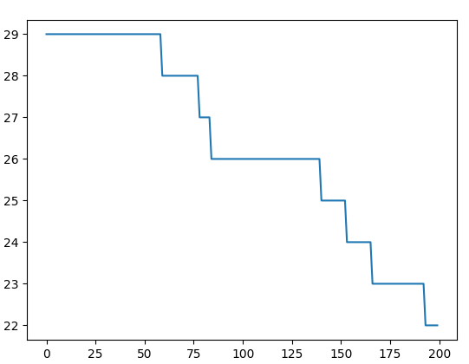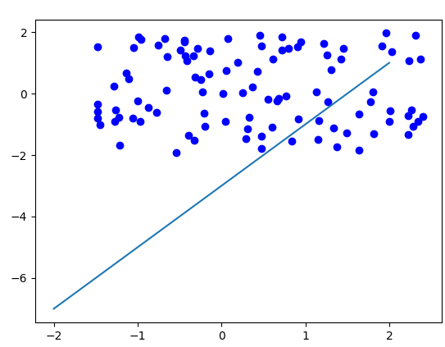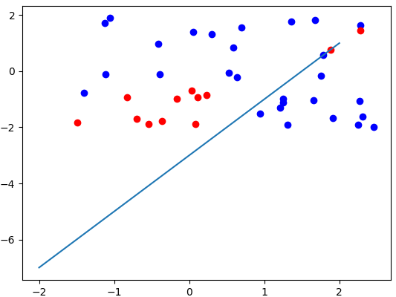

Batch const:

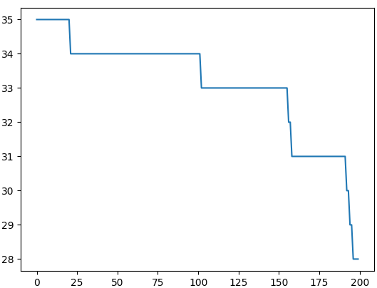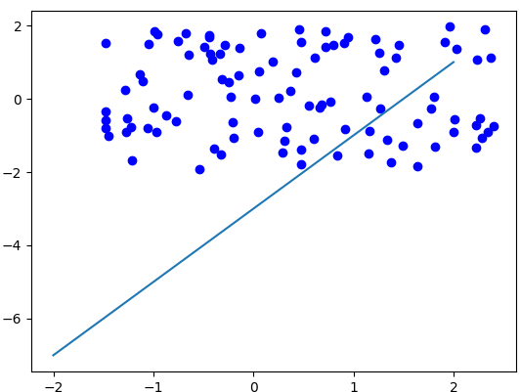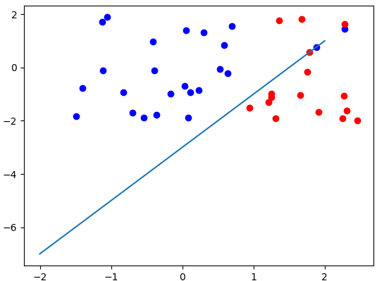

Online adapt:

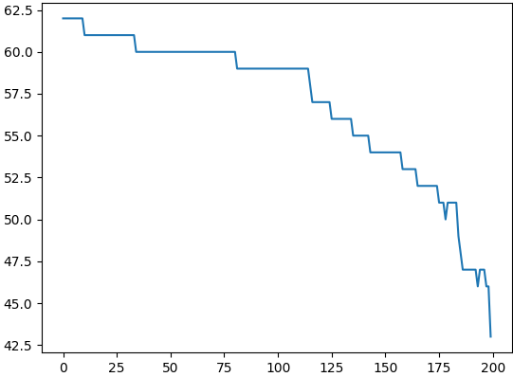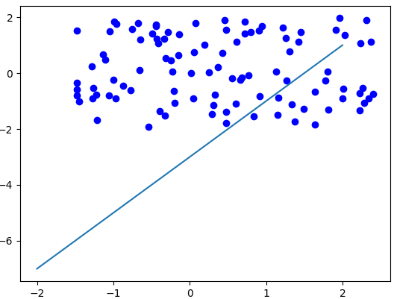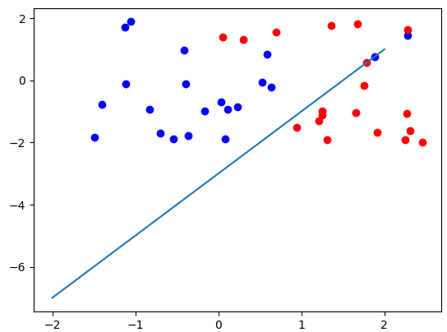

Batch adapt:

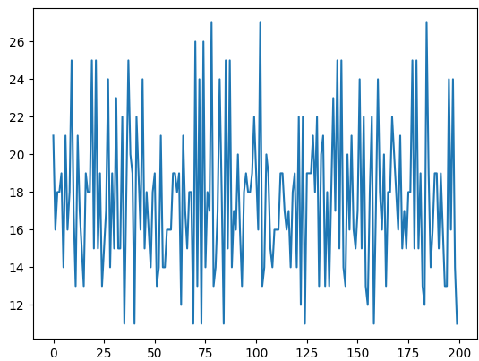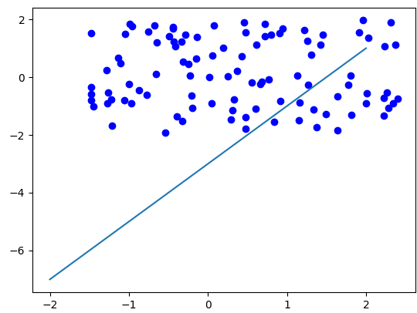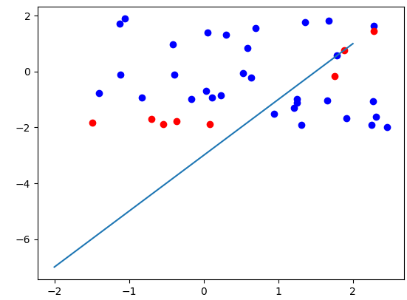

**Вывод:** в ходе лабораторной работы я изучил функционирование ИНС при решении задач классификации.