Министерство образования Республики Беларусь

Учреждение образования

«Брестский Государственный технический университет»

Кафедра ИИТ

**Лабораторная работа №3**

По дисциплине «Основы алгоритмизации и программирования»

Тема: «Структуры, массивы, указатели. Динамические массивы структур. Функции»

**Выполнил:**

Студент 1 курса

Группы ИИ-22

Литвинюк Т. В.

Кирилович А. А.

**Проверил:**

Гирель Т. Н.

Брест 2022

**Цель:** ознакомиться с указателями на функцию, изучить структуры.

**Ход работы:**

**Вариант 4**

«Пациент»:

фамилия; имя; отчество; пол; национальность; рост; вес; дата рождения (год,

месяц число); номер телефона; домашний адрес (почтовый индекс, страна,

область, район, город, улица, дом, квартира); номер больницы; отделение;

номер медицинской карты; диагноз; группа крови.

#include <iostream>

#include <windows.h>

#include <string>

#include <iomanip>

using namespace std;

struct Date

{

int year = 0;

int month = 0;

int day = 0;

};

struct Address

{

int zipCode = 0;

string country;

string region;

string district;

string city;

string street;

int house = 0;

int apartment = 0;

};

struct Patient

{

string surname;

string name;

string lastName;

string sex;

string nationality;

float growth = 0;

float weight = 0;

struct Date dateOfBirth;

string phoneNumber;

struct Address homeAddress;

int hospitalNumber = 0;

string branch;

int medicalCardNumber = 0;

string diagnosis;

string bloodType;

};

void create();

void viewing();

void add();

void search();

void sort();

int menu();

void(*masf[])() = {create, viewing, add, search, sort};

Patient* AddStruct();

void setData();

int amount = 0;

Patient* OurPatients = new Patient[0];

int main(int argc, char* argv[])

{

if (argc != 2)

{

cout << "You forgot to enter your name.\n";

system("pause>null");

exit(0);

}

else

{

cout << "Hi, " << argv[argc - 1] << "! Let's start!" << endl;

}

while(1) (*masf[menu()])();

}

int menu()

{

char n;

do

{

cout << "\t Menu\n";

cout << "\t1. Create.\n";

cout << "\t2. Viewing.\n";

cout << "\t3. Add.\n";

cout << "\t4. Search.\n";

cout << "\t5. Sort.\n";

cout << "\t6. Exit.\n";

printf ("Make a choice: ");

n = getchar();

system("cls");

}

while(strchr("123456", n) == NULL);

if(n == '6') exit(0);

return n - 49;

}

void create()

{

int YesOrNot = 0;

do

{

OurPatients = AddStruct();

setData();

amount++;

cout << "Continue entering data (1 - yes, 0 - no)?";

cin >> YesOrNot;

cin.get();

} while (YesOrNot != 0);

}

void viewing()

{

system("cls");

cout << left << setw(3) << "N" << "|" << setw(15) << "Surname" << "|" << setw(10) << "Name" << "|" << setw(15) << "Last name" << "|"

<< setw(6) << "Gender" << "|" << setw(15) << "Nationality" << "|" << setw(6) << "Growth" << "|"

<< setw(6) << "Weight" << "|" << setw(10) << "Date" << "|" << setw(13) << "Phone number" << "|"

<< setw(15) << "Hospital number" << "|" << setw(6) << "Branch" << "|" << setw(19) << "Medical card number" << "|"

<< setw(15) << "Diagnosis" << "|" << setw(10) << "Blood type" << endl;

for(int i = 1; i <= 164; i++)

{

cout << "=";

}

cout << endl;

for (int i = 0; i < amount; i++)

{

cout << left << setw(3) << i + 1 << "|" << setw(15) << OurPatients[i].surname << "|"

<< setw(10) << OurPatients[i].name << "|" << setw(15) << OurPatients[i].lastName << "|"

<< setw(6) << OurPatients[i].sex << "|" << setw(15) << OurPatients[i].nationality << "|"

<< setw(6) << OurPatients[i].growth << "|" << setw(6) << OurPatients[i].weight << "|"

<< setw(2) << OurPatients[i].dateOfBirth.day << "."

<< setw(2) << OurPatients[i].dateOfBirth.month << "." << setw(4) << OurPatients[i].dateOfBirth.year

<< "|" << setw(13) << OurPatients[i].phoneNumber << "|" << setw(15) << OurPatients[i].hospitalNumber << "|"

<< setw(6) << OurPatients[i].branch << "|" << setw(19) << OurPatients[i].medicalCardNumber << "|"

<< setw(15) << OurPatients[i].diagnosis << "|" << setw(10) << OurPatients[i].bloodType << endl;

}

int YesOrNot = 0;

cout << "Do you want to see information about the place of residence (1 - yes, 0 - no)?";

cin >> YesOrNot;

cin.get();

if (YesOrNot == 1)

{

system("cls");

cout << left << setw(3) << "N" << "|" << setw(15) << "Surname" << "|" << setw(10) << "Name" << "|" << setw(15) << "Last name" << "|"

<< setw(8) << "Zip code" << "|" << setw(10) << "Country" << "|" << setw(10) << "Region" << "|"

<< setw(10) << "District" << "|" << setw(10) << "City" << "|" << setw(20) << "Street" << "|"

<< setw(5) << "House" << "|" << setw(9) << "Apartment" << endl;

for(int i = 1; i <= 164; i++)

{

cout << "=";

}

cout << endl;

for (int i = 0; i < amount; i++)

{

cout << left << setw(3) << i + 1 << "|" << setw(15) << OurPatients[i].surname << "|"

<< setw(10) << OurPatients[i].name << "|" << setw(15) << OurPatients[i].lastName << "|"

<< setw(8) << OurPatients[i].homeAddress.zipCode << "|" << setw(10) << OurPatients[i].homeAddress.country << "|"

<< setw(10) << OurPatients[i].homeAddress.region << "|" << setw(10) << OurPatients[i].homeAddress.district << "|"

<< setw(10) << OurPatients[i].homeAddress.city << "|" << setw(20) << OurPatients[i].homeAddress.street << "|"

<< setw(5) << OurPatients[i].homeAddress.house << "|" << setw(9) << OurPatients[i].homeAddress.apartment << endl;

}

}

}

void add()

{

create();

}

void search()

{

string str;

cout << "Search: ";

cin >> str;

int k = 0;

for (int i = 0; i < amount; i++)

{

if (str == OurPatients[i].surname || str == OurPatients[i].name

|| str == OurPatients[i].lastName)

{

system("cls");

cout << left <<setw(3) << "N" << "|" << setw(15) << "Surname" << "|" << setw(10) << "Name" << "|" << setw(15) << "Last name" << "|"

<< setw(6) << "Gender" << "|" << setw(15) << "Nationality" << "|" << setw(6) << "Growth" << "|"

<< setw(6) << "Weight" << "|" << setw(10) << "Date" << "|" << setw(13) << "Phone number" << "|"

<< setw(15) << "Hospital number" << "|" << setw(6) << "Branch" << "|" << setw(19) << "Medical card number" << "|"

<< setw(15) << "Diagnosis" << "|" << setw(10) << "Blood type" << endl;

for(int i = 1; i <= 164; i++)

{

cout << "=";

}

cout << endl;

cout << left << setw(3) << i + 1 << "|" << setw(15) << OurPatients[i].surname << "|"

<< setw(10) << OurPatients[i].name << "|" << setw(15) << OurPatients[i].lastName << "|"

<< setw(6) << OurPatients[i].sex << "|" << setw(15) << OurPatients[i].nationality << "|"

<< setw(6) << OurPatients[i].growth << "|" << setw(6) << OurPatients[i].weight << "|"

<< setw(2) << OurPatients[i].dateOfBirth.day << "."

<< setw(2) << OurPatients[i].dateOfBirth.month << "." << setw(4) << OurPatients[i].dateOfBirth.year

<< "|" << setw(13) << OurPatients[i].phoneNumber << "|" << setw(15) << OurPatients[i].hospitalNumber << "|"

<< setw(6) << OurPatients[i].branch << "|" << setw(19) << OurPatients[i].medicalCardNumber << "|"

<< setw(15) << OurPatients[i].diagnosis << "|" << setw(10) << OurPatients[i].bloodType << endl;

int YesOrNot = 0;

cout << "Do you want to see information about the place of residence (1 - yes, 0 - no)?";

cin >> YesOrNot;

cin.get();

if (YesOrNot == 1)

{

system("cls");

cout << left << setw(3) << "N" << "|" << setw(15) << "Surname" << "|" << setw(10) << "Name" << "|" << setw(15) << "Last name" << "|"

<< setw(8) << "Zip code" << "|" << setw(10) << "Country" << "|" << setw(10) << "Region" << "|"

<< setw(10) << "District" << "|" << setw(10) << "City" << "|" << setw(20) << "Street" << "|"

<< setw(5) << "House" << "|" << setw(9) << "Apartment" << endl;

for(int i = 1; i <= 164; i++)

{

cout << "=";

}

cout << endl;

cout << left << setw(3) << i + 1 << "|" << setw(15) << OurPatients[i].surname << "|"

<< setw(10) << OurPatients[i].name << "|" << setw(15) << OurPatients[i].lastName << "|"

<< setw(8) << OurPatients[i].homeAddress.zipCode << "|" << setw(10) << OurPatients[i].homeAddress.country << "|"

<< setw(10) << OurPatients[i].homeAddress.region << "|" << setw(10) << OurPatients[i].homeAddress.district << "|"

<< setw(10) << OurPatients[i].homeAddress.city << "|" << setw(20) << OurPatients[i].homeAddress.street << "|"

<< setw(5) << OurPatients[i].homeAddress.house << "|" << setw(9) << OurPatients[i].homeAddress.apartment << endl;

}

}

else

{

k += 1;

}

}

if (k == amount)

{

cout << "Result not found.\n" << endl;

}

}

void sort()

{

Patient buffer;

for (int i = 0; i < amount - 1; i++) {

for (int j = 0; j < amount - i - 1; j++) {

if (OurPatients[j].surname > OurPatients[j + 1].surname) {

buffer = OurPatients[j];

OurPatients[j] = OurPatients[j + 1];

OurPatients[j + 1] = buffer;

}

}

}

}

Patient* AddStruct()

{

if (amount == 0)

{

OurPatients = new Patient[amount + 1];

}

else

{

Patient* tempOurPatients = new Patient[amount + 1];

for (int i = 0; i < amount; i++)

{

tempOurPatients[i] = OurPatients[i];

}

delete [] OurPatients;

OurPatients = tempOurPatients;

}

return OurPatients;

}

void setData()

{

cout << "Surname: ";

cin >> OurPatients[amount].surname;

cout << "Name: ";

cin >> OurPatients[amount].name;

cout << "Last name: ";

cin >> OurPatients[amount].lastName;

cout << "Gender (m/f): ";

cin >> OurPatients[amount].sex;

cout << "Nationality: ";

cin >> OurPatients[amount].nationality;

cout << "Growth: ";

cin >> OurPatients[amount].growth;

cin.get();

cout << "Weight: ";

cin >> OurPatients[amount].weight;

cin.get();

cout << "Date of birth (year, month, day): ";

year:

cin >> OurPatients[amount].dateOfBirth.year;

if(OurPatients[amount].dateOfBirth.year < 1900)

{

cout << "Enter the normal year! >>";

goto year;

}

month:

cin >> OurPatients[amount].dateOfBirth.month;

if(OurPatients[amount].dateOfBirth.month > 12 || OurPatients[amount].dateOfBirth.month < 1)

{

cout << "Enter the normal month! >>";

goto month;

}

cin >> OurPatients[amount].dateOfBirth.day;

cin.get();

cout << "Phone number: ";

cin >> OurPatients[amount].phoneNumber;

cout << "Home address (zip code, country, region, district, city, street, house, apartment): \n";

cin >> OurPatients[amount].homeAddress.zipCode;

cin >> OurPatients[amount].homeAddress.country;

cin >> OurPatients[amount].homeAddress.region;

cin >> OurPatients[amount].homeAddress.district;

cin >> OurPatients[amount].homeAddress.city;

cin >> OurPatients[amount].homeAddress.street;

cin >> OurPatients[amount].homeAddress.house;

cin >> OurPatients[amount].homeAddress.apartment;

cin.get();

cout << "Hospital number: ";

cin >> OurPatients[amount].hospitalNumber;

cin.get();

cout << "Branch: ";

cin >> OurPatients[amount].branch;

cout << "Medical card number: ";

cin >> OurPatients[amount].medicalCardNumber;

cin.get();

cout << "Diagnosis: ";

cin >> OurPatients[amount].diagnosis;

cout << "Blood type: ";

cin >> OurPatients[amount].bloodType;

cout << endl;

}

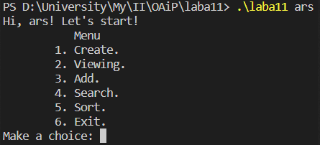

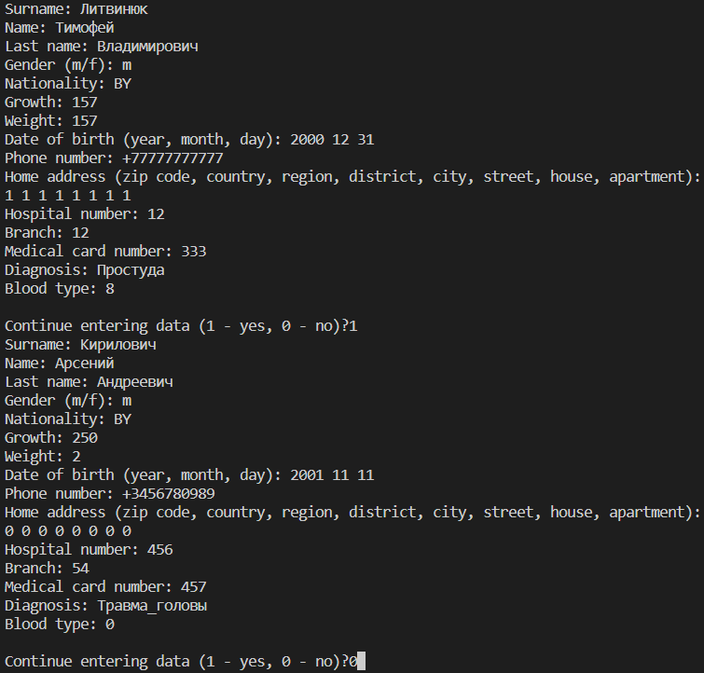



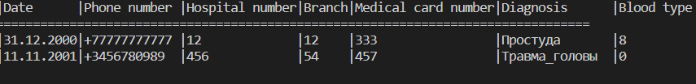

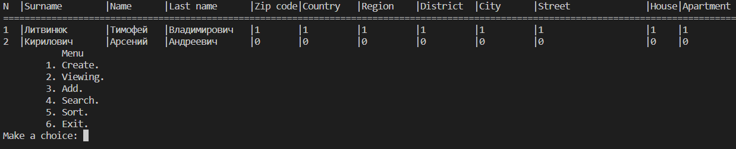

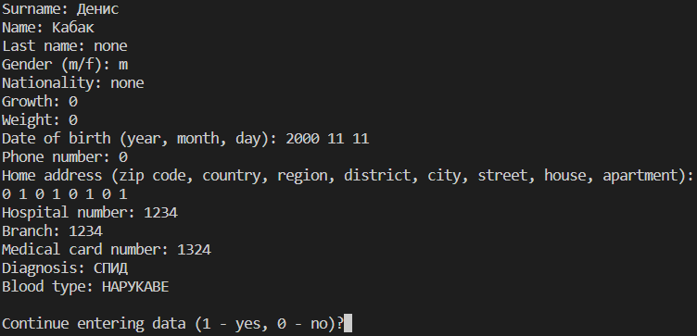



**Вывод:** в ходе лабораторной работы я ознакомился с указателями на функцию, изучил структуры.