Task 2

Controller.Micro830.Micro830.Prog1

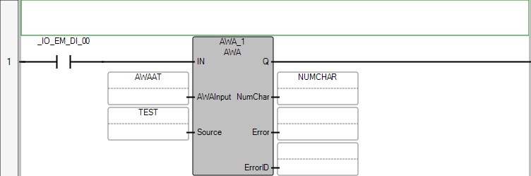

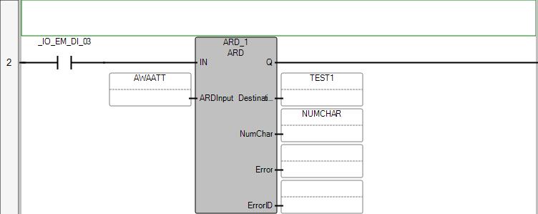

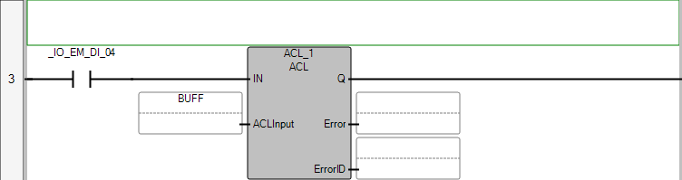

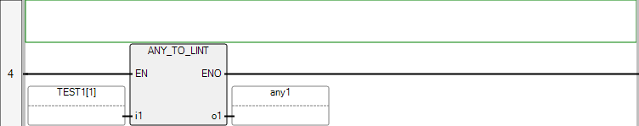

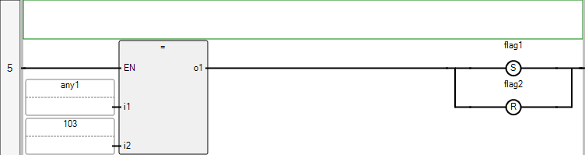

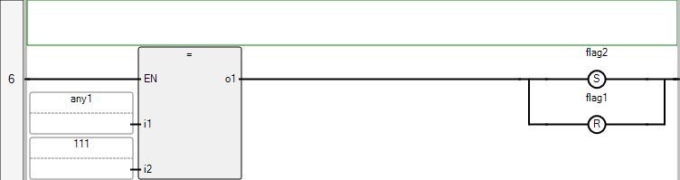

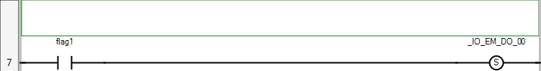

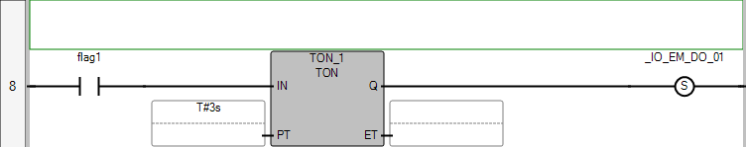

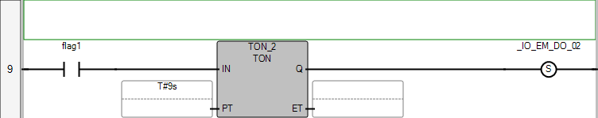

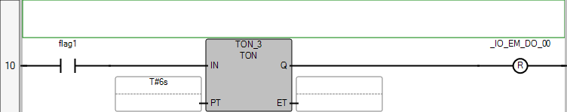

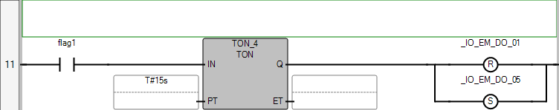

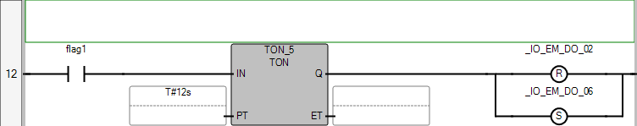

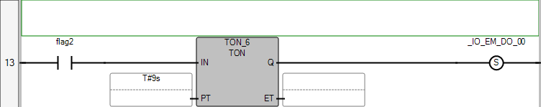

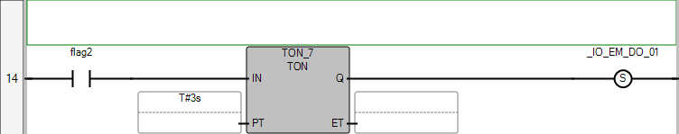

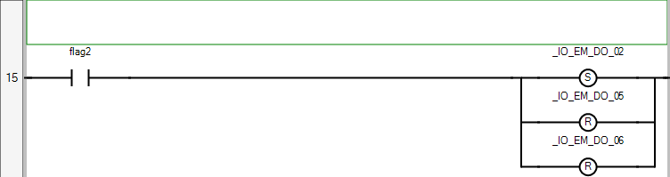

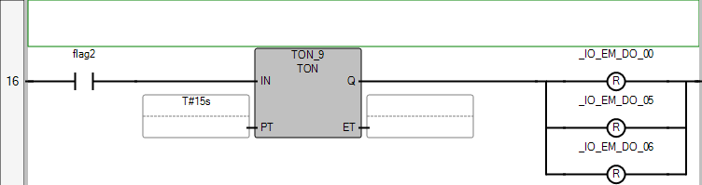

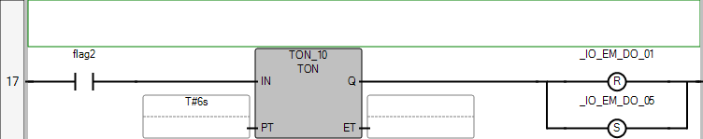

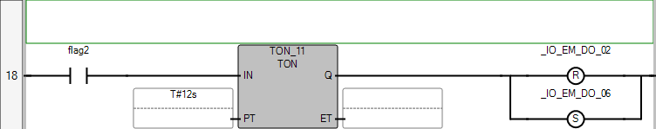

POU Prog1

The POU defines 31 variable(s).

Variable tflag

(* *)

Direction: Var

Data type: BOOL

Attribute: Read/Write

Variable increment

(* *)

Direction: Var

Data type: BOOL

Attribute: Read/Write

Variable AWAAT

(* *)

Direction: Var

Data type: AWAAWT

Attribute: Read/Write

Variable TEST

(* *)

Direction: Var

Data type: ASCIILOCADDR

Attribute: Read/Write

Variable kelma

(* *)

Direction: Var

Data type: STRING

Attribute: Read/Write

Variable test2

(* *)

Direction: Var

Data type: BYTE

Attribute: Read/Write

Variable counter

(* *)

Direction: Var

Data type: DINT

Attribute: Read/Write

Variable ARD_1

(* *)

Direction: Var

Data type: ARD

Attribute: Read/Write

Variable AWAATT

(* *)

Direction: Var

Data type: ARDARL

Attribute: Read/Write

Variable itfa

(* *)

Direction: Var

Data type: ASCIILOCADDR

Attribute: Read/Write

Variable NUMCHAR

(* *)

Direction: Var

Data type: UINT

Attribute: Read/Write

Variable BUFF

(* *)

Direction: Var

Data type: ACLI

Attribute: Read/Write

Variable ACL_1

(* *)

Direction: Var

Data type: ACL

Attribute: Read/Write

Variable TEST1

(* *)

Direction: Var

Data type: ASCIILOCADDR

Attribute: Read/Write

Variable FLAG_8

(* *)

Direction: Var

Data type: BOOL

Attribute: Read/Write

Variable DATA_STORE

(* *)

Direction: Var

Data type: ASCIILOCADDR

Attribute: Read/Write

Variable CV

(* *)

Direction: Var

Data type: DINT

Attribute: Read/Write

Variable AWA_1

(* *)

Direction: Var

Data type: AWA

Attribute: Read/Write

Variable any1

(* *)

Direction: Var

Data type: LINT

Attribute: Read/Write

Variable flag1

(* *)

Direction: Var

Data type: BOOL

Attribute: Read/Write

Variable flag2

(* *)

Direction: Var

Data type: BOOL

Attribute: Read/Write

Variable TON_1

(* *)

Direction: Var

Data type: TON

Attribute: Read/Write

Variable TON_2

(* *)

Direction: Var

Data type: TON

Attribute: Read/Write

Variable TON_3

(* *)

Direction: Var

Data type: TON

Attribute: Read/Write

Variable TON_4

(* *)

Direction: Var

Data type: TON

Attribute: Read/Write

Variable TON_5

(* *)

Direction: Var

Data type: TON

Attribute: Read/Write

Variable TON_6

(* *)

Direction: Var

Data type: TON

Attribute: Read/Write

Variable TON_7

(* *)

Direction: Var

Data type: TON

Attribute: Read/Write

Variable TON_9

(* *)

Direction: Var

Data type: TON

Attribute: Read/Write

Variable TON_10

(* *)

Direction: Var

Data type: TON

Attribute: Read/Write

Variable TON_11

(* *)

Direction: Var

Data type: TON

Attribute: Read/Write