Task1

Controller.Micro830.Micro830.Prog1

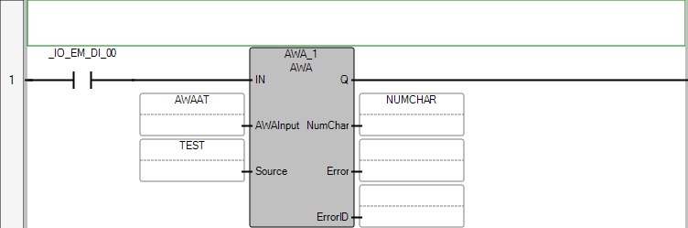

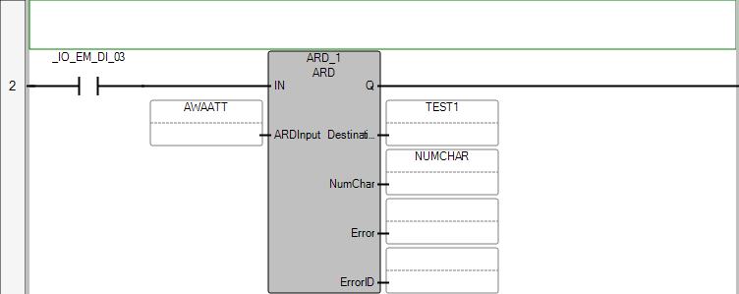

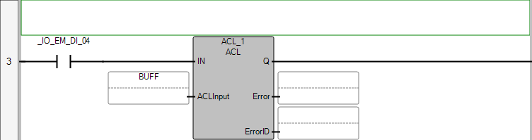

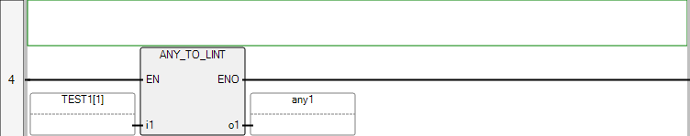

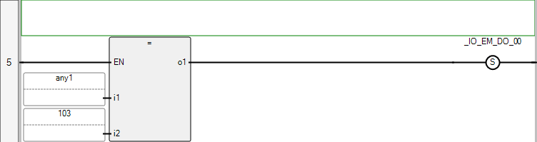

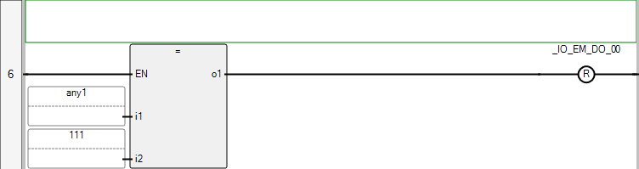

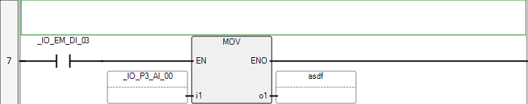

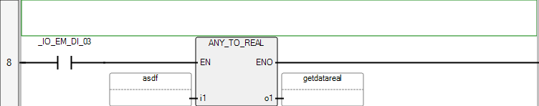

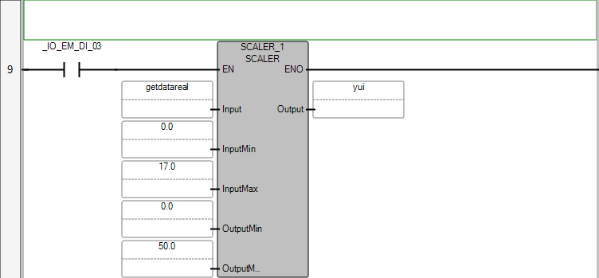

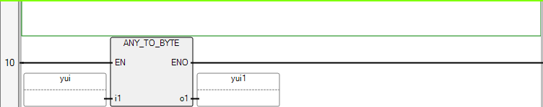

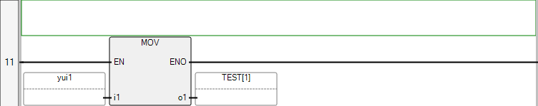

POU Prog1

The POU defines 31 variable(s).

Variable tflag

(* *)

Direction: Var

Data type: BOOL

Attribute: Read/Write

Variable increment

(* *)

Direction: Var

Data type: BOOL

Attribute: Read/Write

Variable AWAAT

(* *)

Direction: Var

Data type: AWAAWT

Attribute: Read/Write

Variable TEST

(* *)

Direction: Var

Data type: ASCIILOCADDR

Attribute: Read/Write

Variable kelma

(* *)

Direction: Var

Data type: STRING

Attribute: Read/Write

Variable test2

(* *)

Direction: Var

Data type: BYTE

Attribute: Read/Write

Variable counter

(* *)

Direction: Var

Data type: DINT

Attribute: Read/Write

Variable ARD_1

(* *)

Direction: Var

Data type: ARD

Attribute: Read/Write

Variable AWAATT

(* *)

Direction: Var

Data type: ARDARL

Attribute: Read/Write

Variable itfa

(* *)

Direction: Var

Data type: ASCIILOCADDR

Attribute: Read/Write

Variable NUMCHAR

(* *)

Direction: Var

Data type: UINT

Attribute: Read/Write

Variable BUFF

(* *)

Direction: Var

Data type: ACLI

Attribute: Read/Write

Variable ACL_1

(* *)

Direction: Var

Data type: ACL

Attribute: Read/Write

Variable TEST1

(* *)

Direction: Var

Data type: ASCIILOCADDR

Attribute: Read/Write

Variable FLAG_8

(* *)

Direction: Var

Data type: BOOL

Attribute: Read/Write

Variable DATA_STORE

(* *)

Direction: Var

Data type: ASCIILOCADDR

Attribute: Read/Write

Variable CV

(* *)

Direction: Var

Data type: DINT

Attribute: Read/Write

Variable AWA_1

(* *)

Direction: Var

Data type: AWA

Attribute: Read/Write

Variable any1

(* *)

Direction: Var

Data type: LINT

Attribute: Read/Write

Variable flag

(* *)

Direction: Var

Data type: BOOL

Attribute: Read/Write

Variable any2

(* *)

Direction: Var

Data type: LINT

Attribute: Read/Write

Variable asdf

(* *)

Direction: Var

Data type: UINT

Attribute: Read/Write

Variable getdatareal

(* *)

Direction: Var

Data type: REAL

Attribute: Read/Write

Variable SCALER_1

(* *)

Direction: Var

Data type: SCALER

Attribute: Read/Write

Variable scaleroutput

(* *)

Direction: Var

Data type: REAL

Attribute: Read/Write

Variable position

(* *)

Direction: Var

Data type: DINT

Attribute: Read/Write

Variable newreed

(* *)

Direction: Var

Data type: STRING

Attribute: Read/Write

Variable scale1

(* *)

Direction: Var

Data type: INT

Attribute: Read/Write

Variable yui

(* *)

Direction: Var

Data type: REAL

Attribute: Read/Write

Variable yui1

(* *)

Direction: Var

Data type: BYTE

Attribute: Read/Write

Variable yui2

(* *)

Direction: Var

Data type: BYTE

Attribute: Read/Write