**HOSPITAL MANAGEMENT SYSTEM**

**LOGISTICS II**

**(VENDOR PORTAL, FLEET MANAGEMENT SYSTEM, VEHICLE RESERVATION, DOCUMENT TRACKING SYSTEM, AND AUDIT MANAGAMENT)**

A Project Study

Presented to the IT Project Evaluation Committee of

BESTLINK COLLEGE OF THE PHILIPPINES

In Partial Fulfillment

Of the Requirements for the Capstone:

Bachelor of Science in Information Technology

PROPONENTS:

Astrera, Arvin

Caliwara, Reycelle

Escorel, Mico

Navarroza, Mico

Repotente, Mary Grace

April 2022

# DECLARATION

I certify that this project study does not incorporate, without acknowledgement, any material previously submitted for a degree or Diploma in any University and to the best of my knowledge and belief, it does not contain any material previously published or written by another person or myself except where due reference is made in the text. I also hereby give consent for our Project Study, if accepted, to be made available for photocopying and for inter-library, and for the title and summary to be available to outside organizations.

|  |  |
| --- | --- |
| Signature of Group/Individual Date: | January 31, 2022 |



|  |  |  |
| --- | --- | --- |
| Astrera, Arvin | Caliwara, Reycelle | Escorel Vanessa |



|  |  |
| --- | --- |
| Navarroza, Mico | Repotente, Mary Grace |

Countersigned By:

______________________________ Date: ________________

**Jorge Lucero**

Project Adviser

# CERTIFICATION

This Project Study entitled ***HOSPITAL MANAGEMENT SYSTEM LOGISTIC II*** prepared and submitted by Astrera Arvin, Caliwara Reycelle, Escorel Vanessa, Navarroza Mico, Repotente Mary Grace in partial fulfillment of the requirements for the degree **BACHELOR OF SCIENCE IN INFORMATION TECHNOLOGY** has been examined and recommended for **Oral Examination.**

**Mr. Jorge B. Lucero**

Project Adviser

# APPROVAL

Approved by the Panel on Oral Examination on **3 January 2022** with the grade of _____.

|  |  |
| --- | --- |
| **Mr. Rommel J. Constantino, MSIT**  Chairman | |
| **Engr. Junnel E. Avestro, MIT**  Member | **Engr. Diosdado T. Lleno**  Member |
| **ROSICAR E. ESCOBER, Ph.D.**  Dean, College of Computer Studies | |

Passed the Comprehensive Project Study 1 Defense: January 4, 2022

Passed the Comprehensive Project Study 2 Defense:

# CERTIFICATE OF ORIGINALITY

This is to certify that the research work presented in this Project Study entitled *HMS – LOGISTICS II* for the degree Bachelor of Science in Information Technology at the Bestlink College of the Philippines embodies the result of original and scholarly work carried out by the undersigned. This Project Study does not contain words or ideas for the published sources nor written works that have been accepted as basis for the award of a degree from any higher education institution, except where proper referencing and acknowledgement were made.

|  |
| --- |
| Researchers: |
| Astrea Arvin |
| Caliwara, Reycelle |
| Escorel, Vanessa Rose |
| Navarroza, Mico |
| Repotente, Mary Grace |
| January 2022 |

# ABSTRACT

**Introduction**

The Logistic II Hospital Management (HMS), which is simply defined as a systematic flow that interacts with hospitals, has been proposed to replace the manual system. Logistics II is a subsystem in this project that manages the complete process of acquiring, storing, and transporting materials to their destination. Logistics II is divided into five sub-modules. To view the transactions, tasks, or activities that have occurred in the hospital, use the Vendor Portal, Fleet Management, Vehicle Reservation, Document Tracking, and Audit Management tools. The Vendor Portal enables other businesses to conduct transactions and exchanges with one another, while Fleet Management enables users to manage and monitor vehicle transactions and overall transportation. Vehicle Reservation is a method of organizing the operation of a vehicle transportation schedule. Document Tracking allows users to keep track of incoming and outgoing papers, while Audit Management allows them to make reports and control incoming and exiting supplies.

**Methodology**

Agile methodology enables us to do multiple tasks simultaneously and provides a strategic technique, the sprint-by-sprint cycle method, to complete the task. Agile methodology allows us to plan and arrange all of the tasks that must be completed. This strategy encouraged our team to be more accountable for completing things on schedule. This strategy enabled us to be self-sufficient in our research and provided us the confidence to present our project without fear. We have learned to work together to make our Hospital Management System a successful endeavor.

**Result**

As a result the project team has successfully provided what the user’s needs to do on a daily task. The project team has set up system to provide the logistics II system with the necessary and perform the daily work in hospital. Logistic II is needed to manage the hospital and monitor the transaction; however this system is still underway and there are a lot of things to improve.

**Discussion**

The project team set up the system which would benefit both the Hospital Management System (HMS) Logistic II and the precision care. Agile methodology helps to reduce the time required for the development phase of the project system. As a result, the development team has developed a system with user-friendly and full functionality.

**Keywords**

Hospital logistics, logistics activities, logistics management, organization of hospital logistics.

# ACKNOWLEDGEMENT

The researchers would like to express their profound gratitude to the following people for their valuable contribution that helped in the completion of this study:

**Dr. Mary M. Vicente**, President of Bestlink College of the Philippines, we extend our gratitude for the guidance and for providing us with quality education.

**Dr. Charlie I. Cariño**, Executive Vice President of Bestlink College of the Philippines, we extend our gratitude for making the school a second home for students helping them to learn and gain knowledge.

**Engr. Doni T. Lleno**, Vice President for Administration, we extend our gratitude for building a strong foundation and ensuring that a school is a place for learning.

**Dr. Thelma Villaluna**, OIC for Research, Bestlink College of the Philippines, we extend our gratitude for giving us proper education to enhance our skills and helping us to become better students.

**Dr. Rosicar Escober**, Dean of College of Computer Studies Bestlink College of the Philippines, for providing us the study equipment to enhance and improve our skills for our career.

**Mr. Rommel Constantino**, Program Head of College of Computer Studies, for the constant supervision as well as providing necessary information regarding the project and also for his support in completing this Project;

**Mr. Enrico Pineda**, Teacher of Project Study, for giving us ideas and suggestions to improve our research and sharing his experience for us to have insights to further develop our knowledge.

**Mr. Jorge Lucero**, Teacher of Project Study, for guiding us and providing the necessary connection for those people that we need to provide all the requirements need for this project.

**Almighty God,** for everything He provided for us, giving us another day to live to enjoy life and making us safe through the pandemic and every day.

# TABLE OF CONTENT

DECLARATION I

CERTIFICATION II

APPROVAL II

CERTIFICATE OF ORIGINALITY III

ABSTRACT IV

ACKNOWLEDGEMENT VI

TABLE OF CONTENT VIII

LIST OF ACRONYMS XIII

LIST OF FIGURES XIV

LIST OF TABLES XV

1. Project Management 1

1.1 Business Case 1

1.1.1.1 Executive Summary 1

1.1.1.2 Business Case Analysis Team 2

1.1.1.3 Problem Definition 5

1.1.1.4 Project Overview 8

1.1.1.5 Strategic Alignment 16

1.1.1.6 Cost-Benefit Analysis 17

1.1.1.7 Approvals 19

1.1.2 Project Charter 20

1.1.3 Stakeholder Strategy 22

1.1.3.1 Introduction 22

1.1.3.2 Identify Stakeholders 22

1.1.3.3 Key Stakeholders 23

1.1.3.4 Stakeholder Analyst 24

1.2 Project Planning 24

1.2.1 Project Management Plan 24

1.2.1.1 Introduction 24

1.2.1.2 Project Management Approach 25

1.2.1.3 Project Scope 25

1.2.1.4 Milestone List 26

1.2.1.5 Schedule Baseline and WBS 28

1.2.1.6 Change Management Plan 29

1.2.1.7 Cost Management Plan 31

1.2.1.8 Project Scope Management Plan 32

1.2.1.9 Schedule Management Plan 32

1.2.1.10 Quality Management Plan 33

1.2.1.11 Risk management plan 33

1.2.1.12 Cost Baseline 34

1.2.2 Risk management plan 34

1.2.2.1 Introduction 34

1.2.2.2 Top three risk 35

1.2.2.3 Risk management approach 35

1.2.2.4 Risk identification 36

1.2.2.5 Risk Qualification and Prioritization 36

1.2.2.6 Risk Monitoring 37

1.2.2.7 Risk Mitigation and Avoidance 38

1.2.2.8 Risk Register 38

1.2.3 Scope Management Plan 39

1.2.3.1 Introduction 39

1.2.3.2 Scope Management Approach 40

1.2.3.3 Roles and Responsibilities 41

1.2.3.4 Scope definition 45

1.2.3.5 Project scope statement 46

1.2.3.6 Work Breakdown Structure (WBS) 47

1.2.3.7 Scope Verification 49

1.2.3.8 Scope Control 49

1.3 Project Execution plan 51

1.3.1 Implementation and migration plan 51

1.3.1.1 Purpose 51

1.3.1.2 Description of implementation 51

1.3.1.3 Points of contact 51

1.3.1.4 Major task 52

1.3.1.5 Implementation Schedule 52

1.3.1.6 Security 53

1.3.1.7 Implementation Support 53

1.3.1.8 Listing of hardware, software and facilities 54

1.3.1.9 Performance Monitoring 55

1.3.1.10 Implementation Requirements 55

1.3.1.11 Back Out Plan 55

1.3.1.12 Post Implementation Verification 57

1.4 Project Closure 59

1.4.1 Transition-out plan 59

1.4.1.1 Executive Summary 59

1.4.1.2 Transition Approach 59

1.4.1.3 Transition Team Organization 60

1.4.1.4 Work Transition 61

1.4.1.5 Work Execution during Transition 61

1.4.1.6 Subcontracts 61

1.4.1.7 Property Transition 62

1.4.1.8 Knowledge Transfer 65

1.4.1.9 Schedule 66

1.4.1.10 Handover and Acceptance 66

1.4.2 Project Acceptance 68

1.4.3 Post project review 70

1.4.3.1 Project Summary 70

1.4.3.2 Project Cost 72

1.4.3.3 Project Schedule 73

1.4.3.4 Recommendations 74

1.5 Technical solution design 75

1.5.1 Project Information 75

1.5.2 Executive Summary 76

1.5.3 Requirement Definition 76

1.5.4 Solution Description 79

1.5.4.1 Logical Architecture 79

1.5.4.2 High-Level Architecture 80

1.5.4.3 Process Flow 81

1.5.5 Implementation Timeline 82

1.6 System architecture 83

1.6.1 Business Process Architecture 83

1.6.2 Application Architecture 84

1.6.3 Data Architecture 85

1.6.4 Technology Architecture 86

2. Product Backlog 87

2.1 Product backlog (user stories) Table 87

2.2 Product Backlog for EIS Information Security 116

2.3 Product Backlog for EIS Standards 119

2.3.1 UI/UX (Icons, color, etc.) 121

2.4 Product Backlog for integration 124

2.5 Product Backlog for analytics 125

2.5.1 Application System Analytics 125

2.5.2 EIS Analytics 126

3. Sprint backlog 128

3.1 Sprint backlog table 128

3.1.1 User stories 128

3.1.2 Information security 131

3.1.3 EIS standard 132

3.1.4 EIS Integration 133

3.1.5 Analytics 135

Appendices 137

Appendix A Curriculum Vitae 137

Appendix J Photos During Authorship and Oral Evaluation **Error! Bookmark not defined.**

# LIST OF ACRONYMS

**BPA – Business Process Architecture**

**EIS – Enterprise information System**

**AA - Application Architecture**

**DA - Data Architecture**

**TA – Technology Architecture**

**BPA – Business process Architecture**

**UI – User Interface**

**UX – User Interface**

**VP - Vendor Portal**

**FM - Fleet Management**

**VR – Vehicle Reservation**

**DTS – Document tracking System**

**AM – Audit Management**

**WBS - Work Breakdown Structure**

**GFE – Government Furnished Equipment**

# LIST OF FIGURES

Figure No. Page No.

*Figure 1: Gantt Chart* 47

*Figure 2: Stakeholder Analyst Chart* 49

*Figure 3: Work Breakdown Structure (User)* 49

*Figure 4: Work Breakdown Structure (Admin)* 50

*Figure 5: Schedule* 69

*Figure 6: Logical Architecture* 80

*Figure 7: High-Level Architecture* 81

*Figure 8: Vendor Portal (User)* 82

*Figure 9: Vendor Portal (Admin)* 82

*Figure 10: Vendor Portal (Suppler Lists)* 83

*Figure 11: Vendor Portal (Supplier Items Table)* 83

*Figure 12: Fleet Management (Vehicle Lists)* 84

*Figure 13: Fleet Management (Monitor Lists)* 84

*Figure 14:* *Fleet Management ( Vehicle Reports)* 85

*Figure 15: Vehicle Reservation (Requisition)* 85

*Figure 16: Vehicle Reservation ( Returned Vehicle Lists)* 86

*Figure 17: Vehicle Reservation ( Reservation Information)* 86

*Figure 18: Document Tracking System (Incoming Documents)* 87

*Figure 19: Document Tracking System (New Documents)* 87

*Figure 20: Document Tracking System (Storage)* 88

*Figure 21: Audit Management (Storage)* 88

*Figure 22: Audit Management (Audit Inventory)* 89

*Figure 23: Audit Management (Audit Team)* 89

*Figure 24: Audit Management (Plan & Schedule)* 90

*Figure 25: Audit Management ( Audit Reports)* 90

*Figure 26: Implementation Timeline* 91

*Figure 27: BPA Top Level 1* 92

*Figure 28: BPA Top Level 2* 92

*Figure 29: Vendor Portal* 93

*Figure 30: Fleet Management* 93

*Figure 31: Vehicle Reservations* 93

*Figure 32: Document Tracking Systems* 93

*Figure 33: Audit Management* 93

*Figure 34: Data Architecture* 94

*Figure 35: Technology Architecture* 95

# LIST OF TABLES

Table No. Page No.

*Table 1: Business Case Analysis Team* 5

*Table 2: Goals and Objectives* 12

*Table 3: Project Performance* 14

*Table 4: Project Milestones* 16

*Table 5: Strategic Alignment* 17

*Table 6: Cost-Benefit Analysis (Cost)* 18

*Table 7: Cost-Benefit Analysis (Saving)* 19

*Table 8: Approval* 19

*Table 9: Stakeholder Analyst* 24

*Table 10: Stakeholder Strategy* 24

*Table 11: Milestone List* 28

*Table 12: Cost Baseline* 34

*Table 13: Roles and Responsibilites* 45

*Table 14: Point of Contact* 52

*Table 15: Implementation Schedule* 52

*Table 16: Transition Team* 61

Table 17: Subcontracts 62

*Table 18: User Account and Password* 65

*Table 19: Project Team and Staffing* 71

*Table 20: Project System Design* **Error! Bookmark not defined.**

*Table 21: Project Production (Prototype)* **Error! Bookmark not defined.**

*Table 22: Project Testing* **Error! Bookmark not defined.**

*Table 23: Final Project Deliverables* **Error! Bookmark not defined.**

*Table 24: Project Cost* 72

*Table 25: Project Schedule* 74

*Table 26:Vendor Portal* 76

*Table 27: Fleet Management* 77

*Table 28: Vehicle Reservation* 77

*Table 29:Document Tracking System* 78

*Table 30:Audit Management* 79

*Table 31: Product Backlog (User Stories)* 115

*Table 32: Product Backlog (EIS Information Security)* 118

*Table 33: Product Backlog (EIS Standards)* 121

Table 34: UI/UX 123

*Table 35: Product Backlog for Integration* 124

*Table 36: Application System Analytics* 126

*Table 37: EIS Analytics* 127

*Table 38: Sprint User Stories* 130

Table 39: Sprint Information Security 131

*Table 40: Sprint EIS Standards* 133

*Table 41: Sprint EIS Integration* 135

Table 42: Sprint for Analytics 135

# Project Management

## Business Case

### Executive Summary

The Hospital Management System is specifically designed to meet the needs of medium-sized and large-sized hospitals around the world. The team developer designs and creates a user-friendly system that can help the employees easily manage and navigate the hospital. It also meets the standards of the industry and includes all of the necessary modules, such as vehicle reservation, fleet management, vendor management, document tracking and audit management. The team developer project is built on database, object-oriented, and networking techniques. As there are many areas where we keep records in a database, we use PHP software, which is one of the best and easiest programs to use to keep our information.

#### Issue

Since Hospitals are associated with the lives of common people and their day-to-day outlines are to manage and assist the patients. The handling and monitoring of the record is time consuming.

#### Anticipated Outcomes

By using the proposed project, the Hospital department will enable directly that needed for every transaction. And by this, the engaging time of processing will be reduced because the data input will also be reduced. The employee will easily access and retrieve the file they needed in their favor. The company will also benefit from more timely and accurate reports for the ability to enter and continuously update on their recording system. This real time access reduces errors, improves cycle time, and is readily available to any authorized user

#### Recommendation

### Business Case Analysis Team

The business case analysis team consists of five (5) members that are prior set by the Project Manager. In this section, these individuals are responsible for the development of this project. The names, roles, and descriptions are as follows:

|  |  |  |
| --- | --- | --- |
| **Name** | **Role** | **Description** |
| Astrera, Arvin | Project Manager | * I Professional in the field of project management. * I Responsible for planning, procurement and execute of a project. * I Undertaking that has a define start and a defined finish |
| Escorel, Vanessa Rose | Programmer | * This person is responsible for creating program, system architecture, and system design. |
| Navarroza, Mico T | Scrum Master | * I Report to and receive direction from sponsors. I manage, review, and prioritize project works plans. * I Provide status Reports |
| Repotente, Mary Grace | Document Analyst | * This person responsible for revising and analyzing the document. |
| Caliwara, Reycelle | Research Analyst | * This person responsible for Gathering data and information |

*Table 1****:*** *Business Case Analysis Team*

### Problem Definition

#### Problem Statement

Precision Care Hospital is experiencing a shortage of experienced staff, which is having a major impact on operations. This includes retaining highly skilled individuals while improving performance, intellectual capability, and skill development. Employee performance was badly controlled and monitored under the current situation. Logistics II is having difficulty evaluating employees on a regular basis in order to update their performance and quality of work because they rely solely on recommendations with no supporting evidence. Furthermore, the institution is at odds with offering their employees proper pay raises for the hard work they put in for the organization. Another issue is that the institution is having problems selecting individuals for a vital job post that requires immediate filling, which necessitates extensive review to guarantee that institutions have what they need.

#### Organizational Impact

The Precision Care Hospital will impact in so many ways. The following provides an explanation of how the organization, tools, processes, hardware, software and roles and responsibilities will be affected in implementing the project.

Tools: The existing manual system will no longer be used as the project has been implemented. Authorized users will be required to be trained for a new useful tool of system project.

Processes: The Hospital Project will make the process easier, for it will lessen the workload and the consuming time for processing the collection of such vehicles the accuracy of the record will be more maintainable and manageable.

Hardware/Software: The Hospital Management will be required to have the workstation that will meet the needs of the following:

**Hardware Minimum Requirements:**

* + - * + 166 MHZ Pentium IV or equivalent
        + 256 MB memory
        + 1 TB external hard disk space
        + VGA display

**Software minimum requirements:**

* + - * + JRE 6 for windows
        + JRE 6 for Linux

**Internet Service Provider:**

* + - * + 100 Mbps
        + Unlimited Connections

**Hosting Server:**

* + - * + With SSL
        + With Domain
        + Unlimited Bandwidth
        + Unlimited Database
        + Access Manager

#### Technology Migration

A phased approach has been developed to discuss the day-to- day processes in order to effectively transition the existing data to a web-based system project.

The following is a high-level overview of the phased approach.

**Phase I:** Developed a web-based system that will be installed to the workstation and will be tested by our team.

**Phase II**: All Logistics 2 will undergo training about the new web-based system implemented

### Project Overview

The PrecisionCare Hospital overview provides detail for how this project will address Bachelor Science of Information of Bestlink College of the Philippines business problem. The overview consists of a project description, goals and objectives for the PrecisionCare Hospital. As a project is approved and moves forward each of these components will be expanded to include a greater level of detail in working towards the project plan.

#### Project Description

The Purposed system will make it easier for the it workload. This project will be used as a single tool with multiple functions. With this project, the system will able to collect data, track documents, audit and manage reservations with the flick of a hand. Reports can also be generated at any time. Keeping records will no longer be overload for the employee because they will be easily accessible in the system. Using the system, transactions will be easier and workload will take less time.

#### Goals and Objectives

The Develop Project directly supports several goals and objectives established by Logistic 2. The following table lists the business goals and objectives that the Hospital Management supports and how it supports them:

|  |  |
| --- | --- |
| **Goal** | **Objectives** |
| Develop a system that focuses on the needs of the job successor on organize way. | **Vendor Portals**   * To develop a system from purchased software or developed internally that assumes the responsibility of maintaining the portal in a cost-efficient manner. |
| Develop a system that can analyze and allow to view the capabilities of the Admin and to recognize the efficiency of the past will be better in the present. | **Fleet Management**   * To develop a system that complete administration control and security. * To develop a system to make a higher customer retention rate, increased driver satisfaction. |
| To acknowledge and supervise competent admin’s according to required competencies. | **Vehicle Reservation**   * To develop a system that gets valuable insight about the business and allows for maintenance scheduling. |
| Provide a system that may help to recognize or generate a report whether the training is effective or not. | **Document Tracking System**   * To develop a system that allows members of Hospital Management System to electronically track important documents. |
| To recommend a new systematic approach to all users and wanted to build up a simple but a dynamic system that easy to use and understand the User Interface (UI) | **Audit Management**   * To develop a system that makes auditing easy and improves the performance and generates reports faster. |

*Table 2: Goals and Objectives*

#### Project Performance

The table shows the key resources, processes or services and their anticipated business outcomes in measuring the performance of the project. These performance measures will specify and elaborate for the detailed project plan.

|  |  |
| --- | --- |
| **Key Resource, process Service** | **Performance Measure** |
| **Evaluation** | **Identify the individual rankings and competiveness of the employees.** |
| **Monitoring** | **Observing and recording the employees’ performance.** |
| **Reporting** | **The data from the web system are more accessible and easier to generate print handouts of data collected from the entire system.** |
| **Learning Program** | **Educate employees by providing learning materials and seminars with evaluation.** |
| **Training System** | **Train new hired and old employees.** |
| **Web Application** | **It will ease the transaction.** |

*Table 3: Project Performance*

#### Project Assumption

Helps admin manage task individually and improve their skills as project planning progresses, more assumptions will be identified and included as needed.

#### Project Constraints

The possible Constraints in the Logistics are as Follows. As project planning progresses, more assumptions will be identified and included as needed.

**Time constraints:** Refers to the project schedule for completion, including the deadlines for each milestone and the availability of every member to do each task.

**Information constraints**: Because of the pandemic and protocol of the government, to limit the people outside. The project team has limited resources to support the project.

#### Major Project Milestones

The following table list is the identified project milestones at this time. As the project planning advances and the schedules identified, the project milestones and their target completion dates will be modified, adjusted, and finalized as necessary to establish the baseline schedule.

|  |  |
| --- | --- |
| **Milestone/Deliverable** | **Target Date** |
| Project Charter | 11/17/2021 |
| Project Plan Review and Completion |  |
| Project Kick-Off |  |
| Sprint 1 |  |
| Sprint 2 |  |
| Sprint 3 |  |
| Sprint 4 |  |
| Sprint 5 |  |
| Close Out/Project Completion |  |
| Project Charter |  |

*Table 4: Project Milestones*

### Strategic Alignment

|  |  |  |
| --- | --- | --- |
| **Plan** | **Goals/Objectives** | **Relationship to project** |
| Logistic II Strategic Plan for 2021 Information Management | Adopt the systematic approach that will benefit the hospital and its department effortless | The new improve business process that will allow Logistic Admin and staffs to work efficiently |
| Logistic II Strategic Plan for 2021 Transactions | Improve keeping record and make fast transactions | This project will keep records of supplies, vehicle and the transaction information and real time management information in hospital. |

*Table 5: Strategic Alignment*

### Cost-Benefit Analysis

The following table captures the cost and savings actions of HR2 project, descriptions of these actions, and the costs or savings associated with them through the year. At the bottom of the chart is the net savings for the year of the project.

|  |  |  |
| --- | --- | --- |
| **Action** | **Description** | **First Year Cost** |
| Development of the Project | The ongoing process of development of the project | ₱ 100,000 |
| Purchase web server and domain | initial investment for development of LOG 2 Project | ₱ 2,850.00 |
| Installation of * set of computers | Since the system require certain specification to use the full potential | ₱ 90,000 |
| Subscribe in Internet provider | he system will require to stay connected on the internet to function | ₱ 40,000 |
| Estimate Cost: ₱ 232,850.00  : | | |

*Table 6: Cost-Benefit Analysis (Cost)*

|  |  |  |
| --- | --- | --- |
| **Action** | **Description** | **First year cost** |
| Reduce the number of Staff | Reduction in overhead equal to the annual salary of 3 to 4 HR staff (18,800 per month and 225,600 per year). | ₱ 730,000 |
| Reduce the number of Staff | Reduction in overhead equal to the annual salary of 3 to 4 staff (18,800 per month and 225,600 per year). | ₱ 15,000 |
| **Estimate Saving: ₱87,000** | | |

*Table 7: Cost-Benefit Analysis (Saving)*

### 

### Approvals

The signatures of the people below indicate an understanding of the purpose and content of this Business Case by those signing it. By signing this document, you indicate that you approve of the proposed project outlined in this business case and that the next steps may be taken to create a formal project in accordance with the details outlined herein.

|  |  |  |  |
| --- | --- | --- | --- |
| **Approver Name** | **Title** | **Signature** | **Date** |
| Enrico Pineda | Project Owner |  |  |
| Jorge Lucero | Process Improvement |  |  |

*Table 8: Approval*

## Project Charter

This charter formally authorizes the Precision Care project to develop a Hospital Management System to use in Bestlink College of the Philippines a project plan will be developed and submitted to the Project Sponsor for approval. The project plan will include scope statement; schedule; cost estimate; and provision for scope, resource, schedule communications, quality, risk, stakeholder management as well as project control. All resources will be assigned by Project Sponsor, Mr. Enrico Pineda

The purpose of the Precision Care project is to easily manage the transaction in hospital. The project deliverables shall include hospital system design, all coding, testing, implementation. The objectives of the hospital management system are to speed up the hospital transaction services, tracking document and easily report, automatically tallies the supplies and provide reports. High level risks for this project include ensuring implementation is completed without impacting ongoing hospital operations and ensuring there are no issues with migrating collection files from the legacy system to the system. Success will be determined by the Project Sponsor once the system is implemented, and one full transaction cycle has been complete that meets the objectives with no discrepancies.

The Project Manager, Arvin Astrera, is hereby authorized to interface with management as required, negotiate for resources, delegate responsibilities within the framework of the project, and to communicate with all contractors and management, as required, to ensure successful and timely completion of the project. The Project Manager is responsible for developing the project plan, monitoring the schedule, cost, and scope of the project during implementation, and maintaining control over the project by measuring performance and taking correct action.

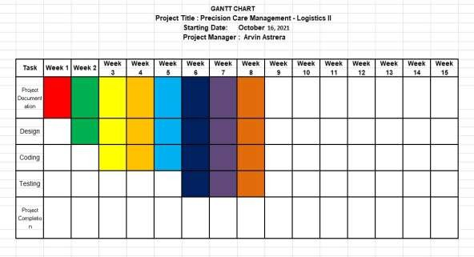*Figure 1: Gantt Chart*

## Stakeholder Strategy

### Introduction

The project's stakeholders will be identified and classified using the Stakeholder Management Strategy for Logistics Project. This will make it easier to determine the stakeholders' impact and interests. It will also know how to approach or communicate with stakeholders, as well as the approach and methodology to utilize. As a result, the project will be able to freely solicit feedback for its progress.

Identifying and connecting with stakeholders assists in ensuring the Hospital Project's success by obtaining support and input. Clear objectives and maximizing the resources needed to execute the project will help the project.

### Identify Stakeholders

A meeting of the Logistics Project Team will be held in order to identify project stakeholders. The principal project team and the project sponsor will be present at this meeting. Audit management, Document personnel, Drivers, Development Team, and any other employee who may be affected by Logistics 2 are examples of stakeholders.

The following criteria will be used to determine if an individual will be included as a stakeholder:

Will the person or their organization be directly affected by this project? Will the person or their organization hold a position from which they can influence the project?

Will the person have an impact on the project’s resources (material, personnel, funding)?

Will the person potentially benefit from the projects?

Any individual who meets one or more of the above criteria will be identified as a stakeholder

### Key Stakeholders

The project team will identify the key stakeholders who will be affected by the project and also have a greater impact. The people who already are critical towards the successful team are referred to as key stakeholders. Stakeholders include the supplier, receiver, carriers, government, and the consumer.

### Stakeholder Analyst

|  |  |  |  |
| --- | --- | --- | --- |
| **Key** | **Organization** | **Power**  **(1-5)** | **Interest**  **(1-5)** |
| A | Administrator | 5 | 5 |
| B | Staffs | 4 | 4 |

*Table 9: Stakeholder Analyst*

*Table 10: Stakeholder Strategy*

# Project Planning

## Project Management Plan

### Introduction

Logistic II plays an important role in the growth and success of a company; it serves as an analyst for a large or medium-sized company. The logistics process does not end with ordering supplies from suppliers. The logistics department in a company is responsible for storing materials or supplies required for production. It is also the person in charge of a company's assets.

### Project Management Approach

To ensure successful and timely completion of the project, the Project Manager, Astrera Arvin, is hereby authorized to interface with management as needed, negotiate for resources, delegate responsibilities within the project framework, and communicate with all project team members and management as needed. The product owner will examine and approve all project and company management plans. Throughout the project, the project team will report on their progress. The Project Manager is also responsible of keeping the project team updated on their progress to the project's performance.

### Project Scope

**Vendor Portal System** - The vendor portal is a way to find products that will come into your business or it is also a way for you to find supplies and the vendor portal and you can also post your products here.

Fleet Management System- To create a module that can monitor and maintain registered vehicles.

**Vehicle Reservation System** - To reserve a vehicle that the supplier picks from fleet management, and track where the vehicle goes and where is the destination.

**Document Tracking System** - The document tracking system is a module that tracks all incoming and outgoing documents.

**Audit Management System** - The system that can be able to manage audit planning and scheduling and allows users to print report.

### Milestone List

The table below lists the major milestones for the Hospital Management System. This chart only includes major project milestones such as project phase completion or gate review. There may be smaller milestones that are not shown on this chart but are included in the project schedule and work breakdown structure. If there are any scheduling delays that could affect a milestone or delivery date, the project manager must be notified right away so that proactive measures can be taken to mitigate date slips. The project manager will notify the project team of any approved changes to these milestones or dates.

|  |  |  |
| --- | --- | --- |
| Milestone | Description | Date |
| Requirements Gathering | All Requirements for PrecisionCare must determine to base design upon | 10/20/2021 |
| Designing | To design for the software. This the theoretical | 02/20/2022 |
| Developing | All coding completed resulting in software prototype. | 02/20/2022 |
| Testing and Debug | All functionally tested and all identified errors corrected | 04/?/22 |
| Transition of system | Completed software and documentation transitioned to operations group to begin production. | 04/?/22 |

*Table 11: Milestone List*

### Schedule Baseline and WBS

The Logistics Project's WBS is made up of work packages that have been assigned a specific amount of time to complete by the team development. With input from functional managers and research from previous projects, work packages were designed through close collaboration among project team members and stakeholders.

All work packages for the Logistics Project are listed in the WBS Dictionary. All tasks, resources, and deliverables are included.

The Logistics Project Schedule was created with input from all project team members and was based on the WBS and Project Charter. The project sponsor reviewed and approved the timetable. The project manager will keep track of the timetable, and any proposed adjustments will require the project sponsor's agreement. The impact of the modification on the schedule, cost, resources, scope, and risks will be determined by the Project Manager and team.

If the Project Sponsors approve the change, it will be implemented by the Project Manager, who will update the schedule and all documentation, as well as notify all stakeholders.

### Change Management Plan

The following steps comprise the PrecisionCare Hospital change control process for the project and will be utilized on the Logistic II project:

Step #1: Identify the need for a change (Any Stakeholder)

Requestor will submit a completed change request form to the project manager.

Step #2: Log change in the change request registers (Project Manager)

The project manager will maintain a log of all change requests for the duration of the project.

Step #3: Conduct an analysis of the change (Project Manager, Project Team, Requestor)

The project manager will conduct an evaluation of the impact of the change to cost, risk, schedule, and scope.

Step #4: Submit change request to (Project Manager)

The project manager will submit the change request and analysis to all the project team and stakeholders.

Step #5: Project team and stakeholder decision

The project manager will discuss the proposed change and decide whether it will be approved based on all submitted information.

Step #6: Implement change (Project Manager)

When the changes approved by the project owner, team, and stakeholders. The project manager will update and set new guidelines project documentation as necessary to ensure any changes are clear to the team and stakeholders.

If a change is approved by the project team and stakeholders, the project manager will update and re-baseline project documentation as necessary as well as ensure any changes are communicated to the team and stakeholders

### Cost Management Plan

The Project Manager will be in charge of identifying and monitoring on the project's costs during its duration. During the time of review, the Project Manager will present and audit the project's cost and schedule. The Project Manager is responsible for cost deviations and presenting options to the Project Sponsor for getting the project on track using earned value calculations. The logistics 2 Project Sponsor has complete budget authority and decision-making authority, including budget changes

### Project Scope Management Plan

The project's final deliverable must be formally recognized by the Project Sponsor. This approval will be contingent on an evaluation of all project documentation, testing results, early access study results, and finalization of all tasks/work packages and product functionality.

Scope changes can be proposed by the Project Manager, Stakeholders, or any project team member. All change requests will be forwarded to the Project Manager, who will evaluate the requested scope of the project.

### Schedule Management Plan

PHP will be used to produce project schedules for the Hospital Management System. The Work Breakdown Structure identified the schedule and deliverable (WBS). All activities have been described in order to identify particular work that will be done in order to complete all deliverables.

The project team will examine the schedule after it has been created, and any allocated project tasks will be tracked. The project's work package assignments, durations, and timetable must be agreed upon by the project's team and resources. The project sponsor will evaluate and approve the schedule when this is accomplished, and it will then be baseline. The following shall be identified as milestones for all project timelines in compliance with Hospital Management organizational standards:

* + - * Completion of scope statement and WBS
      * Base lined project schedule
      * Approval of final project budget
      * Approval of roles and responsibilities
      * Requirement’s definition approval
      * Project implementation
      * Acceptance of final deliverable

### Quality Management Plan

In quality management, team members of Logistic II project team will collaborate, from individual work packages through the final project deliverables. The team must guarantee that everything is inline in an acceptable standard.

The following are the quality roles and responsibilities for the Logistic II:

The Project Owner is in responsible of verifying all quality standards for the Logistic II, and also checking all project activities and deliverables to ensure that they meet the specified and approved quality standards.

The Project Manager is in charge of quality management. The Project Manager is responsible for putting the Quality Management Plan into action and ensuring that all activities, processes, and documentation are included. All deliverables will be monitored by the Project Manager to verify that acceptable quality standards are met. The Project Manager is also responsible for informing the project team and stakeholders about all quality standards and keeping track of them.

The project team and stakeholders will be responsible for helping the Project Manager in developing acceptable quality standards. They'll also make sure that all quality standards are followed and that any quality problems are communicated to the Project Manager.

The Logistics project meets the delivery objectives and expectations, and it also creates a structured procedure for measuring and accepting quality standards. Implementing a quality control project will need the use of tools and procedures to ensure that all project outputs meet authorized quality standards.

If any changes are suggested and accepted, the Project Manager is also responsible for updating the project team on the changes and revising all project plans and documentation.

### Risk management plan

### Cost Baseline

The cost baseline for the Logistic II Project includes all budgeted costs for the successful completion of the project.

|  |  |  |
| --- | --- | --- |
| **Project Phase** | **Budgeted total** | **Comments** |
| Planning | 15,000 | Includes work hours for all project team members for gathering requirements and planning project. |
| Design | 20,000 | Work hours for project team members for work on conceptual design |
| Coding | 50,000 | Includes all work hours for coding |
| Testing | 30,000 | Includes al work hours for testing (including beta testing of Web-Based System |
| Transition and Closeout | 40,000 | Includes all work hours for transition to operations and project closeout |

*Table 12: Cost Baseline*

## Risk management plan

### Introduction

When a company embarks on a new project, it enters the realm of uncertainty that comes with the production of new and distinctive products or services. As a result, these firms take risks, which are critical in every undertaking that involves risk.

A risk management plan's goals are to lay the groundwork for the project team to identify risks and develop solutions to mitigate or eliminate them. However, there are several preliminary project elements that must be accomplished before the risks can be identified and addressed. The strategy explains how to manage the risks associated with these factors.

### Top three risk

**Delay Internet Connection** - Due to an unstable network, a transaction may be delayed, resulting in a significant or a transaction may be duplicated. As a result, when appropriate, the project manager will use a high-speed network to lessen the risk.

**Hacking of data** - Because of the system's low level of security; it is possible that a hacker will get unauthorized access to it. As a result, the project manager will mitigate the danger by installing a high-level antivirus that can clean the system's hard disk.

**Untrained Staff**- Even though the UX/UI interface is user-friendly, it is still prone to human error. That’s why the project manager will undergo a training program for all staff; a walkthrough to understand how the system works that includes a user manual for better guides.

### Risk management approach

The risk management process we used for this project included a planned cycle in which the project team identified, categorized, and positioned the various risks. The most likely and significant effect risks were included to the job timetable to ensure that the demoted hazard supervisors were able to implement the moderation reaction at the appropriate time. Risk administrators will make statements about them.

Assigned risk during every other week project group meetings, but only if the meetings include their risk outlined time frame. The project manager will break down each risk throughout the end phase when the project is completed

### Risk Identification.

### Risk Qualification and Prioritization

To control the document of the key risks by the team, each risk was assigned a likelihood and impact factor. This activity empowers the project manager to prioritize risks depending on the impact they will have on the project. To assist the team in moving each risk to an acceptable location on the graph, the project manager used a probability and effect.

The recorder captures the finished result and the project manager continues the process to the next level: the risk mitigation / avoidance strategy, after setting the risks and their impact and placing them in the correct location on the chart.

### Risk Monitoring

When the project is submitted to each risk, high impact risks are included to the project plan to ensure that they are constantly monitored. At the appropriate point in the project timeline, each risk is assigned to a risk manager. During weekly project team meetings, each risk manager conveys the risk status; however, only risks related to the current time frame will be covered. Risk monitoring will be a continuing activity throughout the duration of this project.

As the project deadline approaches, the project manager will ensure that the appropriate risk manager provides the necessary status updates, such as risk status, trigger identification, and risk response outcomes documentation.

### Risk Mitigation and Avoidance

The project manager directs the development of a response to each recognized risk by the project team. As more hazards are found, they are certified, and the team develops methods for risk avoidance and mitigation. These risks are included to risk registration and project planning in order to be monitored and addressed in a timely manner.

This project's risk will be managed and controlled within the constraints of time, scope, and budget. All identified hazards will be assessed to determine their impact on this triple limitation. The project manager will decide the best approach to respond to each risk with the support of the project team to ensure compliance with these limits.

### Risk Register

The Risk Register for this project is a list of any and all risks identified, their probability and effect on the project, the classification to which they belong, mitigation plan, and when the risk will occur. The initial project risk management meeting, which resulted in the creation of the register, was led by the project manager. During this discussion, the project team identified and described each risk. Besides that, the team assigned a score to each risk simply on the basis of occurrence and possible effects. The Risk Register also includes each risk's mitigation strategy as well as when the risk is most likely to occur. Each risk has been added to the project plan based on the identified risks and timelines in the risk register.

## Scope Management Plan

### Introduction

The scope framework for this project is provided by Scope Management. The scope management strategy, roles and duties as they relate to project scope, scope definition of the system, verification and management procedures, scope management control, and project's work breakdown structure are all organized in this section. To adhere to the Scope Management, create, each project communication that relates to the project's scope must be fulfilled.

This is the result of a study that developed, created, and tested replacement software that may be used to enhance hospital transaction and report creation. This covers the package's type, all programming and writing, and package testing and validation

### Scope Management Approach

For this project, scope management unit planning is the only real responsibility of the Project Manager. The scope for this project is defined by the scope statement, work breakdown structure (WBS), and WBS reference. The Project Manager, Sponsor, and Stakeholders can establish and approve documentation for measuring project scope that has deliverable quality checklists and work performance measurements. Planned scope changes are to be initiated by the Project Manager, stakeholders, or any member of the project team. All modification requests to unit planning must be submitted to the Project Manager, who can then appraise the requested scope modification. Upon acceptance of the scope modification request, the project manager can submit the scope modification request to the modification panel and project sponsor for acceptance. Upon approval of scope modifications by the modification panel and the project sponsor, the project manager can update all project documents and communicate the scope change to any or all stakeholders. With supported feedback and input from the project manager and stakeholders, the project sponsor is accountable for the acceptance of the last word in project deliverables and project scope.

### Roles and Responsibilities

|  |  |  |
| --- | --- | --- |
| **Name** | **Role** | **Responsibilities** |
| Enrico Pineda | Project Owner | * Approve or deny scope changes requests as appropriate * Evaluate need for change requests * Accept project deliverables |
| Astrera, Arvin | Project Manager | * Plan and develop the projects idea. * Monitor Project Progress and Set Deadlines – Responsible for planning Procurement and execute of a project. |
| Mary Grace Repotente | Business Analyst | * Responsible for revising and analyzing the document. |
| Mico Navarroza | Process Improvement | * Participate in defining change resolutions * Evaluate the need for scope changes and communicate them to the project manager as necessary |
| Vanessa Rose Escorel | Software Support | * Responsible for creating program system. * Participate in defining change resolutions * Evaluate the need for scope changes and communicate them to the project manager as necessary |
| Reycelle Caliwara | Technical Support | * Responsible for gathering data and information. * Responsible for revising and analyzing the information. * Participate in defining change resolutions * Evaluate the need for scope changes and communicate them to the project manager as necessary |

*Table 13: Roles and Responsibilities*

### Scope definition

The scope detailed need's assortment approach was used to define the scope of this project. First, an in-depth examination of the company's present package applications to support worker and user’s input. The project team used this information to create the project needs and the desires management arrangement, and, as a result, the required documentation matrix for the new package application's objectives. To support the desired selection of the system, the project description and deliverables were developed and approach, as well as input from experts in package design, technical support, programming, and business applications.

### Project scope statement

This project's scope was made through a comprehensive wants collection method. First, an extensive examination of the company's present package applications was undertaken with staff and user feedback. The project team developed the project based on information, wants documentation, wants management managed, and therefore needs the documentation for what the new package application should do. The project description and deliverables were created to support the collection of needs and material consultants in package vogue, technical support, programming, and business applications technique and input this method of expert opinion provided comments on the primary effect that to meet the first needs of giving a brand-new package platform from which the company can improve their documentation.

### Work Breakdown Structure (WBS)

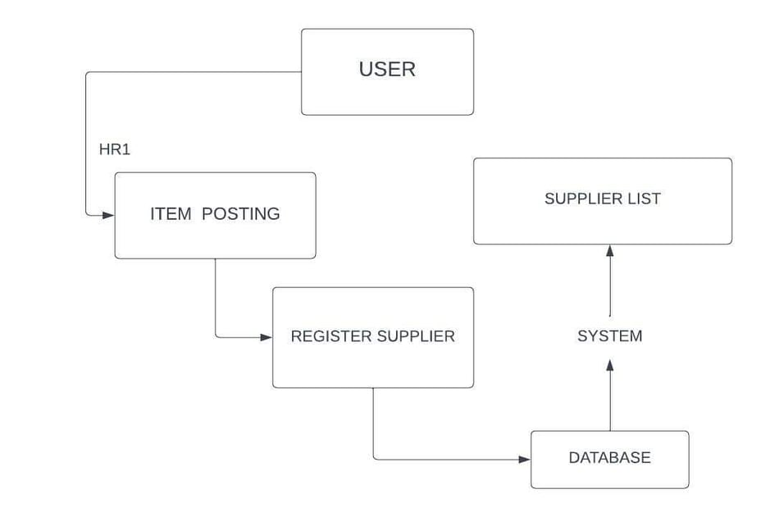

*Figure 3: Work Breakdown Structure (User)*

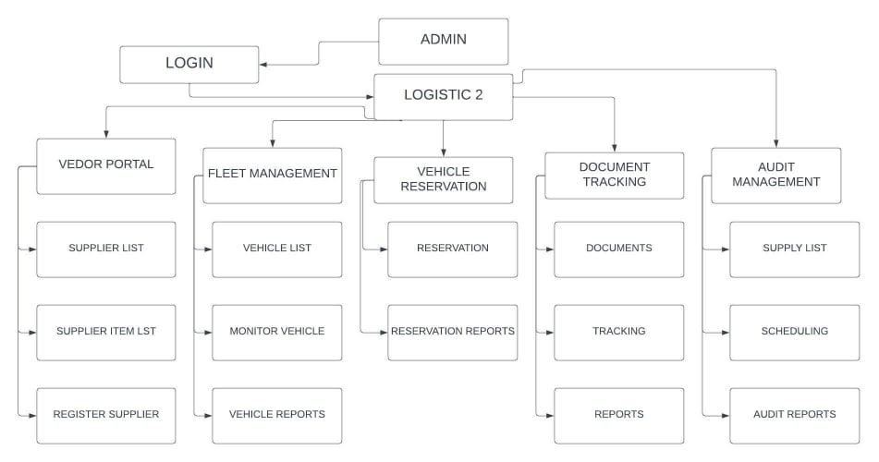

*Figure 4: Work Breakdown Structure (Admin)*

### Scope Verification

The Project Manager can check temporary project deliverables against the initial scope as specified in the scope statement, WBS, and WBS language as the project develops. The Project Manager and Sponsor can meet for formal approval of the deliverable once the Project Manager checks that the scope fits the requirements established in the project setup.

The Project Manager can present the deliverable to the Project Sponsor for official acceptance at this presentation. By signing a project deliverable acceptance paper, the Project Sponsor can agree to the deliverable. This may ensure that project work remains within the scope of the project on a consistent basis throughout its duration.

### Scope Control

The Project Manager and the project team may collaborate to control the project's scope. The project team may create use of the WBS by using it as a work announcement for each WBS section. The project team may ensure that they only do the work specified in the WBS and produce the deliverables specified for each WBS section. To ensure that this scope management strategy is followed, the Project Manager may oversee the project team and, as a result, the project's progress. If a change to the project scope is necessary, the technique for suggesting modifications to the project scope should be abandoned. Changes to the project scope can be requested by any project team member or sponsor. All requests for changes should be sent to the Project in the manner of a project change request document, the manager. The Project Manager can then evaluate the situation.

# Project Execution plan

## Implementation and migration plan

### Purpose

The purpose of the Implementation and Migration Plan is to keep track of every document performance and upkeep in order to boost productivity and make a company work more smoothly. The purpose of this implementation and migration plan is to describe how the Hospital management Logistic II project is implemented, established, and moved to its operational environment.

The goal of this project is to make all stakeholders aware of the specifics, requirements, and responsibilities involved in finishing the project and sending the product to the operating group. Prior to evaluation and approval, any requested changes to the project must be implemented through the project change control process.

### Description of implementation

The hospital's present maintenance logistic systems are insufficient for extension work; thus, the Logistic Project will be conducted to replace them. This database's implementation is an intentional and highly technical undertaking. This implementation description gives all stakeholders a clear picture of how the project will be implemented.

### Points of contact

The table below shows all stakeholders with the points of contact should any urgent questions or concerns arise.

|  |  |  |
| --- | --- | --- |
| **Name** | **Roles** | **Contact information** |
| Enrico Pineda | Project Owner | 00000000000 |
| Arvin Astrera | Project Manager |  |
| Mary Grace Repotente | Business Analyst | 09127791363 |
| Reycelle Caliwara | Technical Support | 09287137976 |
| Mico Navarroza | Process Improvement | 09484835008 |
| Vanessa Rose Escorel | System Support | 09205337873 |

*Table 14: Points of Contact*

### Major task

All Major Tasks necessary for effectively executing and migrating the LOG2 Project in PrecisionCare Hospital were identified by the Project Team. The Project Manager has double-checked all of the specified Major Tasks and allocated people or groups to each task. As a result, the project will stay within its scope and be conveyed to stakeholders in a clear and straightforward manner. The following is the LOG2 Project's Major Task; Implementation and Migration Plan:

1. **Complete Logistics II Design:**

This task implies the conclusion of all system design works for the new Web-based System.

1. **Complete Testing.**

This task indicates the requirements of the system which is the installation of computer, software application, and internet service.

1. **Initial implementation:**

This task indicates the beta testing of the system in the business operation. This will include the calibrating of functionality, and adjustment on the system based on the evaluation.

1. **Full Implementation:**

This task indicates the training and coaching of personnel of proper handling of system and maintenance, including the capturing of existing data to the new database of the system.

1. **Launching of the system: Logistic II Project Team and IT Department.**

This task represents the official launch of the system into the business operation.

1. **Project Acceptance: IT Department and Project Owner.**

This task involves formal acceptance of the LOG2 Project and other project deliverables by the Project Owner and IT Department.

### Implementation Schedule

The table shows the implementation schedule of the LOG2 Project. The Major Tasks described above are included in this schedule for the awareness of project team and stakeholders.

|  |  |
| --- | --- |
| **Major Task** | **Target Date** |
| Complete Human Resource II Design | 04/01/2022 |
| Complete installation of devices | 04/05/2022 |
| Initial implementation | 04/15/2022 |
| Full Implementation | 04/24/2022 |
| Launching of the system | 04/17/2022 |
| Project Acceptance | 05/01/2022 |

*Table 15: Implementation Schedule*

### Security

The IT department will be responsible for establishing and implementing information technology security measures. The logistics database will be protected by the IT department's security administrator's current firewall and security procedures. While historical systems will not have any unique or additional security protections, the security manager will be engaged in the design, testing, implementation, and migration of all phases.

### Implementation Support

The Project Manager will facilitate all gatherings and talks in order to complete the project's tasks. The Project Manager will work with both the admin and the IT Department to achieve these duties. Based on the views and needs of the operations and maintenance group, the IT department creates, tests, and installs the database on both the test server and the maintenance server. Maintenance is also prepared and trained by the IT department. The database's operators the lead and helper are in charge of this task. The Management Operations Group supplies the IT group with all operational requirements for the database's design and execution. The test should also receive input from of the maintenance operations group. In addition, all maintenance managers are involved. In database education it is integrated with the Product Owner if additional support is required

### Listing of hardware, software and facilities

Precision Care Logistic II requires database architecture based on the hospital system platform rather than the location of the existing database. While this enhances functionality and capabilities, no additional hardware or updates to existing hardware are required. Therefore, no new facilities are required to finish the project's implementation and migration. This project will be executed within the scope of the company's current abilities. The existing building and the hardware.

### Performance Monitoring

Logistics 2 has the same features as the database. But also, some more features. As a result, these extra functions have been implemented into the Supply chain Database Performance Monitoring supply/product by the design team. Additional monitoring standards were introduced to the manufacturing environment once the database was moved to capture real-time data in order to achieve this aim. Maintenance Operations Leads are in able to monitor performance and generate weekly reports for the hospital's IT leaders as well as senior executives. If database performance is found to be over acceptable limits by Logistics 2 Performance Monitoring, the problem is instantly escalated to personnel, who determine and implement corrective actions as well as the root cause

### Implementation Requirements

For the Logistics 2 Project, the stakeholders have completed the requirements collection activity. However, even though this is a medium-sized project, the lack of resources affects the implementation. As a result, the institution requires external support to complete the implementation. The following list shows the requirements for a successful implementation of the logistics 2 Project.

* Hardware/Software:
  + 8pcs of Computer Desktop
  + Internet (LAN)
* Personnel:
  + Project Manager – Astrera Arvin
  + Business Analyst – Repotente, Mary Grace
  + Software Support - Escorel Vanessa Rose
  + Technical Support - Caliwara Reycelle
  + Process Improvement - Navarroza, Mico
* Facilities
  + None - Existing workspace will be utilize

### Back Out Plan

We noticed the risk of a new database failing as soon as it starts on a Precision Care administration management server when preparing a database installation. To mitigate this risk, the project team devised a contingency plan that allows the maintenance staff to continue working even if the system is not turned on. All maintenance data for both the database and the maintenance database is updated as the data information task progresses. Until the checkout database is developed and operationally accepted, the deprecated database is kept on the service server. When the system boots up and a fault or malfunction is recognized, the developers delete all maintenance immediately. Access to the old database for technicians and restore access to the old database this permits repair activities to continue while the logistics 2 is being troubleshoot and tested.

### Post Implementation Verification

Following the deployment of the system, many procedures will be conducted to ensure that it is working properly implementation. First and important, managers of operations will guarantee that to do the given maintenance task, the allocated maintenance technician has access to the database. Managers will ensure that their database maintenance approaches evaluate their capacity to accomplish all given duties in the database, as well as that the right permissions and actions are in place after this has been validated. Finally, to confirm that all database capabilities are satisfied, maintenance managers will query and execute all given metrics and reports. Maintenance administrators will meet with project managers when these actions are completed. The team goes through all of the testing operations and validate that all of the implementation criteria have been met

* 1. **Project Closure**

## Transition-out plan

### Executive Summary

This plan formally documents the process of transitioning the Logistics System's powers, duties, activities, and functions of tasks and tools. It describes the method for transitioning work and employees from Bestlink College of the Philippines to the Logistics System. The Logistics System is used to build a new Logistics system. This Logistics system will enable Bestlink College of the Philippines to integrate other systems in the Hospital Management System into a unified system. This business project is currently in progress and will be completed within the time frame specified by the project advisors. The efficiency began on September 29, 2021 and is still on- going.

### Transition Approach

The Project Team can provide the system and hand it over to the Planning process in this case. The employees will evaluate the program, while the development team will ensure its dignity, performance, and troubleshooting. The transition will take 30 days to complete. Now, prior to the change, the Planning process will take a stand and the Researcher Team will manage all matters necessary for the transition to be successful

### 1.4.1.3 Transition Team Organization

The table shows the team members and their roles and responsibility that are in charge for the transition of LOG 2 system.

|  |  |  |
| --- | --- | --- |
| **Name** | **Title** | **Role/**  **Responsibility** |
| Arvin Astrera | Project Manager | By overseeing complex projects from inception to completion.  Initiating, Planning, executing. Monitoring and Controlling, Closing. |
| Mary Grace Repotente | Business Analyst | Putting a business thoughts and goals in front of the stakeholders. |
| Vanessa Rose Escorel | System Support | Monitor and maintain computer systems and networks. |
| Reycelle Caliwara | Technical Support | Providing technical support to clients in person and remotely. |
| Mico Navarroza | Process Improvement | Deciding on the best methods to make those changes.  Identifying, analyzing and improving upon existing business processes within an organization for optimization and to meet new standards of quality. |

*Table 16: Transition Team*

### Work Transition

For the duration of this contract change, all members of the workforce will continue to work in their present roles. The employees of the Best Link College Philippines will stay on standby to carry out their transition duties until the transition is complete. All parties agree that the task has been completed and accepted. Until the transition is complete, the development team will offer a workspace for all subjects involved

### 

### Work Execution during Transition

Bestlink College of the Philippines will continue to perform work in line with the requirements project timeline and work breakdown structure (WBS) in place throughout the transition of this agreement. The transition management team will ensure that Logistics 2 employees collaborate with Bestlink College of the Philippines equivalents; however, Bestlink College of the Philippines will maintain complete responsibility for tasks and tasks. Logistics 2 will assume full responsibility for all tasks and deliverables at the end of the 90-day transition period and upon transition approval.

### Subcontracts

The table shows the subcontractors that will fulfill the implementation requirements of the Logistic 2 system in PrecisionCare Hospital.

|  |  |  |
| --- | --- | --- |
| **Subcontract** | **Awarded to** | **Task** |
|  |  |  |
|  |  |  |
|  |  |  |

Table 17: Subcontracts

### Property Transition

#### Government Furnished Equipment (GFE)

All GFE provided to Bestlink College of the Philippines under the Logistics 2 System contract will be turned in to the authorities upon finalization and approval of the transitional period as part of this transition. The transition phase is completed and approved as part of the GFE. Laptop computers, all PEDs, flash and external hard drives and employee ID badges are all part of GFE. All electronic devices will be re-imaged and s new to Logistics 2 staff by government IT personnel

#### Incumbent Owned Equipment

Following the completion and approval of the transition, all incumbent owned devices will be preserved by the appointee. This equipment includes incumbent- issued laptop computers, organizational tools, organizational process maps, company ID badges, and other items. If it is determined that any incumbent-owned equipment must remain with the customer to ensure the agreement's successfulness, the customer and incumbent contracting officer representatives will coordinate procurement of the equipment through the customer's established procurement management process.

#### Intellectual Property

To ensure the successful completion of the logistics 2 System contract, all intellectual property that is a direct result of work on the contract deliverables will be transitioned to the new contractor. The contract pricing takes into account intellectual property, and as a result, any resulting intellectual property will be owned by the customer.

#### User Accounts and Passwords

As part of the contract transition, multiple user account accesses and authorizations must be created and removed. Employees indicated in the table below presently have access to the user accounts and system required for contract deliverables. The listed Precision Care employees will be granted access on the first day of the contract transition phase. Once transition is complete and approved, all official’s user accounts will be disabled.

|  |  |
| --- | --- |
| **User Account** | **PCH** |
| Manager | IT Department |
| Staff | T Department |

*Table 18: User Account and Password*

### Knowledge Transfer

Knowledge transfer will take place all through the 30-day transition period for this transition. Several methods will be used to transfer knowledge. These meetings will focus on particular IT issues related to database tasks and activities. The elected PM will also coordinate with the elected Administrator. These sessions will go over documentation requirements as well as organizational processes and assets. These sessions must be completed no later than 20 days before the end of the 30- day transition period. Furthermore, throughout the 30-day period, all staff will work at a fast pace to become acquainted with the database, tools, processes, and organizational assets

### Schedule

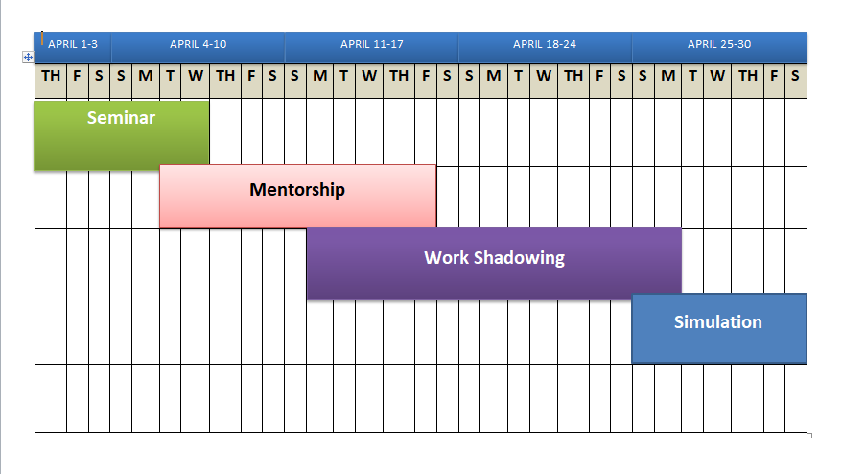

*Figure 5: Schedule*

### Handover and Acceptance

The client's transition email will use the established transition checklist to determine when all transition-related activities have been completed. The checklist and supporting documentation will be signed and approved by the client's project sponsor and company's human resources director. Only after all of these approvals and signatures have been obtained will the transition be considered complete.

## Project Acceptance

Knowledge transfer will take place all through the 30-day transition period for this transition. Several methods will be used to transfer knowledge. These meetings will focus on particular IT issues related to database tasks and activities. The elected PM will also coordinate with the elected Administrator. These sessions will go over documentation requirements as well as organizational processes and assets. These sessions must be completed no later than 20 days before the end of the 30- day transition period. Furthermore, throughout the 30-day period, all staff will work at a fast pace to become acquainted with the database, tools, processes, and organizational assets

The Project Manager is authorized to continue with the formal close out of this project. The closeout process will include a post-project review, documentation of lessons learned, release of the Project Team, close out all procurements and archive all relevant project documents. Once the closing process is completed the Project Sponsor will be notified and the Project Manager will then be released from the project.

Project Owner Acceptance

Approved by the Project Owner:

__________________________________ Date: ________________

(Signature over Printed name)

## Post project review

### Project Summary

The logistics 2 project's goal is to improve the generation of collection reports. This project meets the need for faster vehicle services and easily generates collection reports. System design, all coding, testing, implementation of an integrated system for use with existing IT infrastructure, and a user's guide are all part of the project deliverables. The logistics 2 project's goals are to speed up vehicle and document services, make it easier to generate collection reports, automatically tallies amounts, and provide reporting functions.

#### Project Team and Staffing

The Logistics2 Project consisted of a skilled and knowledgeable team. The table shows information about Logistics 2 Project team member:

|  |  |  |
| --- | --- | --- |
| Name | Project Title | Contact |
| Mr. Enrico Pineda | Product Owner | [enrico.pineda@gmail.com](mailto:enrico.pineda@gmail.com) |
| Astrera Arvin | Project Manager | [Arvin.draisen@gmail.com](mailto:Arvin.draisen@gmail.com) |
| Caliwara Reycelle | Technical Support | [reycellecaliwara11@gmail.com](mailto:reycellecaliwara11@gmail.com) |
| Escorel Vanessa Rose | Software Support | [Escorelvanessa0921@gmail.com](mailto:Escorelvanessa0921@gmail.com) |
| Navarroza Mico | Process Improvement | [miconavarroza@gmail.com](mailto:miconavarroza@gmail.com) |
| Repotente Mary grace | Business Analyst | [Repotente18@gmail.com](mailto:Repotente18@gmail.com) |

*Table 19: Project Team and Staffing*

#### Project Deliverable (Planned vs. Actual)

This section highlights the planned deliverables and compares them to actual deliverables as they occurred.

#### Transition to Operations

Transitioning to a new technological initiative to modernize the functioning of any industry, such as PrecisionCare Hospital, may be a difficult component of any rising institution.

To maintain continuity after the handover, the Project Team ensures that all stakeholders and the Project Owner communicate effectively throughout the project's length.

The Logistic 2 Project successfully transitioned to operation as a consequence of strong communication and planning. The Project Owner, IT department, and other stakeholders will be in charge of ensuring a collaborative approach to a new web-based system that can successfully transition to an operating environment.

Involving operations employees early in the project planning phase and soliciting comments on essential operational aspects can improve future projects. As a result, the transfer of the system to business operations was nearly flawless. This stage would have occurred in the future if the operations employees had not been engaged as stakeholders or participated in project planning. This would have caused the project to be delayed and incur additional expenditures.

### Project Cost

The Precision Care Management System Project's budgeted price was set at this cost was divided out by project innovation in the following chart with actual prices compared to the planned/budgeted price.

|  |  |  |  |
| --- | --- | --- | --- |
| **Project Phase** | **Budgeted Cost** | **Actual Cost** | **Comments** |
| Product Design | 50,000 | 50,000 | Product Design costs were on budget |
| Testing | 50,000 | 50,000 | Testing costs were on budget |

*Table 20: Project Cost*

The total actual costs of the LOG2 Project amounted to ₱. This project was not only successful in meeting all of its objectives and deliverables, but by completing under budget, it also allowed the project team to allocate ₱ 50,000 to other important initiatives. The completed product's refinement as intended. According to the budget, the expenditure was sufficient to the overall budget.

### Project Schedule

The table shows each phase of the project lifecycle, the planned schedule dates, and the actual completion dates of each phase.

|  |  |  |  |
| --- | --- | --- | --- |
| **Project Phase** | **Scheduled Completion** | **Actual Completion** | **Comments** |
| Project Plan ongoing | 03/00/2022 | Ongoing | Ongoing |
| Design ongoing | 03/00/2022 | Ongoing | Ongoing |
| Coding ongoing | 03/00/2022 | Ongoing | Ongoing |
| Testing ongoing | 03/00/2022 | Ongoing | ongoing |
| Implementation ongoing | 03/00/2022 | Ongoing | ongoing |
| One Transaction ongoing | 03/00/2022 | Ongoing | ongoing |
| Project Clouse | 03/00/2022 | ongoing | ongoing |

*Table 21: Project Schedule*

### Recommendations

The Precision Care Hospital Logistics II Project was a planned and successful project as the Human resource system for PrecisionCare Hospital. The recommendation and lesson learned are stated below:

**Recommendation #1:**

Always update the Project Owner and stakeholder for any changes occurred before and after the project development

**Recommendation #2:**

Perform different techniques for the transition and trainings of employees, to achieve the desirable result.

# Technical solution design

# 1.5.1 Project Information

|  |  |
| --- | --- |
| **Name** | PrecisionCare Hospital Logistic II  (PCH-LOG2) |
| **Description** | A system that will Evaluate, Train, and Hone every employee’s potential and skills for their own career path |
| **Business Owner** | Mr. Enrico Pineda |
| **Objective** | To provide a streamline approach in managing employee's competency, learning and training development, and accessible platform of information. |

## 

* + 1. **Executive Summary**

Nowadays, Hospitals are considered one of the most important establishments in the midst of a pandemic because, with COVID-19, transactions are limited only during the lockdown. To accommodate or resolve transactions- related concerns. The proposed system will help hospitals to manage the transactions in vendor portal, fleet management, vehicle reservations, document tracking, and audit management.

## 1.5.3 Requirement Definition

|  |  |  |  |
| --- | --- | --- | --- |
| **Req No.** | **User Story** | **Business Requirement** | **Acceptance Criteria** |
| U-1 | As an Admin, I should have supervision in Vendor Portal |  | * Log-in * View Dashboard |
| **U-2** | As an LOG2 Manager, I must be |  |  |
| **U-3** | As Vendor Portal Staff, I must be able to. |  |  |
| **U-4** | As an |  |  |

*Table 22: Vendor Portal*

|  |  |  |  |
| --- | --- | --- | --- |
| **Req No.** | **User Story** | **Business Requirement** | **Acceptance Criteria** |
| U-1 | As an Admin, I should have |  |  |
| **U-2** | As a Manager I can manage most of the process of |  |  |
| **U-4** | As an |  |  |
| **U-5** | As Head/Manage of the |  |  |

*Table 23: Fleet Management*

|  |  |  |  |
| --- | --- | --- | --- |
| **Req No.** | **User Story** | **Business Requirement** | **Acceptance Criteria** |
| **U-1** | As an ___, I must be able to |  |  |

*Table 24: Vehicle Reservation*

|  |  |  |  |
| --- | --- | --- | --- |
| **Req No.** | **User Story** | **Business Requirement** | **Acceptance Criteria** |
| **U-1** | As an Admin, I should have |  |  |
| **U-2** | As a Manager, I must be able to |  |  |
| **U-3** | As a DTS staff, I should have |  |  |
| **U-4** | As a |  |  |

*Table 25: Document Tracking System*

|  |  |  |  |
| --- | --- | --- | --- |
| **Req No.** | **User Story** | **Business Requirement** | **Acceptance Criteria** |
| **U-1** | As an Admin, I should have |  |  |
| **U-2** | As a |  |  |
| **U-3** | As a |  |  |

*Table 26: Succession Planning Requirement*

## 1.5.4 Solution Description

## 1.5.4.1 Logical Architecture

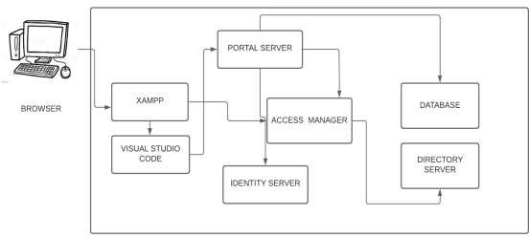

*Figure 6: Logical Architecture*

### High-Level Architecture

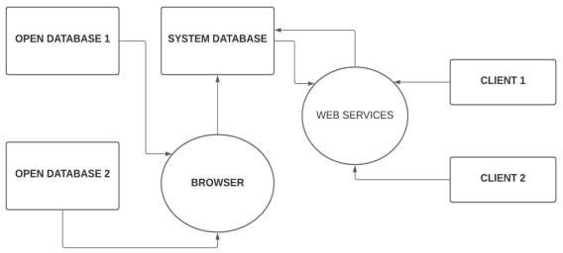

*Figure 7: High-Level Architecture*

### Process Flow

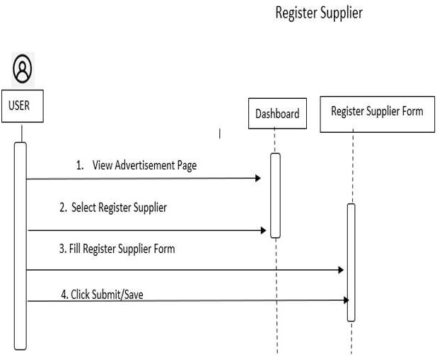

*Figure 8: Vendor Portal (User)*

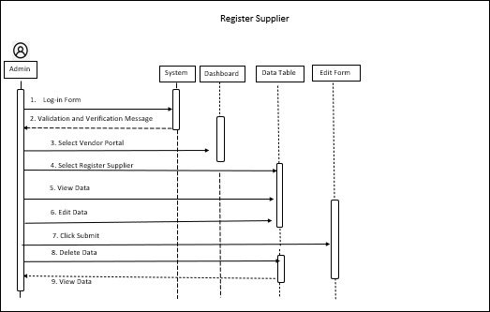

*Figure 9: Vendor Portal (Admin)*

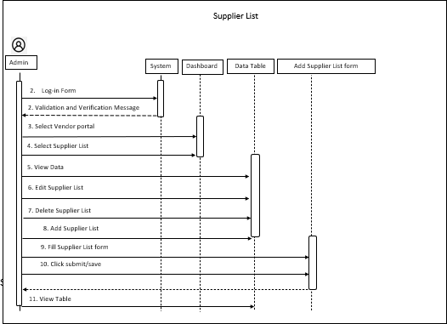*Figure 10: Vendor Portal (Supplier Lists)*

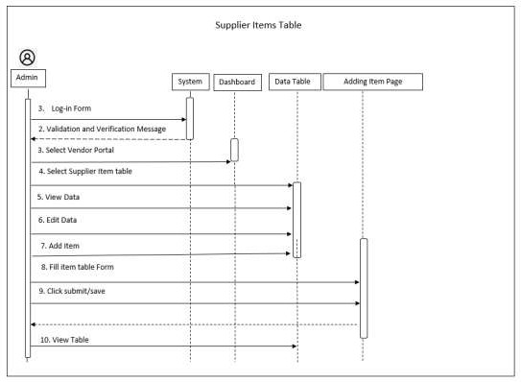

*Figure 11: Vendor Portal (Supplier Items Table)*

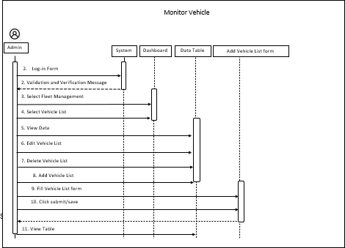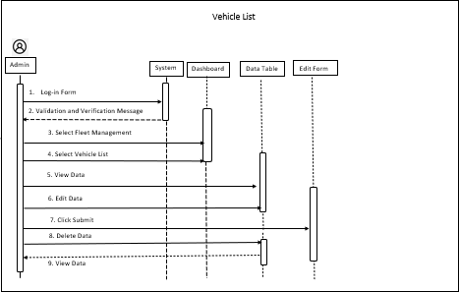 *Figure 12: Fleet Management (Vehicle Lists)*

*Figure 13: Fleet Management (Monitor Vehicle)*

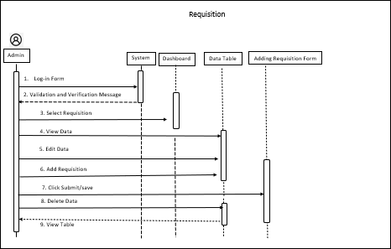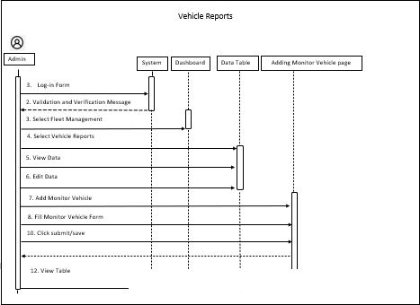*Figure 14: Fleet Management (Vehicle Reports)*

*Figure 15: Vehicle Reservation (Requisition)*

*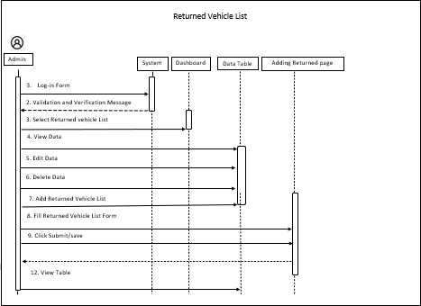Figure 16: Vehicle Reservation (Returned Vehicle Lists)*

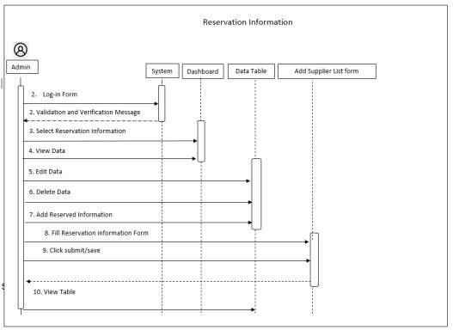

*Figure 17: Vehicle Reservation (Reservation Information)*

*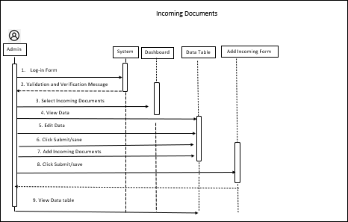Figure 18: Document Tracking Systems (Incoming Documents)*

*Figure 19: Document Tracking Systems (New Documents)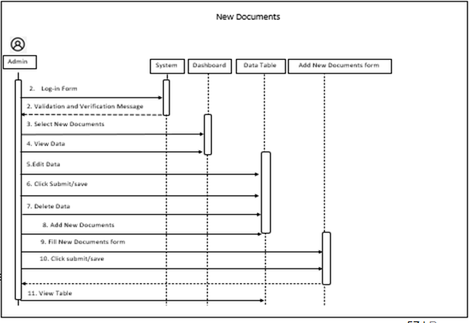*

*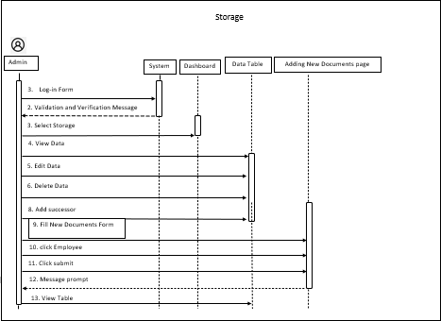Figure 20: Document Tracking System (Storage)*

**

*Figure 21: Audit Management (Storage)*

*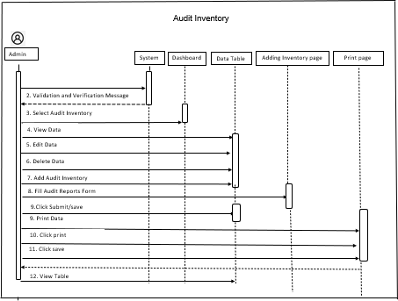Figure 22: Audit Management (Audit Inventory)*

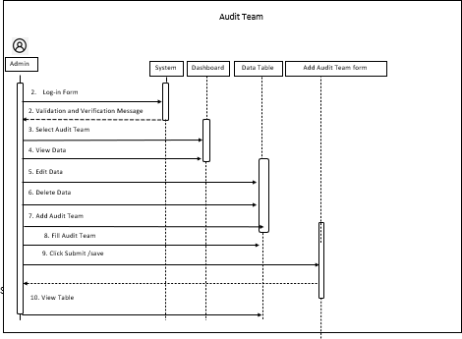

*Figure 23: Audit Management (Audit Team)*

*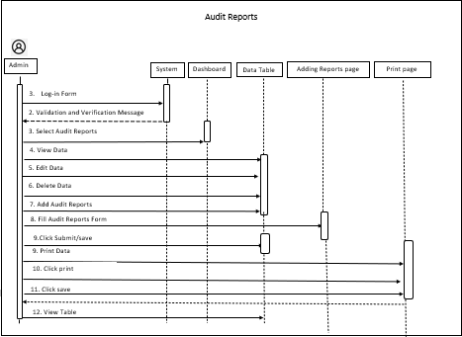Figure 24: Audit Management (Plan & Schedule)*



*Figure 25: Audit Management (Audit Reports)*

## 1.5.5 Implementation Timeline

Estimated 90 working days upon kick-off

Target Start Date: January 3, 2022

Deploy

Test

Develop

Design

Close

Initiate

*Figure 26: Implementation Timeline*

# System architecture

## Business Process Architecture

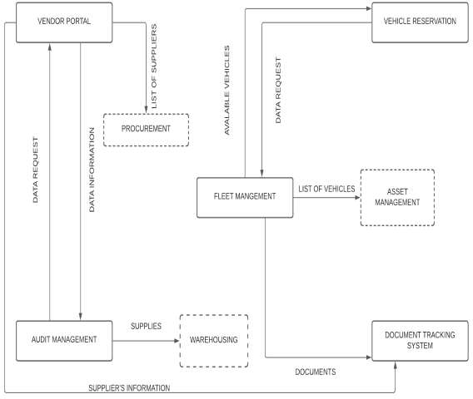

*Figure 27: BPA Top Level 1*

*Figure 28: BPA Top Level 2*

## Application Architecture

Figure 29: Vendor Portal

Figure 30: Fleet Management

Figure 31: Vehicle Reservation

Figure 32: Document Tracking System

Figure 33: Audit Management

## Data Architecture

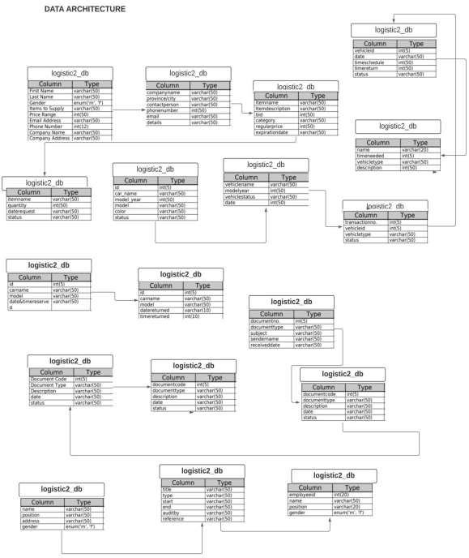

*Figure 34: Data Architecture*

## Technology Architecture

*Figure 35: Technology Architecture*

# Product Backlog

## Product backlog (user stories) Table

|  |  |  |  |  |  |  |  |  |  |
| --- | --- | --- | --- | --- | --- | --- | --- | --- | --- |
| **User Story No** | **User Stories** | | | **User Story Priorities** | | **Requirements**  **Reference** | | **Revised Priority** | **Status** |
| 1 | As a Logistic I can view the Procurement and Warehousing for past transaction that has been done in LOGISTIC 1. | | | 5 | |  | |  | On-going |
| 2 | As an Admin I can Manage (View and Permanently Delete) Archives files (All deleted files/data) | | | 5 | |  | |  | On-going |
| **Vendor Portal** | | | | | | | | | |
| 1. | As a Logistic Admin I want to have a Vendor Registration so that suppliers can register to offer supplies they have online.  Create Vendor Registration | 2 | | |  | | 2 | | On-going |
| 2. | As a Logistic Admin I want to have a supplier list so that I can ask for a supplies needed.  *Create Supplier’s list* | 1 | | |  | | 1 | | On-going |
| 3. | As a Logistic Admin I want to have a supplier’s feedback form.  *Create Supplier’s Feedback form.* | 2 | | |  | | 2 | | On-going |
| 4. | As a Logistic Admin I want to have a Vendor’s feedback form.  *Create Vendor’s feedback form.* | 2 | | |  | | 2 | | On-going |
| 5 | As a Logistic Admin I can look for supplier and find supplies |  | | |  | |  | | On-going |
| 6. | As a Logistic staff I want to update the supplies that come in |  | | |  | |  | | On-going |
| 7. | As a Logistic Admin I want to maintain the process of the system to have a smooth process of transaction |  | | |  | |  | | On-going |
| 8. | As a Logistic staff I want notify if the new supply is release and if its having a good quality that will be suited to our needs |  | | |  | |  | | On-going |
| 9. | As a Logistic Admin I want to have approval request form |  | | |  | |  | | On-going |
| 10. | As a Logistic staff I want  to have a viewing of the list in vendor portal |  | | |  | |  | | On-going |
| **Fleet Management** | | | | | | | | | |
| 11. | As a Logistic staff I want to have a Driver Request form so that I can request drivers if needed.  *Create Vehicle status form.* | | 1 | |  | | 1 | | On-going |
| 12. | As a Logistic admin I want to have a Reservation Request list, so that I can view the entire reserved request.  *Create Reservations Request* | | 2 | |  | | 2 | | On-going |
| 13. | As a Logistic admin I want to have Vehicle availability and Schedules to view all the available schedules.  *Create Vehicle schedule availability* | | 1 | |  | | 1 | | On-going |
| 14. | As a Logistic admin I want to have a Reserved vehicle details so that I can view and monitor all the vehicles.  *Create Vehicle Reservation.* | | 2 | |  | | 2 | | On-going |
| 15 | As a Logistic admin I want to have a Vehicle Condition so that I can have Information status of the vehicles  *Create Vehicle Status Form.* | | 2 | |  | | 2 | | On-going |
| 16. | As a Logistic admin I want to have a Concern List so that I can view all the list of the request to repair or maintenance of their concern.  *Create feedback form.* | | 1 | |  | | 1 | | On-going |
| 17. | As a Logistic admin I want to have a List Overview of the checked concern list  *Create Overview feedback of user’s.* | | 1 | |  | | 1 | | On-going |
| 18. | As a Logistic admin I want to have a Tracking GPS to find the vehicles in the area  *Create Tracking GPS.* | | 2 | |  | | 2 | | On-going |
| 19. | As a Logistic admin I want to have a Report Vehicle Risks and Availability  *Create Reports.* | | 2 | |  | | 2 | | On-going |
| 20. | As a Logistic staff I want to have a Driver’s Licensed Status so that I can request drivers if needed.  *Create Driver’s Licensed status* | | 2 | |  | | 2 | | On-going |
| **Vehicle Reservation** | | | | | | | | | |
| 21. | As a Logistic admin I want to have a Request List so that I can view all the vehicles pending for approval.  *Create Request’s*  *List.* | | 1 | |  | | 1 | | On-going |
| 22. | As a Logistic admin I want to have a Vehicle View Log so that I can track who used the vehicles.  *Create vehicle log-in.* | | 1 | |  | | 1 | | On-going |
| 23. | As a Logistic admin I want to have Vehicle availability and Schedules so that I have details of the approved vehicles.  *Create Vehicle Schedule form.* | | 2 | |  | | 2 | | On-going |
| 24. |  | |  | |  | |  | | On-going |
| 25 | Reservation information | |  | |  | |  | | On-going |
| 26. | Returned vehicle list | |  | |  | |  | | On-going |
| 27. | Vehicle list | |  | |  | |  | | On-going |
| 28. |  | |  | |  | |  | | On-going |
| 29. |  | |  | |  | |  | | On-going |
| 30. | Vehicle reports | |  | |  | |  | | On-going |
| Document Tracking System | | | | | | | | | |
| 31. | As a logistic, I can see the list of documents | |  | |  | |  | | On-going |
| 32. | As a logistic, I can search the specific documents | |  | |  | |  | | On-going |
| 33. | As a logistic, I can see the status of document if it is pending on document list | |  | |  | |  | | On-going |
| 34. | As a logistic, I can see the status of document if it is approved on document list | |  | |  | |  | | On-going |
| 35 | As a logistic, I can see the status of document if it is received on document list | |  | |  | |  | | On-going |
| 36. | As a logistic, I can sort the documents by date | |  | |  | |  | | On-going |
| 37. | As a logistic, I can sort the documents by name | |  | |  | |  | | On-going |
| 38. | As a logistic, I can see the reports of new added documents | |  | |  | |  | | On-going |
| 39. | As a logistic, I can track the status of supply’s documents | |  | |  | |  | | On-going |
| 40. | As a logistic, I can see the user who received the documents. | |  | |  | |  | | On-going |
| **Audit Management** | | | | | | | | | |
| 41. | As a Logistic Admin I want to have a creating report | |  | |  | |  | | On-going |
| 42. | As a Logistic Admin I want to have request to audit that can view all the record of transaction in logistic | |  | |  | |  | | On-going |
| 43. | As a Logistic Admin I want to have a scheduling audit for everyone who need audit report | |  | |  | |  | | On-going |
| 44. | As a Logistic Admin I want to have auditing status | |  | |  | |  | | On-going |
| 45 | As a Logistic Admin I want to have an update, delete audit plan in case of any changes | |  | |  | |  | | On-going |
| 46. | As a Logistic staff I want to have a checklist and updating of supplies | |  | |  | |  | | On-going |
| 47. | As a Logistic staff I want to have a creating report of supplies | |  | |  | |  | | On-going |
| 48. | As a Logistic Admin I want to view the statistics of tally of supplies | |  | |  | |  | | On-going |
| 49. | As a Logistic staff I want to have a update report in incoming and outgoing data supplies | |  | |  | |  | | On-going |
| 50. | As a Logistic staff I want to have submit report | |  | |  | |  | | On-going |

*Table 27: Product Backlog (User Stories)*

## Product Backlog for EIS Information Security

|  |  |  |  |  |
| --- | --- | --- | --- | --- |
| **User Stories #** | **User Stories** | **User Stories Priorities** | **Revised Priority** | **Status** |
| 1. | As a product owner, I want the system to have a Log-in in portal. | 1 |  | On-going |
| 2 | As a product owner, I want to prevent, identified user that tries  To access the system. | 5 |  | On-going |
| 3. | As a product owner, I  Want to see who access the system. | 2 |  | On-going |
| 4. | As a product owner, I  Want to know the process of the system. | 3 |  |  |
| 5 | As a product owner, I want the system to ensure that no invalid information will be  Accepted. | 1 |  | On-going |
| 6. | As a product owner, I want the password in  Masked type. | 2 |  | On-going |
| 7. | As a product owner, I  want to know if my input details are invalid. | 5 |  | On-going |

*Table 28: Product Backlog (EIS Information Security)*

## Product Backlog for EIS Standards

|  |  |  |  |  |
| --- | --- | --- | --- | --- |
| **User Stories #** | **User Stories** | **User Stories Priorities** | **Revised Priority** | **Status** |
| 1. | As a product owner, I want the system to have a Log-in in portal. | 1 |  | On-going |
| 2 | As a product owner, I want to prevent, identified user that tries  To access the system. | 5 |  | On-going |
| 3. | As a product owner, I  Want to see who access the system. | 2 |  | On-going |
| 4. | As a product owner, I  Want to know the process of the system. | 3 |  |  |
| 5 | As a product owner, I want the system to ensure that no invalid information will be  Accepted. | 1 |  | On-going |
| 6. | As a product owner, I want the password in  Masked type. | 2 |  | On-going |
| 7. | As a product owner, I  want to know if my input details are invalid. | 5 |  | On-going |

*Table 29: Product Backlog (EIS Standards)*

## 2.3.1 UI/UX (Icons, color, etc.)

|  |  |  |
| --- | --- | --- |
| **Elements** | **Description** | **Examples** |
| Input Controls | | |
| Buttons | In an implementation of a  push button to trigger an action if the users click it |  |
| Text Area | Is a multiline text area that displays plain text? |  |
| Text Fields | Is a text  Component that allows Editing of a single line of no formatted text? |  |
| Data Fields | Is a component use for choosing year, month and day |  |
| Combo Boxes | Is a component that combines button or editable field And a dropdown list. |  |
| Navigation Components | | |
| Search Field | Used for searching data | https://lh5.googleusercontent.com/uTFXju5Ecvbo5w1BUs3w2Yk7pXJxgXhZVUSjJ02Ib-nUaiuKjpKZwOic_Di4lVuGvpAnUvEn1vEIg2uLp_gfjs-IgL5PPBitlSXEwgCjfMtW7nEd3SZEYrhQ0OG_Si7o2CxMPmqE |
| Date Time Picker | Used for picking the date and time | https://lh6.googleusercontent.com/dXobrKoSxasb4TszyFvVTZGElYxgFkVXVczN6TTI2RMRiH0K_jbJ1g68yrPHDVLYFLPuHtEXjSKSQ6_nF7v-qjcLwd5LhVWEdQaTqyqvfdGQRnZ0JJ5kjQEF97DwJ9eTMyjyWokP |
| Color | | |
| Main UI | Providing touch points for the user as they navigate their way around. | Blue-Green |
| Background | Is a stored for image and photo files that have a  Color specified. | White |

Standard for Messages

|  |  |
| --- | --- |
| **Description** | **Examples** |
| Data have been successfully updated! | https://lh5.googleusercontent.com/DBT4bJHmEUyDFCXMYKZRN8XU5FFQJa9rHkpzljM6X4FeDsPTLNCaEHXGp48WvMKzGZ7gg-2oR1qDBanKCE3bpk9X7wqxlpV6pc-yadHYwSPEYh1go1HBw9N3klsiNWFpNrtq08F6 |
| Are you sure want to edit the report type? |  |

Table 30: UI/UX

## Product Backlog for integration

|  |  |  |  |  |
| --- | --- | --- | --- | --- |
| User story number | User Stories | User Story Priority | Revised Priority | Status |
| 1 | As a Developer I must, create a system that can send, receive, view  data inputs and change updates | 1 |  | On-going |
| 2 | As a Developer I need to connect the sub modules to the respective connection of sub modules | 2 |  | On-going |

*Table 31: Product Backlog for Integration*

## Product Backlog for analytics

### Application System Analytics

|  |  |  |  |  |
| --- | --- | --- | --- | --- |
| **Integration Number** | **Integration Stories** | **Task (1.n)** | **Integration Standards Points** | **Responsible Team Member** |
| 1. | As a Logistic Admin and Staff, I want to the list of supplies in vendor |  |  | *On-going* |
| 2. | As a Logistic Admin I want to Vehicle availability and Monitor Vehicle. |  |  | *On-going* |
| 3. | As a Logistic Admin I want to Reserve a Vehicle. |  |  | *On-going* |
| 4. | As a Logistic Admin I want to Track Documents. |  |  | *On-going* |
| 5. | As a Logistic Admin I want to Audit Supplies. |  |  | *On-going* |

*Table 32: Application System Analytics*

### EIS Analytics

|  |  |  |  |  |  |
| --- | --- | --- | --- | --- | --- |
| **User Story Number** | **User Stories** | **User Story Priority** | **Requirements Reference** | **Revised Priority** | **Status** |
| 1 | As a Logistic Staff I want to see and view , on Item posting. |  |  |  | On-going |
| 2 | As a Logistic Staff I want to view Vehicle List on Asset. |  |  |  | On-going |
| 3 | As a Logistic Staff I want to create reservation. |  |  |  | On-going |
| 4 | As a Logistic Staff I want to track documents. |  |  |  | On-going |
| 5 | As a Logistic Staff I want to view warehousing for supplier availability. |  |  |  | On-going |
| 6 | As a Logistic Staff I want to view asset for |  |  |  | On-going |

*Table 33: EIS Analytics*

# Sprint backlog

## Sprint backlog table

### User stories

|  |  |  |  |  |
| --- | --- | --- | --- | --- |
| **User Story Number** | **User Stories** | **Task** | **User Story Points (Hour)** | **Responsible Team Member** |
| 1 | As an Admin, I have a features that I can post, item . | Design  Database  Testing | 2  2  0.5 | Escorel, Vanessa  Escorel, Vanessa  Astrera, Arvin |
| 2 | As an Admin, I want to have features that can view all the lists of vehicles and view the Availability. | Design  Database  Testing | 2  2  0.5 | Escorel, Vanessa  Escorel, Vanessa  Navarroza,Mico |
| 3 | As an Admin, I want to have features that can create reservation of vehicle. | Design  Database  Testing | 2  2  0.5 | Escorel Vanessa  Escorel  Vanessa  Escorel  Vanessa |
| 4 | As an Admin, I want to have features that can track documents. | Design  Database  Testing | 2  2  0.5 | Escorel Vanessa  Escorel  Vanessa  Repotente Mary Grace |
| 5 | As and Admin, I want to have features that can view, update, and tally the supplies so that I can easily create Report, if the supply is incomplete. | Design  Database  Testing | 2  2  0.5 | Escorel Vanessa  Escorel  Vanessa  Caliwara Reycelle |
| 6 | As an Admin, I want to create update, edit and delete records. | Design  Database  Testing | 2  2  0.5 | Escorel Vanessa  Escorel  Vanessa  Escorel  Vanessa |
| 7 | As an Admin I want the client to have a user-friendly UI. | Design  Database  Testing | 2  2  0.5 | Escorel Vanessa  Escorel  Vanessa  Escorel  Vanessa |
| 8 | As an Admin I want the admin to have an account | Design  Database  Testing | 2  2  0.5 | Escorel Vanessa  Escorel  Vanessa  Escorel  Vanessa |
| 9 | As an Admin, I want to print the audit report. | Design  Database  Testing | 2  2  0.5 | Escorel Vanessa  Escorel  Vanessa  Caliwara Reycelle |
| 10 | As an Admin, I want to create scheduling for auditor. | Design  Database  Testing | 2  2  0.5 | Escorel Vanessa  Escorel  Vanessa  Caliwara Reycelle |
| 11 | As an Admin, I want to print document reports. | Design  Database  Testing | 2  2  0.5 | Escorel Vanessa  Escorel  Vanessa  Repotente Mary Grace |
| 12 | As an Admin, I want to have storage for the record documents. | Design  Database  Testing | 2  2  0.5 | Escorel Vanessa  Escorel  Vanessa  Repotente Mary Grace |
| 13 | As an Admin, I want to have an edit and delete button in each table. | Design  Database  Testing | 2  2  0.5 | Escorel Vanessa  Escorel  Vanessa  Escorel  Vanessa |

*Table 34: Sprint User Stories*

### Information Security

|  |  |  |  |  |
| --- | --- | --- | --- | --- |
| **IS** **Number** | **IS Description** | **Task**  **(1...n)** | **Timeline** | **Responsible Team Member/s** |
| 1 | As a system developer, I must be able to create a log-in page. This way, only authorized users can access the system. | Design UIs | 5 | Vanessa  Escorel |
| Coding | 10 | Edrian Magallanes |
| Perform QA and Test | 4 | Jan Erick Francisco |
| Document | 7 | Jan Erick Francisco |
| 2 | As a system developer, I must be able to implement a two-layer verification in checking the log-in credentials inputted that is matched on the database. | Coding | 3 | Edrian Magallanes |
| Perform QA and Test | 3 | Jan Erick Francisco |
| Document | 2 | Ron Diosay |
| 3 | As a system developer, I must implement hashing of passwords to add extra protection. | Coding | 1 | Edrian Magallanes |
| Perform QA and Test | 2 | Jan Erick Francisco |
| Document | 1 | Ariel Joshua Capulso |

|  |  |  |  |  |
| --- | --- | --- | --- | --- |
| **IS No:** | **IS Description** | **Task** | **Timeline** | **Responsible Team Member** |
|  | As a system developer, I must be able to create a log-in page. This way, only authorized users can access the system. |  |  |  |

Table 35: Sprint Information Security

### EIS standard

|  |  |  |  |  |
| --- | --- | --- | --- | --- |
| **Standard No.** | **Standard Description** | **Task** | **Integration Points** | **Responsible Team Member** |
| 1 | As an admin I must, Create User interface and also based on the standard system  template | Creating a user interface design for each module in the system and website**.** | 5 | Escorel, Vanessa |
| 2 | As an admin I must, Set standard icons and context such as text for design Uniformity of  system. | Inserting icons and appropriate font size and colors in the system | 5 | Escorel, Vanessa |
| 3 | As an admin I must, create a system that should display a confirmation text before the client could  Continue. | Adding confirmation box for specific feature testing. | 5 | Escorel, Vanessa |
| 4 | As an admin I  must, create a | Adding error  message box |  |  |

*Table 36: Sprint EIS Standards*

### EIS Integration

|  |  |  |  |  |
| --- | --- | --- | --- | --- |
| **Int No.** | **Standard Description** | **Task** | **Integration Points** | **Responsible team Member** |
| 1 | As an admin I must, Create User interface and also based on the standard system  template | Creating a user interface design for each module in the system and website**.** | 5 | Escorel  Vanessa |
| 2 | As an admin I must, Set standard icons and context such as text for design Uniformity of  System. | Inserting icons and appropriate font size and colors in the system | 5 | Escorel, Vanessa |
| 3 | As an admin I must, create a system that should display a confirmation text before the client could  Continue. | Adding confirmation box for specific feature testing. | 5 | Escorel, Vanessa |
| 4 | As an admin I  must, create a | Adding error  message box |  |  |

*Table 37: Sprint EIS Integration*

### Analytics

|  |  |  |  |  |
| --- | --- | --- | --- | --- |
| **Integration No.** | **Integration Description** | **Task** | **Timeline** | **Responsible Team Member/s** |
| 1 | As a Manager and Staff, I want to see all the employees in the hospital | |  | | --- | | Design UIs | | Coding | | Perform QA and Test | | Document | | |  | | --- | |  | |  | |  | |  | | |  | | --- | |  | |  | |  | |  | |
| 2 |  |  |  |  |
| 3 |  |  |  |  |
| 4 |  |  |  |  |
| 5 |  |  |  |  |
| 6 |  |  |  |  |
| 7 |  |  |  |  |
| 8 |  |  |  |  |

Table 38: Sprint for Analytics

## Sprint Burn down Chart

### Sprint Backlog

# EIS Implementation Model

**4.1 Information and Data Management**

### Data Integration Model

### Data Migration Strategies

This section will enumerate the migration planning and strategies implemented in the system. The company will follow the Trickle Data Migration Approach (TDMA), an approach that breaks down the migration process into sub-processes where data is transferred in small segments to reduce the risk during migration.

* + - 1. **Pre migration Planting**

The planning involves the evaluation of vital data or data provided by the company for stability in the new system. An analysis of the source and target system should be carried out. Data standards should also be set to spot any potential data problems. More crucially, it is where migration budgets, timelines, schedules, and deadlines are set.

* Assess the viability of data migration by performing pre-migration impact assessment to verify the cost and likely outcome of the migration.
* Inform all the stakeholders involved in data migration and technical teams about the plan and procedures before the migration kicks off.
* Identify and understand the security restriction will be implemented in the migration process. Obtain the formal agreement from PrecisionCare Hospital about the security policies that will be implemented.
* Identify the key migration resources and when this will be required. This will set the key understanding of migration activities and dependencies and to plan the right resources available when the times required.
* Create a structured task workflow. This will prevent the confusion before the project inception and moving forward into the initiation phase. This will also identify gaps in the resourcing model and necessary skills or budgets are still lacking.
* Create appropriate training documentation or materials and design a training plan. This ensures the readiness and familiarity of personnel are involved in the upcoming migration.
* Finalize the configuration management approach before the project inception. This will prevent the delays that may cause stumbling through project initiation trying to test out different approaches.
* Prepare the agreed set of data migration policy documents. This will involve how the data will be handled securely, who is responsible for signing off data quality rules, and what procedures will be taken when problems are encountered during migration.
  + - 1. **Data Profiling**
      2. **Data Backup**

The backup stage is backing up all the data from the PrecisionCare Hospital. All the data should have a copy and be stored on another server. Through this backup process, all the data from PrecisionCare Hospital is safe and eliminates the risk of data loss. Before backing up all the data, the migration team should identify how big the capacity of storage is needed for the backup of data.

* + - 1. **Migration Design**

The migration process design shows the data migration model where the data is being migrated. The migration strategy applied for migration is the trickle migration strategy where the past data will migrate to the new database of PrecisionCare Hospital. The migration process should meet the migrating requirements. Hiring the in-charge personnel such as system analysts and business analysts is required for planning and examining the system to confirm if the system is ready for data migration.

The migration team starts with planning for the data migration. The migration team will set a timeline and schedule for the migration planning. The migration team will check and verify all the data that are going to transfer. Converting the physical document or data of PrecisionCare Hospital into softcopy data is required for data backup in the database. The migration testing phase is to identify and locate what are the possible errors or problems that may be encountered in the migration process. Once the data migration plan is settled, the execution phase will start. All the planning and preparation will be executed; the data will transfer and loaded to the target database of PrecisionCare Hospital Management. After the execution, the de-commission of old data will be performed. The old data of PrecisionCare Hospital will be disposed of and the stakeholders will start to use the PrecisionCare Hospital website. The monitoring of data and the system will start to perform.

* + - 1. **Execution**

In this phase, all the planning and preparation initiated will be rolled out. Data was inspected and identified, transformed, cleansed, and loaded into the target system by applying the migration rules. This will support auditing and log to keep track of the progress in a day until the end of the migration. In terms of validating, an independent validation of migration is the advisable method. This will ensure that the migration process has delivered the data to a sufficient quality level. The migration process should be validated to see if it has been executed as per set guidelines and ensure data migrated to the new environment is complete and viable for business use. The following are the rules to identify a successful Data Migration;

* Clearly define the scope of the project.
* Minimize the amount of data to be migrated.
* Define a realistic project budget and timeline, based on knowledge of data issues.
* Prioritize with a top-down, target-driven approach.
* Aim to volume-test all data in the scope as early as possible at the unit level.
* Allow time for volume testing and issue resolution.

Segment the project into manageable, incremental chunks

* + - 1. **Testing**
      2. **Post Migration Audit**

**4.1.3 Data Analytics (Business Intelligence Framework)**

**4.1.4 Privacy and Security**

In this section will elaborate the security measures, standards, and guidelines implemented in order protect the sensitive information and data of PrecisionCare Hospital against data breaches and related malicious threats.

1. **User Authentication**

In this category of Privacy and Security, User Authentication is a process that verifies someone’s identity and allowing to access the system depends on the role and permission linked into his/her account.

* 1. The User Authentication of the company is handled by a Web Hosting Server. This platform will enable the authorized personnel to identify who exactly is accessing the information of the company.
  2. Authentication is applied to every user account in the company. Authentication Verifies who is the user and directs them to its user interface depending on the given role capabilities.
  3. The authentication used by the Web Hosting server uses password-based authentication including the username and password of the employee to prove their identity to the Web Hosting server.

1. **Random Generated User Password and User Input Password**
   1. **Random Generated User Password (RGUP)** The RGUP is a system feature that auto-generates a password parameter, consisting of mixed-case letters, numbers, symbols, pronounce ability, length, and strength.
      1. The RGUP will be given to the bonafide employees of PrecisionCare Hospital.
      2. After the Creation of user Account, the RGUP including the Account ID will automatically be sent to the contact details provided by the employee.
      3. The RGUP is disposable and not for permanent use.
   2. **User Input Password (UIP)** The UIP is a system feature that will force users to change their passwords when they log-on for the first time.
      1. Each Employee and Stakeholder must follow the UIP standard in terms of changing and resetting the password
         1. Minimum length of 8 characters and maximum length of at least 14 characters if chosen by the user.
         2. Allow usage of ASCII characters (including space) and Unicode characters.
         3. No password expiration period.
         4. Enforce the use of individual Account IDs and passwords to maintain accountability.
         5. Change the password immediately in the event of a breach.
      2. For the password reset, only the System Administrator is authorized to reset the user account password. The user is necessary to provide the requirements:
         1. Letter (Signed by the Supervisor or Higher to the Escalation)
         2. Employee ID
         3. Account ID
2. **User Access to Business Functions**The user access is based on the user account role together with its specific user’s view and capabilities.
3. **Audit Logs**
   1. The PrecisionCare Hospital Website maintains the Login Logs that include the following:
      * 1. Account ID
        2. Ip Address
        3. Date and time
        4. Records of system access attempts (success/failed)
   2. The PrecisionCare Hospital Website maintains the Action Logs that include the following:
      * 1. Account ID
        2. In Address
        3. Date and Time
        4. Records of system action (transaction log and maintenance log)
4. **Data Checking and Validations** In this section will elaborate what checking and validation implemented in the system such as data fields are validated upon input to detect the following errors by the users.
   1. Login Interface
      1. The Login Interface is supported by a Double-Checking Feature that will prevent the vulnerabilities of Account IDs and Passwords.
      2. The first layer of checking will identify if the user input a right format or parameter in the input fields or if the attacker changes a certain line of code in browser terminals.
      3. The second layer of checking is focused on the backend side, the system will process the credentials inputted by the user to verify if its match on the system's database.
   2. Required and Non-Required Input Fields
      1. The best practices are implemented for input validation included:
         1. Define length of the input data, minimum and maximum.
         2. Notify the user if the input field has missing or incomplete data.
         3. Implement a restriction based on the requirements that are allowed in the input type.
5. **Service or Connection IDs** The credential gathered from the authentication of the PrecisionCare Hospital website is encrypted and stored in the database. The privilege access level given by the PrecisionCare Hospital website depends on credentials provided by the user.
6. **Website Authentication** The PrecisionCare Hospital website is activated with an SSL certificate that declares the PrecisionCare Hospital website is a safe and legitimate website for the users.
7. **Encryption** In this category of Privacy and Security implements standard practices when it comes of encrypting. This will fortify the digital data of PrecisionCare Hospital by using one or more techniques to decrypt the information including the third-party service implemented in the system.
   1. The Encryption used by PrecisionCare Hospital is Secure Shell (SSH) and Socket Layer (SSL) for the encryption process. The SSH is an encrypted key for connection to the server. The SSL Encrypts the transaction and communication within the PrecisionCare Hospital website to the server.
   2. The SSL transaction within the PrecisionCare Hospital website is encrypted between the website, Cloud flare, and the server. Before the data is transferred from the PrecisionCare Hospital website to the Server, the PrecisionCare Hospital Website should connect to Cloud flare first before connecting to the server.
   3. When communicating at the shell, All the data in SSH sessions between the client and the server is encrypted.
   4. Exchanging data between the PrecisionCare Hospital to the Cloud flare and server is encrypted, the data can be sent to the internet having a lesser chance of being intercepted during the transaction.

**4.1.5 Backup, Retention, and Disposal**

|  |  |  |  |  |
| --- | --- | --- | --- | --- |
| **Library** | **Contents** | **Archiving Strategies** | **Retention**  **Period** | **Disposal Strategies** |
|  |  |  |  |  |
|  |  |  |  |  |

## Information Security

### Physical Security

**Overview**

Applying the protection of personnel, hardware, software, networks and data from physical actions and events that could cause serious loss or damage to the company. The system is maximizing one's physical security measures is to limit and control what employee have access to sites, facilities and materials. This prevents threats in physical facility, money and resources may lost because of these events.

**Purpose**

The purpose of the Physical Security Policy is to:

* Establish the rules for granting, control, monitoring, and removal of physical access to office premises;
* to identify sensitive areas within the organization; and
* to define and restrict access to the same.

**Scope**

This applies to all employees, contractual employees, trainees, privileged customers and all other visitors. The document shall be made available to all the employees covered in the scope. All the changes and new releases of this document shall be made available to the persons concerned. The maintenance responsibility of the Physical Security Policy document will be with the System Administrators.

**Policy**

* Physical access to the server rooms/areas shall completely be controlled and servers shall be kept in the server racks under lock and key.
* A list of personnel with authorized access to the facilities where information systems reside shall be maintained with appropriate authorization credentials. The access list and authorization credentials shall be reviewed and approved by authorized personnel periodically.
* Security perimeters shall be developed to protect areas that contain information systems to prevent unauthorized physical access, damage, and interference.
* Physical protection and guidelines for working in the areas where information systems reside shall be designed and applied.
* Physical protection against damage from fire, flood, earthquake, explosion, civil unrest, and other forms of natural and man-made disasters shall be designed and applied.
* Physical access to the information systems shall be monitored to detect and respond to physical security incidents.
* The access records of the visitors shall be maintained.
* The real-time physical intrusion alarm and surveillance equipment shall be monitored.
* A record of all physical accesses by both visitors and authorized individuals shall be maintained.
  + - 1. **Administrative Security Controls**

**Overview**

Administrative security controls refer to policies, procedures, or guidelines that define personnel or business practices in accordance with the organization’s security goals. This refers to the policies, procedures and guidelines that outline company practices in accordance with security objectives. Some common examples of this will be employee hiring and termination procedures, equipment and internet usage, physical access to facilities and separation of duties.

**Purpose**

Administrative controls define the human factors of security. It involves all levels of personnel within an organization and determines which users have access to what resources and information by such means as:

* + Training and awareness
  + Disaster preparedness and recovery plans
  + Personnel recruitment and separation strategies
  + Personnel registration and accounting
  + System Maintenance
  + Database Management
  + Administrative security controls include any security measures focused on managing people.

**Policy**

* + Aims to ensure right-action among employees, keeping systems safe by promoting desired behavior or preventing undesirable actions.
  + A password policy sets requirements for the use of passwords, including complexity standards, change frequencies, and re-use timelines. It may also outline additional requirements, such as best practices about storing password information.
  + It can access and manage the system properly.
  + Only Admin have authority to access in this security.
    - * 1. **Personnel Security**

**Overview**

System of policies and procedures which aim to manage and minimize the risk of people exploiting legitimate access to an organization’s assets or premises for unauthorized purposes. Outline methods of network protection for companies. In this lesson, you'll learn more about these types of policies and the various security methods implemented for IT security.

**Purpose**

* + Identify and analyze the root cause of the incident
  + Identify the appropriate disciplinary actions or interventions that need to be undertaken
  + Assess the effectiveness of current control measures in place
  + Identify gaps in practice
  + Develop more effective control measures

**Policy**

* + Security responsibilities should be addressed prior to employment in adequate job descriptions and in terms and conditions of employment.
  + All candidates for employment, contractors, and third-party users should be adequately screened, especially for sensitive jobs.
  + Employees, contractors, and third-party users of information processing facilities should sign an agreement on their security roles and responsibilities.
  + Security roles and responsibilities of employees, contractors, and third-party users should be defined and documented in accordance with the organization's information security policy.
    - * 1. **Account Management**

**Overview**

The practice of providing customers with service, support and improvement opportunities to increase their consumption of a product or service and maximize retention, cross-sell and upsell opportunities within the customer base. Account managers have two primary objectives: retain clients’ business and grow those opportunities. They accomplish these objectives by learning what their clients’ goals are and helping their clients achieve them.

**Purpose**

Define a full relationship between your business and the client as well as nurturing that relationship and providing value to your customer. Demonstrating that you have their best interests at heart and that you, as a company are dedicated to fulfilling them. Establish a standard for the administration of computing accounts that facilitate access or changes information resources.

**Scope**

This policy is applicable to those responsible for the management of user accounts or access to shared information or network devices; information can be held within a database, application or shared file space. This policy covers departmental accounts as well as those managed centrally by the Information Technology Division.

**Policy**

* + All accounts must have a password that adheres to the practices outlined in the Password Management Policy document.
  + Users must attend all appropriate application or data handling training courses prior to their account being activated.
  + There may be only one user associated with an account. Users may NOT share an account.
  + Accounts should not be granted any more privileges than those that are necessary for the functions the user will be performing. When establishing accounts, standard security principles of “least required access” to perform a function must always be used, where administratively feasible. For example, a root or administrative privileged account must not be used when a non-privileged account will suffice.
  + All managers of accounts with privileged access to Hospital data must sign a Confidentiality Agreement that is kept in the department file under the care of a Human Resources representative.
    - 1. **IT and Security Policy**

**Overview**

Allowing employees to install on company computing devices opens the organizations up to exposure. Conflicting file versions or DLL’s which can prevent programs from running, the introduction of malware from infected installation software, unlicensed software which could be discovered during audit, and program which can be used to hack the organization’s network are examples of the problem that can be introduce when employees install software on company equipment.

**Purpose**

The purpose of this policy is to outline the requirements around installation software on Precision Care Hospital computing devices. To minimize the risk of loss of program functionality, the exposure of the sensitive information contained within Precision Care Hospital computing network, the risk of introducing the malware, and the legal exposure of running unlicensed software.

**Scope**

This policy applies to all Precision Care Hospital employees, contractors, vendors, and agents with a Precision Care Hospital-owned mobile devices. This policy covers all computers, servers, smartphones, tablets, and other computing devices operating within Precision Care Hospital.

**Policy**

* + Precision Care Hospital maintains and communicates an Information Security Program consisting of topic-specific policies, standards, procedures and guidelines that:
  + Serve to protect the Confidentiality, Integrity, and Availability of the Information Resources maintained within the organization using administrative, physical and technical controls.
  + Provide value to the way we conduct business and support institutional objectives.
  + Comply with all regulatory and legal requirements, including: (adjust as appropriate)
  + HIPAA Security Rule,
  + State breach notification laws,
  + PCI Data Security Standard,
  + Information Security best practices, including ISO 27002 and NIST CSF,
  + Contractual agreements,
  + All other applicable federal and state laws or regulations.
  + The information security program is reviewed no less than annually or upon significant changes to the information security environment.
    - 1. **Technical Security Controls**
         1. **IT Infrastructure**

**4.2.1.3.1 IT Infrastructure**

**Overview**

The company put some devices that can really help to increase the security of the system and specially the company. From the inputting security code up to the employees working hours. Through it the hackers are difficult to enter, only employees and person in charge that have the security codes can enter the company.

**Purpose**

The purpose of this policy is to protect the Precision Care Hospital and employees from the hackers. Security codes will serve as the key enter on the system even in the Precision Care Hospital, to lessen the cyber-attacks that can cause by peoples or hackers.

**Scope**

This policy applies from the company up to the system of the Precision Care Hospital, so that no can attack or cause risk to the system. And this policy can help the employees stay safe even their confidential information.

**Policy**

* + Entrance to the building during non-working hours is controlled by a security code system21. Attempted entrance without this code results in immediate notification to the police department.
  + Only specific Practice employees are given the security code for entrance. Disclosure of the security code to non-employees is strictly prohibited.
  + The security code is changed on a periodic basis and eligible employees are notified by company e-mail or voice mail. Security codes are changed upon termination of employees that had access.
  + The door to the reception area is locked at all times and requires appropriate credentials or escort past the reception or waiting area door(s).
  + The reception area is staffed at all times during the working hours of 8:00 AM to 5:00 PM22.
  + Any unrecognized person in a restricted office location should be challenged as to their right to be there. All visitors must sign in at the front desk, wear a visitor badge (excluding patients), and be accompanied by a Practice staff member. In some situations, non-Practice personnel, who have signed the confidentiality agreement, do not need to be accompanied at all times.
  + Swipe cards control access to all other doors. Each card is coded to allow admission to specific areas based on each individual’s job function or need to know23.
  + The first floor of the building has motion detection sensors that are activated after hours. Any movement within the building will result in immediate notification to the police department24.
  + All outside windows have glass breakage sensors which, if tripped, will result in immediate notification to the police department25.
  + The building is equipped with security cameras to record activities in the parking lot and within the area encompassing the front entrance. All activities in these areas are recorded on a 24 hour a day 365 day per year basis26.
  + Fire Protection: Use of local building codes will be observed. Manufacturer’s recommendations on the fire protection of individual hardware will be followed.
    - * 1. **Software Security Management**

**Overview**

The Software Security Management policy, which aims to improve the current state of application development by coordinating software security.

**Purpose**

The purpose of this policy is to provide a foundation for an organization’s cyber-security strategy. The information and procedures developed as part of security management processes will be used for data classification, risk management, Spam Filters and threat detection and response.

**Scope**

The policy applies to all PrecisionCare Hospital Management provide information for employees setting up security management systems and for those using the computer and network resources of the PrecisionCare Hospital

**Policy**

* Employees may establish an organization’s aims and objectives on various security concerns on PrecisionCare hospital Management network
* Purpose of intentionally
* Data Classification
* Data Operations and Support
  + - * 1. **Cloud Security**

**Overview**

The Cloud Security Policy encompasses the three core capabilities: confidentiality, integrity, and availability.

**Purpose**

The purpose of this policy is to define the activities associated with the provision of security for cloud-supported activities that protect PrecisionCare Hospital’s cloud-based information systems, networks, data databases and other information assets.

**Scope**

The scope of this cloud security policy is applied only in PrecisionCare hospital and affiliation, pertaining to the systems, databases, and network resources that are implemented in cloud-based server.

**Policy**

* Cloud flare Inc., will define cloud security processes and procedures of PCH; secure and utilize specialized software and systems to reduce the threat of cloud security breaches; regularly test the security of the company's perimeters using penetration tests and other forensic methods; and document all information cloud procedures and controls.
* The assigned team of Cloud flare Inc. for PCH will prepare and document IT information security and cyber security plans with a focus on cloud services, it will facilitate the maintenance and review of those plans.
* The IT department will periodically conduct a risk assessment of the internal and external threats and vulnerabilities of cloud servers.
* The IT department will establish a policy for data media implemented in cloud services, its creation, storage and destruction.
* Cloud flare established a policy for accessing PCH systems, networks, applications and files implemented in cloud services, both locally and remotely; this policy will also include authentication of PCH.
* Cloud flare will ensure that malware (e.g., viruses, spam, phishing attacks, denial-of-service attacks and other unauthorized access attempts) is prevented through the use of antivirus software and other appropriate prevention and detection resources. All the third-party services are approved by PCH.
  + - * 1. **Cyber security**

**Overview**

Cyber security for IT infrastructure security is the protection of computer systems and networks from different cyber-attacks that the stakeholders and PrecisionCare Hospital website may encounter. Cyber security protects the data and prevents the loss of important information of employees and patients from the PrecisionCare Hospital.

**Purpose**

Cyber security for IT infrastructure security is applied to the PrecisionCare Hospital to avoid the different cyber-attacks that may affect the PrecisionCare Hospital website service. Cyber security practices will strengthen the security and protection of PrecisionCare Hospital, these policies will prevent the chances of encountering the cyber-attacks that exist in both software and physical interaction.

**Scope**

The Cyber security policy only applied to the stakeholders of the PrecisionCare Hospital. The cyber security policy or guidelines covers all the computing devices used by stakeholders of PrecisionCare Hospital.

**Policy**

* The stakeholders should not copy or distribute data without authorization.
* The stakeholders should not download or install any kind of software using the PrecisionCare Hospital computing devices without authorization.
* Using the name of the company for unnecessary actions without authorization should be avoided.
* Stakeholders should not visit unsafe/dangerous websites to avoid cyber-attacks.
* The unauthorized personnel should not access the personal information of patients and employees.
* Unknown personnel should not be at the workplace where data is being processed.
* Stakeholders' users' accounts should always be confidential and not shared with others.
  + - 1. **Network Security**
         1. **Firewall Management**

**Overview**

The Firewall Management Policy network security device that monitors and filters incoming and outgoing network traffic based on an organization’s previously established security policies.

**Purpose**

The purpose of this policy is to define the process of configuring and monitoring a firewall to maintain a secure network.

**Scope**

The scope of this Firewall management policy is applied only in PrecisionCare Hospital and used in both personal and enterprise settings.

**Policy**

* An organization’s firewalls should handle inbound and outbound network traffic for specific IP addresses and address ranges, protocols, applications, and content types based on the organization’s information security policies.
* Based on applications. Firewall work involved simply blocking unwanted or suspicious traffic at the network boundary. The application-based approach provides an additional layer of security for incoming traffic by validating some of the traffic before it reaches the desired server.
* Based on User Identity. Traditional packet filtering does not see the identities of the users who are communicating in the traffic traversing the firewall, so firewall technologies without more advanced capabilities cannot have policies that allow or deny access based on those identities.
* Based on Network Activity. Firewalls allow the administrator to block established connections after a certain period of inactivity.
  + - * 1. **Network Devices Security**

**Overview**

Network device security refers to the use of policies and configurations that a network administrator implements to monitor and protect network devices from illegal or unwanted access, alterations, or use

**Purpose**

The purpose of this policy is to establish standards for the base configuration of internal server equipment that is owned and/or operated by PrecisionCare Hospital. Effective implementation of this policy will minimize unauthorized access to PrecisionCare Hospital proprietary information and technology.

**Scope**

This policy applies to server equipment owned and operated by PrecisionCare Hospital, and to servers registered under any PrecisionCare Hospital owned internal network domain. This policy is specifically for equipment on the internal PrecisionCare Hospital network.

**Policy**

* + A compromised password on a network device could have devastating, network-wide consequences. Passwords that are used to secure these devices, such as routers, switches, and servers, must be held to higher standards than standard user-level or desktop system passwords.
  + The logging of certain events is an important component of good network management practices.
  + Firewalls are arguably the most important component of a sound security strategy. Internet connections and other unsecured networks must be separated from the County network through the use of a firewall.
    - * 1. **Software Patch Management**

**Overview**

The Software Patch management multi-faceted process that requires careful planning, risk assessment, and attention to detail. A typical patch management system involves four primary steps: scanning, assessing, deploying, and monitoring.

**Purpose**

The purpose of this policy is to enforce patch requirements for PrecisionCare Hospital or managed IT Resources.

**Scope**

The scope of software patch management is applied in the PrecisionCare Hospital and its affiliation to distribute and apply updates to software.

**Policy**

* + All IT Resources must be part of a patch management cycle.
  + Owners and managers are responsible for the assessment of IT Resources under their management or supervision.
  + All patches or configuration changes must be deployed to PrecisionCare Hospital-owned or managed IT Resources when vulnerability is determined per the Vulnerability Management Policy.
  + IT Department is to create a test environment to deploy patches in. It is crucial to conduct patch testing before you deploy patches into the production environment, checking they are fully functional and will not cause any damage to the systems and applications.
    - * 1. **Malware Protection**

**Overview**

The vast majority of malware attacks are delivered via malicious website links or malicious email attachments. When a user clicks on the link or opens the file, the malware is activated and begins to perform the malicious action for which it was designed.

**Purpose**

The goal of this policy is to encourage the use of anti-virus and other anti-malware software and to educate employees on the policies that are widely used to effectively use anti-malware. Furthermore, this policy provides guidance to ensure that legal regulations are followed.

**Scope**

The scope of malware protection is applied in PrecisionCare Hospital databases and network resources to separates malicious software from legitimate applications to prevent damage on the computer.

**Policy**

* + Every computer on the network should have virus protection installed.
  + All anti-virus clients, servers, and gateway products should always be active and capable of producing audit logs.
  + IT securities must be designed to protect in such a way that they are resistant to virus and malware attacks, and all preventive and protective measures must be used to combat such malware attacks.
  + The policy and respective procedures, guidelines, and forms such as facilities allocation forms shall be available to the PrecisionCare Hospital.
  + Shall undertake and adhere to well-defined and time-tested plans and procedures to protect IT securities from malware and virus attacks.
  1. **Network Design and implementation Model**

**4.3.1 Design Architecture**

**4.3.1.1 Hardware**

In order to build a network, you need to use different types of hardware. These network devices are essential for interaction and communication between hardware units operational on a computer network. These are dedicated hardware components that connect to each other and enable a network to function effectively and efficiently. It helps to establish an effective mode of communication, thereby improving the Core 3: Hospital Management System.

|  |  |  |  |
| --- | --- | --- | --- |
| **HARDWARE** | | | |
| **LOGO** | **NAME** | **DESCRIPTION** | **Example** |
| Desktop pc and laptop stock illustration. Illustration of laptop - 45985575 | LAPTOP and PC | Workstations for creating documentation, and for constructing and coding the system. |  |
|  | Router | The router is used to connect to the internet to do research data about the project and is also used to connect to the system. |  |
|  | Hub | Hub is used to connect multiple devices in a network. They are generally used to connect computers in a LAN. |  |
|  | Network Interface Card | Network Interface Card is used to connect individual computers/devices to a network. |  |
|  | Switch | This switch is used in a wired network to connect to other devices using Ethernet cables. |  |
|  | Bridge | Bridge is used to connect multiple local area networks with the same protocol and achieve communication between the components or devices. |  |
|  | Network Cable | Network Cables are plugged into a computer wired network interface card and connects it to the network. |  |
|  | Printer | A printer is a device that accepts text and graphic output from a computer and transfers the information to paper. |  |

**4.3.1.2 Transition Media**

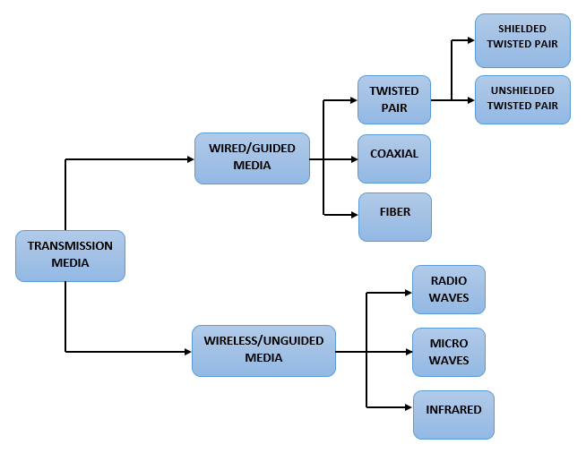The physical connections between the hardware devices on a network are referred to as transmission media. The speed at which data flows from one point to another is determined by the capabilities of various.

Media

The Guided and Unguided transmission or communication media are categorized into two types. Cables are referred to as guided media, while wireless is referred to as unguided media.

There are three types of Guided transmission. Twisted pair, Coaxial, and Fibre are the three options. Unshielded twisted pairs and shielded twisted pairs are the two types of twisted pairs.

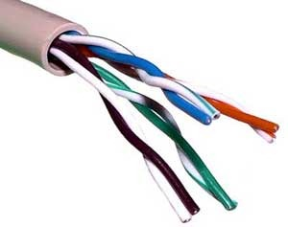Unshielded twisted pair (UTP) is made composed of two copper wires that are wrapped or insulated by a thin layer of plastic twisting that avoids interference from the wires. It's most commonly used with a rj45 connection. UTP cables are commonly used in LAN networks. They can be used for voice, low-speed data, high-speed data, audio and paging systems, and building automation and control systems. UTP cable can be used in both horizontal and backbone cabling subsystems.

*Unshielded twisted pair*

Shielded twisted pair is similar to the unshielded twisted pair except that it includes a distinct insulating material between each pair of wires, which prevents crosstalk even further. A shielded twisted pair is more expensive than an unshielded twisted pair. In some corporate installations, STP (shielded twisted pair) is a form of copper telephone and local area network (LAN) cable. It adds an outer covering or shield that serves as a ground to ordinary twisted pair wire.

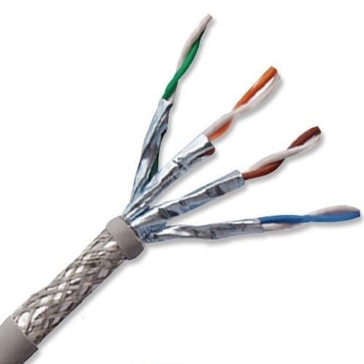

*Shielded twisted pair*

Coaxial cable has a copper center conductor that is surrounding by an insulating material called a dielectric material, which is then surrounded by an upper mesh, and everything is finally covered in a booted insulation material. Coaxial cables can support up to 500 runs and 100 nodes in a network, and they are more resistant to interfaces than twisted pair cables. For radio frequency, video, and data signals, Coaxial cables are used as transmission lines. They have traditionally been used as feed lines to connect radio transmitters and receivers with antennas, internet connections, digital audio and cable television signals.

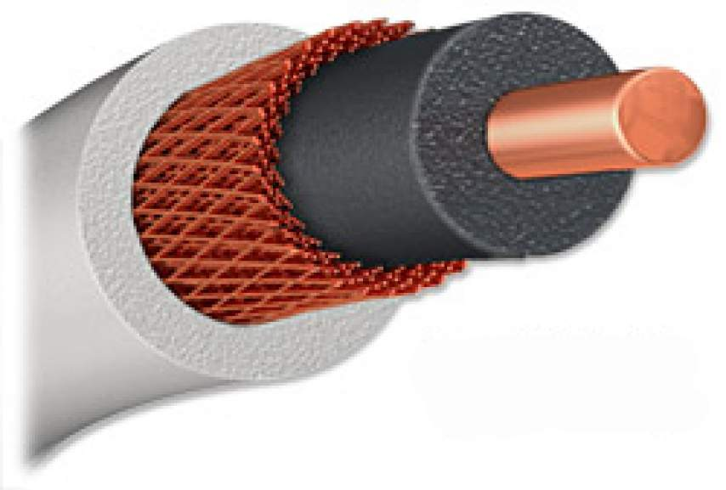

***Coaxial Cable***

Optical fiber is a type of data transmission media that uses light pulses rather than electrical impulses to transmit information. It features a small silicon core and is made of glass or plastic. The core is usually made of silicon and is surrounded in cladding, which is a light-absorbing material. Because cladding adds insulation, be careful because if the core breaks, the signal is lost.

It is more secure than the other two types of guided transmission media. Fibre optic cables are capable of transmitting massive volumes of data at extremely fast speeds.

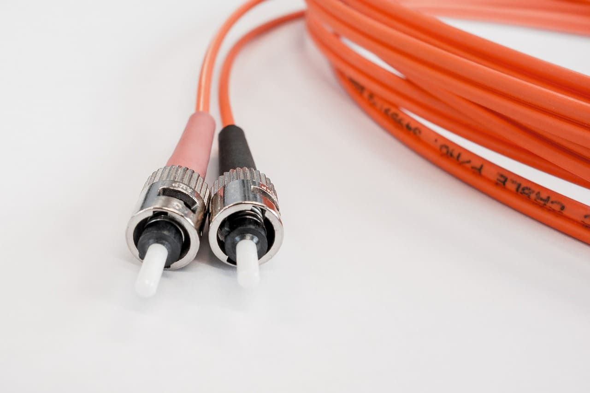

***Optical Fiber***

There are three types of Unguided transmission. Radio waves, Micro waves, and Infraded are the three options.

Radio waves are used for multicast communications such as radio and television. Radio waves are used to transmit all of these radio communications and television broadcasts. It can also pass through walls and employs omnidirectional antennas, which means that the signals are spread out in all directions and may be received by a large number of antennae. The frequency of radio waves ranges from 3 kilohertz to 1 gigahertz.

Micro waves are used in unicast communication systems such as telephones, satellites, and wireless local area networks. It has a greater frequency, and it cannot penetrate walls when it has a higher frequency. Radio waves employ omnidirectional antennas, but microwaves only use directional antennas. Point-to-point communication requires directional antennas, therefore the transmitter and receiver must be aligned.

Infrared - Line of sight propagation allows infrared signals to be used for short-range communication in a closed area. TV remotes, wireless speakers, and other items are examples. Because it only communicates within a short range, it is considered to be one of the most secure transmission media compared to the other two categories.

**4.3.1.3 Protocols**

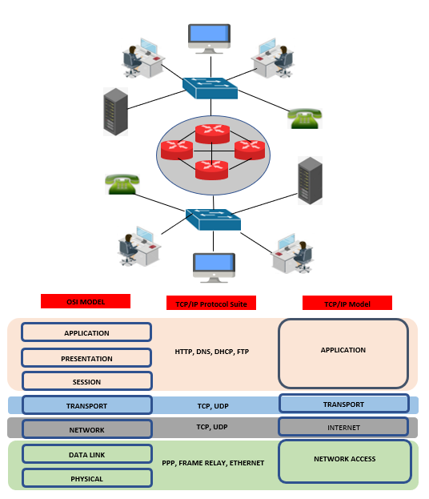

**4.3.1.4 Topology**

**WORKSTATION**

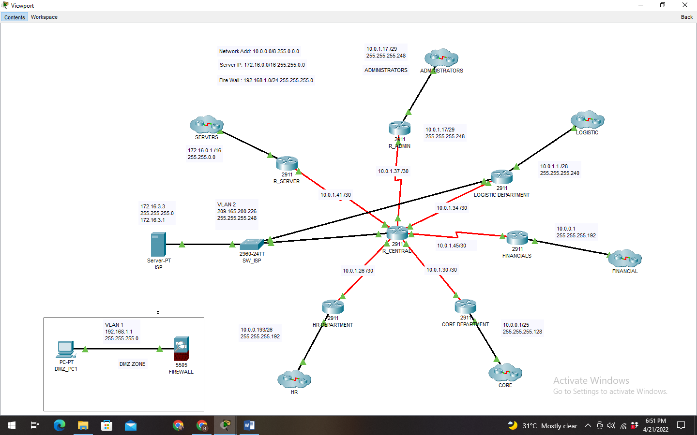

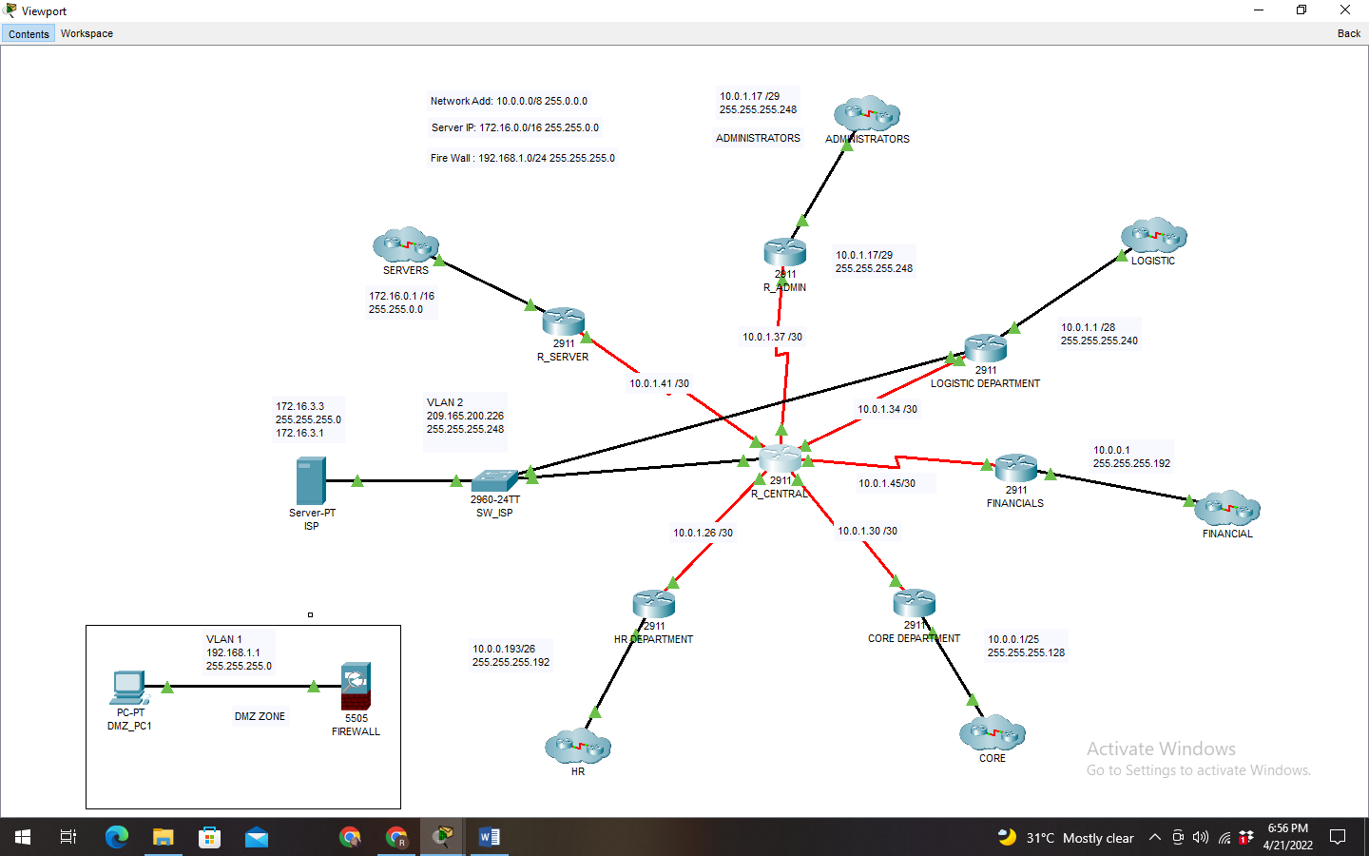

**ADMINSTRATORS CLUSTER**

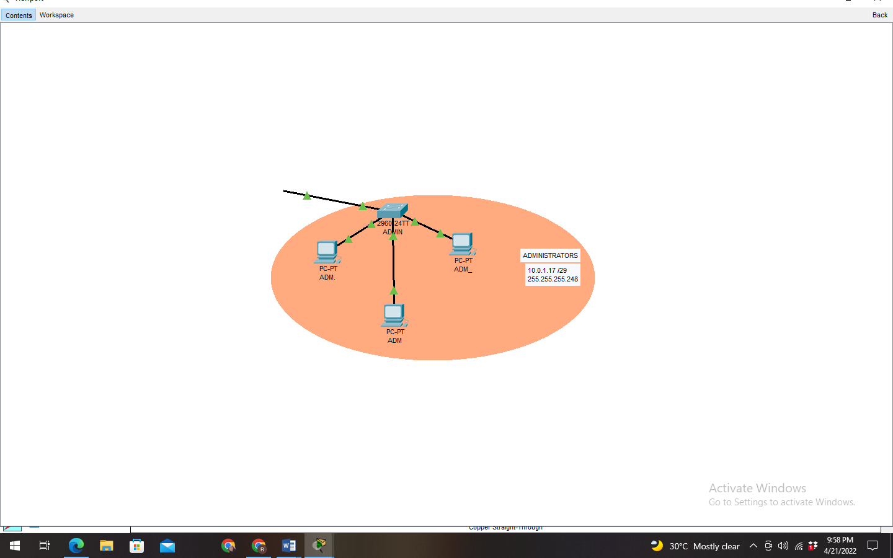

**LOGISTICS CLUSTER**

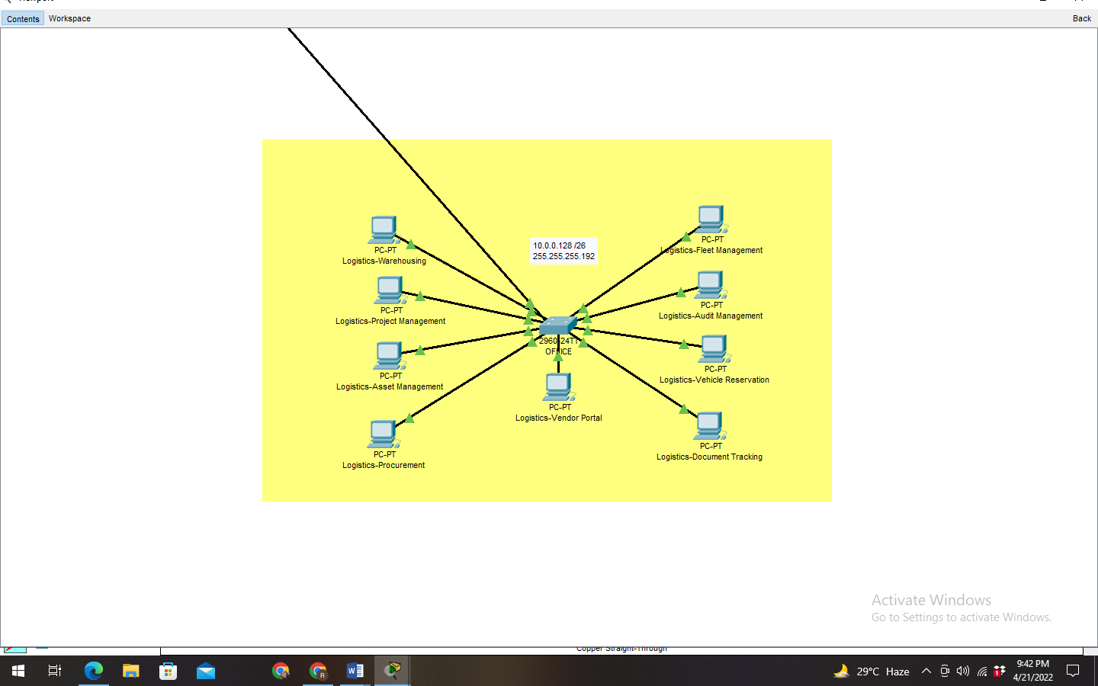

**SERVER CLUSTER**

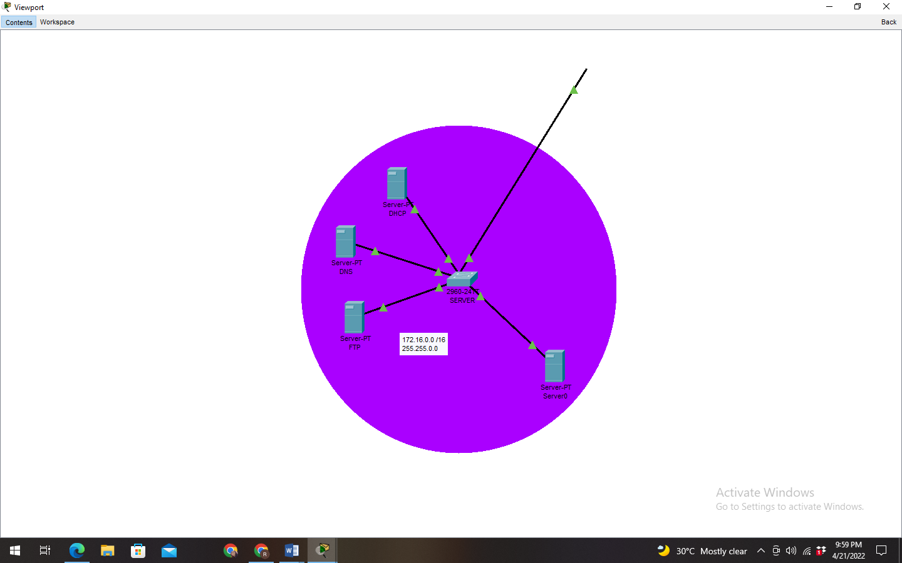

**FINANCIAL CLUSTER**

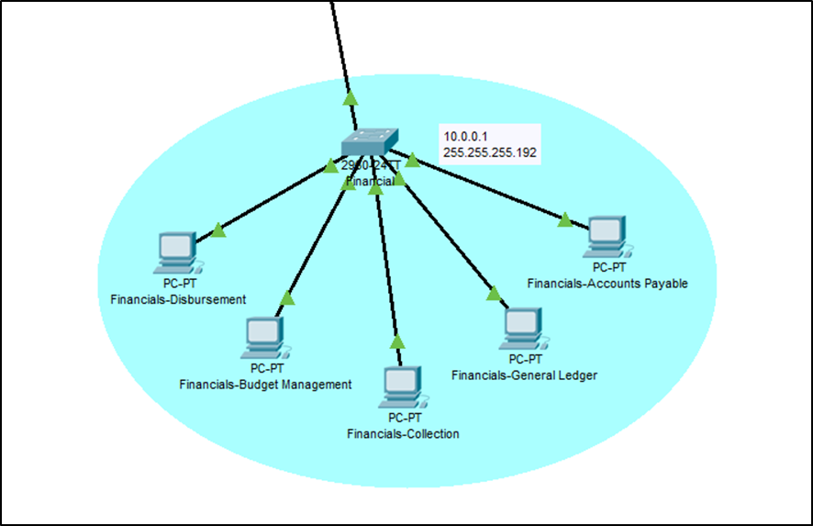

**HR CLUSTER**

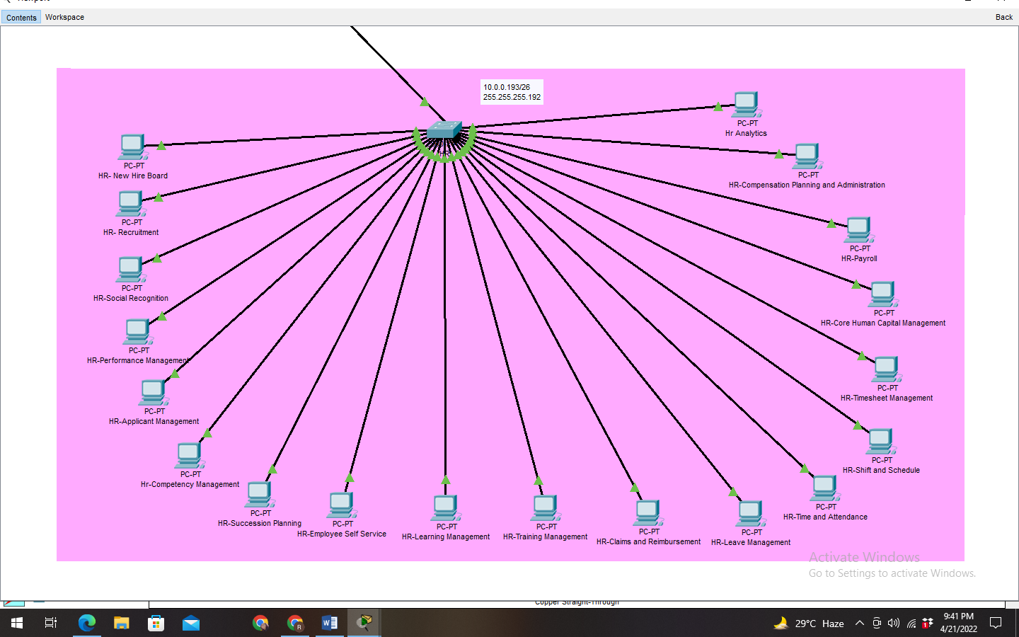

**CORE CLUSTER**

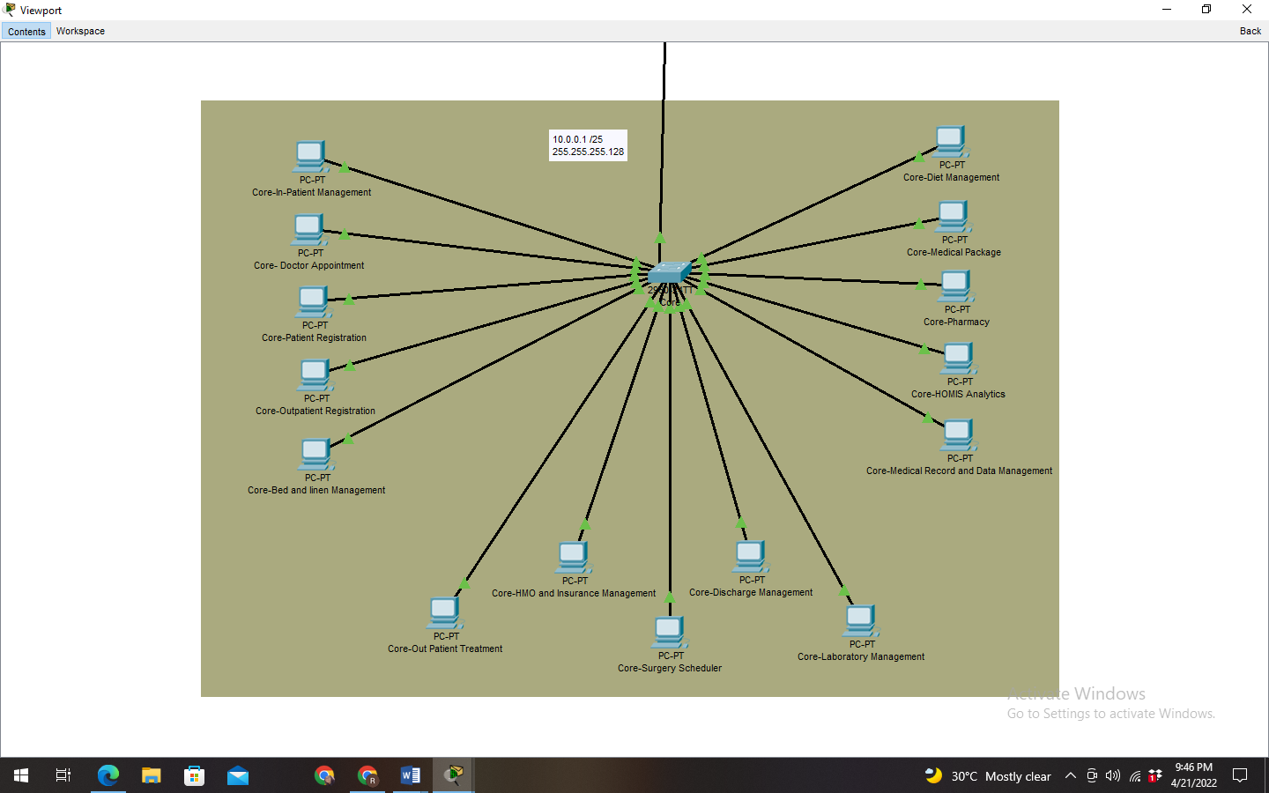

## 4.3.2 Implementation Framework

## Conclusion and Recommendation

# Appendices

## Appendix A Curriculum Vitae

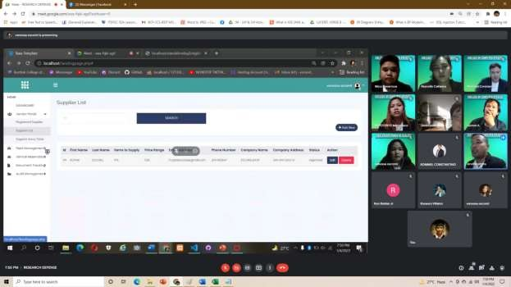

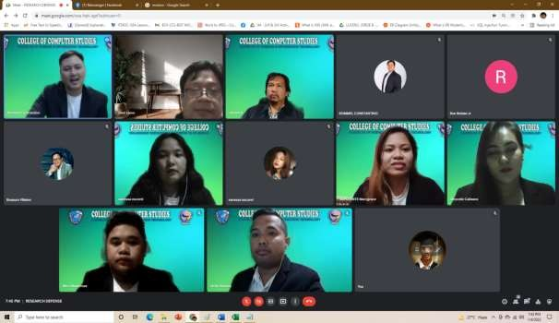

## Appendix J Photos During Authorship and Oral Evaluation