**SERVICE MANAGEMENT SYSTEM  
LOGISTIC**  
(**PROCUREMENT, WAREHOUSING, ASSET MNGT. PROJECT MNGT., VENDOR PORTAL FLEET MNGT., AUDIT MNGT. VEHICLE RESERVATION, MRO**)

A Project Study  
Presented to the IT Project Evaluation Committee  
Bestlink College of the Philippines  
Quezon City, Philippines  
in Partial Fulfillment of the Requirements for the Degree  
Bachelor of Science in Information Technology  
By

Marc Julius M. Barcinal

Romel B. Cabiling

Eunique Lambert L. Malang

Ronalyn M. Ramos

Fridalyn T. Lesigues

April 2022

**CERTIFICATE OF ORIGINALITY**

This is to certify that the research work presented in the Project Study entitled **SERVICE MANAGEMENT SYSTEM – LOGISTIC (PROCUREMENT, WAREHOUSING, ASSET MNGT. PROJECT MNGT. VENDOR PORTAL, FLEET MNGT, AUDIT MNGT, VEHICLE RESERVATION, MRO)**

For the degree Bachelor of Science in Information Technology at the Bestlink College of the Philippines embodies the result of original and scholarly work carried out by the undersigned. This Project Study does not contain words or ideas for the published sources nor written works that have been accepted as basis for the award of a degree from any higher education institution, except where proper referencing and acknowledgement were made.

Marc Julius M. Barcinal

Romel B. Cabiling

Eunique Lambert L. Malang

Ronalyn M. Ramos

Fridalyn T. Lesigues

April 2022**Abstract**

**Introduction**

In year of modernization Logistic was still in manual process based on the personnel the grouped interviewed. The process of transmitting and documenting the item in the vehicle transition was manual. In this case Logistic is not in easy way process due to some information of materials are not secured and the records are sometimes misplaced and even the redundancy if data are occurred that causes the misinterpretation of the management because before the management only uses the paper documentation which do not have a backup that if any risk problem the management will be case-hardened in assessment those records. So, the group proposed system that is reliable to make easy way on how to manage the Logistic on the company, instead of manual process. The groups developed a system which can generate reports and can save a lot of information and even track those records by using search engine references.

**Methodology**

Agile methodology enables us to do multiple tasks simultaneously and provides a strategic technique, the sprint-by-sprint cycle method, to complete the task. Agile methodology allows us to plan and arrange all of the tasks that must be completed. This strategy encouraged our team to be more accountable for completing things on schedule. This strategy enabled us to be self-sufficient in our research and provided us the confidence to present our project without fear. We have learned to work together to make our Service Management System a successful endeavor.

**Result**

As a result, the project team has successfully provided what the user’s needs to do on a daily task. The project team has set up system to provide the logistics system with the necessary and perform the daily work in Service Management. Logistic is needed to manage the services and monitor the transaction; however, this system is still underway and there are a lot of things to improve.

**Discussion**

The project team set up the system which would benefit both the Service Management System (SMS) Logistic and the Tech-Trendz Human Resource. Agile methodology helps to reduce the time required for the development phase of the project system. As a result, the development team has developed a system with user-friendly and full functionality.

# ACKNOWLEDGEMENT

The researchers would like to express their profound gratitude to the following people for their valuable contribution that helped in the completion of this study:

**Dr. Mary M. Vicente**, President of Bestlink College of the Philippines, we extend our gratitude for the guidance and for providing us with quality education.

**Dr. Charlie I. Cariño**, Executive Vice President of Bestlink College of the Philippines, we extend our gratitude for making the school a second home for students helping them to learn and gain knowledge.

**Engr. Doni T. Lleno**, Vice President for Administration, we extend our gratitude for building a strong foundation and ensuring that a school is a place for learning.

**Dr. Thelma Villaluna**, OIC for Research, Bestlink College of the Philippines, we extend our gratitude for giving us proper education to enhance our skills and helping us to become better students.

**Dr. Rosicar Escober**, Dean of College of Computer Studies Bestlink College of the Philippines, for providing us the study equipment to enhance and improve our skills for our career.

**Mr. Rommel Constantino**, Program Head of College of Computer Studies, for the constant supervision as well as providing necessary information regarding the project and also for his support in completing this Project;

**Mr. Enrico Pineda**, Capstone professor, for giving us ideas and suggestions to improve our research and sharing his experience for us to have insights to further develop our knowledge.

**Mr. Jorge Lucero**, Capstone professor, for guiding us and providing the necessary connection for those people that we need to provide all the requirements need for this project.

**Mr. Khristian Hosena**, Capstone adviser, for giving us all of his attention and guidance towards the succession of this project.

**Ms. Evelyn Herrera** Class Adviser, for her excellent advisory and giving us her time to communicate with other professors.

**Almighty God,** for everything He provided for us, giving us another day to live to enjoy life and making us safe through the pandemic and every day.

**TABLE OF CONTENT**

# Project Management

## Business Case

### Executive summary

The **Service Management System** are large modular systems that encompass all or nearly all parts of a service-oriented business. An organization must comprehend the amount of process maturity required to become a service-oriented company in order to have a service-management mindset.

**Logistics** is a detailed process of organizing and implementing an operation. When it comes to business, that process is the flow of work from the beginning to the end, in order to fulfill customer expectations as well as those of your organization. Logistic Management helps the company to reduce costs and efficiently manage customer service

#### Issue

#### Anticipated Outcomes

By utilizing the proposed project, the employment agency will be able to r have the time consumed for processing transactions reduced because of direct access to collected data, track documents, audit and manage reservations with the flick of a hand. Reports can also be generated at any time. Keeping records will no longer be overload for the employee because they will be easily accessible in the system. Using the system, transactions will be easier and workload will take less time.

#### Recommendation

### Business case analysis team

|  |  |  |
| --- | --- | --- |
| **Name** | **Role** | **Descriptions** |
| Mr. Khristian Hosena | Project  Owner | * Serves as an ultimate authority / * responsibility for the project * Provides strategic direction and * guidance * Approves changes to scope * Identifies and secures funding * Makes business / approaches * decisions for the project * Participates in key activities * Makes resources available * Approves work products, address * issues, and approve change * requests |
| Barcinal, Marc Julius | Scrum Master | * Professional in the field of project management. * Responsible for planning, procurement and execute of a project. * Undertaking that has a define start and a defined finish |
| Cabiling, Romel | Backend Developer | * Responsible for database development * Responsible for integration of the whole system |
| Malang, Eunique Lambert | System Designer / Frontend Developer | * Responsible for the designing of the UI/UX of the system * Responsible for the branding of the project |
| Ramos, Ronalyn | Frontend Developer | * Responsible for the UI/UX of the system |
| Lesigues, Fridalyn | Documentation / Frontend Developer | * Responsible for the UI/UX of the system * Responsible for the documentation of the project |

### Problem definition

#### Problem statement

#### Organizational Impact

#### Technology Migration

### Project Overview

#### Project description

#### Goals and objectives

The Developed Project directly supports several goals and objectives established by Logistics. The following table lists the business goals and objectives that the Service Management supports and how it supports them.

|  |  |
| --- | --- |
| **GOALS** | **OBJECTIVES** |
|  | * **Procurement** |
|  | * **Asset Management** |
|  | * **Project Management** |
|  | * **Vendor Portals** |
|  | * **Fleet Management** |
| To acknowledge and supervise competent admin’s according to required competencies | * **Vehicle Reservation**   To develop a system that gets valuable insight about the business and allows for maintenance scheduling |
| To recommend a new systematic approach to all users and wanted to build up a simple but a dynamic system that easy to use and understand the User Interface (UI) | * **Audit Management**   To develop a system that makes auditing easy and improves the performance and generates reports faster. |
|  |  |

#### Project performance

#### Project assumption

#### Project constraints

#### Major project milestones

### Strategic Alignment

### Cost-benefit analysis

### Approvals

## Project charter

## Stakeholder Strategy

### Introduction

### Identify stakeholders

### Key stakeholders

### Stakeholder analyst

# Project Planning

## Project management plan

### Introduction

Managing a project is no easy feat, no matter what the scale and scope are. From planning the minutia to handling the ever-changing demands of clients to shipping the deliverables on time, there’s a lot that can go wrong. When you divide the project into manageable stages, each with its own goals and deliverables, it’s easier to control the project and the quality of the output.

In a project management guide, if you are somehow in a position where you are expected to manage projects for your organization and are feeling overwhelmed, it’s better to start learning the basic stages of the project life cycle phases.

According to the PMBOK Guide (Project Management Body of Knowledge) by the Project Management Institute (PMI), a project management life cycle consists of 5 distinct phases including initiation, planning, execution, monitoring, and closure that combine to turn a project idea into a working product.

### Project management approach

### To ensure successful and timely completion of the project, the Scrum Master, *Barcinal, Marc Julius*, is hereby authorized to interface with management as needed, negotiate for resources, delegate responsibilities within the project framework, and communicate with all project team members and management as needed. The product owner will examine and approve all project and company management plans. Throughout the project, the project team will report on their progress. The Project Manager is also responsible of keeping the project team updated on their progress to the project's performance

### Project scope

**Procurement**

Is the process of purchasing goods or services and is usually in reference to business spending. Business procurement requires preparation, solicitation, and payment processing, which usually involves several areas of a company.

**Warehousing**

The item that is needed. Monitoring of items in the warehouse. List of ordered item. Trackingof item.

**Asset Management**

The item that is needed. Monitoring of items in the warehouse. List of ordered item. Trackingof item.

**Project Management**

To set a certain plan for a project Setting of schedule for the project plan. Monitored the project schedule is followed.

**Vendor Portal**

Some people call it Supplier portal; it is a web-based platform that allows you to communicate in real time with vendors and suppliers. Vendor portal search a supplier for common supply that the company needs.

**Fleet Management**

Is an administrative approach that allows companies to organized and coordinate work vehicles with the aim to improve efficiency, reduce cost. While most commonly used for vehicle tracking, fleet management includes following and recording mechanical diagnostic.

**Audit Management**

Is responsible for recording transaction and complying with internal control policies and procedures and ensuring that board-approved audit directives are implemented. It helps simplify and well-organize the work flow and collaboration process of compiling audits.

**Vehicle Reservation System**

To reserve a vehicle that the supplier picks from fleet management, and track where the vehicle goes and where is the destination.

**Maintenance Repair and Overhaul**

Have schedule maintenance to organize the task and preventive maintenance has able to monitor the mileage in order to set change oil for vehicle. System has repair history to review the previous transaction of maintenance or repair

### Milestone list

The table below lists the major milestones for the Service Management System. This chart only includes major project milestones such as project phase completion or gate review. There may be smaller milestones that are not shown on this chart but are included in the project schedule and work breakdown structure. If there are any scheduling delays that could affect a milestone or delivery date, the project manager must be notified right away so that proactive measures can be taken to mitigate date slips. The project manager will notify the project team of any approved changes to these milestones or dates.

|  |  |  |
| --- | --- | --- |
| Milestone | Description | Date |
| Requirements Gathering | All Requirements for Tech-Trendz must determine to base design upon | TBA |
| Designing | To design for the software. This the theoretical | TBA |
| Developing | All coding completed resulting in software prototype. | TBA |
| Testing and Debug | All functionally tested and all identified errors corrected | TBA |
| Transition of system | Completed software and documentation transitioned to operations group to begin production. | TBA |

### Schedule baseline and WBS

### Change management plan

### Communication Management Plan

### Cost management plan

### Procurement Management Plan

### Project scope management plan

### Schedule management plan

### Quality management plan

### Risk management plan

### Risk Register

### Staffing Management Plan

### Cost Baseline

### Quality Baseline

## Risk management plan

### Introduction

### Top three risk

### Risk management approach

### Risk identification

### Risk Qualification ad Prioritization

### Risk Monitoring

### Risk Mitigation and Avoidance

### Risk Register

## cope management plan

### Introduction

### Scope management approach

### Roles and responsibilities

### Scope definition

### Project scope statement

### WBS

### Scope verification

### Scope control

# Project Execution plan

## Implementation and migration plan

### Purpose

### Description of implementation

### Points of contact

### Major task

### Implementation Schedule

### Security

### Implementation Support

### Listing of hardware, software and facilities

### Performance Monitoring

### Implementation Requirements (Hardware/Software/ Personnel/ Facilities/ other capital investment:

### Back Out Plan

### Post Implementation Verification

# Project Closure

## Transition-out plan

### Executive Summary

### Transition Approach

### Transition Team Organization

### Work Transition

### Work Execution during Transition

### Subcontracts

### Property Transition

#### Government Furnished Equipment (GFE)

#### Incumbent Owned Equipment

#### Intellectual Property

#### User Accounts and Passwords

### Knowledge Transfer

### Schedule

### Handover and Acceptance

## Project acceptance

## Post project review

### Project Summary

#### Project Team and Staffing

#### Project Deliverable (Planned vs. Actual)

#### Transition to Operations

### Project Costs

### Project Schedule

### Recommendations

# Technical solution design

## Project Information

## Executive Summary

## Requirement Definition

## Solution Description

### Logical Architecture

### High-Level Architecture

### Process Flow

## Implementation Timeline

# System architecture

## Business Process Architecture

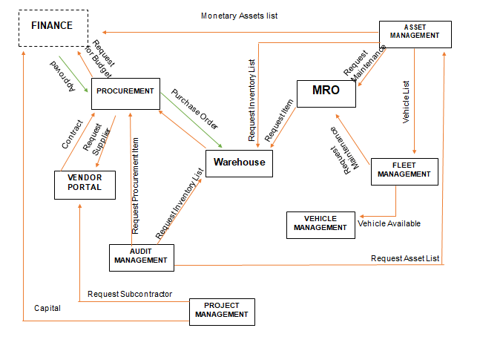*BPA Top Level 3 Figure 1.1*

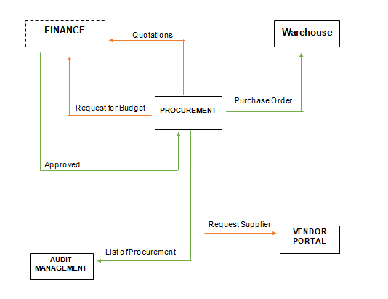

*BPA Top Level 3 Figure 1.2*

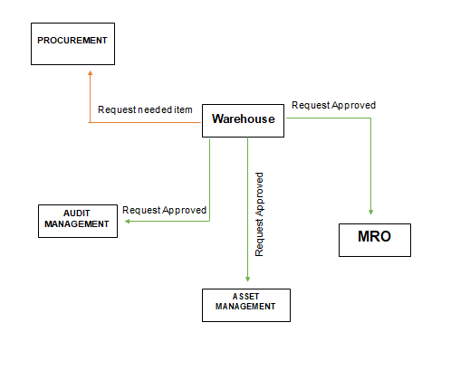

*BPA Top Level 3 Figure 1.3*

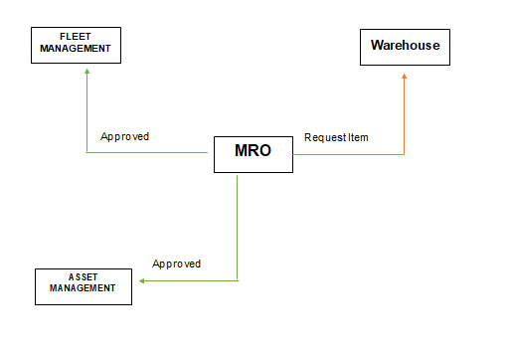

*BPA Top Level 3 Figure 1.4*

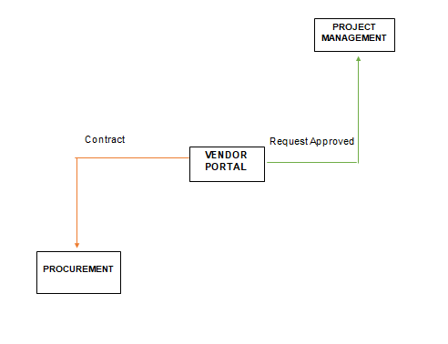

*BPA Top Level 3 Figure 1.5*

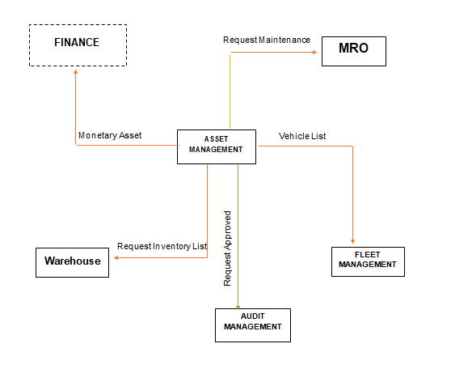

*BPA Top Level 3 Figure 1.5*

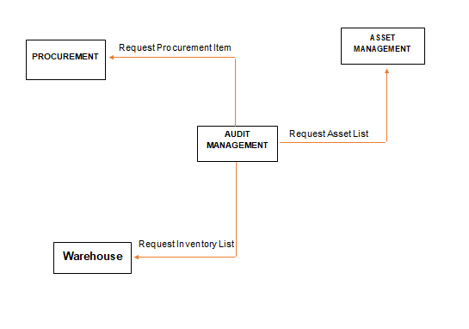

*BPA Top Level 3 Figure 1.6*

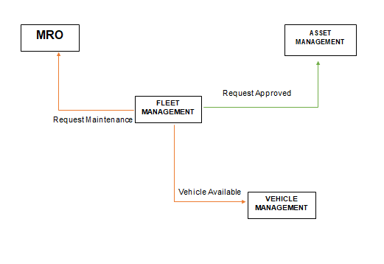

*BPA Top Level 3 Figure 1.7*

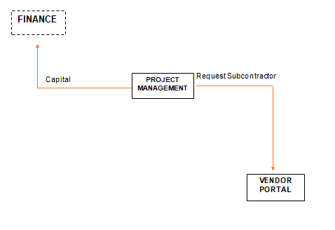

*BPA Top Level 3 Figure 1.8*

## Application Architecture

## Data Architecture

## Technology Architecture

|  |  |
| --- | --- |
| **Title** | **Description** |
| HTML 5 | * HTML, or Hypertext Markup Language, allows web users to create and structure sections, paragraphs, and links using elements, tags, and attributes |
| css3, original, wordmark, logo Icon  CSS 3 | * CSS3 is used with HTML to create and format content structure. It is responsible for colors, font properties, text alignments, background images, graphics, tables, etc. It provides the positioning of various elements with the values being fixed, absolute, and relative. |
| Web Design and Development Course : ITRA  BOOTSRAP 5 | * Bootstrap is a potent front-end framework used to create modern websites and web apps. It's open-source and free to use, yet features numerous HTML and CSS templates for UI interface elements such as buttons and forms. Bootstrap also supports JavaScript extensions. |
| Laravel - Wikipedia  LARAVEL | * Laravel is a web application framework with expressive, elegant syntax. We believe development must be an enjoyable and creative experience to be truly fulfilling. |
| Logo Mysql PNG images, Free Download - Free Transparent PNG LogosMYSQL | * MySQL is a popular database system. |
| Ubuntu icon Logo PNG Transparent & SVG Vector - Freebie Supply  UBUNTU | * Ubuntu is a Linux distribution based on Debian and composed mostly of free and open-source software. Ubuntu is officially released in three editions: Desktop, Server, and Core for Internet of things devices and robots. |
| Composer - Free brands and logotypes iconsCOMPOSER | * Composer is an application-level dependency manager for PHP. Dependency simply means libraries/packages your application depends upon. |
| Visual Studio Code | * Visual Studio Code, also commonly referred to as VS Code, is a source-code editor made by Microsoft for Windows, Linux and macOS. Features include support for debugging, syntax highlighting, intelligent code completion, snippets, code refactoring, and embedded Git. |
| GitbashUsing git commands on Windows | * Git Bash is an application for Microsoft Windows environments which provides an emulation layer for a Git command line experience. |
| PHP | * . A PHP Function feature is a piece of code that can be used over and over again and accepts argument lists as input, and returns a value. PHP comes with thousands of built-in features |
| JavaScript Logo  Javascript | * A function in JavaScript is similar to a procedure—a set of statements that performs a task or calculates a value, but for a procedure to qualify as a function, it should take some input and return an output where there is some obvious relationship between the input and the output |
| XAMPP Logo Vector (SVG, PDF, Ai, EPS, CDR) Free Download - Logowik.comXAMPP | * A special tool is provided to password-protect the most important parts of the package. XAMPP also provides support for creating and manipulating databases in MariaDB and SQLite among others. |
| Application server Computer Icons Web application Computer Servers, world  wide web, text, logo, web Application png | PNGWingAPACHE | * Apache is responsible for accepting directory (HTTP) requests from Internet users and sending them their desired information in the form of files and Web pages. |
| .TTECH domains | GitHub Student Developer PackECH | * tech is a generic top-level domain (gTLD) of the Domain Name System (DNS) used in the Internet. The name is truncated from technology. |
| Let’s Encrypt | * Let's Encrypt is an open and automated certificate authority that uses the ACME (Automatic Certificate Management Environment) protocol to provide free TLS/SSL certificates to any compatible client. These certificates can be used to encrypt communication between your web server and your users. |
| Digital Ocean | * Digital Ocean, Inc. is an American cloud infrastructure provider organization. |
| NGINX | * NGINX is open source software for web serving, reverse proxying, caching, load balancing, media streaming, and more. It started out as a web server designed for maximum performance and stability. |
| Laratrust - Roles & Permission Management - Made with LaravelLARATRUST | * "Laratrust is an easy and flexible way to add roles, permissions and team’s authorization to Laravel." |
| GITHUB | * GitHub, Inc. is a provider of Internet hosting for software development and version control using Git. |

# Product Backlog

## Product backlog (user stories) Table

|  |  |  |  |
| --- | --- | --- | --- |
| **User Story No.** | **User Stories** | **User Stories Priorities** | **Status** |
| **Procurement** | | | |
| 1 | As a logistic manager, I want to have an access to procurement department  *Integrate procurement dashboard to logistic manager panel* | 1 | On-Going |
| 2 | As a logistic manager. I want to view a list of suppliers  *Create a table list of supplier* | 2 | On-Going |
| 3 | As a logistic manager, I want to create an account for procurement officer.  *Add create account function to logistic manager panel.* | 3 | On-Going |
| 4 | As a procurement officer, I want to have a list of suppliers.  *Create a list of suppliers* | 4 | On-Going |
| 5 | As a procurement officer, I want to have a purchase order form to create a purchase order.  *Create a form for purchase order.* | 5 | On- Going |
|  | As a procurement officer, I want to see the list of procured items  *Create a list of procured items.* |  | On- Going |
| 6 | As a procurement officer, I want to view procurement requests from other departments.  *Create a request list.* |  | On-Going |
| **Warehousing** | | | |
| 7 | As a logistic manager, I want to have an access to warehousing department  *Integrate Warehousing dashboard to admin panel* | 1 | On-Going |
| 8 | As a logistic manager. I want to view the entire inventory  *Create an inventory function* | 2 | On-Going |
| 9 | As a logistic manager, I want to create an account for warehousing officer.  *Add create account function to logistic manager panel.* | 3 | On-Going |
| 10 | As a warehousing officer, I want to view the entire inventory  *Create an inventory function* |  | On-Going |
| 11 | As a warehousing officer, I want to send a request for supplies to procurement department  *Create a request function* |  | On-Going |
| 12 | As a warehousing officer, I want to have a stock number or code for each item  *Create an unique code for each item* | 5 | On-Going |
| **Asset Management** | | | |
| 13 | As a logistic manager, I want to have an access to Asset Mgmt. department  *Integrate Asset Mgmt. dashboard to admin panel* | 1 | On-Going |
| 14 | As a logistic manager. I want to view a list of assets  *Create a table list of assets* | 2 | On-Going |
| 15 | As a logistic manager, I want to create an account for Asset Mgmt. officer.  *Add create account function to logistic manager panel.* | 3 | On-Going |
| 16 | As an Asset Mgmt. officer, I want to have a list of all assets in the company.  *Create a table listing for all asset* | 4 | On-Going |
| 17 | As an Asset Mgmt. officer, I want to add new asset in the table  *Create a add asset function* | 5 | On-Going |
| **Project Management** | | | |
| 18 | As a logistic manager, I want to have an access to Project Mgmt. department  *Integrate Project Mgmt. dashboard to admin panel* | 1 | On-Going |
| 19 | As a logistic manager, I want to view a list of projects  *Create a table list of projects* | 2 | On-Going |
| 20 | As a logistic manager, I want to create an account for Project Mgmt. officer.  *Add create account function to logistic manager panel.* | 3 | On-Going |
|  | As a project management officer, I want to view a list of projects  *Create a table list of projects* |  | On- Going |
|  | As a project management officer, I want to see the status of our projects  *Create a status report for project list* |  |  |
| **Vendor Portal** | | | |
| 21 | As a logistic manager, I want to have an access to Vendor Portal Mgmt. department  *Integrate Vendor Portal Management dashboard to admin panel* | 1 | On-Going |
| 22 | As a logistic manager, I want to view a list of posted ads  *Create a table list of posted ads* | 2 | On-Going |
| 23 | As a logistic manager, I want to create an account for Vendor Portal Mgmt. officer.  *Add create account function to logistic manager panel.* | 3 | On-Going |
| 24 | As a vendor portal officer, I want to view a list of posted ads.  *Create a list of posted ads* | 4 | On-Going |
| 25 | As a vendor portal officer, I want to post a listing for finding the supplier  *Create a posting function for ad listing* | 4 | On-Going |
| **Fleet Management** | | | |
| 26 | As a logistic manager, I want to have an access to Fleet Mgmt. department  *Integrate Fleet Mgmt. dashboard to admin panel* | 1 | On-Going |
| 27 | As a logistic manager. I want to view a list of scheduled deliveries  *Create a table list of scheduled deliveries* | 2 | On-Going |
| 28 | As a logistic manager, I want to create an account for Fleet Mgmt. officer.  *Add create account function to logistic manager panel.* | 3 | On-Going |
| 29 | As a Fleet Mgmt. officer, I want to have a list of current deliveries  *Create a table listing for current delivery* | 4 | On-Going |
| 30 | As a Fleet Mgmt. officer, I want to have an access to past deliveries  *Create a table for past deliveries* | 5 | On-Going |
| **Audit Management** | | | |
| 31 | As a logistic manager, I want to have an access to Audit Mgmt. department  *Integrate Audit Mgmt. dashboard to admin panel* | 1 | On-Going |
| 32 | As a logistic manager. I want to view a list of all assets  *Create a table list of assets* | 2 | On-Going |
| 33 | As a logistic manager, I want to create an account for Audit Mgmt. officer.  *Add create account function to logistic manager panel.* | 3 | On-Going |
| 34 | As an Audit Mgmt. officer, I want a list of all assets in the company  *Create a table for listing all of the assets* | 4 | On-Going |
| 35 | As an Audit Mgmt. Staff, I want to view the current value of an asset in the company  *Include the current value of the asset in the table* | 5 | On- Going |
| **Vehicle Reservation** | | | |
| 36 | As a logistic manager, I want to have an access to Vehicle Reservation Mgmt. department  *Integrate Vehicle Reservation Mgmt. dashboard to admin panel* | 1 | On-Going |
| 37 | As a logistic manager. I want to view a list of all available vehicle  *Create a table list of available vehicle* | 2 | On-Going |
| 38 | As a logistic manager, I want to create an account for Vehicle Reservation Mgmt. officer.  *Add create account function to logistic manager panel.* | 3 | On-Going |
| 39 | As a Vehicle Reservation officer, I want to have a list of request  *Create a table list of all request* | 4 | On-Going |
| 40 | As a Vehicle Reservation officer, I want to approve or decline request  *Create a function for approve or decline request* | 5 | On-Going |
| 41 | As a logistic manager, I want to know the status of the vehicles  *Create a simulcast status report for vehicles* | 3 | On-Going |
| 42 | As a Vehicle Reservation officer, I want to set a reservation of vehicle  *Create a function for vehicle reservation* | 4 | On-Going |
| 43 | As a Vehicle Reservation officer, I want a list of reserved vehicle  *Create a table listing for reserved vehicle* | 4 | On-Going |
| **Maintenance, Repair and Overhaul (MRO)** | | | |
| 44 | As a logistic manager, I want to have an access to MRO. department  *Integrate MRO. dashboard to admin panel* | 1 | On-Going |
| 45 | As a logistic manager. I want to view a list of all damaged assets  *Create a table list of damaged assets* | 2 | On-Going |
| 46 | As a logistic manager, I want to create an account for Vehicle Reservation Mgmt. officer.  *Add create account function to logistic manager panel.* | 3 | On-Going |
| 47 | As an MRO officer, I want to status of damaged assets  *Create a status report for damaged assets* | 4 | On-Going |
| 48 | As an MRO officer, I want have a list of damaged assets  *Create a table list of damaged assets* | 5 | On-Going |

## Product Backlog for EIS Information Security

|  |  |  |  |
| --- | --- | --- | --- |
| **User Story No.** | **User Stories** | **User Stories Priority** | **Status** |
| 1 | As a product owner, I want a secured domain  *Create a domain with SSL certificate* | 1 | On-Going |
| 2 | As a product owner, I want a login form so that the user has need an account to access the system | 1 | On-Going |
| 3 | As a product owner, I want an access to all department  *Give admin privilege*  *To the owner* | 1 | On-Going |
| 4 | As a product owner, I want to have a secured database.  *Secured a database with strong encryption* | 1 | On-Going |

## Product Backlog for EIS Standards

|  |  |  |  |
| --- | --- | --- | --- |
| **User Story No.** | **User Stories** | **User Stories Priority** | **Status** |
| 1 | As a logistic manager, I want to create a user for specific department  *Add a create user for specific department* | 1 | On-Going |
| 2 | As a Logistic admin, I want to have a list of document  *Create a list for all documents* | 1 | On-Going |
| 3 | As a product owner, I want an access to all department  *Give admin privilege*  *To the owner* | 1 | On-Going |
| 4 | As a product owner, I want to have an access to all delete/archive files and document  *Create a features to view all deleted and archived files and document* | 5 | On-Going |

## UI/UX (Icons, color, etc.)

|  |  |  |
| --- | --- | --- |
| **UI** | **Icons** | **Descriptions** |
| Buttons |  | Design for all button |
| Icons |  | Design for Icons |
| Forms |  | Form Design |
| Dropdown |  | Dropdown design |
| Charts |  | Charts Design |
| Tables |  | Design for tables |
| Colors Scheme |  | Color Scheme |

## Product Backlog for integration

|  |  |  |  |
| --- | --- | --- | --- |
| **User Story No.** | **User Stories** | **User Stories Priority** | **Status** |
| 1 | As a product owner, I want a single domain for all subsystems  *Create a single domain for all subsystem* | 1 | On-Going |
| 2 | As a product owner, I want a login that can access all of subsystem  *Create a super admin account* | 1 | On-Going |
| 3 | As a product owner, I want an access to all department  *Give admin privilege*  *To the owner* | 1 | On-Going |
| 4 | As a logistic manager, I want to access connected subsystem.  *Connect logistic subsystem to other subsystems* | 1 | On-Going |

## Product Backlog for analytics

## Application System Analytics

## EIS Analytics

# Sprint backlog

## Sprint backlog table

### User stories

### Information security

### EIS standard

### EIS integration

### Analytics

## Sprint Burndown Chart

### Sprint Backlog

# EIS Implementation Model

## Information and Data Management

### Data Integration Model

### Data Migration Strategies

#### Planning

#### Data Profiling

#### Data Backup

#### Migration Design

#### Execution

#### Testing

#### Post-Migration Audit

### Data Analytics (Business Intelligence Framework)

### Privacy and Security

### Backup, Retention, and Disposal

## Information Security

### Physical Security

#### Administrative Security Controls

##### Personnel Security

##### Account Management

#### It and Security Policy

#### Technical Security Controls

##### It Infrastructure Security

##### Software Security Management

##### Cloud Security

##### Cybersecurity

#### Network Security

#### Firewall Management

#### Network Devices Security

#### Software Patch Management

#### Malware Protection

## Network Design and implementation Model

### Design Architecture

#### Hardware

#### Transmission Media

#### Protocols

#### Topology

### implementation Framework

# Conclusion and Recommendations

# Appendices:

## Appendix A Detailed System Architecture/ Reference requirements

### A.1 Business Process Architecture (Business Process Model)

### A.2 Application Architecture

#### A.2.1 UML- Use Case Diagram

#### A.2.2 UML- Detailed Diagrams

#### A.2.3 UI Navigation Diagram

#### A.2.4 UIs (Design Layout)

### A.3 Data Architecture

#### A.3.1 ERD

#### A.3.2 Class Diagram

#### A.3.3 Data Dictionary

### A.4 Technology Architecture

# Appendix B Deployment Diagram

# Appendix C Adviser Acceptance (Functional)

# Appendix D Sprint Burndown Charts (per sprint) Signed by the adviser

# Appendix D.1 Individual burndown charts per member

# Appendix B Deployment Diagram

# Appendix E Requirements Traceability Matrix (PB, Test Scenarios, status

# Appendix F Panel Evaluation and Signature (Plus photo ops during defense)

# Appendix G Pilot Companies Background with proofs of interviews

# Appendix H USB Copy of the codes (reliable USB)

# Appendix I IMRAD Format Summary

# Appendix J Comparison of the EIS to existing EIS’s (5 Pages)

# Appendix K Operation Manual (10 Pages max, 5 Pages min)