Blockchain Basics: A Comprehensive Guide

By Aftab Alam

## Chapter 1: Introduction to Blockchain and Bitcoin

### What is Blockchain?

Blockchain is a revolutionary technology that enables peer-to-peer transfer of digital assets without the need for intermediaries. Initially created to support Bitcoin, blockchain has evolved to become a foundational technology for numerous industries, including finance, healthcare, supply chain, and governance. It provides a decentralized, immutable, and secure system for recording transactions and enforcing digital trust.

### Why Does Blockchain Matter?

Unlike traditional centralized systems that rely on intermediaries such as banks, payment processors, and regulators, blockchain allows direct transactions between peers. This decentralization reduces costs, increases efficiency, and enhances security by removing single points of failure.

Blockchain has the potential to create an inclusive (wide ranging) economy, allowing individuals worldwide to participate in financial systems, governance, and secure transactions without reliance on traditional institutions.

### The Genesis of Bitcoin

Blockchain first emerged as the underlying technology for Bitcoin, a digital currency introduced by the pseudonymous Satoshi Nakamoto in 2008. Bitcoin was designed as a decentralized alternative to traditional financial systems, allowing peer-to-peer value transfer without the need for a central authority.

Bitcoin revolutionized the financial world by offering:

* A continuously operating digital currency system.
* A decentralized application model based on blockchain.
* A trustless system where security and verification are maintained through cryptographic methods rather than intermediaries.

### Trust and Security in a Decentralized System

With no central authority governing transactions, blockchain ensures trust and security through a combination of cryptographic techniques and consensus mechanisms. Key components include:

* **Validation & Verification:** Transactions are checked for authenticity before being recorded.
* **Consensus Protocols:** A decentralized network agrees on the validity of transactions.
* **Immutable Ledger:** Once recorded, transactions cannot be altered or deleted.
* **Distributed Nature:** Copies of the ledger exist across multiple nodes, preventing a single point of failure.

### Centralized vs. Decentralized Networks

In traditional financial systems, transactions involve multiple intermediaries such as banks, credit card companies, and payment processors. Each intermediary adds complexity, cost, and potential security risks.

In contrast, a decentralized network allows direct transactions between participants. Trust is established through distributed ledger technology, consensus mechanisms, and cryptographic validation rather than reliance on a single entity.

### How Blockchain Works

To illustrate blockchain’s core principles, consider a simple transaction:

* Alice lends Bob $10,000.
* They both record the transaction in a ledger.
* If Alice tries to alter the record, Bob can dispute it.
* To ensure trust, multiple independent validators (nodes) keep a copy of the ledger.
* If Alice tries to tamper with the data, the majority consensus will reject the fraudulent change.

This process forms the foundation of blockchain technology, ensuring transparency, security, and immutability in digital transactions.

### Blockchain Structure

#### The Anatomy of a Blockchain

A blockchain is composed of a series of interconnected blocks, each containing multiple transactions. The structure consists of:

* **Transactions**: Basic units of data that record value transfers.

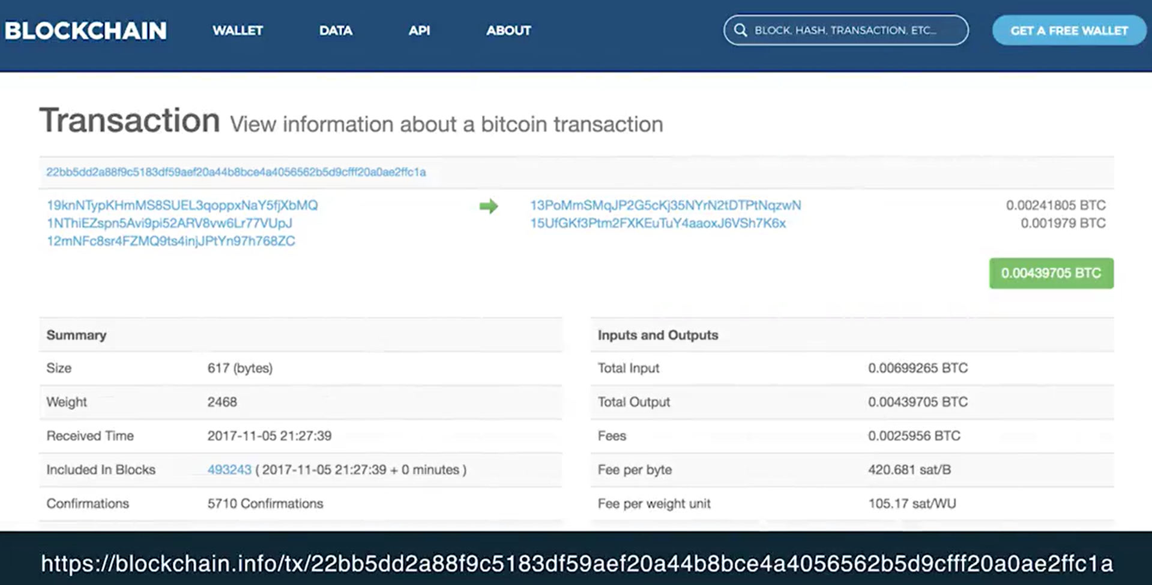

Output UTXOs

Input UTXOs

* **Blocks**: Collections of validated transactions.

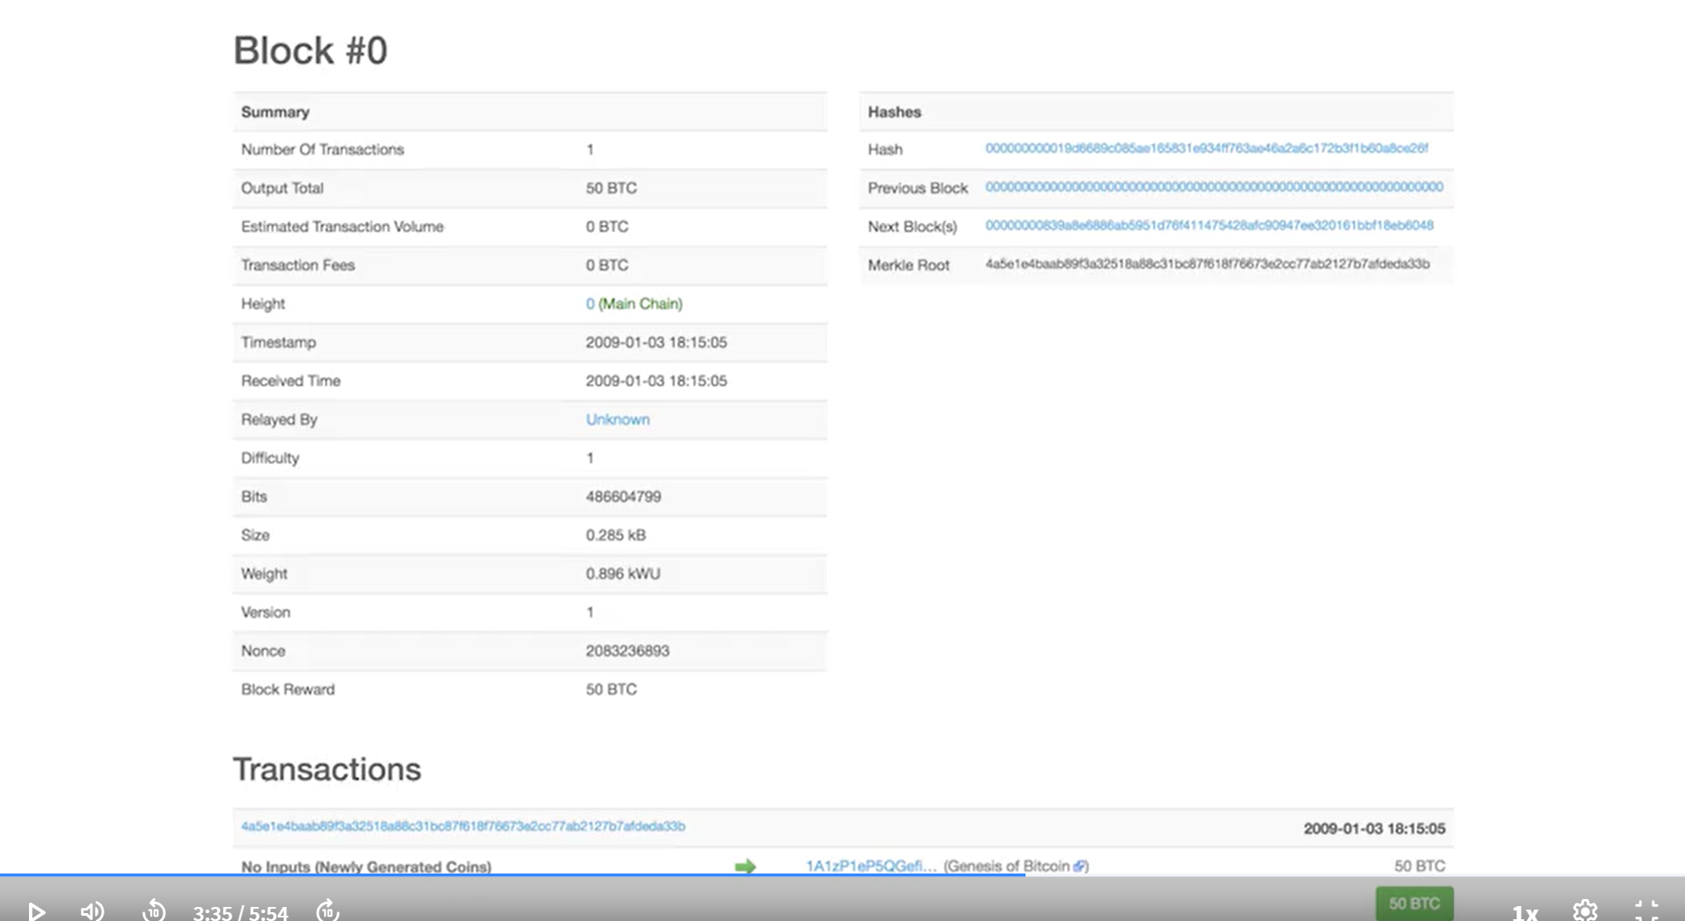

* **Chains**: Blocks are linked together through cryptographic hashes, forming a secure and immutable chain.

Each block undergoes a consensus process to ensure only valid transactions are added to the blockchain.

#### Unspent Transaction Output (UTXO) Model in Bitcoin

Bitcoin transactions follow the UTXO model, where:

* Every transaction consumes previously unspent outputs.
* Each transaction creates new unspent outputs.
* The blockchain maintains a record of all UTXOs, ensuring accurate account balances.

The UTXO model ensures that Bitcoin transactions are secure, verifiable, and resistant to double-spending.

#### How Transactions Work in Bitcoin

A Bitcoin transaction includes:

* **Transaction ID:** Unique identifier.
* **Inputs**: References to UTXOs being spent.
* **Outputs**: Newly generated UTXOs for recipients.
* **Amount**: Total value transferred.
* **Scripts**: Conditions under which the output can be spent.

Before confirming a transaction, Bitcoin nodes verify that:

1. The referenced UTXOs exist.
2. The transaction is correctly formatted.
3. The total input matches or exceeds the output.
4. The transaction follows network consensus rules.

#### Blocks and Consensus

Each block consists of:

* A **Block** **Header** containing metadata.
* A **Set of Transactions** validated by network participants.
* A **Previous Block Hash** linking it to the chain.
* A **Nonce**, a variable used in the Proof-of-Work consensus mechanism.

New transactions are grouped into blocks, validated, and added to the blockchain through a consensus protocol.

### Basic Operations in Blockchain

#### Roles in a Blockchain Network

Blockchain participants play different roles:

* **Users**: Initiate transactions.
* **Miners**: Validate transactions, solve cryptographic puzzles, and propose new blocks.
* **Nodes**: Store and propagate blockchain data.

#### Transaction Validation

Miners perform validation using more than 20 criteria, including:

* Checking if input UTXOs are unspent.
* Ensuring output amounts are correct.
* Verifying digital signatures.

Invalid transactions are rejected and not broadcast to the network.

#### Block Creation & Consensus

Miners compete to solve a computational puzzle (Proof-of-Work). The first miner to find a valid solution broadcasts the block, and nodes validate it. If the majority agree, the block is added to the blockchain.

The first transaction in a new block is called the **coinbase** transaction, which rewards miners with newly minted Bitcoin (currently 12.5 BTC). This is how new Bitcoin enters circulation.

### Beyond Bitcoin – Evolution of Blockchain

Bitcoin’s blockchain was the first major application of decentralized ledger technology. However, it has since evolved into more sophisticated systems like Ethereum, which introduced smart contracts—self-executing code that enables complex business logic on the blockchain.

#### Types of Blockchain Networks

* **Public Blockchains:** Open to anyone (e.g., Bitcoin, Ethereum).
* **Private Blockchains:** Restricted to authorized participants (e.g., enterprise solutions).
* **Permissioned Blockchains:** Governed by consortiums (groups) with specific access rules (e.g., Hyperledger Fabric).

#### Smart Contracts and Decentralized Applications (DApps)

Ethereum introduced smart contracts, which are pieces of code stored on the blockchain that execute automatically when predefined conditions are met. This allows for:

* Automated Transactions
* Decentralized Finance (DeFi) Applications
* Tokenized Assets and NFTs

#### The Future of Blockchain

As blockchain technology continues to develop, it is shaping the foundation of Web 3.0, a decentralized internet where users have control over their data, identities, and digital assets.

The innovation of blockchain extends beyond financial applications, paving the way for decentralized governance, secure identity management, and transparent public records.

## Chapter 2: Ethereum and Smart Contracts

### The Evolution from Bitcoin to Ethereum

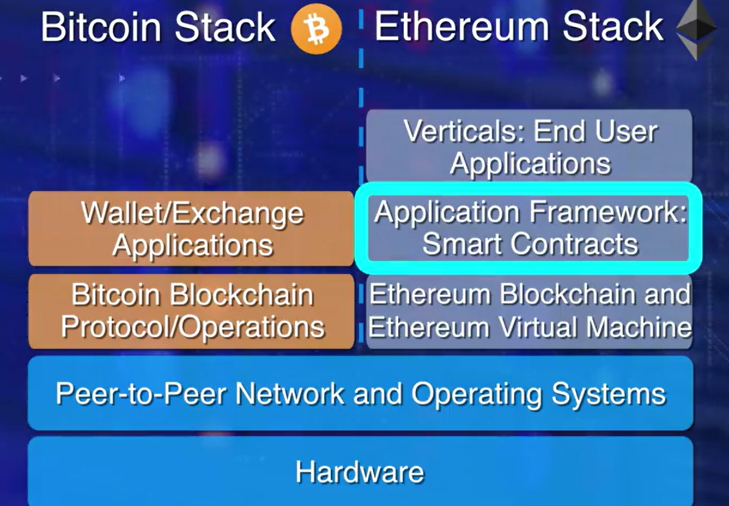Bitcoin revolutionized digital currency by introducing a decentralized, trustless, and immutable financial network. However, its primary function remains limited to peer-to-peer value transfer. Recognizing the potential for more advanced use cases, Ethereum emerged in 2013, introducing a fundamental innovation—smart contracts. Unlike Bitcoin’s blockchain, which only processes transactions, Ethereum is a programmable blockchain that enables developers to build and deploy decentralized applications (DApps) through smart contracts.

Ethereum’s blockchain extended the capabilities of Bitcoin by incorporating a Turing-complete programming language that allows complex logic execution within the network. This evolution opened up new possibilities beyond simple value transfers, enabling automated, self-executing agreements that run exactly as programmed without intermediaries.

### What is a Smart Contract?

A smart contract is a self-executing code stored on the blockchain that automatically enforces and executes an agreement’s terms when predefined conditions are met. Unlike traditional contracts, which require third-party enforcement (lawyers, courts, or arbitrators), smart contracts operate autonomously, ensuring trust, security, and efficiency.

Key Properties of Smart Contracts:

* **Immutable**: Once deployed on the blockchain, a smart contract’s code cannot be altered.
* **Distributed**: Executed on multiple nodes, making them resistant to single points of failure.
* **Transparent**: The contract’s code and execution results are visible to all participants.
* **Self-executing**: Transactions automatically execute when conditions are met, reducing the need for intermediaries.
* **Secure**: Protected by cryptographic techniques, minimizing fraud and tampering.

**Example Solidity Code:**

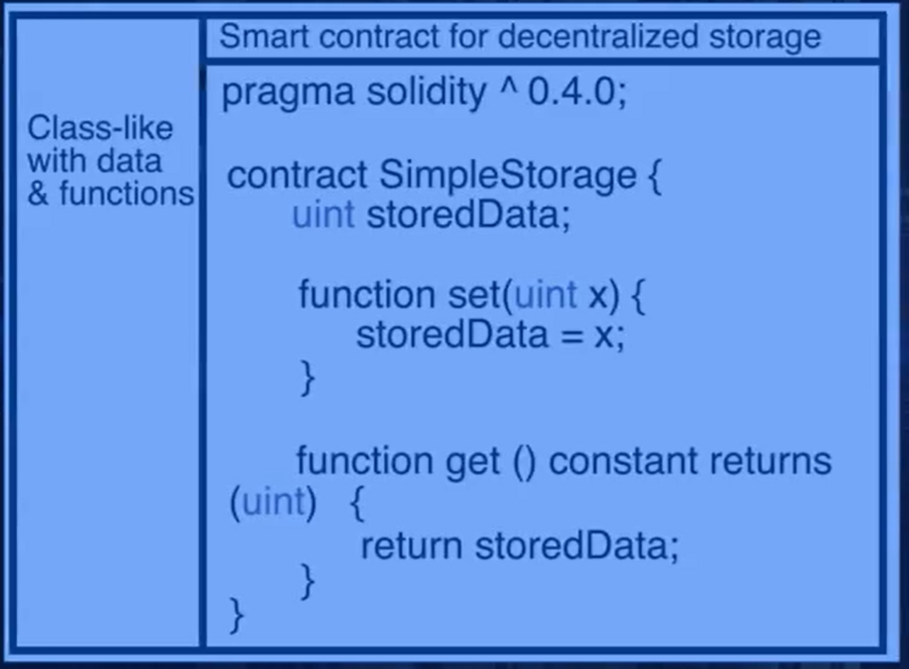

How Smart Contracts Work

* A smart contract operates within the Ethereum network as follows:
  + A developer writes a smart contract using Solidity, Ethereum’s primary programming language.
  + The contract is compiled into bytecode and deployed on the Ethereum blockchain.
  + Once deployed, it resides on Ethereum’s Ethereum Virtual Machine (EVM) and is assigned a unique address.
  + Users interact with the contract by sending transactions containing data (such as payments, conditions, or function calls).
  + The EVM processes and executes the contract’s functions based on predefined logic.

For example, a smart contract for an auction could include logic such as:

* Accept bids only if the bidder is above a certain age.
* Automatically transfer the asset to the highest bidder when the auction ends.
* Refund unsuccessful bidders without manual intervention.

### Ethereum Virtual Machine (EVM)

Since each node has to execute the contract. Each node requires computational resource that could execute the contract irrespective of the underlying hardware or OS. Ethereum’s ability to execute smart contracts stems from the Ethereum Virtual Machine (EVM)—a decentralized computing environment embedded within every Ethereum node. The EVM allows Ethereum to function as a world computer, where smart contracts execute in a consistent and deterministic manner, regardless of the underlying hardware or operating system.

Key Features of the EVM:

* **Universal Execution:** Ensures smart contracts execute identically on all nodes.
* **Bytecode Processing:** Translates Solidity code into low-level instructions that the EVM can interpret.
* **Gas System:** Implements computational cost limits to prevent spam and ensure network efficiency.

### Ethereum Account Model vs. Bitcoin UTXO Model

Ethereum’s blockchain operates differently from Bitcoin’s Unspent Transaction Output (UTXO) model. Bitcoin transactions consume previous outputs and create new outputs, ensuring no double-spending occurs. In contrast, Ethereum introduces accounts, simplifying transaction processing and enabling direct state modifications.

Ethereum features two types of accounts:

* **Externally Owned Accounts (EOA)** – Controlled by private keys, used by individuals to send transactions.
* **Contract Accounts (CA)** – Smart contract addresses that execute code when triggered by an EOA.

Every account holds an Ether balance and can interact with smart contracts, making Ethereum highly versatile for decentralized applications.

### Gas and Transaction Fees

Executing smart contracts and transactions on Ethereum requires computational resources, paid for using Gas. Gas serves as a pricing mechanism to allocate processing power fairly and prevent spam transactions.

**How Gas Works:**

* Every operation (e.g., computations, storage updates) consumes a set amount of Gas.
* Users specify a Gas limit (maximum they are willing to pay) and a Gas price (price per unit of Gas in Ether).
* Miners prioritize transactions with higher Gas fees, ensuring a competitive and efficient network.

A simple Ether transfer requires 21,000 Gas, while complex smart contract executions may require significantly more.

### Smart Contract Use Cases

Ethereum’s smart contracts enable a vast range of applications beyond simple financial transactions. Some key use cases include:

#### Decentralized Finance (DeFi)

* **Lending & Borrowing:** Smart contracts facilitate trustless lending platforms (e.g., Aave, Compound).
* **Decentralized Exchanges (DEXs):** Users trade assets without intermediaries (e.g., Uniswap, SushiSwap).
* **Stablecoins:** Smart contracts maintain price stability for digital currencies (e.g., DAI, USDC).

#### Non-Fungible Tokens (NFTs)

* Smart contracts enable unique digital assets, revolutionizing art, gaming, and digital ownership (e.g., OpenSea, Axie Infinity).

#### Supply Chain Management

* Ensures product authenticity and traceability using transparent and immutable records.

#### Decentralized Autonomous Organizations (DAOs)

* Blockchain-based governance models where smart contracts enforce decision-making rules.

#### Identity & Credential Verification

* Self-sovereign identities stored on the blockchain eliminate reliance on centralized entities.

### Challenges and Future Developments

Despite Ethereum’s innovation, smart contracts and the Ethereum network face several challenges:

#### Scalability Issues

* **High Gas Fees:** Network congestion causes transaction fees to rise.
* **Throughput Limitations:** Ethereum processes around 15 transactions per second (TPS), far below centralized systems like Visa.
* **Solutions**: Ethereum 2.0, Layer 2 scaling (e.g., Optimistic Rollups, zk-Rollups), and sharding aim to improve scalability.

#### Security Risks

* **Smart Contract Vulnerabilities:** Bugs and exploits (e.g., The DAO hack) highlight the need for rigorous audits.
* **Solution**: Formal verification and improved programming best practices.

#### Privacy Concerns

* **Transparent Transactions:** All smart contract executions are public.
* **Solution**: Privacy-enhancing technologies like zk-SNARKs and private smart contracts.

#### Energy Consumption

* Ethereum currently operates on Proof-of-Work (PoW), which is energy-intensive.
* **Solution**: Ethereum 2.0’s Proof-of-Stake (PoS) model will drastically reduce energy use.