Screenshots of Answers

# Answer A

## Ans: A-1

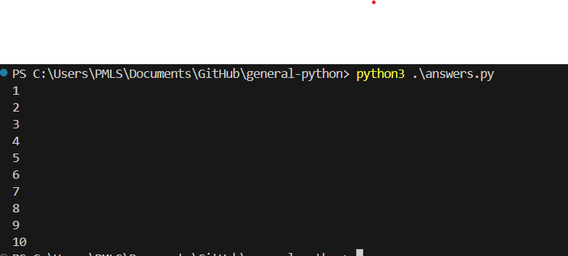

## Ans: A-2

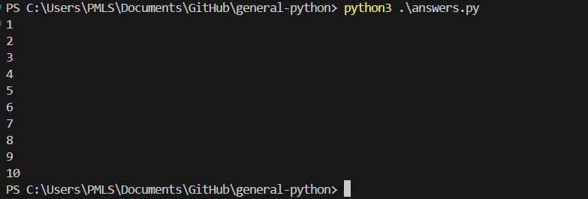

## Ans: A-3a

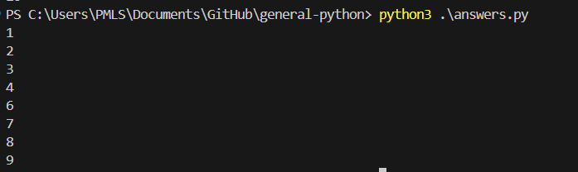

## Ans: A-3b

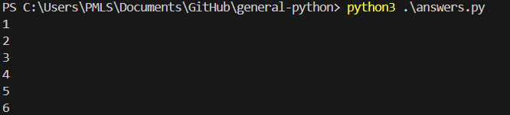

## Ans: A-4

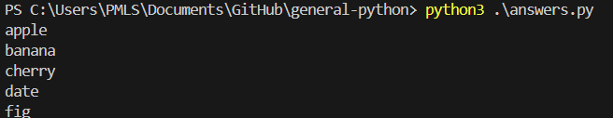

# Answer B

## Ans: B-5

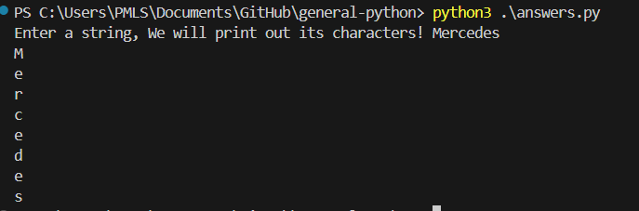

## Ans: B-7



# Answer C

## Ans: C-7

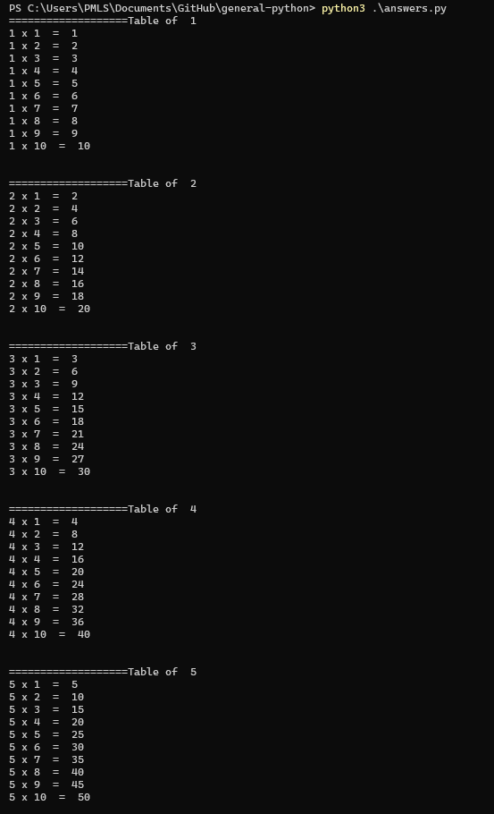

## Ans: C-8

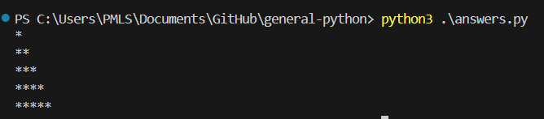

# Answer D

## Ans: D-9

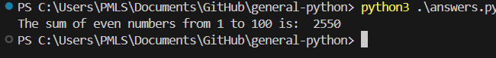

## Ans: D-10

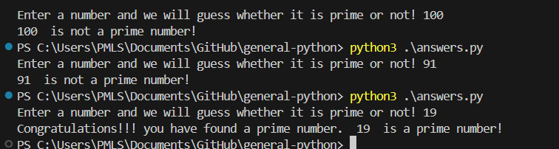

## Ans: D-11

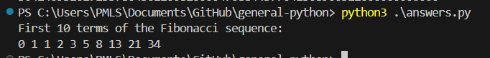

# Answer E

## Ans: E-12

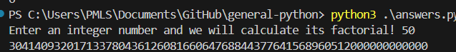

## Ans: E-13

