ShelfSense
A visual learning plan for building a retail inventory system
Learn computer vision by building the system one understandable piece at a time.
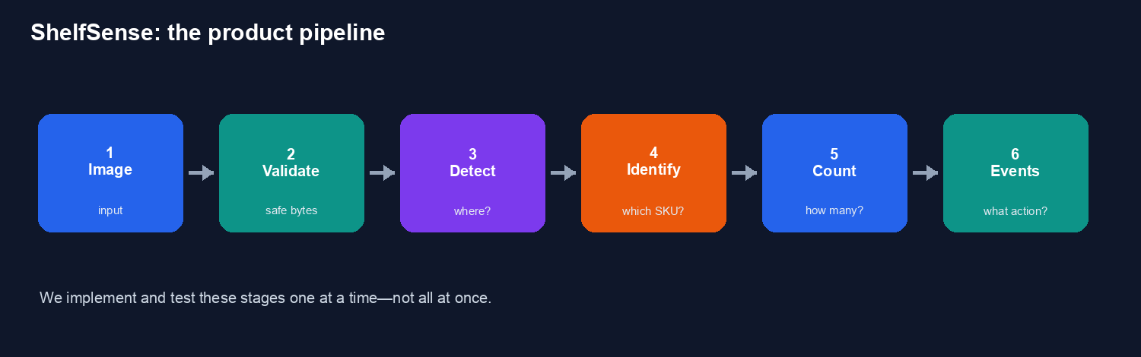

1. What are we building?
ShelfSense is a local-first computer-vision inventory tool. It receives a shelf image, finds visible products, identifies known products, counts them, and reports inventory conditions such as low stock or out of stock.
The important learning decision is to avoid building the whole platform immediately. We will build a sequence of small behaviors that can be run, tested, measured, and explained.

2. The plan in one sentence
Turn one shelf image into one trustworthy inventory observation.

3. The roadmap
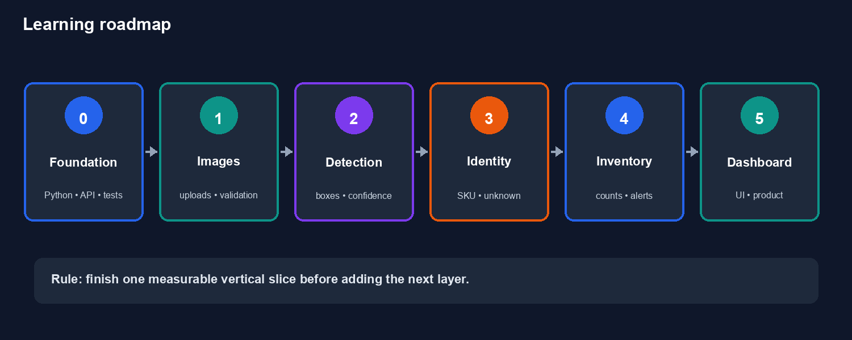
Phase | What we build | What you learn
0 — Foundation | FastAPI app, settings, health route, tests | Project structure, HTTP, testing, tooling
1 — Image ingestion | Upload and validate an image | Files, pixels, validation, errors
2 — Detection | Find products with bounding boxes | Models, confidence, IoU, precision/recall
3 — Identification | Map product crops to 3–5 SKUs | Classification, datasets, unknown results
4 — Inventory | Count SKUs and create events | Domain models, databases, business rules
5 — Dashboard | Show observations and alerts | Frontend, API contracts, product design

4. How each coding session works
- Choose one narrow behavior.
- Write down its input and expected output.
- Implement the smallest version.
- Write tests for normal and invalid input.
- Run it on a real example.
- Measure the result and inspect failures.
- Explain what happened before changing it.
This is the core skill: not merely writing code, but connecting a requirement to an implementation, a test, and evidence.

5. The first milestone
Our first milestone is intentionally small:
- One uploaded shelf image
- One configured shelf
- Three to five known products
- Local inference on your M3
- SQLite persistence
- A FastAPI endpoint returning structured results
- Tests and a small evaluation report
We will not start with live video, a multi-store system, cloud deployment, or a polished dashboard. Those are later layers, not prerequisites for learning the fundamentals.

6. What the technical pieces mean
Concept | Meaning
Detection | Where are the products? The result is a set of bounding boxes.
Identification | What product is inside each detected box? The result is a SKU or unknown.
Aggregation | How many detections belong to each SKU?
Observation | What did this particular image show at this time?
Event | What should the business know or act on, such as low stock?
Abstention | The system admits it does not know instead of making a confident-looking guess.

7. Your role as the learner
You are not expected to know everything before starting. You are expected to inspect the code, run commands, ask why, and attempt small exercises. I can implement with you, but I will explain the design and leave space for you to reason about the next step.
A successful session is not the session with the most code. It is the session where you can explain what changed, why it changed, and how we know it works.

8. First exercise
From the repository directory, run:
uv run pytest
uv run ruff check .
uv run mypy src
Then answer these questions in your own words:
- What is the difference between detection and identification?
- Why are we starting with only 3–5 SKUs?
- What does unknown mean in a vision system?
- Why do we need measurements instead of only checking whether the model runs?
- Why does the dashboard come after the API and vision baseline?

9. Next lesson
We will build a health endpoint and settings object. It will be the first real feature and will teach how the application starts, how an HTTP request reaches code, and how we test an external behavior.
Expected endpoint:
GET /healthz → {"status": "ok", "version": "0.1.0"}

10. Useful project files
- README.md — Project overview and commands
- docs/PLAN.md — Technical architecture and roadmap
- src/shelfsense/ — Application code
- tests/ — Automated tests
- lessons/ — Short project lessons
- reference/ — Quick-reference material
- learning-records/ — What has been learned

