Cab Transaction Using Facial Recognition and Matching.

Rohan Chavan1 , Kshitij Shukla2 , Saniket Patil3

Department of Computer Engineering,

St. John College of Engineering and Management, Palghar

Abstract—After booking a Cab, at the end of the ride one can make the transactions with either cash, card, UPI, E-wallet etc. Sometimes these methods are not hassle free. Therefore, a new system has been proposed for transactions, where face scan method will be used. The system in the cab will calculate the fare based on the distance and then it will authenticate the riders face and transact via connected central database. Face recognition begins with extracting the coordinates of features such as width of mouth; width of eyes, pupil, and compare the result with the measurements stored in the database and return the closest record (facial metrics). The main purpose of this research is to investigate different types of face recognition algorithms like Eigen face and Fisherface. The open CV provides these recognition algorithms. This is done by comparing the receiver operating characteristics curve to implement in the given Transaction using Facial Recognition. In addition, it is noted that Eigen Face delivers better results than Fisherface algorithms; Eigen face delivers between 70 to 80% accuracy between faces. [1] If the user’s input image matched with the trained dataset image then the User Profile and Transaction details gets loaded, and the subsequent trip details gets stored in the User Profile database. The database is connected to frame web server.

1. INTRODUCTION

With the popularity in India of mobile payment platforms such as Paytm and PhonePe, QR codes can be found almost anytime, anywhere in Indian daily life. From luxury shopping centers to street vendors, consumers can make payments easily by scanning a QR code with their smartphones. The awkwardness of forgetting your wallets at home no longer exists. As long as you have a mobile payment set up on your phone, you can virtually always go cashless in India. But, things are changing as we speak. QR codes are just a step in the evolution of mobile payment technology and they may soon be a thing of the past. In fact, soon people in India may be able to forget about QR codes, and pay with virtually nothing but themselves. This new payment method we are talking about is facial recognition, which we are planning to implement in Cabs.

* 1. LITERATURE SURVEY

1. Face Recognition Techniques to differentiate Similar Faces and Twin Faces [2]

In computer technology image based on identical twin, face recognition technology is challenging task. Traditional facial recognition system exhibit poor performance in differentiating identical twins and similar person under practical conditions. Traditionally lot of manual experiments were performed to identify twins and also to recognize their features with differ-ence, and many more systems were existed to show differences in twins by using finger prints, voice and iris as part of pattern recognition. In existing methods, many techniques are

used for twin’s identification like finger print, voice and iris recognition. The process of finger print identification is used to identify unique person in industry or organizations. The method propose a scan image taken from the person and compare with database for identification. The iris recognition also similar method to finger prints identification.

1. Secure Authentication for Mobile Banking Using Facial Recognition [3]

The proposed system is expected to provide higher level of authentication (multifactor authentication) which will bring unauthorized access to the barest minimum. Before access will be granted, the user will have to take a facial photograph to have access to his/her account, the geometry of the face, distance of the eyes and the nose is compared. This photograph will be compared with the photograph in the bank server and the NCC server for verification, if it passes the verification, access will be granted, otherwise it will denied. In the event of unauthorized access, a security alert message will be sent to the bank.

C. Biometric Face Recognition Payment System [4]

Use of payment cards in various places such as shopping, restaurants, lodges and online payment for booking hotels, movie tickets, flight and train tickets etc are increasing day by day. Therefore, the problem is that a person has to carry payment cards along with him and keep the cards secure to use it all the time. This also lacked security. In the present work the biometric face recognition payments is used in all kinds of payments. Thus, it avoids the need to memorize different passwords. Face recognition payment system is safe, secure and even easy to use. It is reliable and more efficient compared to other payment technologies. A general design of online payment system using face recognition is proposed. The methods adopted for face recognition are by finding the Eigen faces and Euclidean distance.

1. METHODOLOGY

The proposed system involves automated cashless payment system using facial recognition. This system will work as an API between the payment system and any other application in which face of the user can be used for authentication. Using this system, the user can directly pay fares for the cab rides or hotel stay etc. The initial step of the system is the registration process. During the time of registration, the system will collect the facial information of the user by asking user to upload an video of user’s face. The system will then extract the frames from that video which will be used stored in the database for further use. Every user has specific user directory in which all collected frames will be saved.

This dataset of images will be used to train our facial recognition model powered by OPENCV, Local Binary Patterns Histograms Face Recognizer (LBPH) algorithm. After the complete registration process, the user can login into the system by using facial recognition, and selects the destination.The system will then allocate a nearby cab to the user, and ensure the pickup for that user. Based on the pickup point and the destination, an invoice will be generated and the amount will be shown to the user. After the completion of the ride,the user will be redirected to the payment engine, where userwill be prompted to enter his special pin to complete the transaction. [5]

IV. ARCHITECTURE

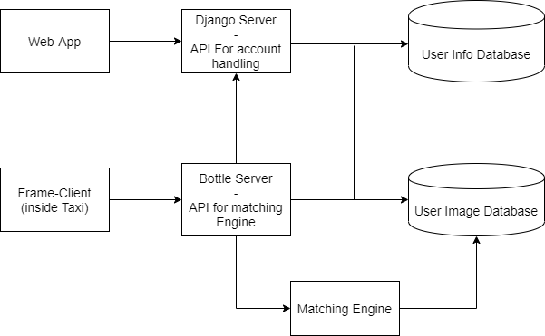

Our Main Web-App will be responsible for User Registration. Here 60 user photos will be taken and stored into the User Image Database. The Django Server will be used for account handling, such as user registration, user login, password updating, data updating, etc. The entire project is based on microservice architecture. Microservices are a software development technique —a variant of the service-oriented architecture (SOA) structural style— that arranges an application as a collection of loosely coupled services. In a microservices architecture, services are fine-grained and the protocols are lightweight. Every module will be independent. The bottle server will help the modules communicate with each other. The client will hit the api endpoint of bottle server to access the matching engine inside the cab. The web app will also use bottle server api to store images in the database.

V. WORKING

Login Screen is made in ReactJs, Consists of Simple Username and Password combination interface. The other links are Registration links and also links for Terms of Use and Privacy policy.



Registration will be done on the following screen. The registration page will accept username, email id, password combination.

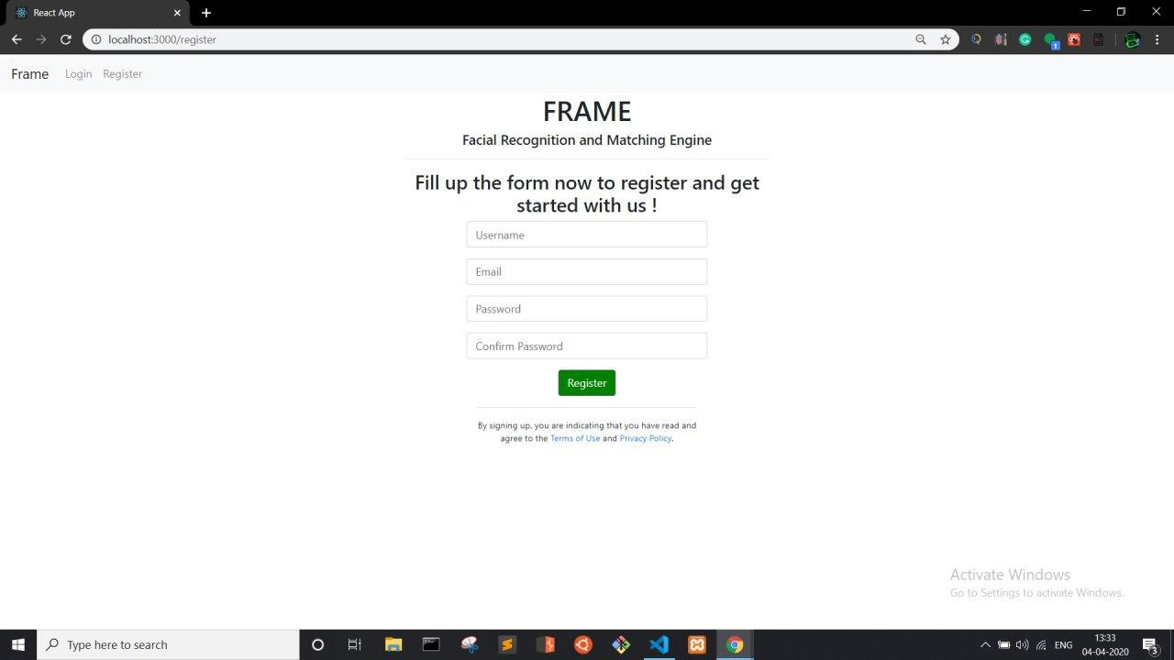

Upon successful registration user will be redirected to the login page which he can login. The login screen will be as shown before.



Upon login the user will be greeted with the above screen from which he can take images for the database.

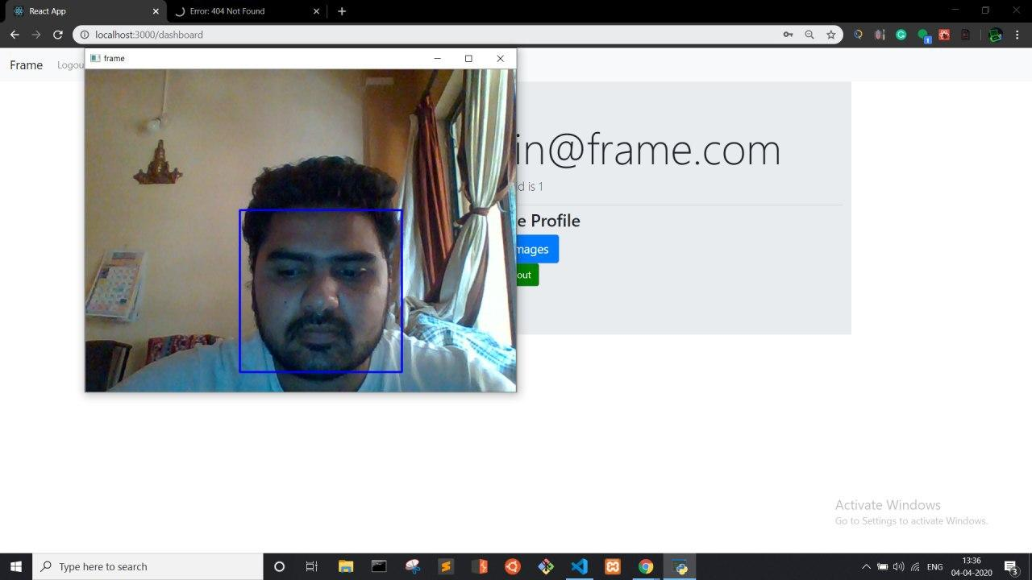

The system will open the webcam and take up to 60 images of the user and save it to the user image database, where as the textual details like username and password will be stored in user info database as show in the architecture diagram.

VI. CONCLUSION

The project is an advanced system which follows microservice architecture based on server client as well as web infrastructure. All the services are interconnected and use REST API for interprocess request/response communication. Account management is done using an API built with Django Rest framework, Bootle server acts as an communication unit with the matching engine which uses opencv LBHP ( local binary histogram pattern) to recognize the images which are stored in the user image database.

VII. REFERENCES

[1] P. N. Belhumeur, J. P. Hespanha, and D. J. Kriegman, “Eigenfaces vs. Fisherfaces: recognition using class specific linear projection,” IEEE Transactions on Pattern Analysis and Machine Intelligence, vol. 19, no. 7, pp. 711–720, 1997. [Online]. Available: 10.1109/34.598228;https: //dx.doi.org/10.1109/34.598228

[2] R. Prema and D. P. Shanmugapriya, “A Face Recognition Techniques for Differentiate Similar Faces and Twin Faces,” International conference on Energy, Communication, Data Analytics and Soft Computing, 2017.

[3] F. A. Adesuyi, “Secure Authentication for Mobile Banking Using Facial Recognition,” IOSR Journal of Computer Engineering, vol. 10, no. 3, pp. 51–59, 2013. [Online]. Available: 10.9790/0661-01035159;https: //dx.doi.org/10.9790/0661-01035159

[4] . R. Surekha, Gondkar, D. B. C. S. Saurab, and Mala, “Biometric Face Recognition Payment System”,” International Journal of Engineering Research & Technology (IJERT). Special Issue, vol. 6, pp. 2278–0181, 2018.

[5] N. Stekas, D. V. Den, and Heuvel, “Face recognition using local binary patterns histograms (lbph) on an fpga-based system on chip (soc),” IEEE International Parallel and Distributed Processing Symposium Workshops (IPDPSW), 2016.