Evidence boundaries in transferring biological computation to artificial systems
NeuroConverge internal manuscript candidate — 4 October 2026. No new experiments by default. Frozen results are retained; technical interpretation, core evidence traceability, reconstruction scope and the contribution assessment remain under audit. Source rights and author declarations are also open.

Abstract
Biological provenance does not specify which artificial comparison can establish transfer. We retrospectively synthesize three independent research programmes and five separately analysed synthetic or engineering tests. Separating source support, information correspondence, mechanism specificity and task utility changed the eligible conclusions in these cases. Direct execution-state information did not improve the tested controller. Preserved temporal correspondence helped a local rule, but generic feature-based prediction prevented attribution to that rule. Fast–slow dynamics did not meet mechanism-specificity criteria. In a source-inspired visual task, normalization reduced the nominal global-context control to a constant offset, changing the comparison into a selective-transform versus effectively local-only test. The single-specimen structural analysis retained an invalid topology null separately from its unsupported positive association. In an equal-compute scheduling comparison, no control could be made eligible because the frozen criterion defined a control's comparability in terms of the treatment's own realized consumption, so the comparison could not be instantiated and no confirmatory evaluation followed. These cases identify different reasons why a local contrast cannot carry a transfer claim, including reasons that arise before any contrast is computed. They provide an operational case-based evidence decomposition, without establishing a common effect, biological mechanism validity or a general transfer law.
Biological systems are increasingly used to motivate artificial architectures, representations and learning rules. Yet evidence that a circuit has a particular structure or supports a biological computation does not specify which signal, representation, objective or learning procedure an artificial system should use. Connectome-derived reservoirs have been used to study task-specific computational capacity [1, 2], and recent work has transferred synaptic-diversity concepts into artificial networks and evaluated their benchmark performance [11]. Bidirectional comparison of macaque neural activity and artificial-network features has also shown that forward neural predictivity need not imply that model units are recoverable from biological activity [12]. These precedents show that biology-to-AI translation is established; they also make clear that each claim depends on the transferred variable, task and comparator. Figure 1 frames this motivation: biological provenance can guide a model, but does not by itself establish utility.
Source support, computational interpretation, information correspondence and artificial utility answer different questions. Mechanism specificity additionally asks whether the proposed operation explains an effect beyond alternative implementations. Existing work provides evaluation taxonomies, documents baseline/reporting biases and formally characterizes negative transfer [15–17]. Our narrower question concerns which comparisons are informative when translating a source-supported computation into an artificial implementation. Supplementary Table S8 positions this study against those precedents without claiming that the categories themselves are new.
NeuroMotif and NeuroMech approached different portions of this chain. NeuroMotif asked whether connectome-derived organization related to selected dynamical properties and whether a broader structure-to-AI claim could be supported. NeuroMech examined named biological computations, including motor-state feedback and cerebellar temporal learning, and tested simplified implementations under synthetic tasks. A third, separately governed engineering programme asked whether an event-driven scheduler confers a compute-budget advantage; it was carried out under a declared boundary that excluded the other two, and its inclusion here is an owner-authorized scope amendment rather than a pre-existing integration. These histories are heterogeneous: they include source literature, source-data analyses, model reproductions, synthetic experiments, negative results, invalid analyses, blocked data paths and comparisons that could not be instantiated.
Here we ask which evidential transitions in neural-to-artificial transfer require separate empirical support. This retrospective, case-based synthesis identifies how separating evidence questions changes the inference in each case and which further comparison would be informative (Supplementary Table S9). Figure 2 maps the coverage of the two original portfolios; the third programme is summarized in Supplementary Table S11. These cases have no common estimand and do not jointly test a unified transfer law. The contribution is a case-grounded analysis of distinct inference failures, not a validated theory predicting transfer success.

Results
We examined evidence at distinct levels: connectome-based structure tests (Fig. 3), published biological computations and source-data analyses, four synthetic experiments on execution-state information, temporal correspondence, fast–slow dynamics and feature-tuned contextual inhibition, and a separate engineering line on budget-matched scheduling. NeuroMotif, NeuroMech and the IRCN line were independent research programmes with different tasks and units of analysis; their outcomes were not pooled, and the third was carried out under a declared boundary that excluded the other two until the owner authorized its inclusion here. M2 and M5 were designed after earlier project outcomes; DMP and the V1 test were later post-result additions; the IRCN pilot was preregistered and its confirmatory stage was never reached. Each protocol was frozen locally before its own outcome run, but none was a project-level preregistration or an independent biological validation (Supplementary Methods S1, S4 and S5; Supplementary Tables S3–S7).

1. Structural association and reservoir retention require distinct tests
The separate Fish1.5 analysis asked whether a connectome-derived recurrence measure was positively associated with neuronal activity persistence (Fig. 3a,b). The predicted association was not supported among 82 neurons from one specimen: Spearman's ρ was −0.1096, the positive-direction permutation P value was 0.8337, and the neuron-bootstrap 95% confidence interval was [−0.2932, 0.1338]. This interval described variation under neuronal resampling within that specimen, not uncertainty across animals. Moreover, the frozen topology-null analysis could not provide valid inference: correlations were undefined for 861 of 1,000 null graphs, leaving 139 defined statistics. No valid topology-null P value was estimable under that procedure. The unsupported positive association and the invalid topology null were therefore retained as separate outcomes; neither justified a population-level structural conclusion. This separates a conditional association estimate from the validity of the proposed topology comparison.
An archived whole-connectome reservoir workstream supplied a separate historical boundary. The recoverable Step-3/3A calibration and falsification sequence applied a prospectively frozen rule requiring a nonzero interference level with recurrent-model source R² ≥ 0.30, superiority over passive diagonal persistence and concordance in at least six of eight paired weight seeds. No tested level in the recovered sequence satisfied the conjunction. This does not establish that the planned M0 pilot or its T00–T11 main experiment was completed: the available evidence is the narrower calibration/falsification sequence, not a full pilot archive. Exact processed graphs and the dirty execution snapshot are also absent, so this record remains a bounded historical result without raw-to-result reconstruction (Supplementary Results S3; Supplementary Table S7).

2. Published source evidence supports bounded computations but does not select an artificial implementation
The motor-state case began with published evidence for a biological computation rather than with an artificial benchmark. Ji et al. reported RIM-dependent motor-state information in AIY and a role for corollary discharge in sustaining forward locomotion during positive thermotaxis in Caenorhabditis elegans [3]. This supported a bounded sensory–motor computation at the reported cell-class and behavioural scope. It did not identify the source signal as an exact measurement of displacement after actuator execution, the variable manipulated in the synthetic experiment below.
The project-level animal analysis could not independently resolve that biological account. The available source tables did not provide the animal/session identity and stimulus alignment required for the frozen reanalysis. Consequently, this path remained schema-blocked. Descriptive events could not be treated as independent animals, and the missing alignment prevented the planned test. The blocked result limited the project reanalysis; it supplied no evidence against the published biological computation (Supplementary Table S1).
The cerebellar case also illustrates the distinction between biological observations and an artificial implementation. Garcia-Garcia et al. studied granule-cell and climbing-fibre activity in relation to long-interval timing [4], while optogenetic evidence for climbing-fibre instructive signals in mouse delay eyeblink conditioning supports a biological learning role [5]. Neither source validates the particular artificial update equation tested here. A separate, post-result analysis of released cerebellar data is retained as a branch-pinned exploratory result in Supplementary Results S2; it is not a row in the 39-record Route-D V3 portfolio and is not included in that portfolio's disposition counts. Together, these source records motivate testing artificial signals and rules separately from biological evidence.

3. Direct execution-state information did not improve the tested action-conditioned controller
We next tested whether an additional state observation improved control in a synthetic actuator-observability problem. A one-dimensional tracking plant combined intermittent, noisy relative-position observations with stochastic actuator reversals. The action-only controller received its preceding command; the realized-state controller additionally received the exact sign of the preceding executed displacement. Both used the same adapted action-conditional recurrent Kalman network (AcRKN) cell architecture, with 320 trainable parameters and equal training budgets [6]. Thirty-two paired training-seed blocks shared environment random streams, with 128 held-out episodes per arm and condition within each block. The independent inferential unit was the training-seed block, not the episode or time step (Supplementary Table S3).
Under hidden reversals, the realized-state observation did not improve the primary outcome. Mean squared tracking error (MSE) was 2.43809 for action-only and 2.50618 for realized-state. The frozen action-only-minus-realized-state contrast was −0.068094, with a paired seed-block bootstrap 95% confidence interval of [−0.141077, −0.003541]. Positive values would have favoured realized-state input; the observed interval instead favoured action-only under this implementation and training budget (Fig. 4b). The input loop is shown in Fig. 4a.
The diagnostic controls did not establish an information-specific explanation for this difference. Supplying the reversal-event bit alongside the command made the realized execution sign reconstructible. In that revealed condition, reversal-event-minus-realized-state MSE was +0.001992 (95% confidence interval, [−0.089678, 0.081652]). The interval included zero, but no equivalence margin was specified, so this did not establish equivalent performance. The corresponding information-recovery contrast also included zero (−0.070086; [−0.152817, 0.003712]). With no reversals, when execution sign was determined by the command, the action-only-minus-realized-state gap was −0.041911 ([−0.101355, 0.021932]). These diagnostics left input representation and training effects as unresolved explanations; they did not isolate a disadvantage caused by the additional information itself.
Generic recurrent and task-aware references achieved lower mean errors. Under hidden reversals, gated recurrent unit (GRU) controllers reached MSEs of 1.86456 with action-only input and 1.84687 with realized-state input, while the particle-filter reference reached 1.44413. Their mean errors were also lower than the AcRKN arms in the other two conditions (Supplementary Results S4). The GRU pair had 323 parameters each; the particle filter used known task dynamics and was not capacity matched. These comparisons situated AcRKN performance without isolating an architecture effect. Two complete executions reproduced the scientific outputs exactly after exclusion of declared timing fields. The result applied to one plant, an exact uncorrupted post-actuator sign measurement and a fixed training budget. That signal was distinct from the premotor/corollary-discharge signal in the worm source evidence.

4. Preserved temporal correspondence supported prediction without establishing mechanism specificity
The timing experiment tested a different question: whether a fixed local learning rule could exploit trial-specific temporal information when its correspondence with the target was preserved. Each synthetic input contained a noisy temporal pulse related to a target interval. For each of 30 independent task seeds, 1,200 training trials and 400 held-out trials were generated. The aligned regime paired inputs with their generating targets; the broken regime independently permuted target assignments within the training and test splits. The input arrays and target multisets were identical between regimes, so the manipulation changed correspondence while preserving those marginals. The climbing-fibre-inspired local rule used 16 temporal radial-basis eligibility features and a 28-class softmax readout. It was an artificial eligibility-gated update, not a literal model of measured cerebellar long-term depression (Supplementary Table S3).
The task met its frozen viability criterion. In the aligned regime, full-input replay achieved nMAE 0.07138, compared with 0.25816 for the constant-median predictor, a 72.35% relative reduction; its paired correspondence-effect interval was above zero. For the local rule, nMAE rose from 0.141521 when aligned to 0.258109 when broken (+0.116588; paired task-seed bootstrap 95% CI, [+0.115072, +0.118065]), with a positive contrast in all 30 seeds. Full-input replay changed from 0.071385 to 0.260936 (+0.189552; 95% CI, [+0.186912, +0.192229]), and same-feature ridge from 0.056643 to 0.259033 (+0.202390; 95% CI, [+0.200123, +0.204675]). Both generic effects were larger than the local-rule effect. In contrast, no-trace nMAE changed from 0.258153 to 0.258083 (−0.000070; 95% CI, [−0.000411, +0.000219]) and CF-time-shuffled nMAE from 0.259511 to 0.258312 (−0.001199; 95% CI, [−0.002510, +0.000072]); both intervals crossed zero. Normalization divided interval MAE by the 27-bin target range. Preserved correspondence therefore improved prediction for this fixed local rule, while the generic references used the same task information more effectively (Fig. 5b,c); the algorithm and correspondence manipulation are shown in Fig. 5a.
The temporal controls qualified that effect. Removing the temporal eligibility profile yielded a correspondence-effect estimate of −0.000070, while shuffling teaching-time assignments yielded −0.001199; both bootstrap intervals included zero (Supplementary Results S5). Generic learners exploited the temporal information more effectively: ridge regression on the same eligibility features achieved aligned nMAE of 0.05664 and a correspondence effect of +0.202390 (95% confidence interval, [+0.200123, +0.204675]). Full-input replay showed an effect of +0.189552 ([+0.186912, +0.192229]). The local rule thus demonstrated usable correspondence without outperforming these alternatives.
Comparator matching limited the specificity claim. The ridge arm shared the 16-feature encoder but fitted a 17-parameter scalar head; the local rule fitted a 476-parameter classification head. Their objectives and fitting procedures also differed. The frozen contract's parameter-matched description was corrected in the post-run audit to feature matched, preserving the original record. The comparison showed that a generic learner could use the same representation; it did not isolate a learning-rule effect at equal capacity. In addition, correspondence was changed in both training and evaluation, so its contrast did not separately identify those contributions. The supported result was a correspondence benefit for the tested synthetic implementations, with no established biological mechanism specificity or general transfer advantage.

5. Fast–slow dynamics did not yield a positive mechanism-specific advantage across the tested tasks
Motivated by fast–slow cortical computation, we tested a source-inspired dual-pathway spiking model against a matched short-state control in three synthetic families: delayed association, partially observed state estimation and delayed contextual decision. The model used 32 leaky integrate-and-fire units and a fixed two-dimensional LMU-like state; the control retained the same trainable shapes and state dimension but replaced the slow transition with a fast-decay matrix. A 2 × 2 design crossed mechanism with whether the slow-context stream remained paired to each trial's fast stream and target. Thirty task-instance seeds per family, two paired initializations and 512 held-out trials per test split were used. The protocol was frozen before this module's run, after earlier project results had been inspected (Supplementary Methods S4).
No task family met the predeclared positive mechanism-specificity criterion, which required a viable task, a positive mechanism × correspondence interaction after Holm correction and a positive aligned DMP advantage. Delayed association failed its GRU-versus-null viability gate (Holm-adjusted P = 1.00); its interaction was −0.00212 (95% CI, −0.00615 to 0.00173; adjusted P = 0.648). In state estimation, the interaction was negative (−0.00218; 95% paired task-seed bootstrap CI, −0.00383 to −0.00054), while the aligned DMP model also had higher error than the short-state control; the Holm-adjusted interaction P value was 0.0506. In contextual decision, the interaction was near zero (+0.00101; 95% CI, −0.00537 to 0.00778; adjusted P = 0.779), and the aligned full-data advantage was not detected. The study therefore did not show that the tested slow dynamics benefited correctly paired context across these task families.
A predeclared secondary scaling analysis found a narrow small-data pattern in contextual decision: the aligned DMP advantage over the short-state control was +0.0724 at N = 128 (95% CI, 0.0504 to 0.0956), +0.0351 at N = 512 (0.0134 to 0.0595), and +0.00156 at N = 2,048 (−0.00573 to 0.00931). Its unit-level advantage slope was negative (−0.0177 per log₂ training-size step; 95% CI, −0.0229 to −0.0127; Holm-adjusted P = 0.000060), meeting the frozen secondary scaling criterion labelled a sample-efficiency gate for this one task. This descriptive label does not establish sample efficiency: with ten fixed epochs and batch size 64, the fits used 20, 80 and 320 optimizer updates at N = 128, 512 and 2,048, respectively. This secondary result did not rescue the failed mechanism-specificity test. In the unchanged longer-delay evaluation, aligned DMP loss increased by 0.00143 (95% CI, −0.00866 to 0.01081) in delayed association, 0.00096 (−0.00187 to 0.00375) in state estimation, and 0.22096 (0.20153 to 0.23841) in contextual decision. The effect was therefore task dependent, with a substantial degradation in the contextual-decision shift (Supplementary Table S4).
The fast–slow abstraction itself is not new: a dual-memory spiking architecture with compact slow state was reported in Nature Machine Intelligence in 2026 [13]. Our implementation was source-inspired, not a reproduction of that model or its hardware co-design. The present synthetic study tests a narrower correspondence interaction and does not establish cortical mechanism validity, energy efficiency, broad transfer or novelty of fast–slow memory.

6. Normalization changed the effective visual-task comparator
We used a reported mouse visual-cortex motif—feature-tuned pyramidal-cell input to SST interneurons [14]—to motivate a synthetic figure/ground test with 30 task-instance seeds. No source neural recordings were used. The nominal design crossed selective versus global inhibition with aligned versus permuted routing. However, the eight-channel responses summed to one at each location; their neighbour mean therefore also summed to one, making global pooling a constant 1/8. Subtracting 0.65/8 was absorbed by the fitted linear readout. The executed global control was thus effectively local-only, not a second functional contextual mechanism (Supplementary Methods S5).
Three procedural facts remain distinct. The frozen interaction was +0.01603 AP (95% CI, 0.00815 to 0.02357; two-sided sign-flip P = 0.00060), passing its numerical criterion. Because the formula was broken minus aligned, that positive direction opposed the prose prediction of an alignment benefit. Aligned selective routing also underperformed the constant-offset control by 0.02208 AP (95% CI, 0.01664 to 0.02737), so the conjunctive gate failed. With identical global cells, the interaction reduced to the selective broken-minus-aligned difference. The tested selective routing did not outperform the present effectively local-only control.
The generic reference exceeded the frozen prevalence reference of 9/121 by 0.37219 AP (95% CI, 0.36046 to 0.38379). This passed the procedural reference criterion, but did not establish contextual learning: the AP implementation used stable pixel-index ordering for ties, so all-equal predictions did not necessarily yield 9/121, and structure-preserving no-learning alternatives were not excluded. Outputs and gates were preserved; control algebra, metric interpretation and verification scope were recorded in a separate technical amendment. This outcome-informed synthetic case supplies no biological validation.

7. An equal-compute comparison whose eligibility depended on the treatment's own realized consumption
We separately examined an engineering line whose question was whether an event-driven scheduler confers a compute-budget advantage for a recurrent circuit. The line had already produced three narrower outcomes, each of which stops short of a utility claim. Its correctness gate passed on two separately frozen contracts: 96/96 calibration cases cleared the trajectory-accuracy ceiling with a maximum relative NRMSE of 5.5743e-9, and 240/240 untouched-seed cases cleared it with a maximum of 4.2635e-9, against a limit of 6.8376e-8 in both. Yet the corresponding decision record still declines to claim efficiency or to enter the baseline comparison, because accuracy of a trajectory is not cost. A later runtime milestone likewise passed: a tick-synchronous execution bridge reproduced the frozen synchronous cell on 21 fixtures with all 42 repeated attempts passing and a maximum state difference of 2.8311e-15, and its decision record states explicitly that this licenses no efficacy claim and that the next evaluation stage should not be entered. A cost-calibration run then found no threshold at or below the frozen error ceiling, leaving its results table header-only; that run also carries a confirmed protocol deviation, in that the smooth-input event cadence was set by implementation convention rather than frozen before the run, so its negative result is an implementation-level probe rather than confirmatory evidence.
The budget-matched pilot is the case of interest. The preregistration froze a per-seed eligibility rule for the four scheduler controls: a control was eligible only if, for every pilot seed, its realized multiply-accumulate count came within one per cent of the treatment's own realized count. That criterion makes the comparability of a control a function of the treatment's realized consumption, which is produced by running the treatment. In the event, no control satisfied it in either task family. On the sparse-key family the treatment realized 500,288 to 508,160 counted operations per seed while each control deviated by 3.79 to 5.42 per cent (random and fixed-frequency), 5.41 to 15.74 per cent (activity) and 4.12 to 5.76 per cent (no-influence). On the feedback-switch family the treatment realized 25,344 per seed and every control deviated by 1466.92 to 1987.63 per cent. The frozen record therefore contains no primary baseline, sets the confirmatory seed count to zero, marks the sample size infeasible and leaves the confirmatory test-seed list empty. No confirmatory evaluation was run.
Three procedural facts remain distinct and must not be merged. The numerical interaction that motivated the line was never tested, because the comparison could not be instantiated; this is a comparison-contract boundary, not a failed mechanism and not evidence that the scheduler is inefficacious. The pilot's descriptive ordering does not rescue the comparison: the treatment did not beat even the zero-output reference (sparse-key mean loss 0.01083973 against 0.01083902; feedback-switch 0.02612243 against 0.02601414), and its feedback-switch critical-event recall was zero, which is consistent with an estimator that failed to trigger rather than with a treatment that was correctly compared and lost. And the pilot's own failure record was reconstructed after the metric and freeze files were written, so it is retained as documentation of the infeasibility rather than as contemporaneous runner output.
This case adds a boundary class not present in the others: a comparison whose eligibility criterion is defined in terms of the treatment's realized behaviour cannot be frozen in advance of running the treatment, and where the treatment's consumption diverges sharply from the planned controls the contract cannot be repaired after the fact without defining a new comparison. Changing to a common compute cap, or to scheduler decisions that make controls plan-able in advance, would constitute a new preregistration rather than a reanalysis of these data. The case supplies no biological validation, no efficiency claim and no evidence about whether the underlying scheduling idea is sound.

Discussion
The cases revealed different reasons why an observed contrast could not establish neural-to-artificial transfer. Extra information did not guarantee utility in the tested controller; correspondence-sensitive prediction did not identify a learning rule; a matched dynamical contrast remained conditional on task viability; and a biologically motivated visual comparison changed meaning when its control algebra was examined. The structural case separately distinguished an unsupported association from an invalid null, and the scheduling case stopped one step earlier still: its comparison could not be instantiated, because the frozen eligibility rule made a control's admissibility depend on the treatment's own realized consumption. Their joint value is the change in eligible inference produced by separating these questions, rather than a common negative effect.
The decomposition makes the required comparison explicit (Supplementary Table S9). M5 requires a same-feature generic learner before attributing correspondence sensitivity to the local rule. M2 requires separating signal availability from controller utility. DMP requires interpreting the mechanism interaction only within the task gate and training protocol. V1 requires checking whether nominal controls retain their intended information. Fish1.5 requires a valid topology null independently of an association estimate. The scheduling case requires an eligibility rule that can be evaluated from the plan rather than from the treatment's realized behaviour, which is a change of comparison contract rather than a reanalysis. These are operational decisions supported by the existing cases, not tested improvements in the performance of the evidence map itself.
Implementation-level explanations remain. M2 did not isolate an intrinsic information penalty. M5 changed both training and evaluation correspondence, used complete-trial features, and compared different heads and objectives. DMP varied optimization steps with dataset size under ten fixed epochs, so its small-data pattern did not isolate pure sample efficiency. V1 passed its frozen prevalence-reference criterion without establishing contextual learning. These limits identify the inference that remains unresolved in each implementation; they do not imply absence or failure of the source biological mechanism.
The study complements connectome-informed computation [1, 2], biological concept transfer [11] and bidirectional brain–model comparison [12] by tracing source-to-implementation inferences within selected cases. Evaluation taxonomies already provide structured study descriptions [15], and weak-baseline analyses establish the importance of comparator choice [16]. Our case table combines these concerns with source identity, effective representation and mechanism specificity. Its increment is this explicit case-level reasoning, not priority for the constituent principles or a representative survey of the field. The present results do not overturn successful transfer in other settings.
The third programme was included under an owner-authorized amendment that crosses a boundary its own provenance record had declared, and that crossing is recorded rather than presented as a pre-existing integration. Selection was outcome-informed, and none of the synthetic tests independently confirmed biology. Fish1.5 was conditional on one specimen; the source readout used within-session splits and modeled weights. The leave-one-case-out argument audit identifies which specific inference is lost when a case is removed and which remaining cases still support the narrower synthesis (Supplementary Table S10). It is not a statistical robustness test or evidence of representative sampling. Historical invalid and blocked records remain visible. Source linkage, third-party rights and end-to-end reconstruction are not uniformly complete.

Methods

Study design and evidence selection
NeuroConverge is a retrospective, case-based synthesis of two independently developed research portfolios, with four separately analysed synthetic tests. It is not a systematic review, a prospectively unified biological study or a meta-analysis, and its cases have no common estimand. We imported all 39 records from the NeuroMech Route-D V3 classification matrix and retained their original evidence labels, units, statuses and interpretation limits in Supplementary Table S1. The nine claims in the initial publication draft are accounted for separately in Supplementary Table S2: three map to V3 main-text candidates, one is an editorial synthesis, three are hash-pinned branch records without exact V3 rows, one is a post-result follow-up whose relationship to M10 remains unresolved, and one maps to a V3 supplementary-only record. The C08 contract identifies it as a distinct follow-up to V2; we do not merge it with V2 or make an M10-linked claim. RR18 and RR19 appear as separately governed exclusions in the 39-row disposition matrix and are excluded from the manuscript synthesis.
Main-text selection considered structural evidence, source-supported computation, execution-state access, temporal correspondence and fast–slow dynamics. Selection was made with knowledge of earlier project outcomes. Historical positive, negative, invalid and inconclusive records were retained in the supplementary portfolio. An invalid analysis or failed viability gate was not interpreted as a valid negative mechanism test. Neither the portfolios nor the M2, M5 and DMP V1 endpoints were pooled. Each module contract was frozen before its own outcome execution, following inspection of earlier project results; this was not project-level preregistration, and none is an independent biological confirmation.

Historical whole-connectome reservoir archive
The M0 workstream label covers a planned pilot and main experiment, but the recovered evidence supports only its Step-2/3/3A calibration, falsification and stopping sequence. The planned M0 pilot and T00–T11 main experiment are not documented as completed. In the recoverable sequence, off-diagonal connectome recurrence (M3) was compared with passive diagonal persistence (M1) under sustained interference. The shared weight-initialization seed was the pairing unit (eight per species × interference cell). The criterion combined usable source information (R² ≥ 0.30), M3 > M1 and at least six of eight seeds in that direction. It was prospectively frozen after calibration and implementation corrections, not preregistered. The corrected report, Step-3/3A seed-level CSVs, verdicts, resolved configurations and manifests are retained in ../evidence/m0_source_archive/, with the source-to-claim audit in ../evidence/M0_PROVENANCE_AUDIT.md. Means and direction counts were recomputed from saved CSVs without running the scientific assay. The exact executed command is unknown, datasets were not registered in the historical manifests, processed graph tensors are unarchived and the execution worktree was dirty. These gaps prevent full raw-to-result reconstruction; this bounded historical sequence does not carry the manuscript's central inference alone.

Fish1.5 structure and functional persistence
The Fish1.5 analysis used released structural annotations from the version-2 preprint source [7] and archived traced axons/synapse tables (Zenodo record 19231045; [9]), together with functional calcium-response arrays from one specimen (Zenodo record 16893093; [8]). Of 97 structurally covered functional identities, the preselected primary cohort comprised 82 with strict structural completeness; the expanded 97-neuron graph was sensitivity-only. Graph construction used each mapped neuron's presynaptic owner table. Only annotations marked valid and partners mapped into the chosen cohort were retained. Self edges were excluded. Repeated synapse identifiers were collapsed only when partner coordinates agreed; ambiguous duplicates were rejected. Directed weights counted retained annotations rather than missing size fields. Postsynaptic files were integrity checks, not sources for filling absent primary edges.
For adjacency matrix W, where Wᵢⱼ is the directed weight from neuron i to neuron j, define out-strengthᵢ = ΣⱼWᵢⱼ and in-strengthᵢ = ΣⱼWⱼᵢ. The local recurrence index was
Lᵢ=Σⱼ WᵢⱼWⱼᵢ / [(out-strengthᵢ)(in-strengthᵢ)],
with zero assigned when the denominator was zero. The numerator is the diagonal of W², not of WWᵀ. The functional endpoint used nominal timing defined by the released analysis code: 160 samples at 0.5-s spacing and dot stimulation during [20,60) s. Baseline, late-stimulus and post-offset windows were [0,20), [50,60) and [60,70) s. A trial required finite values in all three windows. Its persistence ratio was the baseline-subtracted mean post-offset response divided by the baseline-subtracted late-stimulus response. Exactly zero or nonfinite denominators were undefined and recorded, without an amplitude threshold or imputation. Direction-specific trial ratios were summarized by medians; the available left/right direction summaries were averaged per neuron.
The primary statistic was Spearman correlation between Lᵢ and persistence among eligible primary neurons. A positive-direction permutation test shuffled persistence labels 10,000 times and used the add-one upper-tail fraction. A 10,000-draw paired neuron bootstrap produced a percentile interval from defined correlations. The valid draw counts and the descriptive two-sided permutation result were retained in the source outputs; the bootstrap interval was conditional on the specimen and did not capture all network dependence or animal variation. Random streams were derived from seed 2026093001.
The frozen topology null generated 1,000 unique directed binary graphs by degree-preserving double-edge swaps, retaining the binary in/out degree sequences and global positive-weight multiset. Positive weights were randomly assigned to rewired edges; node-specific weighted strengths were not preserved. Every null correlation had to be defined for the frozen topology comparison to be valid. Undefined statistics were retained and the topology P value was left unestimated. Fixed secondary descriptors, Holm-adjusted secondary associations and robustness analyses remained distinct from the primary result. Phase lag and calibrated sine gain were not identifiable from the released schema.

Biological source evidence and descriptive reanalyses
Published findings were attributed to their primary studies and were not represented as experiments performed for NeuroConverge. The worm source concerned RIM-dependent motor-state information in AIY and thermotaxis [3]. The planned animal-level reanalysis required identities and stimulus alignment unavailable in the relevant released tables. A separate project event-sheet summary retained event-weighted descriptions only; events were not used as animal replicates. These paths were kept distinct from the generic M2 synthetic plant.
The separate cerebellar source-readout analysis and its complete procedure are documented in Supplementary Methods S3 and Supplementary Results S2. This post-result package is pinned to a divergent publication branch and is presented as exploratory supplementary evidence, not as one of the 39 Route-D V3 records or part of their disposition counts.

M2 V1 plant and causal inputs
The input, controller, actuator and feedback sequence is summarized in Fig. 4a. M2 V1 used a 64-step differentiable one-dimensional tracking plant. Target position q₀ was uniform on [−1,1], initial target velocity was Gaussian with SD 0.055, and subsequent velocity followed vₜ = 0.91vₜ₋₁ + εₜ, with independent Gaussian innovations of SD 0.055; position was updated by velocity. Agent position began at zero and changed after a bounded command aₜ ∈ [−1,1] by pₜ₊₁ = pₜ + 0.40aₜsₜ, where sₜ = −1 indicated actuator reversal. Training reversal probabilities were sampled independently per episode uniformly from [0,0.25]. Held-out conditions used probability zero or 0.25; hidden and revealed reversals shared trajectories of environmental random variables.
Relative-position observations had Gaussian noise SD 0.14. Missingness used a two-state Markov process initialized with missing probability 0.5 and transition probabilities 0.125 into and out of the missing state, giving mean missing-burst duration eight steps. Six input features were supplied in fixed order: observed relative position or zero, visual-valid flag, previous execution auxiliary value, auxiliary-valid flag, previous command and visual gap clipped at 16 steps and divided by 16. The auxiliary value was zero with validity zero for action-only; the sign of previous executed displacement for realized-state; or +1 for a previous reversal and −1 otherwise for the revealed-event arm. Auxiliary validity began at zero. The revealed-event arm received its event channel during training and the no/revealed-reversal conditions, but not the hidden condition. None received a future or current unexecuted reversal event.

M2 V1 models, training and reference
The adapted AcRKN cell used a six-to-three linear observation encoder, a six-dimensional latent mean and structured covariance, one transition basis, bandwidth two and a 26-unit action-control subnetwork. The policy head mapped the posterior mean through three tanh units to a tanh scalar command. Initial state and observation-variance parameters were learned. Mathematically inert one-basis coefficient-network parameters were frozen and excluded from the trainable count. Encoded observations were treated as valid at each cell update; modality missingness was represented by input flags. The observation update and policy preceded the action-conditioned prediction for the next step. The vendored cell retained its training-time dropout. This wrapper was an adaptation, not a complete reproduction of the original robotics model.
The three AcRKN arms each had 320 trainable parameters. The two generic GRU arms used the same six inputs, eight hidden units and a scalar policy readout, with 323 parameters each. Within family, initialization and environmental streams were paired. Each learned model used 160 Adam updates at learning rate 0.003, batch size 32, full 64-step sequences and global gradient clipping at five. The loss averaged squared target-relative distance measured before each step's new displacement. Gradients propagated through the differentiable rollout; the executed-displacement sign observation was detached. Each fit consumed 327,680 training time steps. Training and test streams were separately identified in the retained registry.
The task-aware particle filter used known target, observation and actuation distributions. Its 256-particle main evaluation inferred reversals when hidden and received preceding reversal events when revealed. Observation likelihoods updated weights, and systematic resampling occurred below half the particle count in effective sample size. The command was tanh(kₚ ê − k_d v̂_agent). Gains were selected from kₚ ∈ {0.45, 0.70, 0.95, 1.20} and k_d ∈ {0, 0.15, 0.30} on four disjoint validation seeds with 32 episodes each, using 64 particles and hidden reversals. The selected gains were held fixed in test evaluation. Particle counts 64, 128 and 256 and effective-sample-size diagnostics were retained. The reference was not matched in information, capacity or inference compute to learned models.

M2 V1 endpoint and reproducibility
The independent unit was one paired training-seed block, with seeds 950000–950031. Each arm and condition used 128 test episodes per block. Episode-mean tracking MSE was averaged within block. The primary contrast was action-only minus realized-state AcRKN MSE under hidden reversals. Diagnostic contrasts comprised revealed-event minus realized-state in the revealed condition, the primary minus that revealed gap, and action-only minus realized-state under no reversals. Percentile intervals resampled paired block contrasts 20,000 times using seed 7813921. They were unadjusted exploratory intervals; no equivalence margin or portfolio-wide error control was specified.
Two full runs used Python 3.9.6, NumPy 2.0.2 and PyTorch 2.8.0 on CPU with one thread. Stored-output verifiers checked summaries, pairing, causal feature tests and hashes. Scientific files were compared byte for byte, excluding only four declared timing fields. Complete fit records, model parameters, episode metrics, stream identifiers, parameter counts and particle diagnostics were retained. Base source commit identity did not substitute for the captured contract, runner and verifier hashes in SOURCE_PROVENANCE.json.

M5 V1 generator, features and learning
The synthetic input, offline feature construction, local update and correspondence manipulation are summarized in Fig. 5a. M5 V1 used task seeds 51000–51029. Each seed independently generated 1,200 training and 400 test trials with 40 bins (t = 0,…,39). Targets y were uniform integers 6–33. Inputs were xₜ = exp[−(t−c)²/(2 × 2.25²)] + εₜ, with c = y + ξ, Gaussian ξ SD 1.5 and independent Gaussian observation noise SD 0.20. Broken correspondence independently permuted training and test targets, preserving complete input arrays and target multisets. Permutations had no fixed trial indices; after at most 100 failed random draws, a cyclic shift was used. Repeated target values could still yield coincident labels after permutation. A separate permutation defined the shuffled-teaching arm.
The eligibility representation projected positive-clipped complete inputs onto 16 Gaussian bases with evenly spaced centres from 0 to 39 and width 2.75. Feature vectors were normalized by their Euclidean norm, with a 10⁻¹² floor, then augmented by a bias. This calculation consumed the full trial array; it was not an implemented online within-trial trace. The local rule processed generated training trials once in their existing order. With zero-initialized weights, class probabilities r = softmax(φ̃ᵀW), and a one-hot target zᵧ, the update was W ← W + 0.08φ̃(zᵧ − r)ᵀ. Predictions were probability-weighted target-bin means. The teaching-time shuffle changed training labels for this update; evaluation retained each regime's actual targets. The no-trace arm used final-bin input and trial mean with bias under the same softmax rule, so it removed the temporal profile rather than every historical summary.
Generic ridge used the same 16 features and a scalar head. Full-input replay used all 40 input bins with a scalar head. Both fitted β by solving ((AᵀA + 0.01D)β = Aᵀy), where the bias penalty in diagonal (D) was zero, and clipped predictions to [6,33]. The generic ridge had 17 fitted output parameters; local/shuffled rules had 476, no-trace had 84 and full-input replay had 41. These arms differed in objective and fitting procedure as well as head capacity. The frozen contract's parameter-matched label was corrected after the run to feature matched without altering recorded outcomes.

M5 V1 endpoint, gate and execution record
The sole performance metric was test MAE divided by 27 bins. The independent unit was task seed. The primary contrast was local-rule nMAE(broken) minus nMAE(aligned); comparator contrasts were descriptive secondary results. A deterministic 20,000-draw paired-seed percentile bootstrap used a generator initialized with seed 2026100105 and advanced across arms in the recorded order. These intervals were not multiplicity adjusted. Task viability required at least 25% relative mean improvement of aligned full-input replay over a training-target median predictor and a strictly positive lower interval bound for replay's correspondence effect. Conditional on viability, a positive primary lower bound supported the frozen correspondence claim; an interval spanning zero was classified as not detected, and an entirely negative interval as reversed.
The first launch failed before producing outcomes because Python 3.9 did not support two zip(strict=True) calls. A syntax-only amendment was frozen before the one successful run under Python 3.9.6 and NumPy 2.0.2. Original and amended freezes and execution-incident records were preserved. Reported NumPy/Accelerate warnings were audited against finite outputs and an independent contraction check; the independent result verifier passed. No arm, seed, model or generator was changed after outcome inspection. The manifest identifies the successful runner, contract and all scientific output hashes. The original labels in frozen files were preserved as historical provenance, even where the manuscript uses corrected terminology.

DMP fast–slow correspondence V1 tasks, models and inference
This synthetic post-result extension was inspired by the dual-memory spiking abstraction reported by Sun et al. [13]. It was not a reproduction of their network or hardware. Three task generators were implemented: (1) a noisy four-level context at steps 0–3 and a four-level query at steps 36–39, mapped to four classes; (2) a unit-variance AR(1) latent state observed through two channels whose relative noise levels were indicated by a switching context, with the final latent value as target; and (3) an early four-level context selecting a mapping from four noisy evidence votes at steps 36–51 to one of four actions. Each task instance also generated an unchanged longer-delay test: query/evidence moved to steps 68–71/68–83 in a 128-step sequence, or state-estimation horizon doubled from 64 to 128. Configuration parameters and class maps were fixed per task-instance seed.
The DMP-style model had 32 leaky integrate-and-fire units (leak 0.5, threshold 1, subtractive reset) and a fixed two-dimensional Legendre-like slow state discretized at horizon 32. The short-state control retained the same learnable parameters, input matrix and state dimension, but used a 0.5I transition. A 2 × 2 factorial crossed model with aligned or broken slow-context correspondence. Broken correspondence independently deranged the context streams within each training prefix (N = 128, 512 or 2,048) and each held-out split, preserving exact context marginals and leaving fast streams, targets and counts unchanged. The comparator GRU had 18 hidden units and trainable parameter count within 5% of DMP. All learned models used two paired initializations, ten epochs, batch size 64 and Adam at learning rate 0.003. FLOPs were not matched. With batch size 64 and ten epochs, N=128, 512 and 2,048 yielded 20, 80 and 320 updates per fit; scaling therefore did not separate sample size from optimization budget.
Thirty independent task-instance seeds were run per family. Each generated 2,048 training trials, 512 IID test trials and 512 longer-delay trials. Classification used 0–1 loss; state estimation used squared error against the unit-variance latent target. The primary family-specific contrast was the mechanism × correspondence interaction, I = [L(DMP, broken) − L(DMP, aligned)] − [L(control, broken) − L(control, aligned)]. The task gate required the aligned full-data GRU to beat the task-null predictor. Paired task-seed percentile bootstrap intervals and two-sided sign-flip tests were calculated at the task-instance level; Holm correction covered the three co-primary interactions and separately the three viability tests. The scaling gate required a positive 95% interval for the aligned DMP advantage at N = 128, negative advantage slope versus log₂(N), and Holm-adjusted slope P < 0.05. Longer-delay results were secondary. The pre-run freeze, source/runner/verifier hashes, per-trial losses and independent verification record are retained in ../new_experiments/DMP_FAST_SLOW_CORRESPONDENCE_2X2_V1/.

Prospective V1 PC→SST feature-correspondence benchmark
This source-informed synthetic package was motivated by Hendricks et al. [14], who reported like-to-like functional connectivity from V1 pyramidal cells to SST interneurons and causal SST contribution to orientation-dependent surround suppression. We did not download or analyse the paper's Zenodo recordings. Each synthetic image comprised an 11 × 11 grid and eight orientation channels spaced over 180°. Responses were generated from a fixed soft orientation-tuning function (κ = 2) with Gaussian noise (s.d. = 0.08), clipped positive and normalized across channels. One randomly placed 3 × 3 figure had an orientation sampled uniformly from the seven categories other than its uniform-background category. Each task-instance seed generated 512 training images, 256 IID test images and 256 test images with a fixed skewed background-orientation prior; the same nested training prefixes of N = 32, 128 and 512 were used across arms.
For each location, surround activity was the mean of eight neighbours. Selective routing subtracted 0.65 times the same-channel surround activity or its frozen no-fixed-point permutation. The historical global_aligned and global_broken cells instead subtracted the across-channel surround mean. Because each normalized response vector summed to one, this mean was 1/8 in exact arithmetic, giving a constant-offset control x − 0.65/8. The fitted linear discriminant absorbed that translation through its class means and intercept; the effective representation was local-only, up to floating-point rounding. Both global cells were identical, simplifying the interaction to the selective broken-minus-aligned contrast. Cell identifiers are retained to preserve the frozen record. All factorial cells used the same eight-input pathway and ridge-regularized linear discriminant (λ = 0.02). The generic reference concatenated local and surround channels (16 inputs), without capacity matching or a strong-neural-network benchmark.
Per-image AP sorted pixels by decreasing score using stable sorting, then averaged precision at each positive pixel's rank. Equal-score ties therefore retained flattened pixel-index order rather than being grouped at a common threshold. The frozen reference was the figure prevalence, 9/121; it was not the executed AP of an all-equal predictor. Passing that reference criterion did not establish contextual learning, because spatially structured ranking and fixed orientation preference were not excluded by it. No reference value or historical gate was retrospectively changed.
Thirty task-instance seeds were independent units; images and pixels were nested. The primary endpoint was mean per-image AP. The frozen interaction used (broken − aligned) AP for selective minus global cells; its prose mistakenly assigned a positive value to an alignment benefit. The positive numerical interaction condition passed, but selective/aligned AP was below the constant-offset control, failing the conjunctive gate. Paired bootstrap intervals used 20,000 draws and two-sided sign-flip tests used 100,000 Monte Carlo sign patterns from NumPy default_rng(20261003). Sample-size and skewed-background endpoints remained secondary. Contracts, original outputs and both interpretation amendments are in ../new_experiments/PROSPECTIVE_V1/.

Budget-matched scheduling pilot and its eligibility rule
A third programme, IRCN, was reviewed for this integration at branch v0.7.0-runtime-icef-bridge, commit 8eac42d; the CBCC pilot directory is present in that working tree and is not committed at that head. Its provenance record classifies the other two programmes as read-only adjacent workspaces not used as its inputs, and its v0.7 development contract excludes manuscript edits; inclusion here is an owner-authorized scope amendment, recorded so that neither declared boundary is silently rewritten.
The evidence used is the v0.8.0 CBCC development and pilot report with its frozen second preregistration, the pilot run directory of 9 October 2026, the two validation-gate records, the v0.7.0 completion record and decision, the work-package status table, and the project decision and protocol-deviation records. All quantities reported here were recomputed from pilot_seed_metrics.csv and checked against confirmatory_freeze.json to 1e-12; the disposition is stored as evidence/IRCN_EVIDENCE_DISPOSITION.json with SHA-256 hashes for each source artifact.
The frozen eligibility rule was transcribed from the pilot driver: for each control policy and each pilot seed, the recorded mismatch is the absolute difference between that control's realized multiply-accumulate count and the treatment's realized count, divided by the treatment's count floored at one; a control is eligible only if that mismatch is at most 0.01 for every pilot seed. The pilot used eight seeds per family and one frozen per-tick budget. The confirmatory stage is preregistered but was not reached; its test seeds are an empty list, its primary baseline is unset and its confirmatory seed count is zero. Descriptive means across the eight pilot seeds are reported as descriptions only and carry no inferential weight, and no Holm-adjusted comparison was computed.

Verification coverage
Verification is reported by coverage rather than by a PASS label alone. Level 1 checks file identity, integrity, completeness and seeds. Level 2 recomputes endpoints or inference from retained outputs. Level 3 reconstructs inputs, features, predictions, endpoints and inference, with its coverage specified. The four current synthetic packages passed their stored Level-1/2 verifiers in this audit; DMP starts from saved trial-loss arrays, while V1 starts from saved AP. M2 additionally retains a historical duplicate full-run comparison, not a new independent reconstruction in this audit. A separate independent implementation reconstructed V1 task seed 0 at N=512 on IID data in its frozen runtime, reproducing 1,280 per-image AP values across five conditions exactly. This bounded Level-3 audit covers 5 of 900 endpoint cells and does not establish full-run reconstruction. Its scores and masks also confirm the constant-offset control and position-dependent equal-score AP (Supplementary Results S7; ../reproducibility/VERIFICATION_LEVELS.md).

Units, inference and writing assistance
Neurons within one specimen, source recording sessions, synthetic training-seed blocks and synthetic task seeds were kept distinct. Trial, episode, frame, null-graph and bootstrap counts were not described as biological replicate counts. No new animal experiment was conducted for this integration. Source-study ethical approvals remain those reported by the original authors; no approval identifier was invented or transferred to the present synthetic work. Published biological conclusions were not reclassified based on synthetic benchmark outcomes.
AI assistance was used to organize the evidence inventory, draft and revise manuscript prose, inspect code and source records, and generate internal-review figure layouts. Numerical reporting was reconciled with retained outputs and reviewed separately. This statement describes the assistance performed; final scientific interpretation, attribution and submission remain the responsibility of the human authors.

Figure legends
Figure 1 | Why biological provenance does not specify artificial utility. Source anatomy, activity, perturbation and behaviour can motivate a computation, but translation still requires choices about signal, representation, objective and learning procedure. Utility is evaluated against a task and comparator set. The diagram motivates the evidence questions; it is not a causal model or an empirical result.
Figure 2 | Retrospective evidence framework for the NeuroMotif and NeuroMech portfolios. Four columns distinguish biological structure, source-supported computation, information correspondence and artificial utility. Colored bars indicate which portions of this retrospective portfolio each project addressed; dotted separators mean each transition requires a separate test. The arrangement is a proposed evidence map, not a causal chain, validated hierarchy or law. The two bars depict the NeuroMotif and NeuroMech portfolios only; the third programme added on 9 October 2026 is not represented in this figure, and its coverage and outcome are given in Supplementary Table S11.
Figure 3 | Fish1.5 structure-to-dynamics evidence. (a) Recurrence–persistence Spearman correlation in one specimen and 82 structurally complete neurons (ρ = −0.110; 95% neuron-bootstrap CI, −0.293 to 0.134; positive-direction permutation P = 0.834). (b) Of 1,000 frozen topology-null graphs, 139 yielded defined correlations and 861 did not; the topology-null P value was not estimable. Neuron-level resampling does not represent between-animal uncertainty.
Figure 4 | Synthetic actuator-observability test. (a) The two AcRKN arms differ in whether the controller receives the exact sign of the preceding executed displacement. (b) Paired seed-block mean-MSE contrasts (first arm minus second; positive values favour the second, lower-MSE arm; n = 32). Points show means and bars show paired seed-block bootstrap 95% confidence intervals. Only the hidden-reversal primary contrast excluded zero, favouring action-only input. This synthetic post-actuator signal is distinct from worm premotor RIM→AIY signalling; the test was outcome-informed.
Figure 5 | M5 synthetic temporal-correspondence test. (a) Input, eligibility features, local update and aligned or broken target correspondence. (b) Paired task-seed nMAE effects (broken minus aligned; positive values favour preserved correspondence; n = 30). Points show means and bars show paired task-seed bootstrap 95% confidence intervals. (c) Mean nMAE by regime (lower is better); row order matches panel b. Ridge shares features with the local rule but differs in head, objective and fitting; replay receives all input bins. The result is task-specific and does not establish mechanism specificity.
Figure 6 | Evidence status and inference ceilings. Rows identify distinct questions and their supported scope. M2, M5, DMP and the visual-cortex-inspired test retain separate endpoints and units. In the visual test, the nominal global-context control became a constant-offset, effectively local-only control after channel normalization. The positive broken-minus-aligned interaction passed its numerical condition but opposed the prose prediction; lower aligned selective AP failed the conjunctive gate. Passing the prevalence-reference criterion did not establish contextual learning. “Not established” marks an evidence limit, not proof of absence. The map is a retrospective organizing proposal.

Data availability
This manuscript uses published or released datasets and source files identified in the Methods and Supplementary Information. The Fish1.5 functional and structural datasets are available through Zenodo (DOIs: 10.5281/zenodo.16893093 and 10.5281/zenodo.19231045; both CC BY 4.0); the cerebellar source-readout data are available through Dryad (DOI: 10.5061/dryad.bk3j9kdm6; CC0 1.0). The source V1 data/code archive is deposited at Zenodo (10.5281/zenodo.17527499), but it was not used as an observation set in the synthetic benchmark. The M2, M5, DMP and prospective V1 synthetic-run outputs, contracts, verifiers and hashes are included in this project workspace. Public source linkage and redistribution rights for all imported records are still being audited; repository contents should not be assumed to confer third-party redistribution rights.

Code availability
The M2, M5, DMP and prospective V1 generators, runners, frozen contracts, verification code and source-linked figure-generation script are included in this repository. Source hashes and execution details are recorded in the corresponding run manifests and Supplementary Information. The V1 post-run amendment records a directional wording error without changing its frozen contract or results. Public release of a final archival code snapshot remains pending the source-freeze and licensing audit.

Author information and declarations
Authors and affiliations: to be supplied and approved by the human authors. Author contributions: to be assigned by the authors. Funding: to be supplied by the authors. Competing interests: to be declared by the authors. These details were not available in the project record and have not been inferred.

References
1. Suárez, L. E. et al. Connectome-based reservoir computing with the conn2res toolbox. Nature Communications 15, 656 (2024). https://doi.org/10.1038/s41467-024-44900-4.
2. Beiran, M. & Litwin-Kumar, A. Prediction of neural activity in connectome-constrained recurrent networks. Nature Neuroscience 28, 2561–2574 (2025). https://doi.org/10.1038/s41593-025-02080-4.
3. Ji, N. et al. Corollary discharge promotes a sustained motor state in a neural circuit for navigation. eLife 10, e68848 (2021). https://doi.org/10.7554/eLife.68848.
4. Garcia-Garcia, M. G. et al. A cerebellar granule cell–climbing fiber computation to learn to track long time intervals. Neuron 112, 2749–2764.e7 (2024). https://doi.org/10.1016/j.neuron.2024.05.019.
5. Silva, N. T. et al. Climbing fibers provide essential instructive signals for associative learning. Nature Neuroscience 27, 940–951 (2024). https://doi.org/10.1038/s41593-024-01594-7.
6. Shaj, V. et al. Action-conditional recurrent Kalman networks for forward and inverse dynamics learning. In Proceedings of the 2020 Conference on Robot Learning, PMLR 155, 765–781 (2021). https://proceedings.mlr.press/v155/shaj21a.html.
7. Boulanger-Weill, J. et al. Correlative light and electron microscopy reveals the fine circuit structure underlying evidence accumulation in larval zebrafish. bioRxiv (2025), version 2. https://doi.org/10.1101/2025.03.14.643363.
8. Boulanger-Weill, J. Functional data for the Fish1.5 dataset. Zenodo (2025). https://doi.org/10.5281/zenodo.16893093.
9. Boulanger-Weill, J., Kämpf, F. & Bahl, A. Zebrafish hindbrain functional and structural datasets. Zenodo, version 1 (2026). https://doi.org/10.5281/zenodo.19231045.
10. Wagner, M. J. Data from: A cerebellar granule cell–climbing fiber computation to learn to track long time intervals. Dryad (2024). https://doi.org/10.5061/dryad.bk3j9kdm6.
11. Hofmann, M., Becker, M. F. P., Tetzlaff, C. et al. Concept transfer of synaptic diversity from biological to artificial neural networks. Nature Communications 16, 5112 (2025). https://doi.org/10.1038/s41467-025-60078-9.
12. Muzellec, S. & Kar, K. Reverse predictivity for bidirectional comparison of neural networks and biological brains. Nature Machine Intelligence 8, 474–488 (2026). https://doi.org/10.1038/s42256-026-01204-0.
13. Sun, P., Su, Z., Achterberg, J. et al. Algorithm–hardware co-design of neuromorphic networks with dual memory pathways. Nature Machine Intelligence 8, 901–912 (2026). https://doi.org/10.1038/s42256-026-01255-3.
14. Hendricks, W. D. et al. Feature-tuned synaptic inputs to somatostatin interneurons drive context-dependent processing. Neuron 114, 1257–1268.e5 (2026). https://doi.org/10.1016/j.neuron.2025.12.021.
15. Hupkes, D. et al. A taxonomy and review of generalization research in NLP. Nature Machine Intelligence 5, 1161–1174 (2023). https://doi.org/10.1038/s42256-023-00729-y.
16. McGreivy, N. & Hakim, A. Weak baselines and reporting biases lead to overoptimism in machine learning for fluid-related partial differential equations. Nature Machine Intelligence 6, 1256–1269 (2024). https://doi.org/10.1038/s42256-024-00897-5.
17. Wang, Z., Dai, Z., Poczos, B. & Carbonell, J. Characterizing and avoiding negative transfer. In Proceedings of the IEEE/CVF Conference on Computer Vision and Pattern Recognition, 11293–11302 (2019). https://openaccess.thecvf.com/content_CVPR_2019/html/Wang_Characterizing_and_Avoiding_Negative_Transfer_CVPR_2019_paper.html.

Figures
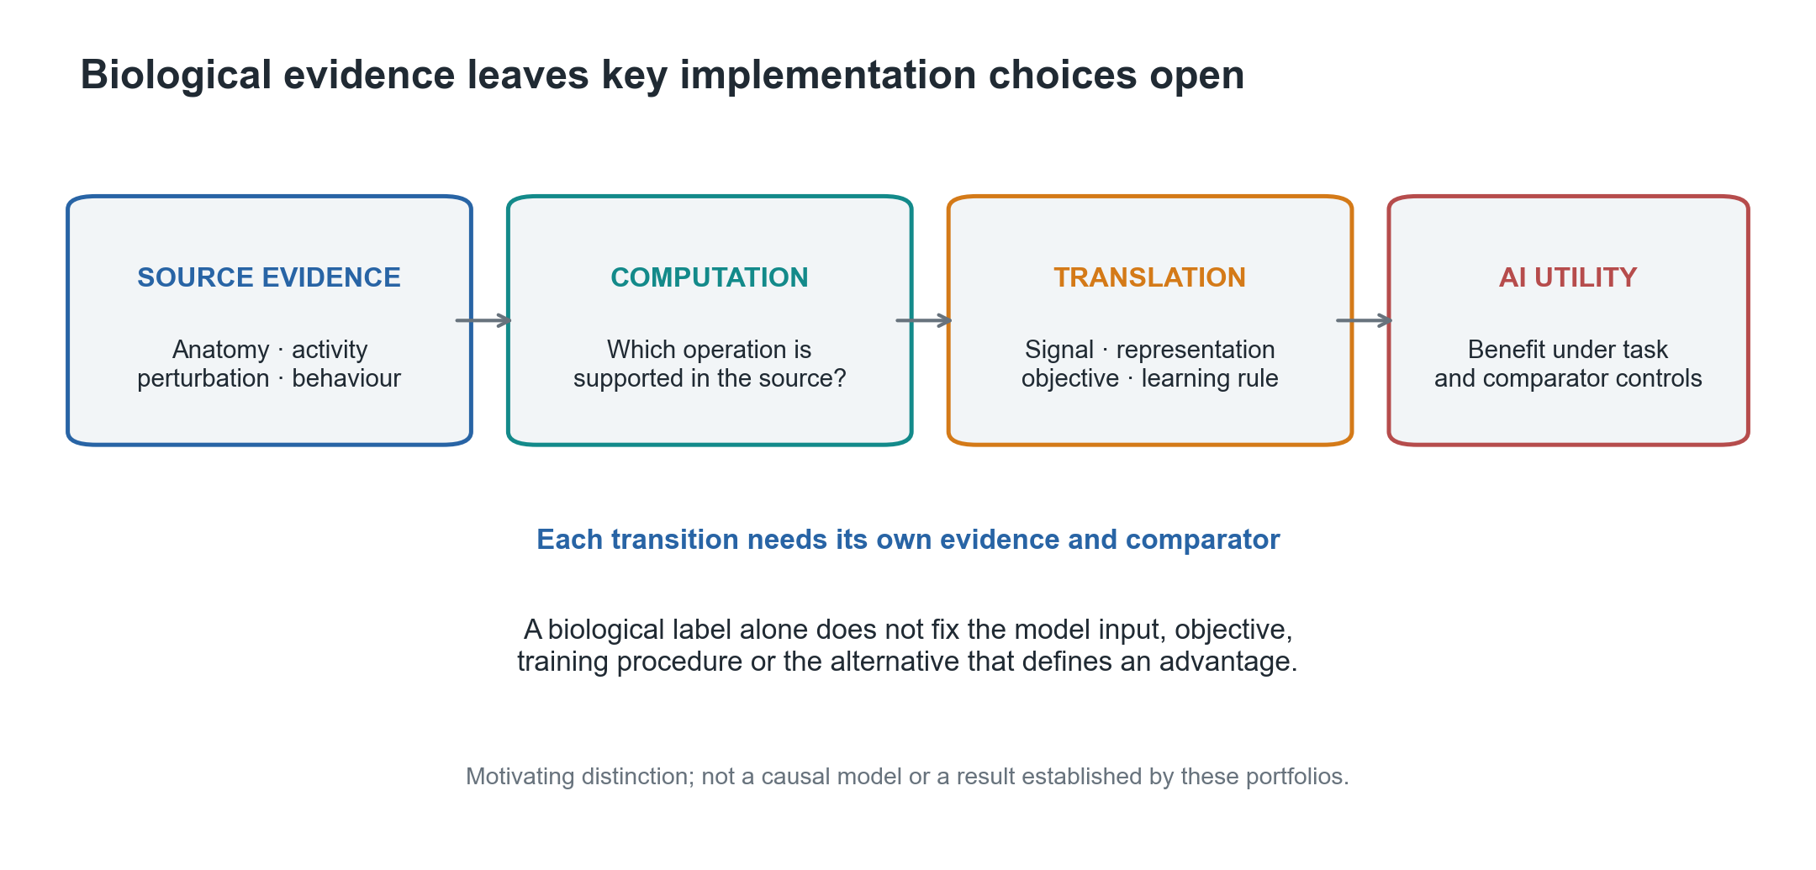
Figure 1 | Why biological provenance does not specify artificial utility. Source anatomy, activity, perturbation and behaviour can motivate a computation, but translation still requires choices about signal, representation, objective and learning procedure. Utility is evaluated against a task and comparator set. The diagram motivates the evidence questions; it is not a causal model or an empirical result.

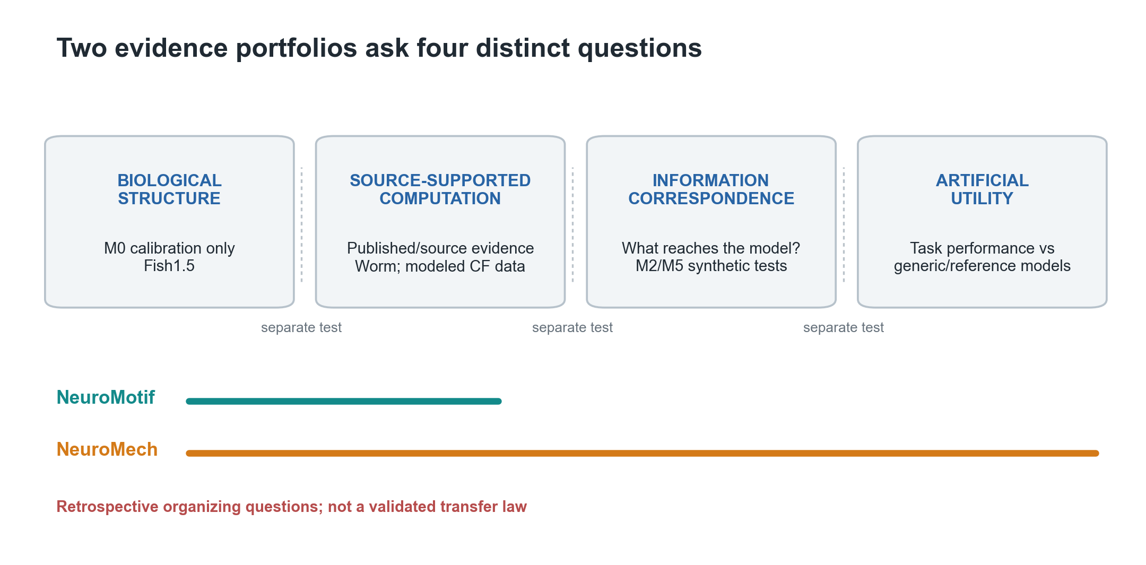
Figure 2 | Retrospective evidence framework for the NeuroMotif and NeuroMech portfolios. Four columns distinguish biological structure, source-supported computation, information correspondence and artificial utility. Colored bars indicate which portions of this retrospective portfolio each project addressed; dotted separators mean each transition requires a separate test. The arrangement is a proposed evidence map, not a causal chain, validated hierarchy or law. The two bars depict the NeuroMotif and NeuroMech portfolios only; the third programme added on 9 October 2026 is not represented in this figure, and its coverage and outcome are given in Supplementary Table S11.

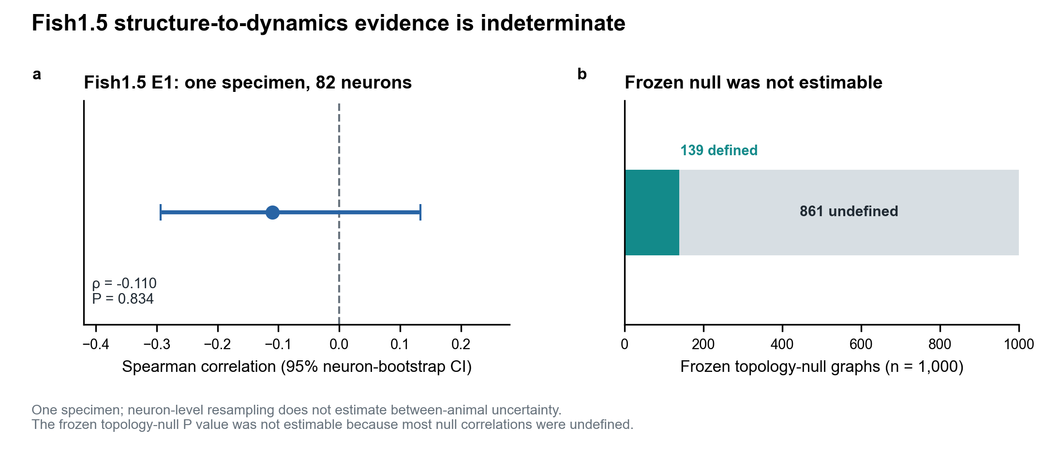
Figure 3 | Fish1.5 structure-to-dynamics evidence. (a) Recurrence–persistence Spearman correlation in one specimen and 82 structurally complete neurons (ρ = −0.110; 95% neuron-bootstrap CI, −0.293 to 0.134; positive-direction permutation P = 0.834). (b) Of 1,000 frozen topology-null graphs, 139 yielded defined correlations and 861 did not; the topology-null P value was not estimable. Neuron-level resampling does not represent between-animal uncertainty.

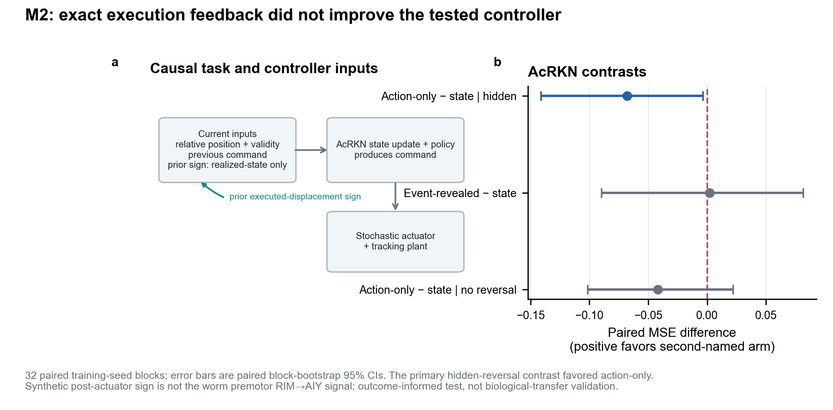
Figure 4 | Synthetic actuator-observability test. (a) The two AcRKN arms differ in whether the controller receives the exact sign of the preceding executed displacement. (b) Paired seed-block mean-MSE contrasts (first arm minus second; positive values favour the second, lower-MSE arm; n = 32). Points show means and bars show paired seed-block bootstrap 95% confidence intervals. Only the hidden-reversal primary contrast excluded zero, favouring action-only input. This synthetic post-actuator signal is distinct from worm premotor RIM→AIY signalling; the test was outcome-informed.

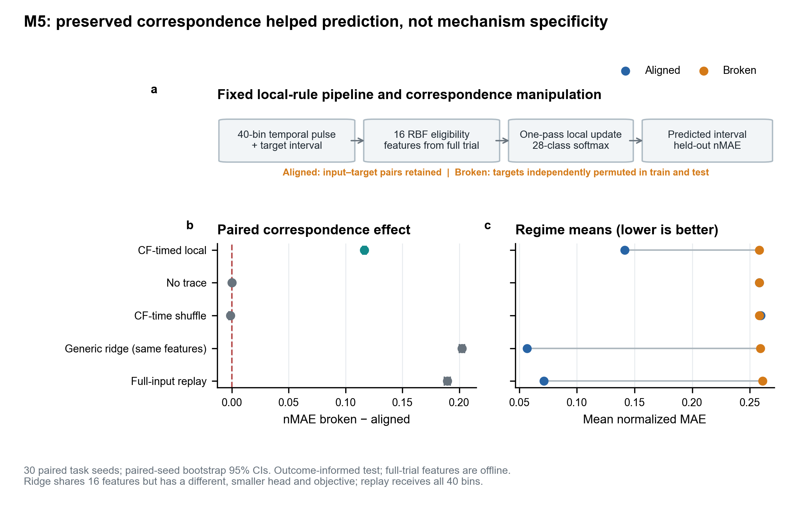
Figure 5 | M5 synthetic temporal-correspondence test. (a) Input, eligibility features, local update and aligned or broken target correspondence. (b) Paired task-seed nMAE effects (broken minus aligned; positive values favour preserved correspondence; n = 30). Points show means and bars show paired task-seed bootstrap 95% confidence intervals. (c) Mean nMAE by regime (lower is better); row order matches panel b. Ridge shares features with the local rule but differs in head, objective and fitting; replay receives all input bins. The result is task-specific and does not establish mechanism specificity.

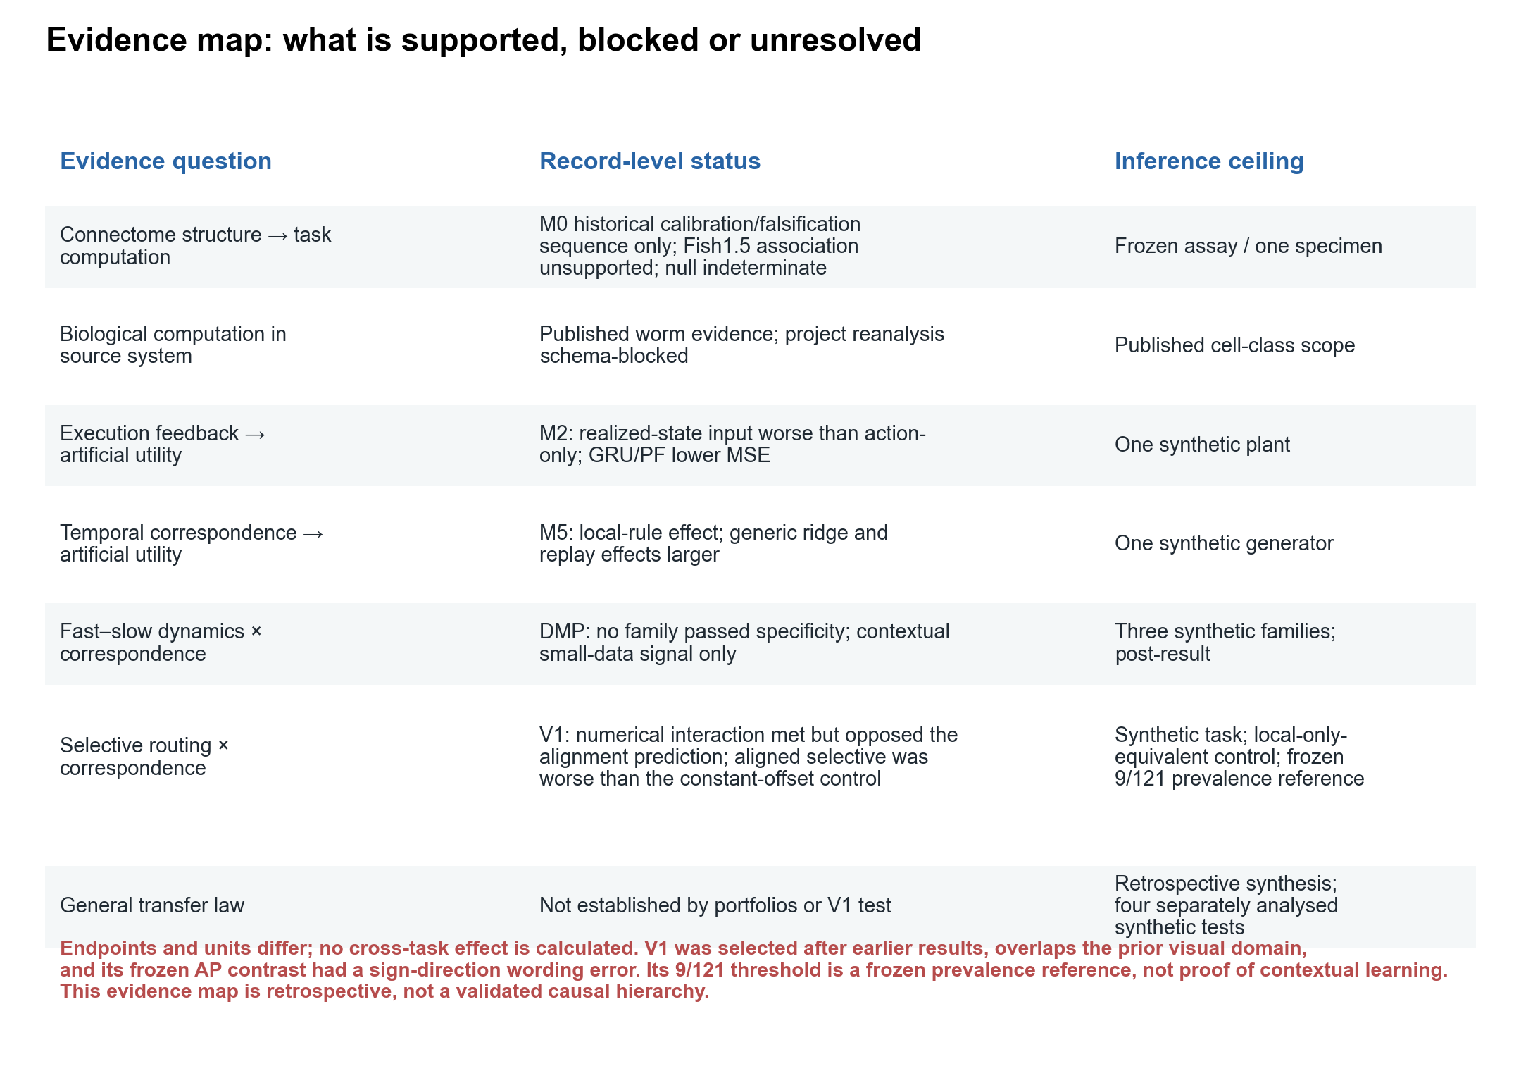
Figure 6 | Evidence status and inference ceilings. Rows identify distinct questions and their supported scope. M2, M5, DMP and the visual-cortex-inspired test retain separate endpoints and units. In the visual test, the nominal global-context control became a constant-offset, effectively local-only control after channel normalization. The positive broken-minus-aligned interaction passed its numerical condition but opposed the prose prediction; lower aligned selective AP failed the conjunctive gate. Passing the prevalence-reference criterion did not establish contextual learning. “Not established” marks an evidence limit, not proof of absence. The map is a retrospective organizing proposal.

