

**FACULTY OF TECHNOLOGY**

**BACHELOR OF SCIENCE IN INFORMATION TECHNOLOGY**

**UNIT: PROJECT PROGRAMMING**

**PROJECT TITLE: LIBRARY MANAGEMENT SYSTEM FOR WAGBERI HIGHSCHOOL**

**DOCUMENT: SYSTEM DESIGN SPECIFICATION FOR A LIBRARY MANAGEMENT SYSTEM DOCUMENT**

**NAME: YUSSUF AHMED YASSIN**

**ADM NO: 21/05125**

**SUPERVISOR: DR. SIMON N. MWENDIA**

**DATE: 03/10/2023**

Contents

1. PURPOSE AND SCOPE 4

1.1. Scope. 4

2. SYSTEM OVERVIEW 4

2.1. Level 0 Data Flow Diagram. 4

2.2. Level 1 Data Flow Diagram. 5

3. SYSTEM ARCHITECTURE. 6

3.1. System components. 6

4. SOFTWARE DESIGN. 7

4.1. Pseudocode and flowcharts for processes in level one DFD. 7

4.1.1. Viewing Books pseudocode. 7

4.1.2. Viewing Books flowchart. 8

4.1.3. Managing Books. 9

4.1.4. Managing Books flowchart 10

4.1.5. Managing users. 11

4.1.6. Managing users flowchart 11

5. DATABASE DESIGN 12

5.1. Database 12

5.2. Refined logical model 12

5.3. A physical description of the DBMS schemas 13

5.4. Access methods 14

5.5. Database updates 14

6. HUMAN-MACHINE INTERFACE 15

6.1. System Input Interface Design 15

6.2. System output Design 15

7. SYSTEM INTEGRITY CONTROLS. 16

8. REFERENCES 17

# PURPOSE AND SCOPE

The purpose of this SDS document is to give insight into the design of the Library management system. This document will contain information about the system architecture and design considerations. The contents of this document are from the requirements outlined in the previous SRS document. This document will also be used as a reference for coding.

## Scope

This document only describes the system design and architecture, the application interactions with users and other systems. Additionally, it defines the application components and how they interact with each other, communicate etc.

# SYSTEM OVERVIEW

This section describes the system overview using several diagrams.

## Level 0 Data Flow Diagram

This is the basic overview of the whole library management system being modeled.

**Main entities of the level 0 dataflow diagram**

* Managing all the library
* Managing all the books
* Managing all the book issues
* Managing all the authors
* Managing all the publishers
* Managing the students

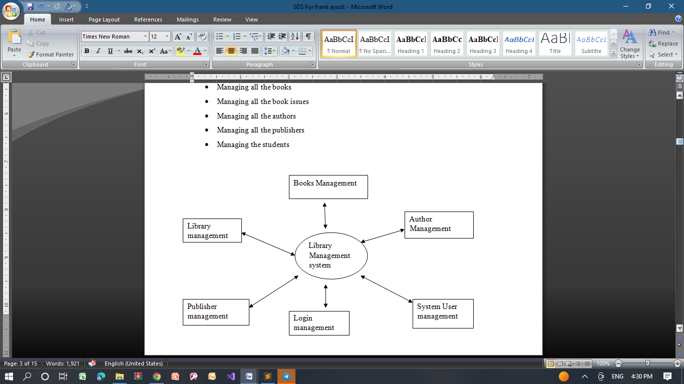

Figure 1: Level 0 DFD

Level 1 Data Flow Diagram.

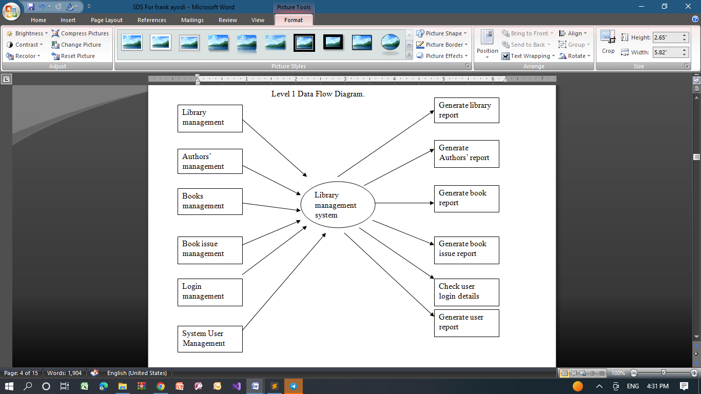

Figure 2: Level one DFD

The level one DFD is a breakdown of the context diagram. It goes on to describe the specific activities, processes, data, components and actors in the system.

**Main entities of the level one DFD**

* **Processing library records and generate report of all library**
* **Processing book records and generate report of all books**
* **Processing issue book records and generate report of all issue books**
* **Processing Authors records and generate report of all authors**
* **Processing publisher records and generate report of all publishers**
* **Processing student records and generate report of all students**

# SYSTEM ARCHITECTURE

System architecture is the organization of the Wagberi highschool Library management system components. The architecture describes the interactions between the application components which are; users, servers etc. The diagram below portrays the general system architecture.

Users

Fig 3.1 System architecture

Data Base

Application

Server

Interface

## System components

Database is the data storage component for this system it contains all data pertaining to the website that is the website users including all students, library staff and Admin. Additionally, it is a repository for all books posted in the system.

The application server connects the database to its users by issuing user requests and delivering database results. It is the central component connecting the mobile application (users) to the database.

The website offers a friendly GUI this is to improve user experience. The website will have different pages according to the respective accounts for a user. For example, the system admin has a different user profile from other users who also have respectively different profiles.

Humans are the users’ aspect of the automated system; they are of different types as discussed in previous documents. They access the system using the website. A user is supposed to have an account to access the automated system. However, the account is specific to the user status, roles and type.

# SOFTWARE DESIGN

This chapter seeks to explain the workings of the software modules the automated system has.

## Pseudo code and flowcharts for processes in level one DFD.

### Viewing Books pseudo code

The user now has access to the system.

* + - 1. User opens website.
      2. The application’s homepage contains the school’s general Books in order of priority and urgency. A user selects Books to view additional information.
      3. The user navigates to their personal page which has their course related Books. The user can also use a search function to view Books of interest to them.
      4. The user can navigate between Books using controls offered by the view.
      5. User exits application when content.

### Viewing Books flowchart

Start

The Major book topics are displayed

Select specific book

View the books

YES

Continue viewing books

NO

End

### Managing Books (Admin)

This process is for the admin

1. Open website.
2. Navigate to personal page -> personal posts.
3. The Admin has multiple actions to take here: post/upload, update or delete a book. Uploading; the user attaches a Book as a text file and offers a brief description of the Book. Updating; the Admin attaches a file to replace the current Book and confirms the replacement. Deleting the Admin selects the Book and on an options menu chooses delete option and confirm deletion.
4. End of process.

### Managing Books flowchart

Start

The Major book topics are displayed

Navigate to settings

Set user preferences

Continue viewing notices/settings

YES

NO

End

### Managing users

Process for Admin.

1. Open website.
2. Navigate to personal page which offers a variety of administrative functions which include managing users.
3. The admin selects the manage users option which offers to block or deactivate a user.

This action will disable the account in that they cannot access the system.

1. The admin confirms the action and quits the application.

### Managing users flowchart

Start

Public books topics are displayed

Select settings

Continue viewing user accounts

End

NO

View different users

YES

# DATABASE DESIGN

## Database

MySQL has been identified as the database to be used for this application. The general objective is to make database access easy, quick, inexpensive, and flexible for the user. Normalization will be done to get internal consistency of data and to have minimum redundancy and maximum stability. This ensures minimizing data storage required, minimizing chances of data inconsistencies and optimizing for updates.

## Refined logical model

Books

Users

User Books

views

Fig 5.1 Entity relationship diagrams.

Books – this is a data table for all the Books sent to the library management system. The Books’ intended audience views the Books from the library management system.

Users – this is a data table for all the application users, includes faculty members, students the admin etc.

User Books – this data table maps Books with their respective posters enabling the generation of reports on the amount of reach the Book has for example.

## A physical description of the DBMS schemas

Database table schema:

The default Book table is;

|  |  |  |
| --- | --- | --- |
| **Attribute**  **description** | **example** |  |
| BookID provides unique  identification symbol to Book | 06347655 |  |
| issueDate date of issue of Book | 12-12-22 |  |
| expiryDate date of expiry of Book | 12-12-23 |  |
| expireOrNot if the Book expires or not | yes |  |
| issuer id of the issuer of Book | 067bct001 |  |
| Book Course topic to which course does the book belong to | Computer science |  |
| BookFormat PDF or word  Table 5.3.2 default Book table.  User database:  The default table for users is; | word |  |
| **Attribute**  **dataType** **defaultValuerequired**  **auto_increment** | | **primary_key** |
| userID alphanumeric NONE YES YES | | YES |
| userName char NONE YES NO | | NO |
| password md5 NONE YES NO | | NO |
| BookList alphanumeric NONE NO NO  Table 5.3.2 default user table | | NO |

Data dictionary for the application

|  |  |  |  |  |
| --- | --- | --- | --- | --- |
| **Variable** | **Variable name** | **Variable type** | **Variable Width** |  |
| USER | ID | Numeric | 8 |  |
| Book | Book | PDF/ WORD | n/a |  |

Table 5.3.3 data dictionary

## Access methods

Indexing is a way to optimize the performance of a database by minimizing the number of disk accesses required when a query is processed. It is a data structure technique which is used to quickly locate and access the data in a database.

## Database updates

The databases are updated anytime there is a change in the Books and or users. This means once there is any write operation in the application then the database is updated. The application admin has exclusive rights to access the databases when required.

# HUMAN-MACHINE INTERFACE

The library management system uses minimum user input especially for the students who are the majority. For students, only login details are required for them to input. However, it is not the case for other user types like the admin who is required to constantly post Books onto the automated library management system. On the other hand, output is mainly by use of PDF or Word documents. Additionally, there could be a feedback module that shows a report on how a Book has been borrowed by the students. Application samples are not available at the moment but will be included in this document once the application has been developed.

## System Input Interface Design

This section discusses the inputs viable for this application.

Students; these system users have limited system input capabilities. The two main inputs are login details which are school id as the user name and the date of birth as the password. These are input upon signing in only and won’t be required for the entire application use unless an account is deactivated. The inputs will be captured by the signup screen which has two edit boxes for the two ids.

Books & Admin; their signup input is similar to that of students. Since they have the capability to post Books, they require more user input capabilities. They can post Books in two formats by attaching their files. The two formats are PDF and Word document.

## System output Design

Explains the available system output and formats.

The major output types for this application are PDF and word documents. The two are the most preferred ways of propagating Books in the current manual system. The files are downloadable and therefore can also be communicated via social media. Toast messages will be used to convey system messages e.g. errors occurred, successful logins etc.

# SYSTEM INTEGRITY CONTROLS.

Due to the sensitive nature of school information it is advisable to manage the automated system application separately from other heavy school systems. The inputs provided by users do not necessarily constitute a serious threat to the users. However, the application development will follow legal requirements regarding the use of user’s information and its storage. The application will only use the information for the application uses only. The information collected will therefore not be shared any other third party entity apart except with the user’s consent.

# REFERENCES

1. IEEE Recommended Practice for Software Design Descriptions, IEEE Standard 1016–1998.
2. C.YungChang, J.PingSheu “Design and implementation of ad hoc classroom and eSchoolbag systems for ubiquitous learning” IEEE International Workshop on Wireless and Mobile Technologies in Education, Pg. 8 – 14, 2002.
3. D.T Ross, K.E. Jr. Schoman, “Structured Analysis for Requirements Definition” IEEE Transactions on Software Engineering, (Volume: SE-3, Issue: 1) Jan. 1977.
4. J.P.Dixion,” automated systemPro”http://www. automated systempro.com/index.html, 2011.