# How To Setup Renoise foobar2000 Remote Control

## Setup Renoise

1. Install de.airmann.FoobarRemoteControl.xrnx: just drag and drop file into open Renoise window
2. Open Renoise -> Tools -> Toolbrowser
3. Right click on de.airmann.FoobarRemoteControl.xrnx -> reveal in Explorer

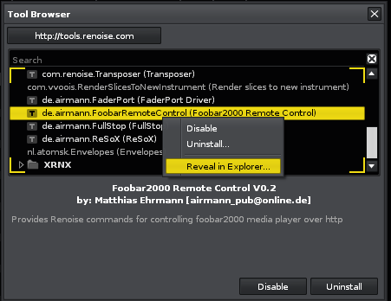

1. **Optional:** open config.xml and adjust foobar2000 http server address and port . Default is localhost:8888
2. remember the folder location foo_httpdcontrol_data. Later on you will need to copy the content of this folder to your foobar2000 profile folder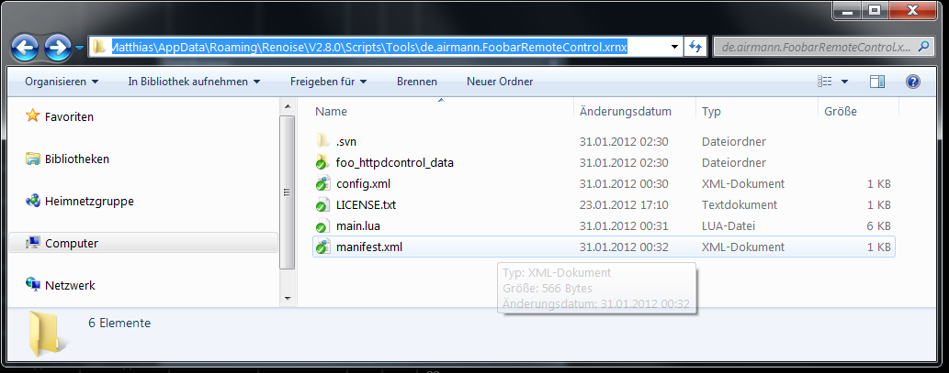
3. Open Renoise -> Preferences -> Keys and search for “fb2k”. Assign the new commands to your personal keyboard shortcuts. Hint: alternatively you can also assign some midi mappings. In this case open midi map dialog and search for “fb2k”

## Setup foobar2000

1. Download latest http control component from [http://code.google.com/p/foo-httpcontrol/](http://code.google.com/p/foo-httpcontrol/%20)
2. Add component to foobar2000 component folder and restart foobar2000
3. Open foobar2000 preferences -> Tools -> HTTP Control
4. **Optional:** define ip address and port number for http control server, default is localhost:8888
5. Open Home Directory

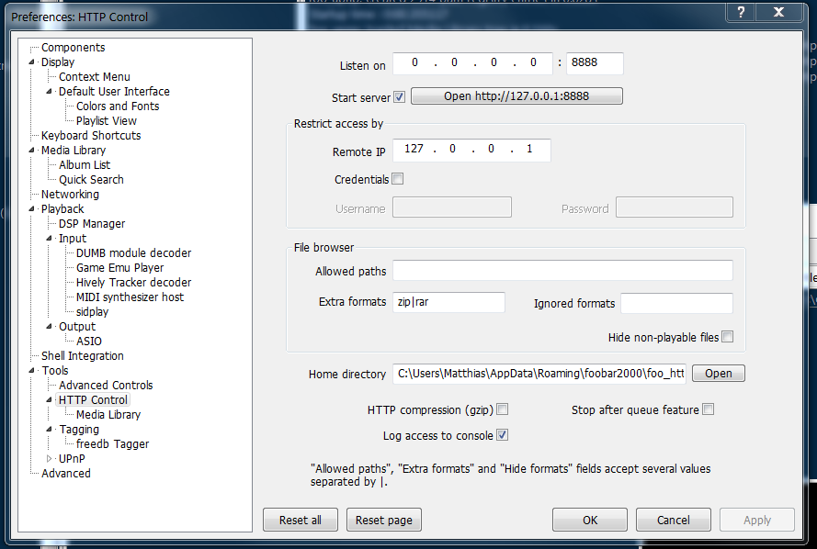

1. Copy the above mentioned folder location foo_httpdcontrol_data into your foobar2000 profile folder
2. That’s it. Now you can test if everything works by just pressing your new keyboard shortcuts / midi mappings in Renoise.
3. If you have the problem that Renoise and foobar2000 can access the ASIO/MME mixer at the same time, check if the sample rates are the same (probably 44.1 KHz). I recommend to use the foobar2000 ASIO output component.