بسم الله الرحمن الرحيم
How to setup Oracle database 11g to be able to use 4jawaly sms services:
- First of all choose the Oracle user where to install the scripts, I assume that the user is SYSTEM, if you choose another so please make the appropriate changes accordingly.
- We need to make an access control, I named it jawaly.xml ( not mandatory ) for user system.
- Execute the following script connected as user sys
begin
dbms_network_acl_admin.create_acl('jawaly.xml',
'Jawaly sms services acl',
'SYSTEM',
true,
'connect');
dbms_network_acl_admin.add_privilege('jawaly.xml',
'SYSTEM',
true,
'resolve');
dbms_network_acl_admin.assign_acl('jawaly.xml', '4jawaly.net');
commit;
end;
- Connect as chosen Oracle user, execute the script in file jawaly_services.pks to create the package.

Configure Weblogic application server:

- Make a directory on application server to store the two files jawaly_service.fmb and fmx. I assumed it as "D:\Projects\4Jawaly\Forms\11g";
- We need to make some changes to the configuration on server ( to avoid any problems with your existing configuration, new web configuration section will be created. Please do the steps as below)
- Connect to your Weblogic application server.
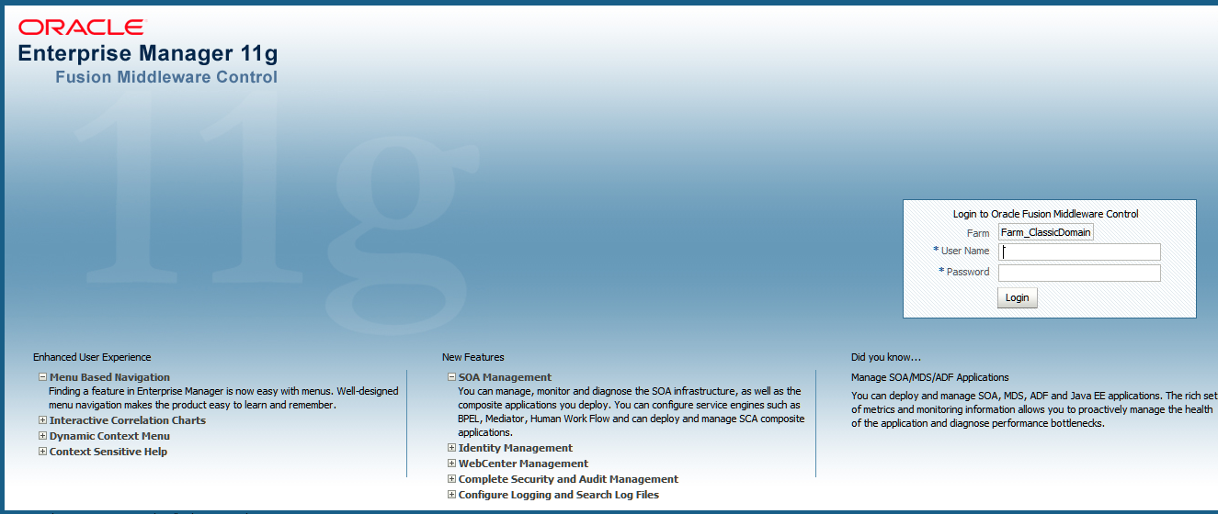
- Click on forms section in the farm tree 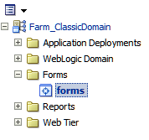
- From the right side of window choose "Environment Configuration"
- Make a duplicate file from default.env and name it as jawaly.env
- Choose jawaly.env from drop down list and navigate to the section forms_path and add the directory D:\Projects\4Jawaly\Forms\11g; to the existing paths.
- Change the section of nls_lang to use UTF8 character set if you want to get the benefit of using any combination of characters in your sms, you may skip this setting but you will be restricted to your local character set. Also change this setting in registry
Run regedit.exe and navigate to the right registry key for Oracle forms/reports and change nls_lang.
For 32 bit installation in 64 bit environment HKEY_LOCAL_MACHINE\SOFTWARE\Wow6432Node\Oracle\KEY_OH1114310874
And for 64 installation
HKEY_LOCAL_MACHINE\SOFTWARE\Oracle\KEY_OH1114310874
- Choose "Web Configuration"
- From the list of your sections choose one and create a new one like it and name it jawaly ( not mandatory)
- 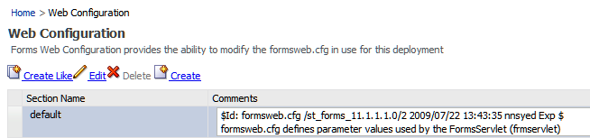
- Navigate to the new section jawaly and choose it.
- Select show "basic" 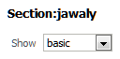
- Make the changes for these three values 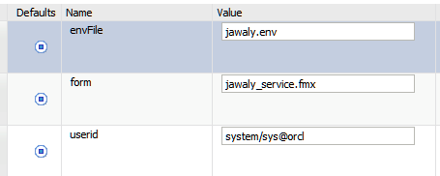

Trying the application:
Please use your favorite internet browser and enter the url to start the application
http://your-server:your-port/forms/frmservlet?config=jawaly
the application will start and the below screen shows the output.
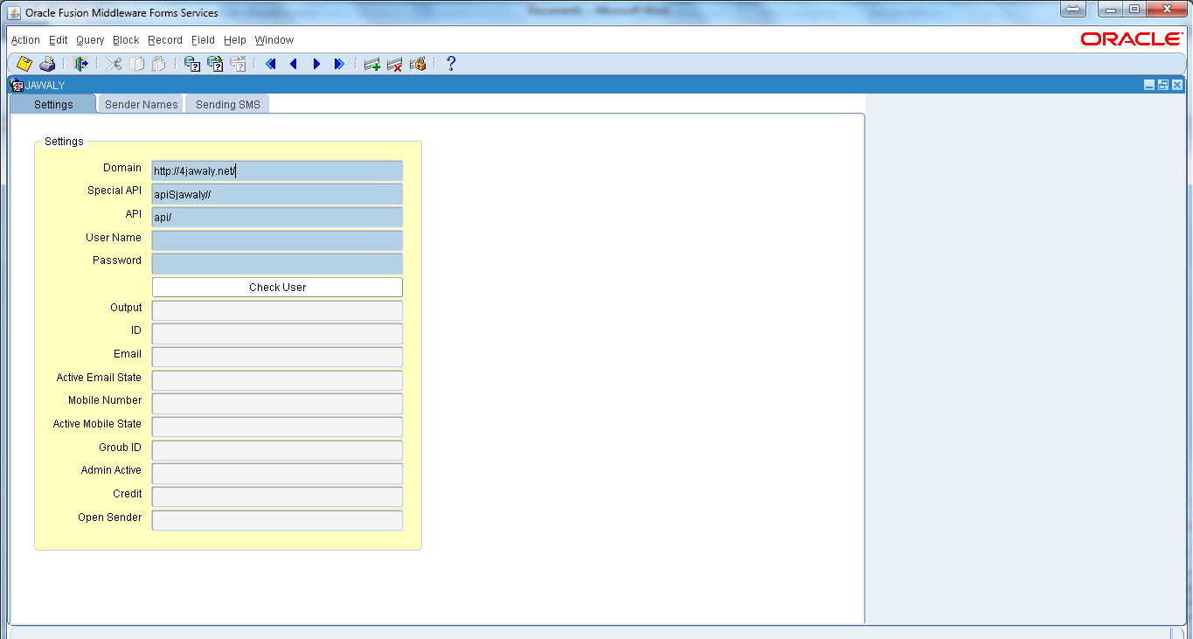
- The first tab is for setting information, provide the following:
Domain | http://www.4jawaly.net/
Special API | apiSjawaly//
API | api/
User Name | A user name given to access the service
Password | The password for the user.

When you click the button "Check User" it will check this user on jawaly server, if it is available the program will give all information in appropriate fields on form.
This user will be used in next operations.

- The second tab is for managing sender names,
- Adding new names.
- Searching for sender names.
- Making a sender as default sender.
- Activating a sender name.
Adding new name:
Put the desired name in the field and hit the button "Add sender".
Searching for sender names:
In the next block fill any part of the name and hit button "Search" to get the result in the below tabular block, you may choose the type of sender from the drop down list to filter the list of senders by categories of (All, Accepted, Rejected, New).
Making a sender as default sender:
When the list of senders are displayed on the screen you can set any sender to be the default sender by ticking the check box "Is Default" at the desired sender name ( it must be in active state as "Accepted").
If a new sender name is new and it belongs to a mobile number so it need to be activated by clicking the "Activate" button for the sender needed, an activate code should be provided and the activation process is done.
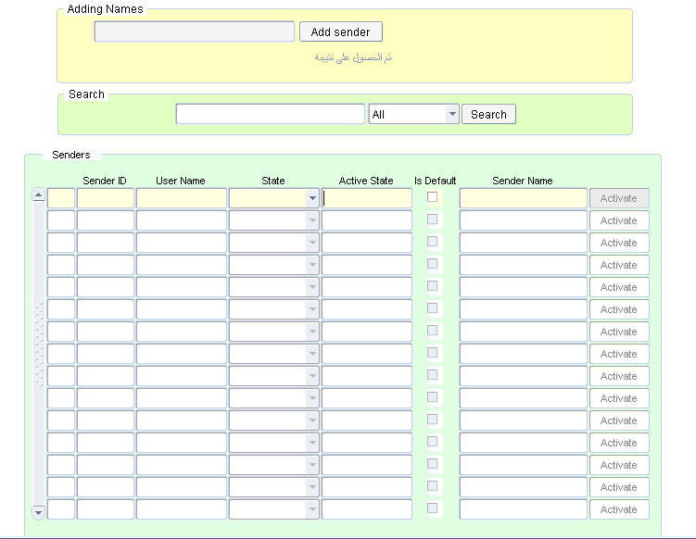

The third tab is for sending an sms to gsm numbers.

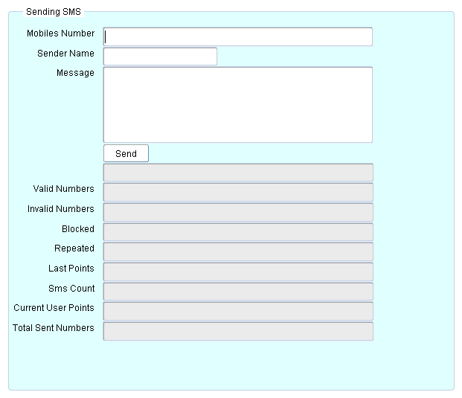
You provide a set of on or many mobile numbers in the field.
The second field "Sender Name" is either a "text box" or a "combo box" according to the type of the sender, if he is an open sender so he can fill and word in this field and when he is not an open sender so a list of active sender names list will be shown here.
Write the sms message in the field and hit the button "Send"
When the operation is successfully done an output information will be displayed on result fields (Valid Numbers, Invalid Numbers, Blocked, Repeated, Last Points, Sms Count, Current User Points, Total Sent Numbers).

