MULTIMEDIA SYSTEMS
WEEK 2 LABORATORY REPORT
Digital Audio Signal Processing, Image/Video Processing and Basic Digital Audio Synthesis
PART A: Digital Audio Generation and Analysis

Activity A1: Generate a Sampled Sine Wave
Given: fs = 44,100 Hz, duration = 2 s, frequency = 440 Hz, amplitude = 0.5.
Expected number of samples:
N = fs × duration = 44,100 × 2 = 88,200 samples.
Result from the program = 88,200 samples.
Because of discrete sampling, the exact printed extrema can be very slightly different from ±0.5.
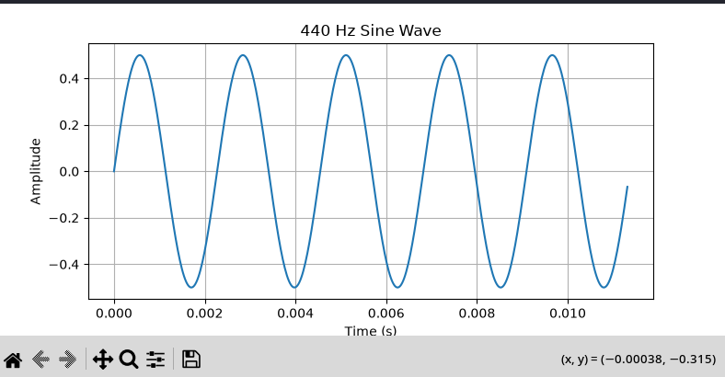
figure A1
Figure A1: 440 Hz sine wave, amplitude 0.5.
When frequency is changed from 440 Hz to 880 Hz, the waveform completes twice as many cycles in the same time interval. The pitch is therefore higher.
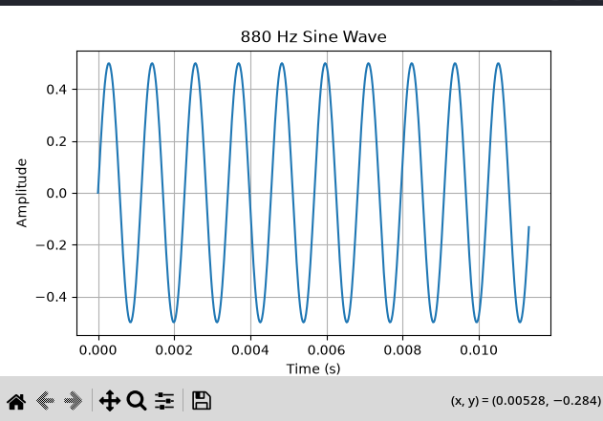
Figure A2: 880 Hz sine wave.
When amplitude is changed from 0.5 to 0.25, the frequency remains 440 Hz, so the number of cycles does not change. The waveform becomes vertically smaller and the signal level is reduced.
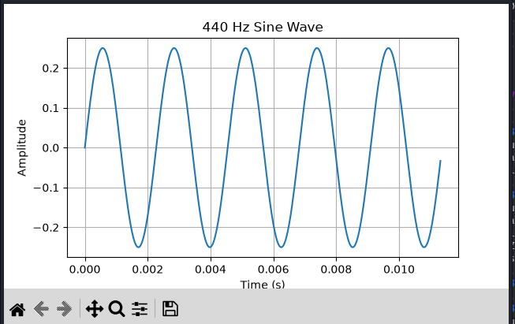
Figure A3: 440 Hz sine wave with amplitude 0.25.

Activity A2: Sampling Rate Experiment
Sampling rate | Duration | Samples
8,000 Hz | 1 second | 8,000
22,050 Hz | 1 second | 22,050
44,100 Hz | 1 second | 44,100
a) For a fixed duration, increasing the sampling rate increases the number of samples in direct proportion to the sampling rate.
b) Nyquist minimum sampling rate for a 440 Hz tone = 2 × 440 = 880 Hz theoretically. A practical system normally uses a higher rate.
c) 44.1 kHz produces more data than 8 kHz because it stores 44,100 samples per second instead of 8,000 samples per second.

PART B: Digital Audio Processing

Activity B1: Amplitude Scaling and Clipping
Original signal peak = 0.5.
Gain 0.5: peak expected = 0.5 × 0.5 = 0.25.
Gain 1.5: peak expected = 0.5 × 1.5 = 0.75.
Gain 3.0: expected peak = 0.5 × 3.0 = 1.5, which exceeds the normalized range of [-1, 1].
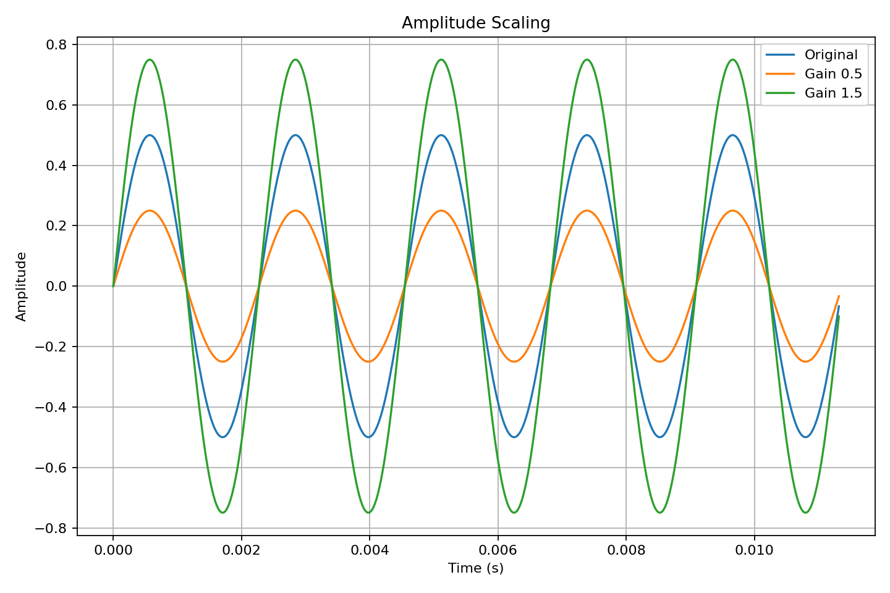
Figure B1: Original, reduced-gain and increased-gain signals.
Clipping limits samples outside [-1, 1] to the nearest boundary. A gain of 3 therefore creates flat portions around the peaks. This changes the waveform shape and introduces distortion, which can be audible.

Activity B2: Mixing Two Audio Signals
The two tones are 440 Hz and 660 Hz, each with amplitude 0.5. The 50/50 mixture is:
mixed = 0.5 × tone1 + 0.5 × tone2.
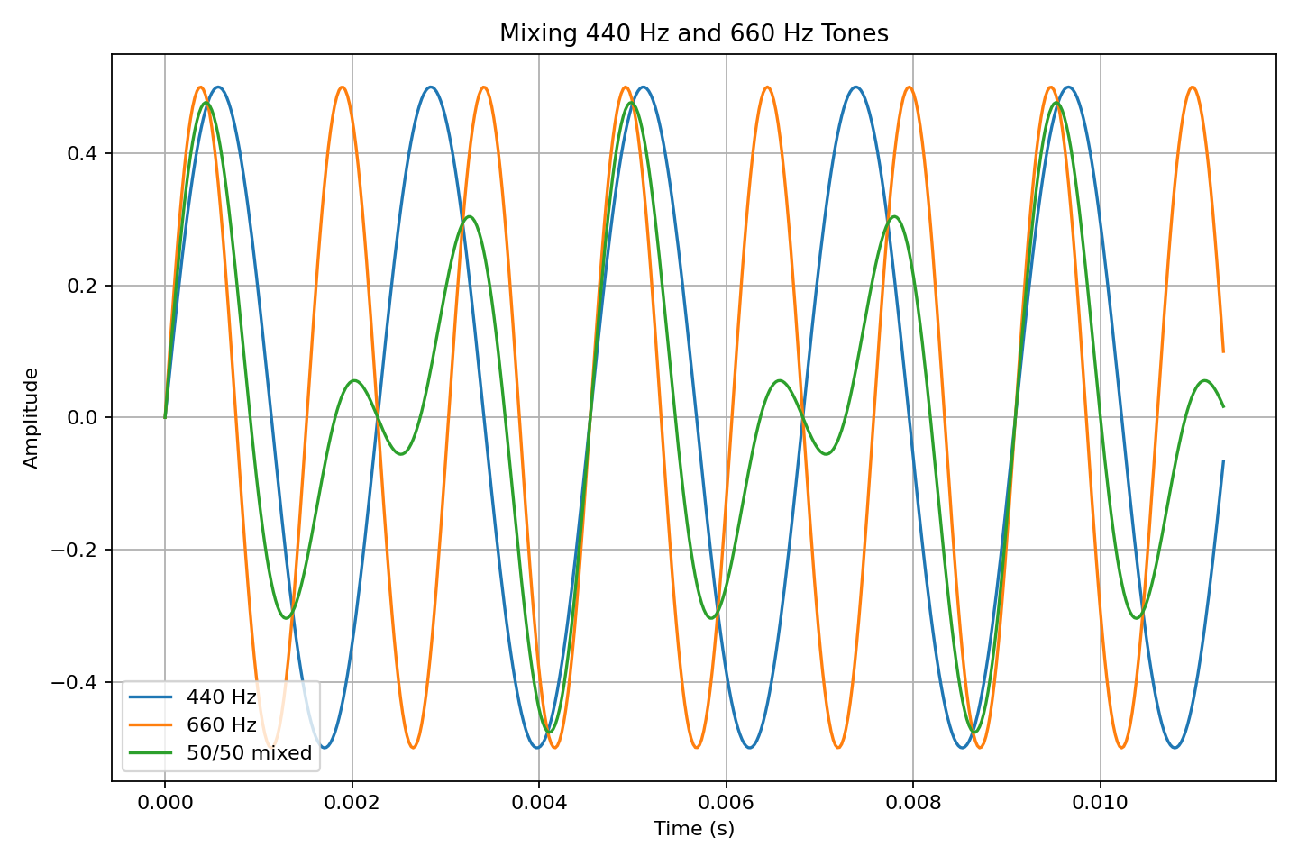
Figure B2: 440 Hz, 660 Hz and their 50/50 mixture.
With weights changed to 0.8 and 0.2, the 440 Hz component becomes more dominant because its contribution is four times the contribution of the 660 Hz component.

Activity B3: Delay and Echo
For fs = 44,100 Hz and delay = 0.25 s:
delay samples = 0.25 × 44,100 = 11,025 samples.
Other delays: 0.10 s = 4,410 samples; 0.50 s = 22,050 samples; 0.75 s = 33,075 samples.
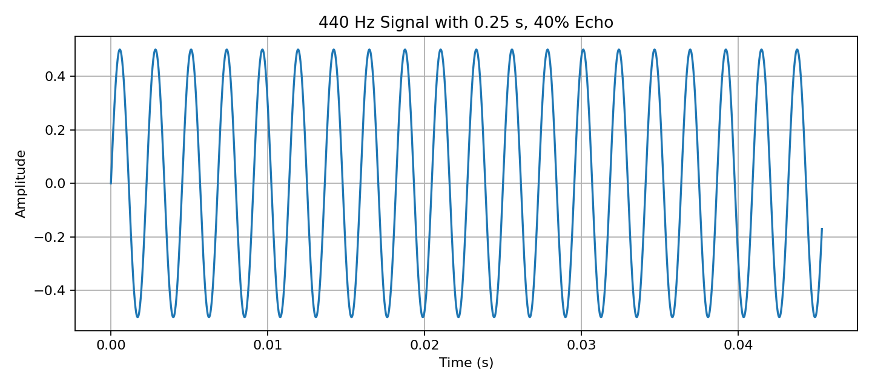
Figure B3: 0.25-second delay with 40% echo.
For the 0.25-second, 40% echo, the discrete-time expression is y[n] = x[n] + 0.4x[n − 11,025] for n ≥ 11,025; before that delayed term exists, y[n] = x[n].
Increasing delay makes the echo occur later. Increasing echo strength makes the repeated signal bigger

PART C: Image Point Processing

Activity C1: Load and Inspect an Image
image height = 404
image width = 52
number of channels = 3
minimum pixel value = 0
maximum pixel values = 229

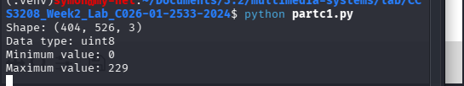

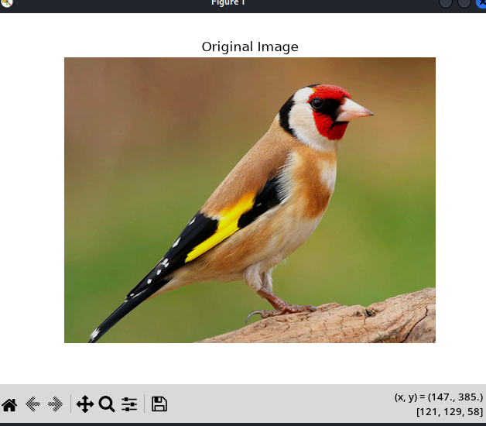

Explanation: A colour image array has dimensions height × width × 3, where the three channels represent red, green and blue(RGB channel). Brightness adjustment is a point operation because each pixel can be changed independently. Clipping is necessary to keep 8-bit RGB values within 0–255.

Activity C2: Brightness adjustments

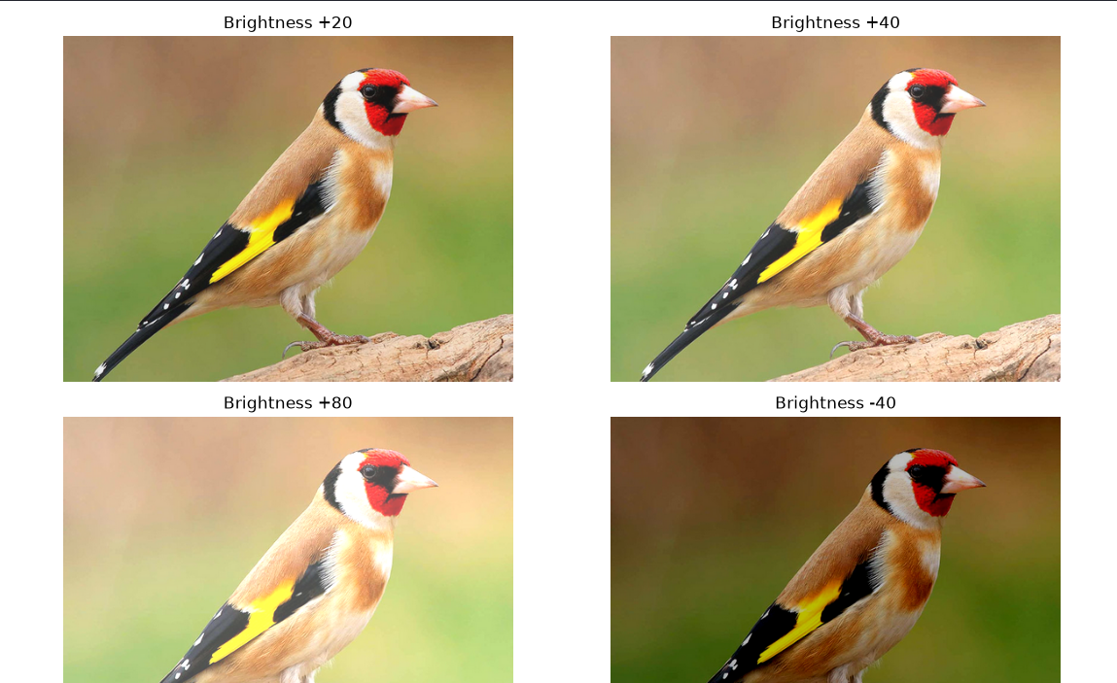

Explanation: Clipping is necessary because an 8-bit RGB image can only represent values from 0 to 255.
Without clipping, adding brightness could produce values greater than 255. Such values cannot be correctly represented as normal uint8 pixel values.

Activity C3: Image Negative

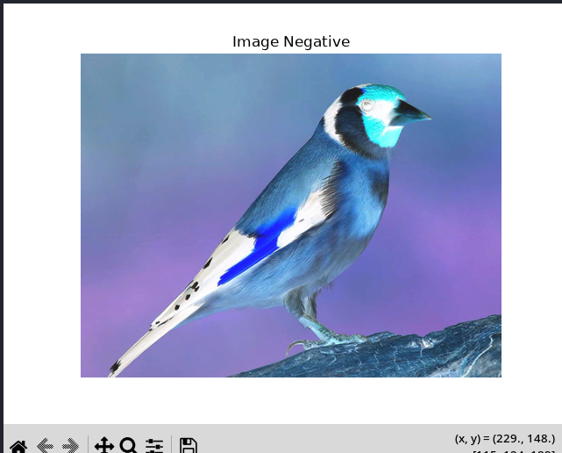
Calculation 1:
255−50=205
Therefore, an original pixel value of 50 becomes 205.
Calculation 2:
255−200=55
Therefore, an original pixel value of 200 becomes 55.

Explanation
The image negative is created using:
negative = 255 - img
Every RGB value is subtracted from 255. Consequently, dark areas of the original image become bright, while bright areas become dark.

Activity C4: Gray Scale and Thresholding


Original image shape: (404, 526, 3)
Grayscale image shape: (404, 526)
Grayscale minimum: 0
Grayscale maximum: 229
Explanation:
Thresholding converts a grayscale image into a binary image containing only black and white pixels. A pixel whose intensity is greater than or equal to the selected threshold is assigned a value of 255 (white), while a pixel below the threshold is assigned a value of 0 (black). At a lower threshold such as 80, more pixels are classified as white. Increasing the threshold to 128 and 180 causes more pixels to be classified as black because fewer pixels satisfy the threshold condition.

PART D: Image Neighbourhood Processing

Activity D1: Manual Mean Filtering
Given neighbourhood:
20 20 20
20 80 20
20 20 20
Sum = 20 + 20 + 20 + 20 + 80 + 20 + 20 + 20 + 20 = 240.
Mean = 240 / 9 = 26.67 (approximated).
New centre pixel value = 26.67
The centre value changes substantially because the mean filter replaces the centre with the average of its surrounding neighbourhood, reducing the effect of the unusually high value 80.

Activity D2 Smoothing with openCV


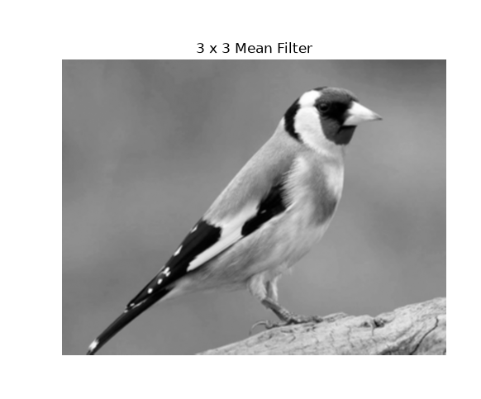

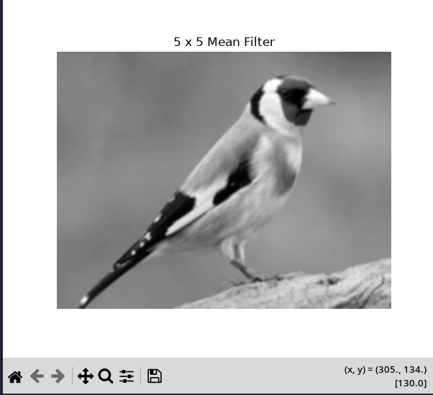

Comparison
Original grayscale | 3 × 3 mean filter | 5 × 5 mean filter
Contains the most detail. | Slightly blurred. | More blurred than the 3 × 3 result.
Edges are relatively sharp. | Small noise and intensity variations are reduced | Fine details are reduced further.
Fine variations are visible. | Most major details remain visible. | Edges become softer.

Which is more blurred
The 5 × 5 mean-filtered image appears more blurred.

Why does increasing the neighbourhood size increase smoothing
A 3 × 3 filter averages 9 pixels around each pixel.
A 5 × 5 filter averages 25 pixels.
The larger filter includes more neighbouring pixels in the calculation. This reduces local intensity variations more strongly, resulting in greater smoothing and blur.

One benefit
Noise reduction: Smoothing can reduce small random variations and noise in an image.

One disadvantage
Loss of detail: Smoothing can remove fine details and make important edges less sharp.

Activity D3: Sharpening with convolution
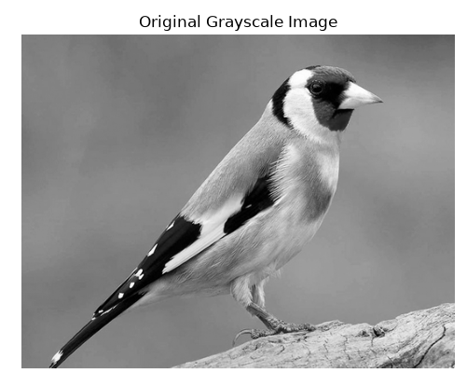
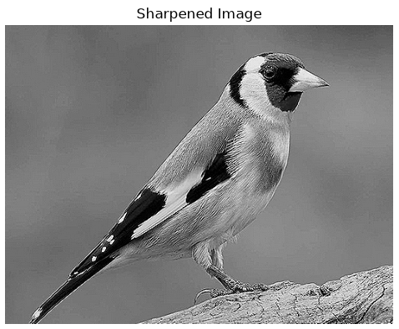

Manual Sharpening Calculation
Centre value = 20 and four direct neighbours = 10.
The neighbourhood can be represented as:
10
10 20 10
10
The kernel Is:
0 -1 0
-1 5 -1
0 -1 0
Therefore:

Answer
Output = 60
So the centre pixel changes from:
20 → 60

Why can sharpening make noise more visible
Sharpening emphasizes rapid changes in pixel intensity.
Noise often appears as small, sudden intensity changes between neighbouring pixels. Because the sharpening operation emphasizes these changes, it can enhance not only genuine edges and details but also unwanted noise.

PART E: Digital Video Processing

Activity E1: Inspect Video Properties
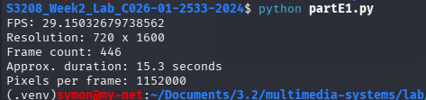

Duration calculation
The formula is:
Duration = Frame Rate / Frame Count​
For example, if your video has 300 frames at 30 FPS:
Duration = 446/29.15032
Duration=15.3 seconds

Number of pixels in one frame
The formula is:
Pixels=Width * Height
1600 * 720 = 1152000 pixels

Why do higher resolution and frame rate require more processing
Higher resolution means that each frame contains more pixels. Therefore, more data must be read, processed, stored and displayed.
Higher frame rate means that more frames must be processed every second.

Activity E2: Extract and Process Frames
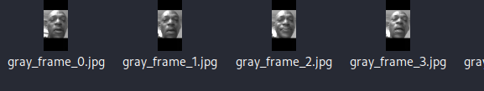

How does this demonstrate frame-by-frame processing
Digital video consists of a sequence of individual frames displayed rapidly over time. In this activity, OpenCV reads the video one frame at a time using cap.read(). Selected frames are then converted from colour to grayscale and saved as separate image files. This demonstrates that video processing can be performed by individually processing each frame in the video sequence.

Real-time processing calculation
If the video is 30 FPS, calculate the maximum time available per frame for real-time processing.
The formula is:
Time per frame=FPS / 1​
For 30 FPS:
1 / 30 ​=0.0333 seconds
Therefore:
0.0333×1000=33.33 ms

Answer:
At 30 FPS, approximately 33.33 milliseconds are available to process each frame in real time.
If processing takes longer than this consistently, the system may not keep up with the incoming video stream.

Two examples of temporal processing
Temporal processing uses information from multiple frames over time, rather than only the current frame.
Two examples are:

1. Motion detection
Compare the current frame with a previous frame to identify changes caused by moving objects.

2. Video stabilization
Information from multiple consecutive frames can be used to estimate camera movement and compensate for unwanted motion.

Activity E3: Resize a Video Frame
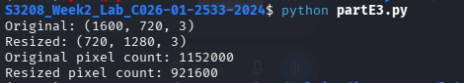

Pixel-count calculation
If the original is 1920 × 1080:
So the original frame contains:
2,073,600 pixels
For 1280 × 720:
So the resized frame contains:
921,600 pixels
contains significantly fewer pixels.
Effect of resizing to a smaller resolution

1. Detail
Reducing resolution generally causes some loss of fine detail, because fewer pixels are available to represent the image.

2. Processing load
A smaller image contains fewer pixels, so operations such as filtering, detection and transformation generally require less computational processing.

3. Storage
A smaller image generally requires less storage space, especially when saved using the same format and comparable compression settings.

4. Bandwidth
For video transmission, smaller frames generally require less bandwidth, making them useful when network bandwidth is limited.

PART F: Digital Audio Synthesis and Integration

Activity F1: Synthesize Different Waveforms
A 440 Hz sine wave was generated at 44.1 kHz with amplitude 0.5.
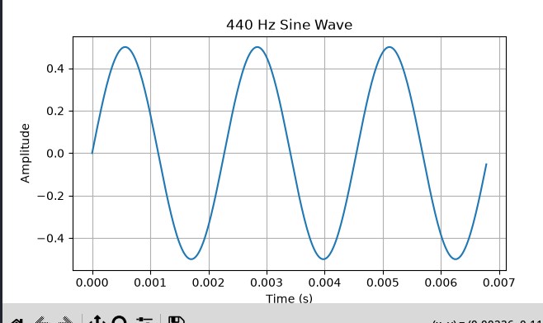

Frequency determines the repetition rate and is associated with perceived pitch. Amplitude determines signal level. A 220 Hz tone has a lower pitch than 440 Hz, while 880 Hz has the highest pitch of the three.

Activity F2: Additive Synthesis
Fundamental = 440 Hz at amplitude 0.5; second harmonic = 880 Hz at amplitude 0.25; third harmonic = 1320 Hz at amplitude 0.125.
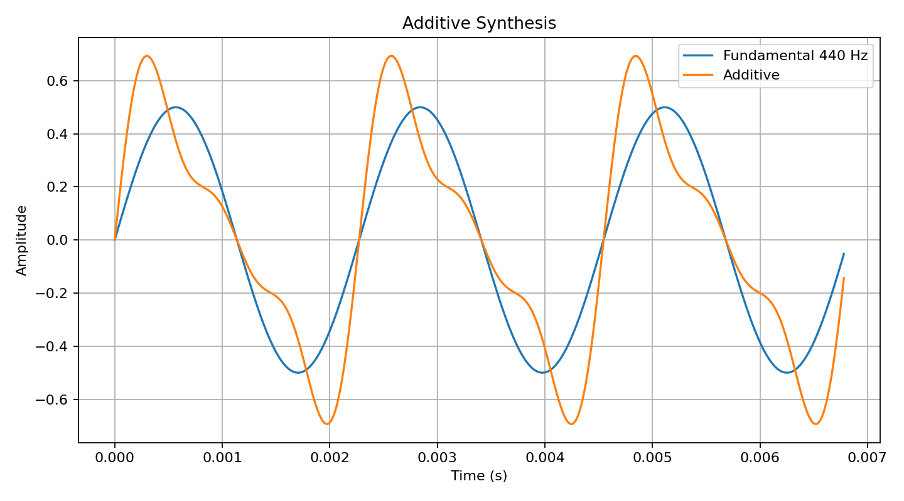

Identify the frequencies
Component | Frequency | Role
Fundamental | 440 Hz | Fundamental frequency
2nd harmonic | 880 Hz | 2 × 440 Hz
3rd harmonic | 1320 Hz | 3 × 440 Hz

Reducing the amplitude of the second harmonic changes the shape of the combined waveform and therefore changes its timbre.
Adding harmonics changes the instantaneous amplitude at different points in time. This produces a different waveform and consequently a different sound character.

Activity F3: Simple ADSR Envelope
The envelope uses attack = 0.10 s, decay = 0.15 s, sustain level = 0.7 and release = 0.20 s.
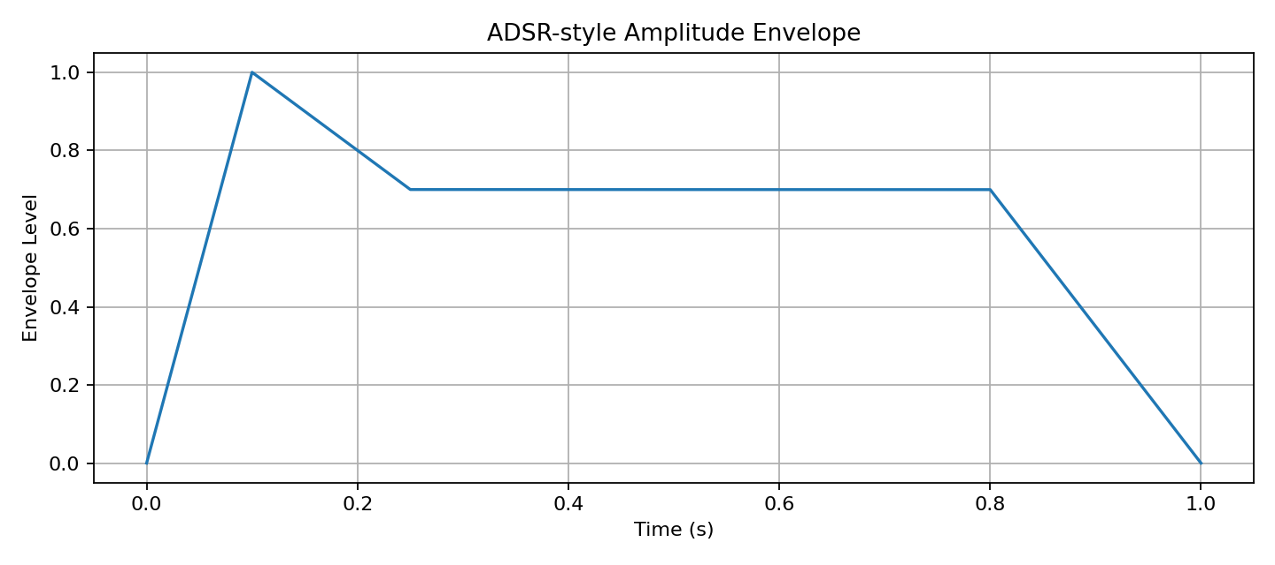
Attack is the initial rise from zero to maximum. Decay reduces the level from maximum to the sustain level. Sustain maintains approximately 0.7 until the release begins. Release reduces the level to zero.
Increasing attack from 0.10 s to 0.30 s makes the sound begin more gradually. Reducing sustain from 0.7 to 0.3 makes the sustained portion quieter. The envelope changes the character of the sound because it changes amplitude over time even when oscillator frequency remains unchanged.

Integrated Analysis Questions
1. Common principle
Audio samples, image pixels and video frames are numerical data. A computer can therefore apply mathematical operations to these numerical values to generate, transform, analyse and store multimedia information.
2. Point vs neighbourhood processing
Point processing changes a pixel using its own value, independently of neighbouring pixels; brightness adjustment and negative transformation are examples. Neighbourhood processing uses surrounding pixels; mean smoothing and convolution sharpening are examples.
3. Spatial vs temporal video processing
Spatial processing operates within an individual frame, for example resizing, grayscale conversion or filtering. Temporal processing uses information across multiple frames or time positions, for example motion estimation or temporal averaging.
4. Recorded vs synthesized digital audio
Both are represented as sequences of digital samples and can be processed using the same numerical techniques. Recorded audio captures an existing sound through sampling, while synthesized audio creates sample values mathematically from functions such as oscillators and additive components.
5. Why data increases
Higher audio sampling rate creates more samples per second; higher image resolution creates more pixels per frame; and higher video frame rate creates more frames per second. Therefore more numerical data must be stored, transferred and processed.
6. Operation that can introduce distortion/loss
Excessive gain followed by clipping can distort audio because values beyond [-1, 1] are truncated. Excessive smoothing can also remove image detail by averaging away fine structures.

Student Evidence Checklist
☐ 440 Hz waveform screenshot
☐ 880 Hz waveform screenshot
☐ 0.25-amplitude waveform screenshot
☐ Sampling-rate results
☐ Gain/clipping plots
☐ Mixing plots
☐ Echo experiment results
☐ Original image
☐ Brightness outputs
☐ Negative image
☐ Grayscale and threshold outputs
☐ Manual mean-filter calculation
☐ 3×3 and 5×5 smoothing outputs
☐ Sharpened image
☐ Video properties
☐ At least two original/processed video frame comparisons
☐ Resized frame and pixel-count calculation
☐ Sine synthesis plot
☐ Additive synthesis plot
☐ ADSR envelope plot
☐ Integrated analysis answers

Conclusion
The laboratory demonstrates that multimedia processing is fundamentally numerical. Audio is processed as samples, images as pixels, and video as sequences of frames with spatial and temporal relationships. The experiments show how sampling, amplitude, filtering, synthesis and resolution affect output quality, data volume and computational requirements.

