DEDAN KIMATHI UNIVERSITY OF TECHNOLOGY
SIMULATION AND MODELLING
Week 1 Laboratory: Introduction, Overview and Simulation Tools

Part A: System Identification and Conceptual Modelling

Task 1: System components
Component | Description / Answer
Entity | The student who arrives at the service desk for assistance.
Entity attributes | Arrival time, service time required, service type (registration, fee enquiry or document processing), service start time, completion time, waiting time.
Resource | The single service officer .
Queue | One FIFO waiting line where students wait when the officer is busy.
Events | Student arrival; start of service; completion of service (departure).
State variables | Officer status (busy/idle); number of students in the queue; time the officer next becomes free (previous completion time); simulation clock.

Task 2: Conceptual model
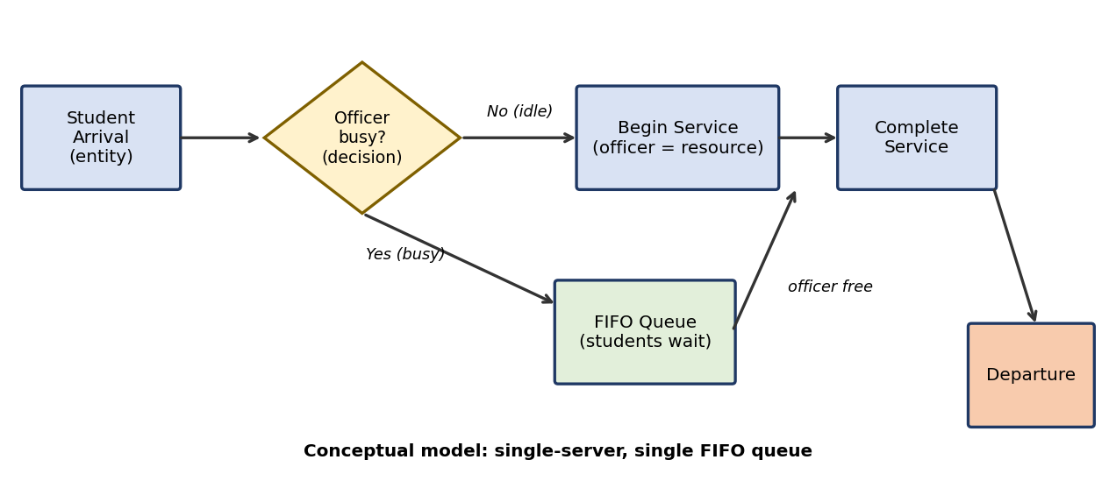
Entity: the student. Resource: the service officer. Queue: the FIFO waiting line. Decision point: "Is the officer busy?" on arrival: if not, service begins immediately; if yes, the student joins the queue and begins service when the officer becomes free.

Part B: Manual Discrete-Event Simulation

Task 3: Event table
Formulas: Start(i) = max(Arrival(i), Completion(i−1)); Completion(i) = Start(i) + Service(i); Wait(i) = Start(i) − Arrival(i); Time in system(i) = Completion(i) − Arrival(i). Completion(0) is taken as 0 since it is the first arrival.
S1:
Start = max(0, 0) = 0; Completion = 0 + 4 = 4
Wait = 0 − 0 = 0; Time in system = 4 − 0 = 4; No Wait
S2:
Start = max(2, 4) = 4; Completion = 4 + 3 = 7
Wait = 4 − 2 = 2; Time in system = 7 − 2 = 5; Waited
S3:
Start = max(4, 7) = 7; Completion = 7 + 5 = 12
Wait = 7 − 4 = 3; Time in system = 12 − 4 = 8; Waited

Student | Arrival | Service | Start | Completion | Wait | Time in System | Wait
S1 | 0 | 4 | 0 | 4 | 0 | 4 | No
S2 | 2 | 3 | 4 | 7 | 2 | 5 | Yes
S3 | 4 | 5 | 7 | 12 | 3 | 8 | Yes
S4 | 5 | 2 | 12 | 14 | 7 | 9 | Yes
S5 | 9 | 4 | 14 | 18 | 5 | 9 | Yes
S6 | 12 | 3 | 18 | 21 | 6 | 9 | Yes
S7 | 14 | 2 | 21 | 23 | 7 | 9 | Yes
S8 | 18 | 4 | 23 | 27 | 5 | 9 | Yes

Task 4: Performance measures
Average waiting time
= total waiting time / 8 = (0+2+3+7+5+6+7+5) / 8 = 35 / 8 = 4.375 min
Maximum waiting time
= largest individual wait = max(0,2,3,7,5,6,7,5) = 7 min (S4 and S7)
Average time in system
= total time in system / 8 = (4+5+8+9+9+9+9+9) / 8 = 62 / 8 = 7.75 min
Percentage who waited
= (7 / 8) × 100% = 87.5%
Explanation. The system is heavily congested. Only S1 was served without waiting, and the average wait (4.375 min) is longer than the average service time (27 / 8 = 3.375 min). The officer was busy continuously from time 0 to 27, with no idle time, so the queue never cleared. During the 18-minute arrival period, students brought 27 minutes of work, so demand exceeded a single officer's capacity. Waits peaked at 7 minutes, and the last student left at minute 27, nine minutes after arriving. A second officer or faster service would be needed for acceptable service.

Part C: Implementing the Simulation in Python [10 marks]

Task 5: Set up the data
students = ["S1","S2","S3","S4","S5","S6","S7","S8"]
arrival_times = [0,2,4,5,9,12,14,18]
service_times = [4,3,5,2,4,3,2,4]

service_start = []
completion_time = []
waiting_time = []
time_in_system = []
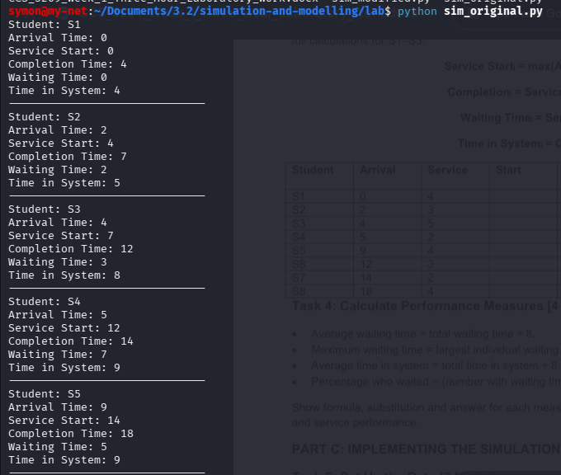
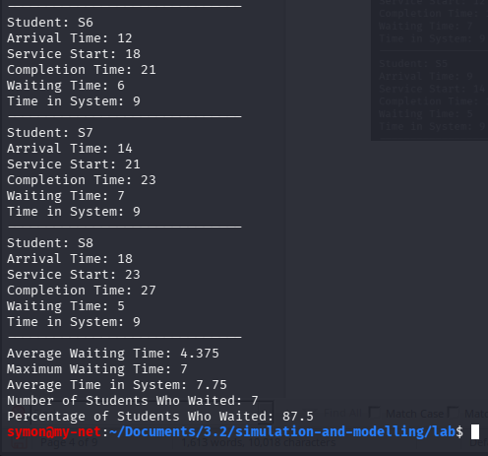

Task 6: Service logic
previous_completion = 0

for i in range(len(students)):
start = max(arrival_times[i], previous_completion)
completion = start + service_times[i]
wait = start - arrival_times[i]
system_time = completion - arrival_times[i]

service_start.append(start)
completion_time.append(completion)
waiting_time.append(wait)
time_in_system.append(system_time)
previous_completion = completion

print("Student:", students[i])
print("Arrival Time:", arrival_times[i])
print("Service Start:", start)
print("Completion Time:", completion)
print("Waiting Time:", wait)
print("Time in System:", system_time)
print("-" * 30)
Expected results (start, completion, wait, time in system per student): S1 0,4,0,4; S2 4,7,2,5; S3 7,12,3,8; S4 12,14,7,9; S5 14,18,5,9; S6 18,21,6,9; S7 21,23,7,9; S8 23,27,5,9. These match the manual event table in Task 3 exactly.
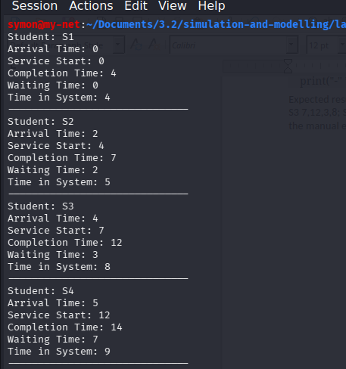

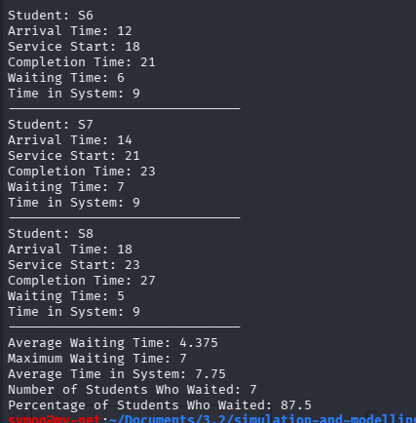

Task 7: System performance
average_wait = sum(waiting_time) / len(waiting_time)
maximum_wait = max(waiting_time)
average_system_time = sum(time_in_system) / len(time_in_system)
number_waited = sum(1 for w in waiting_time if w > 0)
percentage_waited = (number_waited / len(waiting_time)) * 100

print("Average Waiting Time:", average_wait)
print("Maximum Waiting Time:", maximum_wait)
print("Average Time in System:", average_system_time)
print("Number of Students Who Waited:", number_waited)
print("Percentage of Students Who Waited:", percentage_waited)

Measure | Manual (Task 4) | Python output
Average waiting time | 4.375 | 4.375
Maximum waiting time | 7 | 7
Average time in system | 7.75 | 7.75
Students who waited | 7 | 7
Percentage who waited | 87.5% | 87.5
The results agree, so no correction was needed, which supports the verification of both the manual calculation and the code.
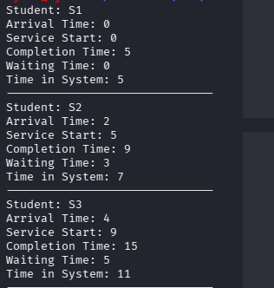
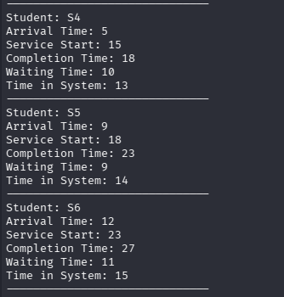

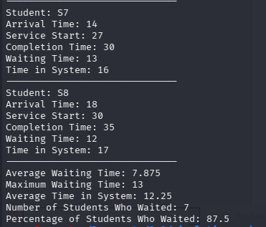

Task 8: Modified model (slower service)
Only one line changed, and the program was restarted so the result lists started empty:
service_times = [5,4,6,3,5,4,3,5]

Student | Arrival | Service | Start | Completion | Wait | Time in System
S1 | 0 | 5 | 0 | 5 | 0 | 5
S2 | 2 | 4 | 5 | 9 | 3 | 7
S3 | 4 | 6 | 9 | 15 | 5 | 11
S4 | 5 | 3 | 15 | 18 | 10 | 13
S5 | 9 | 5 | 18 | 23 | 9 | 14
S6 | 12 | 4 | 23 | 27 | 11 | 15
S7 | 14 | 3 | 27 | 30 | 13 | 16
S8 | 18 | 5 | 30 | 35 | 12 | 17

Measure | Original Model | Slower-Service Model
Average waiting time | 4.375 min | 7.875 min
Maximum waiting time | 7 min | 13 min
Average time in system | 7.75 min | 12.25 min
Percentage who waited | 87.5% | 87.5%
Effect of slower service. Adding about one minute to almost every service time (total 27 to 35 minutes) made the queue grow faster than it could clear. Average waiting time rose by 80% (4.375 to 7.875 min), maximum wait by about 86% (7 to 13 min) and average time in system by about 58% (7.75 to 12.25 min). The percentage who waited stayed at 87.5% because in both models only S1 avoided waiting, so this measure hides how much worse the waits became. Small increases in service time cause large increases in delay when the server is already close to or beyond its capacity, since each delay carries over to everyone behind it.

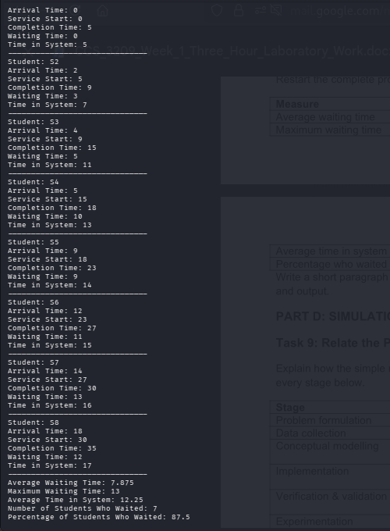

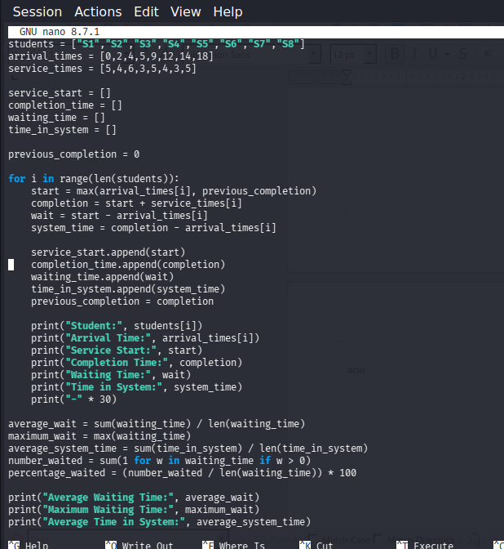

Part D: Simulation Study and Tool Reflection [5 marks]

Task 9: Simulation study process
Stage | Response
Problem formulation | Students face long waits at the service centre at peak periods. Decision to support: how many officers, and what schedule or counter arrangement, are needed to keep average waiting time below a target (e.g. 5 minutes) at reasonable cost.
Data collection | Timestamped arrival records by hour, day and semester period (e.g. registration and fee deadlines); service-time records by service type; proportion of each service type; number of officers and their shifts and breaks; queue length observations; balking or walk-away counts.
Conceptual modelling | Add entity attributes such as service type and priority; several officers or specialised counters; routing rules (e.g. by service type, or one shared queue vs separate queues); random arrival and service distributions; officer breaks and shift changes; peak-period surges.
Implementation | A dedicated discrete-event tool (e.g. SimPy in Python, Arena, Simio or AnyLogic), with random-number streams and fitted distributions. Resources model officers, entities model students, and queue statistics are collected automatically.
Verification and validation | Verification: trace small runs by hand (as done in this lab), test extreme cases, check the code against the conceptual model. Validation: compare simulated waiting times, queue lengths and utilisation with observed data for the current system, and have service-centre staff review the model's behaviour.
Experimentation | Alternatives such as adding a second or third officer, dedicated counters for fee enquiries versus registration, staggered shifts, appointment systems or extended opening hours; multiple replications for each with random variation.
Output analysis | Compare average and maximum waiting time, queue length, throughput (students served per hour) and officer utilisation, with confidence intervals across replications.
Recommendation | Present the least costly option that meets the waiting-time target with evidence (e.g. waiting time and utilisation under each alternative) so management can weigh service quality against staffing cost.

Task 10: Simulation tools
Tool / Approach | Suitable Use | Advantage | Limitation
General-purpose programming (Python, or spreadsheets for very small models) | Small or teaching models and quick prototypes, such as this single-queue study. | Flexible, transparent and free; full control over the logic. | Everything (event handling, random numbers, statistics, animation) must be coded; becomes error-prone and slow to build for large models.
Dedicated discrete-event simulation software or library (e.g. Arena, Simio, AnyLogic, SimPy) | Realistic, larger models with many resources, queues and random behaviour. | Built-in event scheduling, distributions, statistics collection and often animation, which speeds development and reduces errors. | Learning curve; commercial tools can be costly and less flexible for unusual logic.
Preference for a larger service-centre model: a dedicated discrete-event simulation tool (or a library such as SimPy). A realistic study needs several officers, random arrivals, service types, breaks and many replications with statistical output; a specialised tool provides these features and reduces coding errors, so time is spent on analysis rather than on building simulation machinery.

Conclusion
This laboratory showed me how a simple queueing system can be described with entities, a resource, a queue, events and state variables, and then simulated both by hand and in Python. The manual event table and the program gave identical results (average wait 4.375 min, maximum wait 7 min, average time in system 7.75 min), which taught me the value of verifying a model in two independent ways. Increasing the service times by about one minute per student raised the average wait to 7.875 min and the maximum wait to 13 min, so I learned that small changes in service speed can cause large delays when a single server is already busy. I also saw that a simple model like this can grow into a full simulation study, with data collection, validation and experiments with extra officers, and that dedicated simulation tools would be better suited to that larger task

