

cataLOG

Name: Todi Tinu-Constantin
Group: 30237

Table of Contents
Deliverable 1 3
Project Specification 3
Functional Requirements 3
Use Case Model 3
Use Cases Identification: 3
UML Use Case Diagrams 3
Supplementary Specification 3
Non-functional Requirements 3
Design Constraints 3
Glossary 3
Deliverable 2 3
Domain Model 3
Architectural Design 3
Conceptual Architecture 3
Package Design 4
Component and Deployment Diagram 4
Deliverable 3 4
Design Model 4
Dynamic Behavior 4
Class Diagram 4
Data Model 4
System Testing 4
Future Improvements 4
Conclusion 4
Bibliography 4

Deliverable 1

Project Specification

This project aims to create an application that proposes the management of a student catalog. Within this application, various functionalities are available, depending on the role of the user. The frontend is written in : HTML and JavaScript, using Razor Pages, and the backend is written in C#, using ASP.NET and Entity Framework. Data persistence is ensured by the database connection, managed with Microsoft SQL Server.

Functional Requirements

Depending on the role of the user, several functionalities are available. There are 4 user-roles: Student, Teacher, Anonymus User and Admin. They have the same basic functionalities (except Anonymus User), like Login, Logout, Register, etc.

- Student
- Login
- Logout
- Delete Account
- Edit Profile
- See the grades
- Register
- See Account Details
- Search and See other registered users

- Teacher
- Login
- Logout
- Delete Account
- Edit Profile
- Grade the student
- Register
- See Account Details
- Search and See other registered users

- Anonymus User
- Can search and see registered users, but some user details are hidden

- Admin

- Delete registered users if they misconduct

Use Case Model

Use Cases Identification:

Use-Case : Teacher grades a Student
Level : Teacher can grade a student
Primary Actor : Teacher
Main success scenario : Teacher grades the student and the Student can see the grades
Extension : In case of error, the student cannot see the grade.

Use-Case: User registration
Level : Anonymus User can sign up
Primary Actor : Unregistered User
Main success scenario : The database will have a new user
Extension : In case of error, the unregistered user is not registered and he is not in the database.

Use-Case : User Login
Level : User wants to go into the application and he is ALREADY registered.
Primary Actor: Registered User(Student or Teacher)
Main success scenario : The user can go into the role designed dashboard.
Extension : In case of error, the user cannot access the main dashboard.

UML Use Case Diagrams
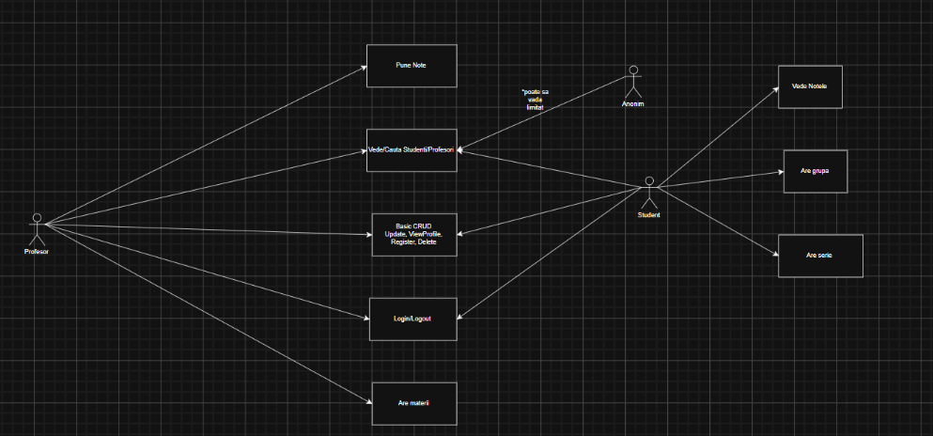

Supplementary Specification

Non-functional Requirements

- Security Multiple Security checks, every account decision (like delete, edit details, etc) requires the password.
- Capacity Microsoft SQL Server maximum capacity
- Technology The system uses Microsoft SQL Server.
- Reability and Availability The system shall not have errors.
- Compatibility It is compatible with all systems and can be implemented everywhere.

Design Constraints

The system is built in Visual Studio IDE. The backend part is built in C#, using ASP.NET and Entity. Exista 4 nivele in cadrul arhitecturii : Model, ViewModel, View si Controller. The frontend part is built using HTML and JavaScript, using Razor Pages. Data persistence is ensured by the connection to a database, specifically to Micosoft SQL Server.

Glossary
Framework supporting structure on which other things are built.
Backend in software development, backend refers to the data management and processing behind the scenes.
Frontend in software development, frontend refers to the presentation layer that users interact with.
Data persistence data persistence means that data is saved permanently, so it is not lost when the system shuts down or restarts.
ASP.NET is a server-side web application framework designed for web development to produce dynamic web pages. It was developed by Microsoft. ASP stands for Active Server Pages Network Enabled Technologies.
Entity is a open source object-relational mapping framework for ADO.NET (.NET family)
C# is a general-purpose high-level programming language supporting multiple paradigms. It encompasses static typing, strong typing, imperative, declarative, functional, generic, OOP. Developed by Microsoft.
Razor Pages Razor is an ASP.NET programming syntax used to create to dynamic web pages with C# or VB.NET programming languages. Razor is a simple-syntax view engine and was released as part of MVC3 and the WebMatrix tool set.
HTML is the standard markup language for documents designed to be displayed in a web browser. It defines the content and structure of web content.
JavaScript is a programming language and core technology of the Web, alongside HTML and CSS.
The overwhelming majority of websites uses JavaScript for client side webpage behaviour.
Microsoft SQL Server is a proprietary relational database management system developed by Microsoft using Structured Query Language (SQL).

Deliverable 2

Domain Model
[Define the domain model and create the conceptual class diagrams]

Architectural Design

Conceptual Architecture
[Define the system’s conceptual architecture; use an architectural style and pattern - highlight its use and motivate your choice.]

Package Design
[Create a package diagram]

Component and Deployment Diagram
[Create the component and deployment diagrams.]

Deliverable 3

Design Model

Dynamic Behavior
[Create the interaction diagrams (2 sequence) for 2 relevant scenarios]

Class Diagram
[Create the UML class diagram; apply GoF patterns and motivate your choice]

Data Model
[Create the data model for the system.]

System Testing
[Describe the testing methides and some test cases.]

Future Improvements
[Present some features that apply to the application scope.]

Conclusion

Bibliography

