Develop and maintain an interactive web platform, similar format of SMR-portal https://yanglab.westlake.edu.cn/smr-portal/ (paper: https://www.nature.com/articles/s41592-024-02561-7) and FUMA https://fuma.ctglab.nl/ (paper https://www.nature.com/articles/s41467-017-01261-5 ), which has gained 3738 citations since it published in 2017. But FUMA is based on MAGMA, we have shown that our mBAT-combo has outperformed conventional MAGMA in gene-based association analysis (https://www.cell.com/ajhg/fulltext/S0002-9297(22)00540-7?uuid=uuid%3A6196af9c-8ec3-43ba-8e0a-0abfff321882#fig1 ). Based on the same concept of MAGMA-gene set analysis’ functional annotations (https://www.nature.com/articles/s41467-018-06022-6 ), we aim to add gene corelation to enable mBAT-combo with flexible functional annotations as well. Our mBAT-combo now is in being implemented in GCTA similar as SMR by C++ to use bash command to easy run but still receive a lot of requests that if it could be more friendly to researchers who could not coding at all. Also, we raised a new benchmark of cell type-trait pairs to detect new method being developed to detect cell type-disease associations using scRNA-seq and GWAS (https://www.medrxiv.org/content/10.1101/2025.05.24.25328275v2 under review in Nature Method now). The platform will be user-friendly with no need of computation skills and do not require access to individual-level reference and GWAS summary statistics:
  - Host gene‐based results from ~4,000 UK Biobank traits (built using mBAT combo, resource is ready to be used), interactively to be viewed in significant genes and their locations in genome as well for the trait people search on.
  - Integrate single‐cell reference data, enabling cell‐type/pathway/gene-set × gene association and visualization.
  - Visualization modules: interactive gene-Manhattan plots, heatmaps of cell-type associations, Sankey/arc diagrams, etc.
Will need to learn on front-end (UI) & back-end development of the web platform. This web tool will be for sure a new good publication, ensuring the Documentation & testing reproducibility and user-friendliness.

Potential useful shiny platform:

Project skeleton
- Create a folder myportal/ with:
  - app.R (Shiny app main file)
  - data/ (your .rds datasets)
  - README.md (document schema + instructions)
Shiny app development:
Goal: Searchable portal for your two datasets with table + download.
Basic Shiny UI
- Build input boxes for gene/SNP search.
- Render a results table.
Server logic
- Filter dataset by user input.
- Render filtered table.
- Add download handler.
Add simple visualization
- Example: show top SNPs for a gene (bar plot of −log10 p).

SHOW DEMO!

- Starting with Shiny, getting familiar with the structure of Shiny in R.
• Install Shiny:
install.packages("shiny")
• Minimal app (app.R)

- Make a simple website using Shiny to show the mBAT-combo results of 5 example traits with P-values, gene names:
Start with 5 mBAT-combo gene based test results (Please get familiar with the format of mBAT-combo output: https://yanglab.westlake.edu.cn/software/gcta/#mBAT-combo ) to be able to be visualized in the Manhattan plot below as a example:
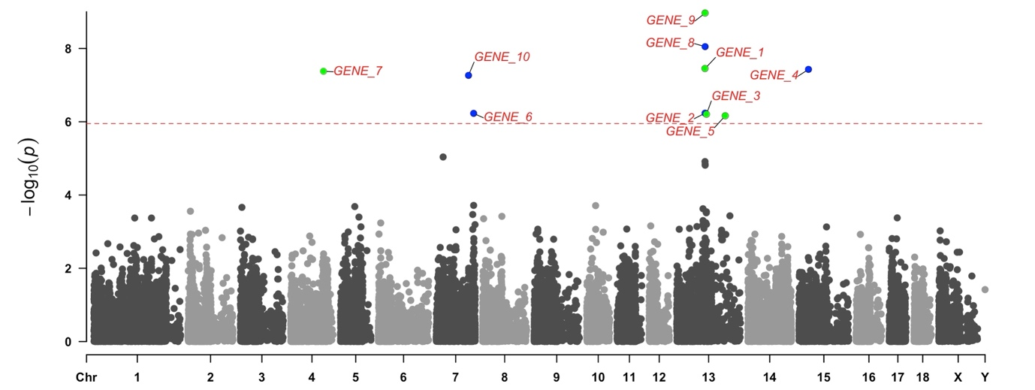
- Try:
• Deploy locally (for demo) and later to a server (shinyapps.io or shiny-server).

Task 2: Interactive Query Layer
Goal: Let users search and visualize dynamically.

Tasks:
- Expand the Shiny app:
  - Add a search box (for trait or gene).
  - Retrieve results on demand from the database rather than from static CSVs.
  - Add reactive filters (p-value threshold, chromosome, cell type, etc.).
- Gene-centric view:
  - For a selected gene, show its top associated traits.
  - Display cross-trait Manhattan or volcano plot (gene vs. −log10 P across traits).
- Trait-centric view:
  - For a selected trait, show its top genes.
  - Allow zooming into one locus (region plot).

Task 3: Metadata and Documentation Integration
Goal: Make the platform self-contained for publication or sharing.

Tasks:
- Add metadata panels:
  - Trait description, reference paper, PubMed link.
  - Symble gene id, Ensembl link, tissue expression summary.
- Add documentation:
  - “About” page describing your statistical model.
  - Download link for gene-level summary files.

Task 4: Database Design and Data Import (Core Backend)
Goal: Make 5,000-trait data queryable rather than pre-loaded.

Tasks:
- Choose a backend:
  - Use PostgreSQL (recommended).
  - Create a dedicated schema.
- Design tables:
  - traits: trait_id, trait_name, category, n_cases, n_controls, reference, etc.
  - genes: gene_id, symbol, chr, start, end.
  - results: trait_id, gene_id, p_value, z_score, beta, annotation (e.g., cell type, metric, stage).
- Import full dataset:
  - Convert the 5000-trait gene-based results into consistent format (e.g., tidy TSV or Parquet).
  - Use R or Python scripts to batch insert into the database (e.g., via RPostgres or SQLAlchemy).
- Indexing:
  - Create indices on (trait_id, p_value) and (gene_symbol) for fast query.

