Relevant History

***“How did Short-Term Market rates React to Liftoff?”*** *by Renee Haltom and Alexander L. Wolman*

Longer-term rates are what drive much economic activity—especially investment decisions and the financing of major consumer purchases such as houses and automobiles. Long-term rates are a function of both the path of short-term rates and a “term premium.”

**Argument**: Size of Federal Reserve’s balance sheet makes it difficult to control short-term rates

**Counter Evidence**: Fed’s response to the Great Recession led to a ballooning Fed balance sheet as well as a large expansion of reserves in the banking system. The Fed employed IOER to maintain control of short-term rates even with a large balance sheet and a large amount of excess reserves (because IOER lets you control the supply of reserves).

**Argument**: Fed’s influence is of long-term rates is lacking after initial Dec. 2015 hike

**Counter Evidence**: The volatile term premium is a major determinant of longer-term interest rates.

**US Economy faces** **four big headwinds**: 1) income inequality 2) education 3) demographics 4) government debt

The Fed aims to achieve the target federal funds rate by adjusting the supply of bank reserves to intersect banks’ demand for reserves at the level at which the market-clearing fed funds rate will be equal to the target rate. To accomplish this, the Fed must on a daily basis estimate banks’ demand for reserves and adjust supply accordingly.

***“Calculating the Natural Rate of Interest: A Comparison of Two Alternative Approaches”*** *by Thomas A. Lubik and Christian Matthes*

NATURAL RATE OF INTEREST:

The real interest rate computed as the difference between the fed funds rate and the expected personal consumption expenditures (PCE) inflation rate. *The real rate is lower than the natural rate by a full percentage point and has been that low or lower since 2009—indicating policy is not tight enough and has not been for a while.*

**“Reverse Repo”** by Tim Sablik

**Raising the interest rate on excess reserves** gives banks more incentive to hold them, putting upward pressure on short-term market interest rates, including the fed funds rate.

Because not all financial institutions hold reserves with the Fed, it employs **ONRRP**—the Fed can effectively set the minimum rate for the overnight repo market since no other institution will pay less than what the Fed is offering (thus, the Fed can set a floor on what financial institutions charge each other for overnight repo lending).

**“A Citizen’s Guide to Unconventional Monetary Policy”** By Renee Haltom and Alexander L. Wolman

**Unconventional Monetary Policy**: LSAP/QE, forward guidance

ZLB means it’s harder to push policy interest rates lower—Fed purchases assets to influence broader market interest rates:

**QE1**: From November 2008 through March 2010, the Fed purchased $1.75 trillion in long-term Treasuries as well as debt issued by Fannie Mae and Freddie Mac and fixed rate MBS guaranteed by those agencies.

**QE2**: From November 2010 through June 2011, the Fed purchased $600 billion in long-term Treasuries.

The Fed replaced $667 billion in short-term Treasuries on its balance sheet with an equivalent amount in longer-term Treasuries between September 2011 and the end of 2012. This action is the “maturity extension program” (MEP) but is often called “operation twist”.

**QE3**: In September 2012, the Fed announced that it would purchase $40 billion in agency-backed MBS per month until economic conditions improved substantially.

**Forward Guidance Progression**…accommodative conditions for

March 2009-June 2011—“extended period”

August 2011-December 2011—“through mid-2013”

September-October 2012—“a considerable time after the economic recovery strengthens”

**A Brief History of QE and the Future of Balance Sheet Normalization**

The Fed funds rate was near its effective lower bound in the wake of the GFC. In order to keep conditions accomodative, the FOMC purchased longer-term securities, specifically, Treasury and agency securities, as permitted under the Federal Reserve Act. From 2008 through 2014, the Fed conducted three LSAPs (large scale asset purchases) and an MEP (maturity extension program), which resulted in purchases of roughly $4.5 trillion in securities that extended the duration of securities held on the Federal Reserve's balance sheet from 5.2 years to 5.9 years and increased ten-year equivalents (TYE) from about $330 billion to $2.8 trillion.

Since the end of 2014, the Federal Reserve has been rolling over maturing Treasury securities and reinvesting principal payments from its holdings of agency debt and agency mortgage-backed securities, keeping the size of its balance sheet roughly unchanged but with the TYE increasing slightly from $2.5 trillion to $2.7 trillion.

**The Effect of Central Bank Asset Purchases**:

1. Ease credit conditions in certain sectors via downward pressure on select rates
2. Lower investors’ expectations for the future path of the federal funds rate by signaling that the central bank intends to pursue a persistently more accommodative policy stance than previously thought, which can result in downward pressure on longer-term real interest rates
3. Increase household and business confidence by reducing concerns regarding deflation

A better explanation for (1): By *increasing* the amount of longer-term Treasury securities and agency MBS on the Federal Reserve's balance sheet, and thereby *reducing* the amount of longer-term Treasury securities and agency MBS that the public would have held otherwise, these purchase programs put downward pressure on longer-term interest rates.

In fact, a FRB/US model suggests that the cumulative effect of the Federal Reserve's LSAPs and MEP results in a reduction in the 10-year Treasury yield term premium of about 100 basis points. By the end of 2017, the term premium will be held down by about 85 basis points. The slight narrowing of the TPE reflects the average maturity of the Federal Reserve's portfolio declining and the cessation of reinvestments drawing nearer.

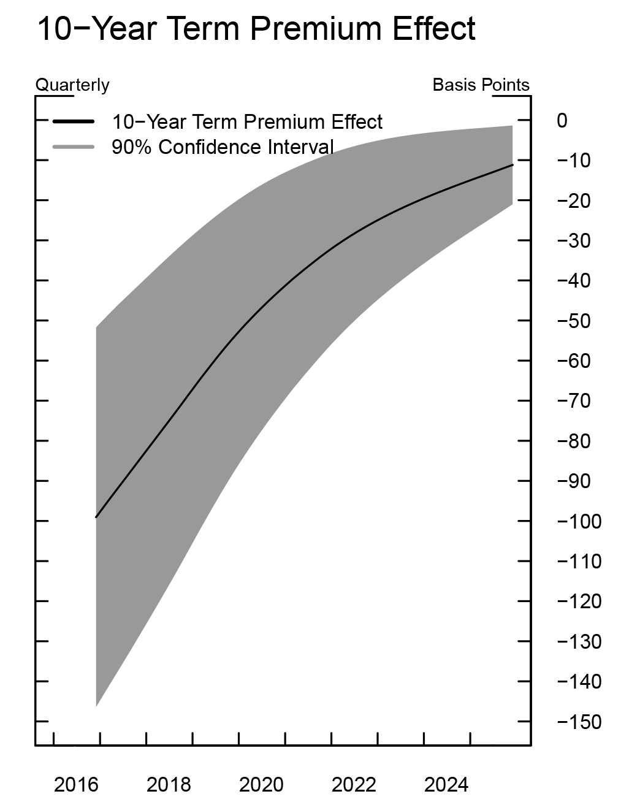

**Current Balance Sheet Composition**:

To help maintain accommodative financial conditions, the Committee has continued its existing policy of reinvesting principal payments from its holdings of agency debt and agency MBS in agency MBS and rolling over maturing Treasury securities at auction. Likewise, Federal Reserve’s total assets have held steady at ~$4.5 trillion, with holdings of UST securities at $2.5 trillion and holdings of agency debt and agency MBS at ~$1.8 trillion. Total liabilities on the Fed’s balance sheet were also mostly unchanged over the first half of 2017.

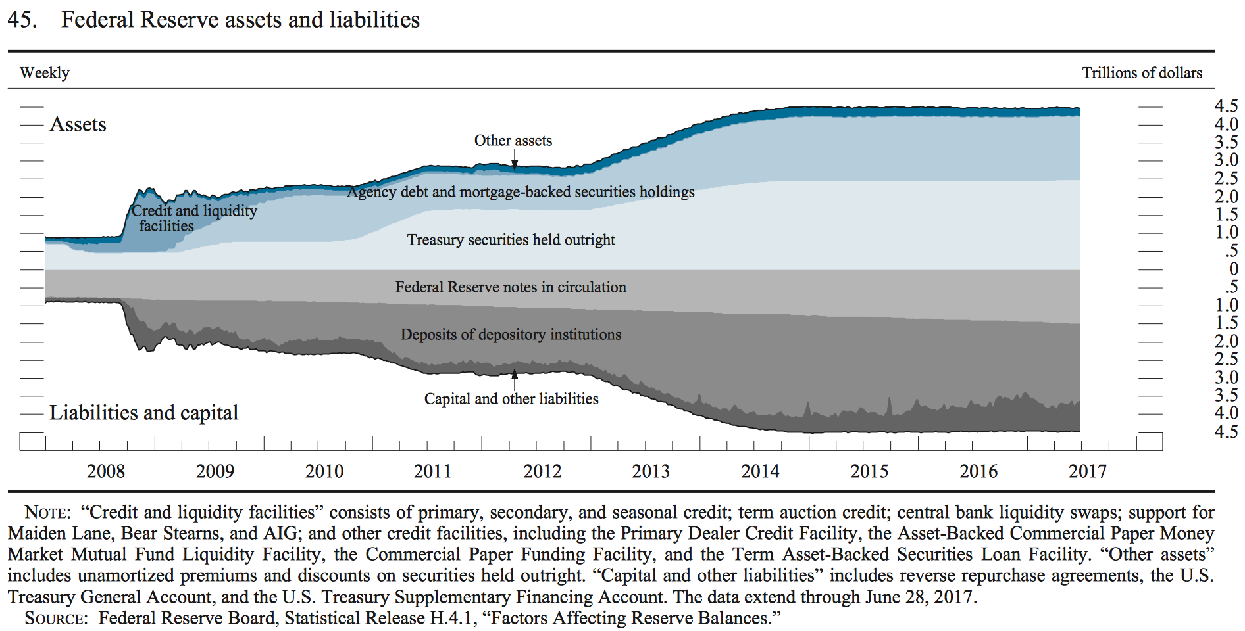

**Balance Sheet Normalization (The Future)**:

The Committee intends to gradually reduce the Fed’s securities holdings by decreasing reinvestment of the principal payments it receives from the securities held in the System Open Market Account. Specifically, such payments will be reinvested only to the extent that they exceed gradually rising caps. Initially, these caps will be set at relatively low levels to limit the volume of securities that private investors will have to absorb.

For payments of principal that the Federal Reserve receives from maturing Treasury securities, the Committee anticipates that the cap will be $6 billion per month initially and will increase in steps of $6 billion at 3-month intervals over 12 months until it reaches $30 billion per month.

For payments of principal that the Fed receives from its holdings of agency debt and MBS, the Committee anticipates that the cap will be $4 billion per month initially and will increase in steps of $4 billion at three-month intervals over 12 months until it reaches $20 billion per month.

**Other Expectations and Forecasts (done by the Fed)**:

The Fed's balance sheet policy is consistent with the FOMC's September 2014 Policy Normalization Principles and Plans: no sales of securities and when reinvestments end, the securities holdings decline in a gradual and predictable manner. This process will take place over the course of multiple years, but is expected to end in Q1 of 2023 when reserve balances are expected to decline to a level of $100 billion.

When the size of the balance sheet normalizes in the first quarter of 2023, the TPE is still nonzero, standing at negative 24 basis points, reflecting the fact that the portfolio composition is still not what would be deemed a normal composition. At that time, the portfolio is projected to hold $1.2 trillion in MBS and half of the $1.1 trillion in Treasury holdings will have maturities greater than 10 years (see figure 2). In comparison, before the crisis, the portfolio held no MBS and only $90 billion of the $800 billion in Treasury holdings had maturities greater than 10 years.

A report issued six months earlier gave the following ranges instead of the more precise numbers above that were given in a paper written in April 20th:

🡪At the end of the projection period in 2025, the size of the balance sheet is expected to be $2.5 trillion along the model path, with possible outcomes ranging between $2.3 and $2.8 trillion.

🡪Treasury securities and MBS holdings are projected to range between $1.5 and $2.0 trillion, and from $525 billion to $950 billion, respectively.



