Balance Sheet Normalization

1. Overview of how the Fed works (Bud)
2. History of QE and Balance Sheet Normalization (Bud)
3. Balance Sheet Normalization (expectations and plans) (Me)

To help maintain accommodative financial conditions, the Committee has continued its existing policy of reinvesting principal payments from its holdings of agency debt and agency MBS in agency MBS and rolling over maturing Treasury securities at auction.

Therefore, the Federal Reserve’s total assets have held steady at ~$4.5 trillion, with holdings of UST securities at $2.5 trillion and holdings of agency debt and agency MBS at ~$1.8 trillion. Total liabilities on the Fed’s balance sheet were also mostly unchanged over the first half of 2017.

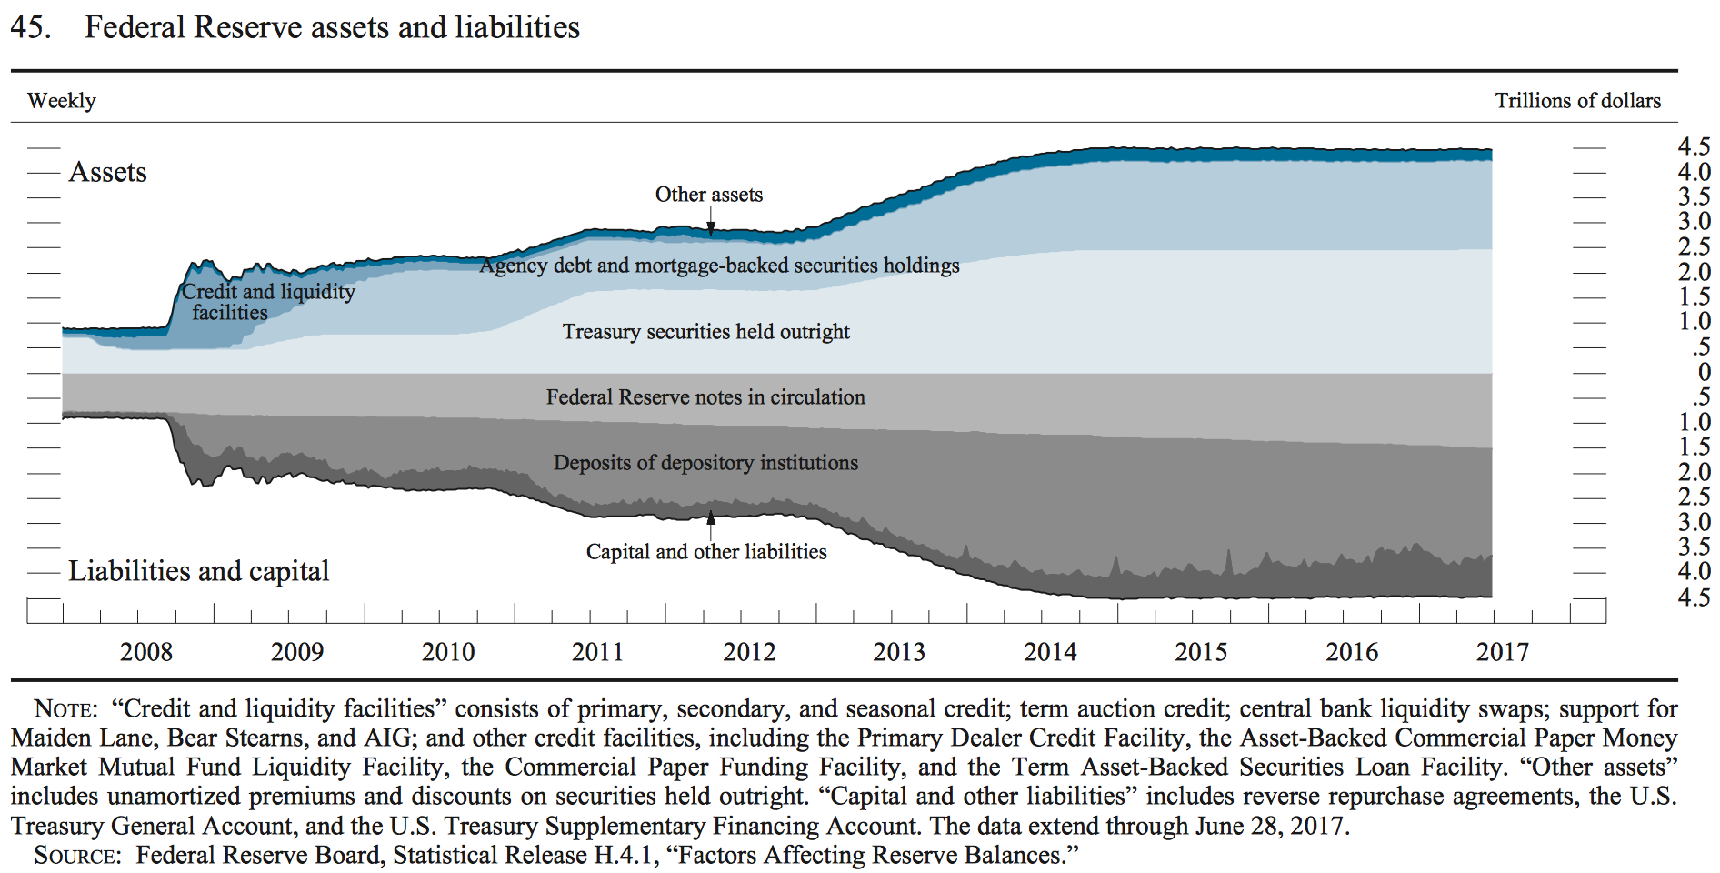

The Committee intends to gradually reduce the Fed’s securities holdings by decreasing reinvestment of the principal payments it receives from the securities held in the System Open Market Account. Specifically, such payments will be reinvested only to the extent that they exceed gradually rising caps. Initially, these caps will be set at relatively low levels to limit the volume of securities that private investors will have to absorb.

For payments of principal that the Federal Reserve receives from maturing Treasury securities, the Committee anticipates that the cap will be $6 billion per month initially and will increase in steps of $6 billion at 3-month intervals over 12 months until it reaches $30 billion per month.

For payments of principal that the Fed receives from its holdings of agency debt and MBS, the Committee anticipates that the cap will be $4 billion per month initially and will increase in steps of $4 billion at three-month intervals over 12 months until it reaches $20 billion per month.

The Committee also anticipates that the caps will remain in place once they reach their respective maximums so that the Fed’s securities holdings will continue to decline in a gradual and predictable manner until the Committee judges that the Fed is holding no more securities that necessary to implement monetary policy efficiently and effectively. (WHAT IS THIS AMOUNT?)

Analysis by Cumberland Advisors:

* The FOMC historically attempted to keep the ratio of currency outstanding to GDP relatively constant, which today would imply a balance sheet of about $1.43 trillion.
* Required reserves are currently about $101 billion; and historically, pre-crisis excess reserves were about 3.78% of required reserves.
* The economy is assumed to grow at about 2%, the FOMC’s current expected rate, which determines the path for both currency and reserves. (No assumptions are made about other balance sheet factors, which are relatively insignificant.)
* Treasuries are assumed to be allowed to run off according to their maturities, which are calculated on a monthly basis from the detail published regularly by the NY Fed for each security in the SOMA portfolio. (We can’t easily estimate what the maturities of future Treasury reinvestments will be.)
* MBS maturities don’t adequately reflect what their effective maturities are – they have an estimated duration of about seven years because of pay-downs. For 2016 the SOMA annual report indicated that pay-downs averaged about $32 billion per month. Conversations with Fed officials reveal that in 2017 pay-downs are averaging about $20 billion per month, which is consistent with the terminal values selected in the FOMC’s plan for MBS. Of course, pay-downs will likely increase, as they did historically when interest rates declined; and they will likely decrease if rates go up.

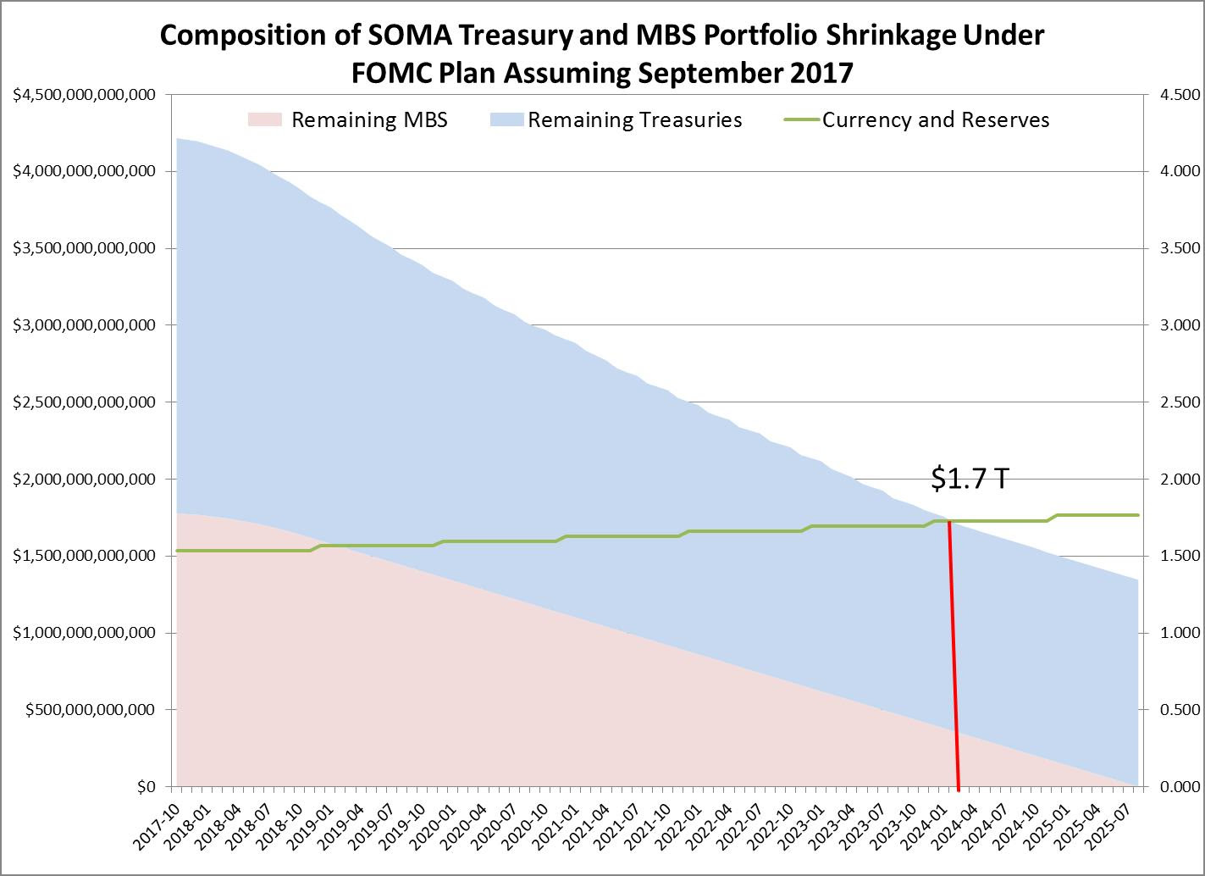

The simulation shows that MBS decline significantly relative to Treasuries and that the historical relationships imply that a normalized balance sheet of $1.7 trillion will be achieved in the spring of 2024. Thereafter, the growth assumptions imply that the Fed should begin to add more and more Treasuries to its holdings, as the remaining MBS simply mature and are paid down. The Fed, under this baseline, would be left with ample amounts of Treasuries with which to conduct open-market operations and to pursue its federal funds targeting regime. Through the remainder of 2017 until the end of 2018 about $246 billion of Treasuries would have to be issued by the Treasury to offset the decline in the Fed’s holdings, which is modest in terms of its potential impact on the Treasuries market. Finally, it is important recognize that this path would increase or decrease depending upon the realization of MBS pay-downs, stretching out a bit should pay-downs slow. All in all, the plan is gradual, seemingly well thought out, and provides a clear path to an alternative regime.

Gradually reducing the Fed’s securities holdings will result in a declining supply of reserve balances. The Committee currently anticipates reducing the quantity of reserve balances, over time, to a level appreciably below that seen in recent years but larger than before the financial crisis—the level will reflect the banking system’s demand for reserve balances and the Committee’s decisions about how to implement monetary policy most efficiently and effectively in the future.

🡪”The Committee expects to learn more about the underlying demand for reserves during the process of balance sheet normalization.”

Additionally, the Committee affirmed that changing the target range for the federal funds rate remains its primary means of adjusting the stance of monetary policy. “Moreover, the Committee would be prepared to use its full range of tools, including altering the size and composition of its balance sheet, if future economic conditions were to warrant a more accommodative monetary policy than can be achieved solely by reducing the federal funds rate.”

Bud’s part:

🡪The fed funds rate is near its effective lower bound. In order to reduce long term interest rates, the Fed employed large-scale asset purchases (LSAPs) and a maturity extension program (MEP).

🡪The results presented in the note therefore help assess the interest rate risk stemming from the configuration of the Fed’s portfolio induced by the LSAPs and the MEP

🡪At the end of the projection period in 2025, the size of the balance sheet is expected to be $2.5 trillion along the model path, with possible outcomes ranging between $2.3 and $2.8 trillion.

🡪Treasury securities and MBS holdings are projected to range between $1.5 and $2.0 trillion, and from $525 billion to $950 billion, respectively.

*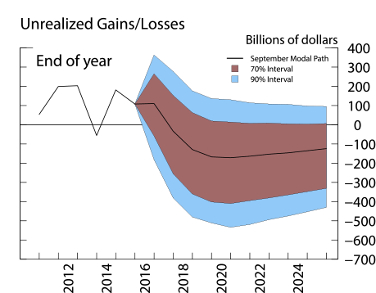*

Nonetheless, the implications of the Federal Reserve's policy actions for its balance sheet and income statement do not represent a factor influencing policy decisions. In fact, the fair value of the Federal Reserve's portfolio as well as its earnings, gains, or losses do not affect the ability to continue its operations or to carry out its responsibilities as the nation's central bank, which is to conduct monetary policy to achieve its statutory goals of maximum employment and stable prices. Finally, all considered, the aggregate gains for U.S. households, businesses, and the federal government resulting from the Federal Reserve's efforts to foster progress towards maximum employment and stable prices far outweigh any estimate of possible financial losses for the Federal Reserve even under higher interest rate scenarios.

By *increasing* the amount of longer-term Treasury securities and agency MBS on the Federal Reserve's balance sheet, and thereby *reducing* the amount of longer-term Treasury securities and agency MBS that the public would have held otherwise, these purchase programs put downward pressure on longer-term interest rates.

Currently, our model suggests that the cumulative effect of the Federal Reserve's LSAPs and MEP results in a reduction in the 10-year Treasury yield term premium of about 100 basis points. By the end of 2017, the term premium will be held down by about 85 basis points. The slight narrowing of the TPE reflects the average maturity of the Federal Reserve's portfolio declining and the cessation of reinvestments drawing nearer.

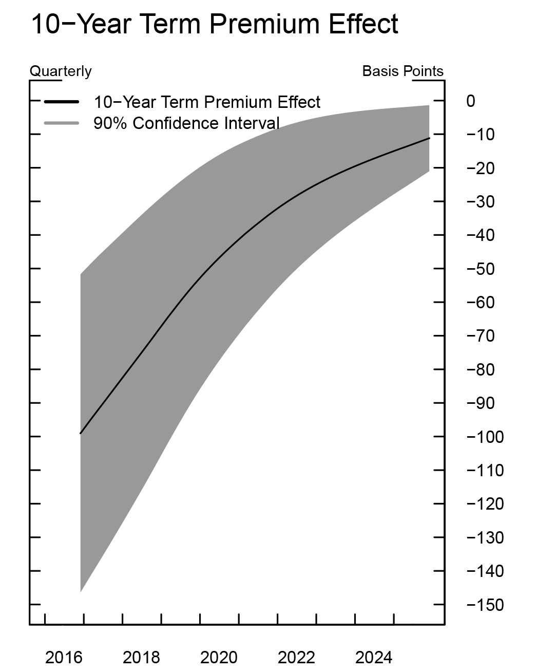

The FOMC purchased longer-term securities, specifically, Treasury and agency securities, as permitted under the Federal Reserve Act. From 2008 through 2014, the Fed conducted three LSAPs and an MEP, which resulted in purchases of roughly $4.5 trillion in securities that extended the duration of securities held on the Federal Reserve's balance sheet from 5.2 years to 5.9 years and increased ten-year equivalents (TYE) from about $330 billion to $2.8 trillion.

Since the end of 2014, the Federal Reserve has been rolling over maturing Treasury securities and reinvesting principal payments from its holdings of agency debt and agency mortgage-backed securities, keeping the size of its balance sheet roughly unchanged but with the TYE increasing slightly from $2.5 trillion to $2.7 trillion.

Central bank asset purchases can influence financial conditions and the broader economy through a variety of channels. They can improve the functioning of financial markets, especially during times of stress, which can result in easing credit conditions in some sectors. They can lower investors' expectations for the future path of the federal funds rate by signaling that the central bank intends to pursue a persistently more accommodative policy stance than previously thought, which can result in downward pressure on longer-term real interest rates. Additionally, they can result in increasing household and business confidence by reducing concerns regarding deflation.

The Fed's balance sheet policy is consistent with the FOMC's September 2014 Policy Normalization Principles and Plans: no sales of securities and when reinvestments end, the securities holdings decline in a gradual and predictable manner.

Finally, the balance sheet is expected to normalize when reserve balances decline to a level of $100 billion.

When the size of the balance sheet normalizes in the first quarter of 2023, the TPE is still nonzero, standing at negative 24 basis points, reflecting the fact that the portfolio composition is still not what would be deemed a normal composition. At that time, the portfolio is projected to hold $1.2 trillion in MBS and half of the $1.1 trillion in Treasury holdings will have maturities greater than 10 years (see figure 2). In comparison, before the crisis, the portfolio held no MBS and only $90 billion of the $800 billion in Treasury holdings had maturities greater than 10 years.



