Fed Challenge Study Guide

🡪send a survey to ask everyone for their dot plot essentially (make this cool survey)

Balance Sheet Normalization:

Following the GFC, the Fed conducted LSAPs and a MEP. By increasing the amount of longer-term USTs and agency MBS on the Fed’s balance sheet (thereby reducing the amount of long-term UST and agency MBS in markets), the Fed put downward pressure on longer-term interest rates. The cumulative effect of the Fed’s LSAPs and MEP results in a reduction in the 10-year UST yield term premium of about 100 bps. By the end of 2017, the term premium is forecast to be held down by ~85 bps. (1)

Between 2008 and 2014, the Fed conducted three LSAPs and an MEP, which resulted in purchases of ~$4.5 trillion in securities, extending the duration of securities held on the Fed’s balance sheet from 5.2 to 5.9 years. Moreover, this increased TYE (ten year equivalents) from ~$330 billion to $2.8 trillion. (1)

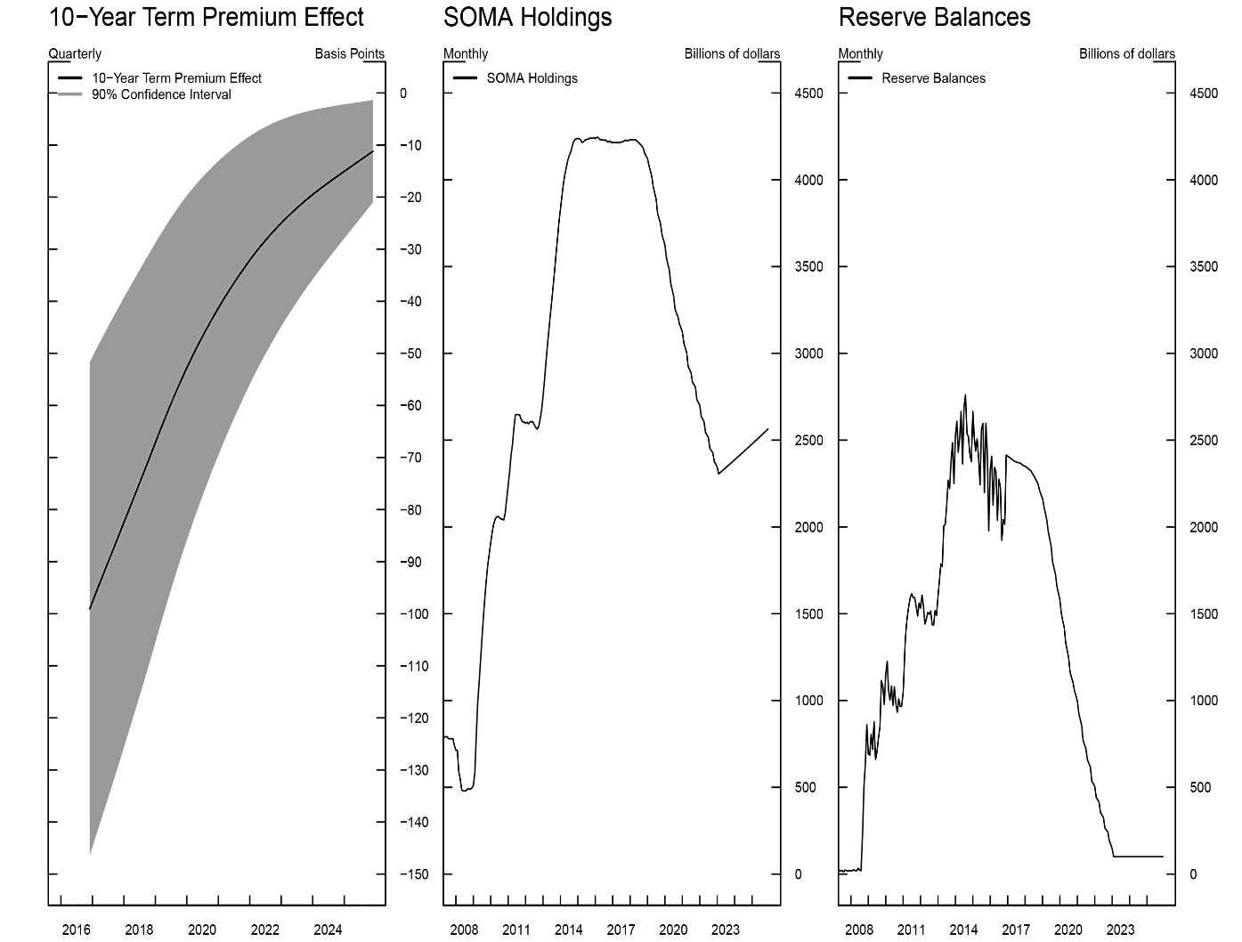

Historically, the Federal Reserve’s liabilities consisted primarily of currency in circulation. As a result of the LSAP programs, reserve balances became the largest liability, standing at ~$2.2 trillion at the end of 2015. (2)

*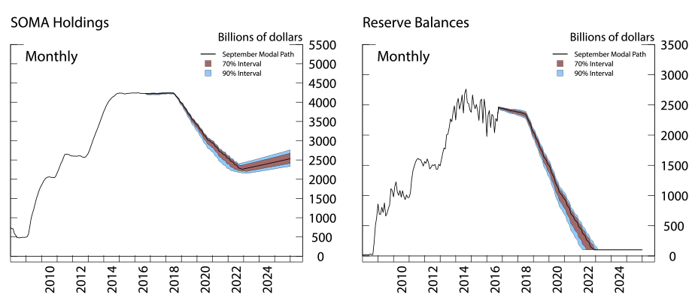*

At the end of the projection period in 2025, the size of the balance sheet is expected to be $2.5 trillion, with possible outcomes ranging between $2.3 and $2.8 trillion. In addition, Treasury securities and MBS holdings are projected to range between $1.5 and $2.0 trillion, and from $525 billion to $950 billion, respectively.

*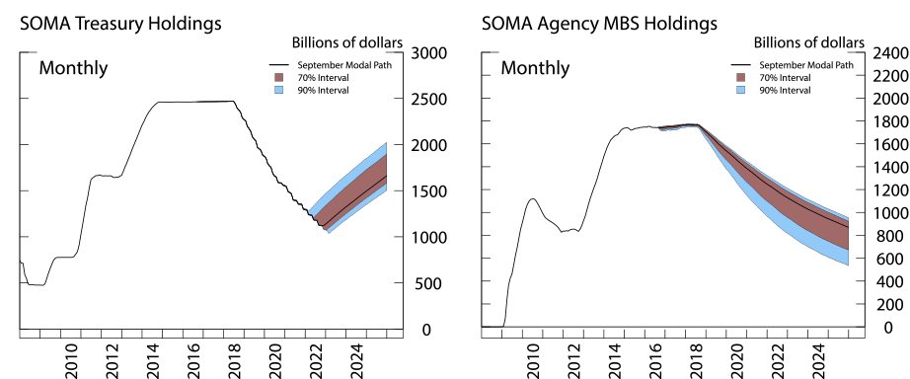*

1. *From FED Notes (The Effect of the Federal Reserve’s Securities Holdings on LT Interest Rates April 20, 2017)*

2. *Confidence Interval Projections of the Federal Reserve Balance Sheet and Income. Ferris, Kim and Schlusche. January 13, 2017*