**HW-7-SECURITY**

**Questions**:

Design and build a PKI infrastructure that includes Root CA, Signing CA, and TLS Certificate,

E.g., as described here: [http Links to an external site.://pki-tutorial.readthedocs.io/en/latest/simple Links to an external site./Links to an external site.](http://pki-tutorial.readthedocs.io/en/latest/simple/)

Use the TLS certificate to install a web server, e.g. tomcat, [https:// Links to an external site.tomcat.apache.org/tomcat-7.0-doc/ssl-howto.html](https://tomcat.apache.org/tomcat-7.0-doc/ssl-howto.html)

**Group Name: 4musks**

**Team members:**

* Utsav Rawat
* Nihal Kaul
* Jaya Krishna Thupili

**Github Repository**: <https://github.com/4musks/CMPE-272-Security.git>

**Answer:**

Step 1: Clone the github repository <https://bitbucket.org/stefanholek/pki-example-1>. Proceed with the instructions given in: <https://pki-tutorial.readthedocs.io/en/latest/simple/> to construct the PKI.

Step 2: Configure Root CA

* 1. Configure Directories type, below mentioned commands:

The ‘ca’ directory holds CA resources, the ‘crl’ directory holds CRLs, and the ‘certs’ directory holds user certificates

* 1. Configure Database, type below mentioned commands:

* 1. Create CA Request

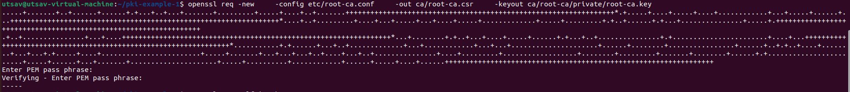

* 1. Create CA Certificate

Step 3: Create Signing CA

3.1 Create Directories

3.2 Create Database

3.3 Create CA Request

3.4 Create CA Certificate

Step 4: Operate Signing CA

4.1 Create email Request

4.2 Create email Certificate

4.3 Create TLS Server Request

4.4 Create TLS Service Certificate

4.5 Create CRL

Step 5: Output Formats

5.1 Create DER Certificate

5.2 Create DER CRL

5.3 Create PKCS#7

5.4 Create PKCS#12

5.5 Create PEM Bundle

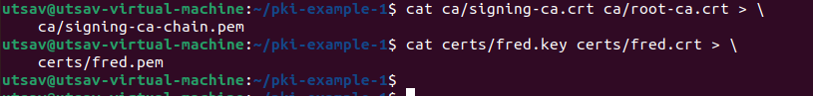

Step 6: Install the web server Tomcat through link: <https://tomcat.apache.org/tomcat-7.0-doc/ssl-howto.html>

Follow the Below commands:



Using the root certificate, Sign the certificate for Tomcat:



Import Tomcat certificate and Root certificate:

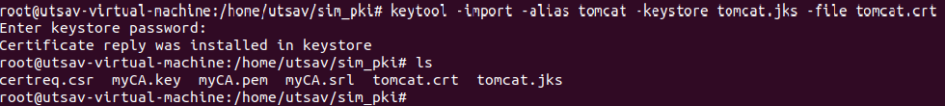

Copy the ‘certs’ folder to /opt/tomcat/conf folder



Update server.xml for the Tomcat Connector

Start-Up Tomcat



**Validate TLS**

