Project 1 Memo - Monthly Analytics-Ready Dataset
FIN 4333 Financial Analytics - Team Hemisphere
Company: Grameenphone Ltd. (DSE: GP) | Coverage: Jan 2020 - Dec 2024 | 60 monthly rows

1. Company and rationale
Grameenphone is Bangladesh's largest listed telecom operator. It was chosen for its long, consistent audited annual reports, active DSE trading (a complete daily price history) and a January-December fiscal year that aligns with the project's calendar-year requirement.

2. Data sources
- Stock (daily -> monthly): Daily price history from investing.com (Grameenphone Historical Data), 1 Jan 2020 - 30 Dec 2024 (1,163 trading days); 'Price' cleaned and resampled to month-end.
- Firm (annual): Revenue, Total Assets and EPS from Grameenphone's audited Annual Reports 2020-2024, read from each year's primary statements and cross-checked vs AR2024 Table-1 (p.89).
- Macro (annual): Bangladesh GDP growth and CPI inflation from the World Bank Indicators API; the raw JSON response is saved, and a cached copy is retained as an offline fallback.

3. Firm and macro values used
Year | Revenue (mn BDT) | Total assets (mn BDT) | EPS (BDT) | Inflation % | GDP growth %
2020 | 139,606 | 148,184 | 27.54 | 5.69 | 3.45
2021 | 143,066 | 163,007 | 25.28 | 5.55 | 6.94
2022 | 150,403 | 185,087 | 22.29 | 7.70 | 7.10
2023 | 158,716 | 200,420 | 24.49 | 9.88 | 5.78
2024 | 158,447 | 198,853 | 26.89 | 10.47 | 4.22

4. Major steps
- Import and clean the daily stock file (parse dates, coerce prices, drop bad/duplicate rows, sort).
- Resample daily closes to month-end prices; compute monthly returns from them.
- Load the annual firm variables (Revenue, Total Assets, EPS).
- Retrieve the two macro indicators from the World Bank API and save the raw JSON.
- Align annual firm and macro values onto monthly rows by calendar year.
- Merge all components into one monthly dataset and order the required columns.
- Run quality checks and save the final CSV.

5. Alignment rule
The dataset is monthly but firm and macro variables are annual, so each annual value is assigned to every month of the same calendar year (all twelve 2023 rows carry the 2023 figures). This is a left-merge on the 'year' key.

6. Data-quality notes
- All 15 automated checks: 15 PASS / 0 REVIEW.
- 60/60 monthly rows; dates month-end and continuous (no gaps or duplicates).
- April 2020 has no month-end price because the DSE suspended all trading 26 Mar - 31 May 2020 (COVID-19; last session 25 Mar, resumed 31 May). The dataset preserves this true 'no trade' state.
- monthly_stock_return is NaN for Jan-2020 (no prior month), Apr-2020 (no price) and May-2020 (prior month NaN). A gap-free series could carry forward the 25-Mar-2020 close - a modelling choice.
- Annual firm/macro columns fully populated after alignment.
- World Bank reports Bangladesh GDP on a fiscal-year (Jul-Jun) basis, so each year's growth figure is a fiscal-year value mapped onto the calendar year.

7. Overview
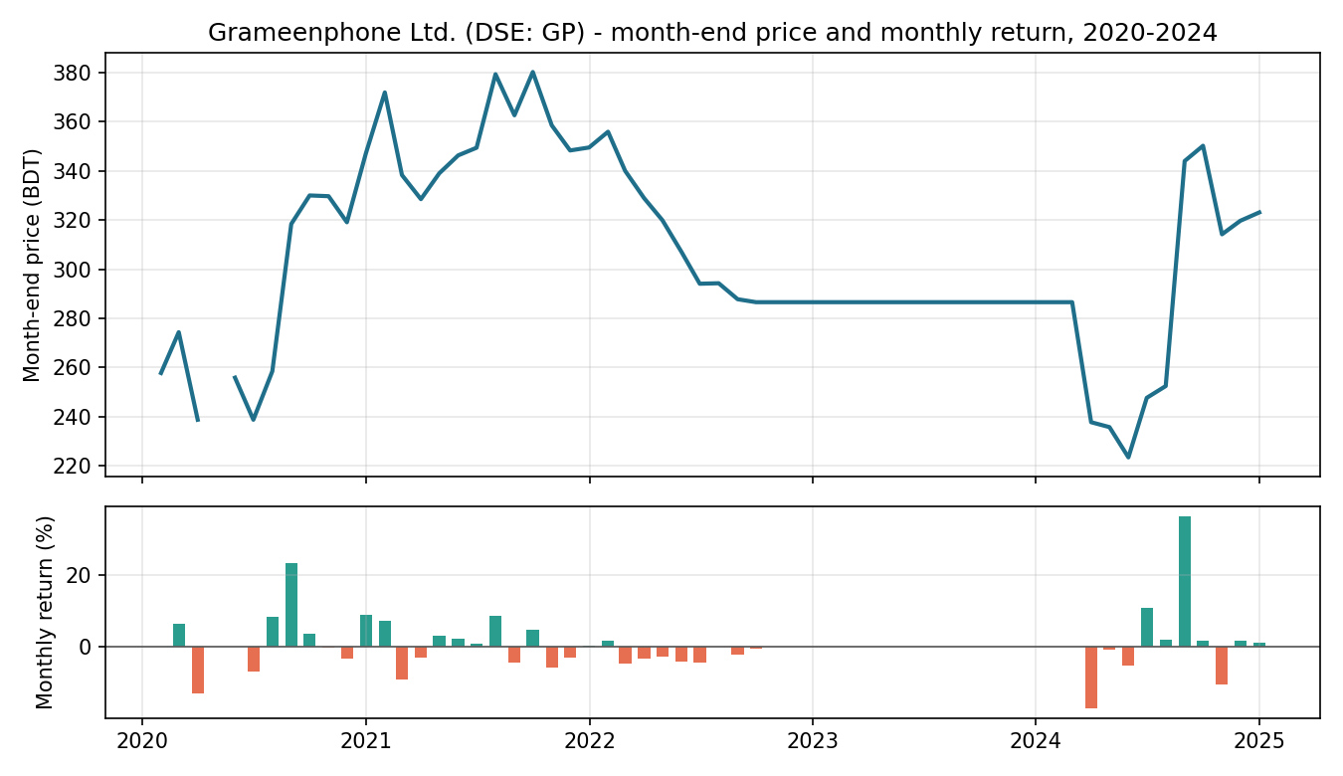

8. Reproducibility
The full workflow is this notebook (Restart & Run All rebuilds every output). pipeline.py runs the identical workflow head-less. The macro step calls the live World Bank API and falls back to cached raw JSON if offline, so the run is reproducible.

