Galen Lansbury

28 JUL 2014

**Various Outlook Files**

Outlook allows you to save messages in 6 different formats.

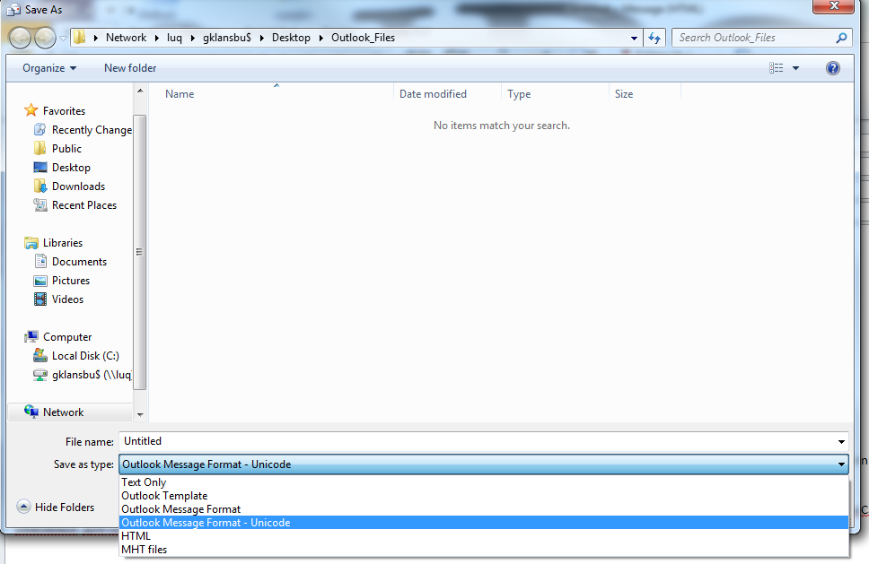

I created a message for each format. Each message I created is the same, it is just saved in a different format. Each message is composed of the following.

1. 2 Attachments
   1. A Word Document
      1. This contains arbitrary data and an email: [Attached_Email@email.com](mailto:Attached_Email@email.com)
   2. A JPEG
      1. This Jpeg Contains EXIF and GPS data
2. The body of the email
   1. The body of this email is just arbitrary text and an email, “InBody_Email@email.com”