Command Queue User Guide

Revision History

|  |  |  |  |
| --- | --- | --- | --- |
| **Rev** | **Date** | **Author** | **Description** |
| 0.1 | 2017/08/10 | Kevin.cheng | First Version |
| 0.2 | 2017/08/14 | Kevin.cheng | Remove do_cmdq_alignment callback function.  Add Trigger event |
| 0.3 | 2017/08/21 | Kevin.cheng | Add more callback API. |
| 0.4 | 2017/08/23 | Kevin.cheng | Add cmdq_poll_reg_bits callback function for poll_eq mode and poll_neq mode. |
| 0.5 | 2017/08/30 | Kevin.cheng | Follow MHAL coding style |
| 0.6 | 2017/09/04 | Kevin.cheng | Modify following API  MHAL_CMDQ_IsCmdqEmptyIdle  MHAL_CMDQ_ReadStatusCmdq  MHAL_CMDQ_ReadDummyRegCmdq  Add API  MHAL_CMDQ_ClearTriggerEvent |
|  |  |  |  |
|  |  |  |  |
|  |  |  |  |
|  |  |  |  |

**Overview**

在I2 platform 有5個command queue，如圖1.1所示，每個CMDQ分配如下，VPE一個、DIVP一個、H264一個、H265兩個。

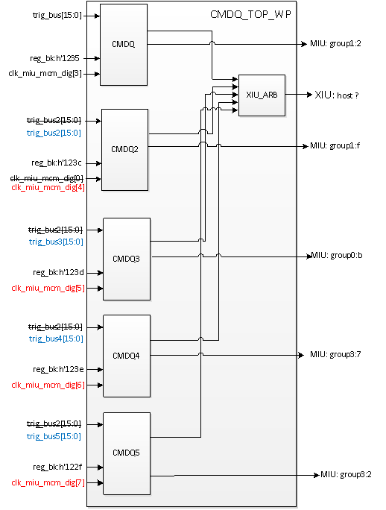

圖1-1

* Trigger bus definition

|  |  |  |  |  |  |
| --- | --- | --- | --- | --- | --- |
|  | CMDQ1 | CMDQ2 | CMDQ3 | CMDQ4 | CMDQ5 |
| **ID** | **source** | **source** | **source** | **source** | **source** |
| [15] | S0_intr_mdw_write_done_d | dmagen_cmdq_trig1 | bdma_cmdq_trig1 | dmagen_cmdq_trig1 | S0_intr_mdw_write_done_d |
| [14] | S0_intr_mgw_fire | dmagen_cmdq_trig0 | bdma_cmdq_trig0 | dmagen_cmdq_trig0 | bdma_cmdq_trig0 |
| [13] | Reg_cmdq_dummy[15] | S1_intr_mdw_write_done_d | ive_cmdq_trig | S1_intr_mdw_write_done_d | ive_cmdq_trig |
| [12] | ldc_cmdq_trig | S1_intr_mgw_fire | ldc_cmdq_trig | S1_intr_mgw_fire | S0_intr_mgw_fire |
| [11] | ge_cmdq_trig | Reg_cmdq2_dummy[15] | ge_cmdq_trig | Reg_cmdq4_dummy[15] | Reg_cmdq5_dummy[15] |
| [10] | core1_mhe_cmdq_trig | core1_mhe_cmdq_trig | core1_mhe_cmdq_trig | core1_mhe_cmdq_trig | core1_mhe_cmdq_trig |
| [9] | core0_mhe_cmdq_trig | core0_mhe_cmdq_trig | core0_mhe_cmdq_trig | core0_mhe_cmdq_trig | core0_mhe_cmdq_trig |
| [8] | core1_mfe_cmdq_trig | core1_mfe_cmdq_trig | core1_mfe_cmdq_trig | core1_mfe_cmdq_trig | core1_mfe_cmdq_trig |
| [7] | core0_mfe_cmdq_trig | core0_mfe_cmdq_trig | core0_mfe_cmdq_trig | core0_mfe_cmdq_trig | core0_mfe_cmdq_trig |
| [6] | dip_cmdq_trig | dip_cmdq_trig | dip_cmdq_trig | dip_cmdq_trig | dip_cmdq_trig |
| [5] | gop_cmdq_trig4 | gop_cmdq_trig4 | gop_cmdq_trig4 | gop_cmdq_trig4 | gop_cmdq_trig4 |
| [4] | gop_cmdq_trig2 | gop_cmdq_trig2 | gop_cmdq_trig2 | gop_cmdq_trig2 | gop_cmdq_trig2 |
| [3] | gop_cmdq_trig013 | gop_cmdq_trig013 | gop_cmdq_trig013 | gop_cmdq_trig013 | gop_cmdq_trig013 |
| [2] | sc_cmdq_trig2 | sc_cmdq_trig2 | sc_cmdq_trig2 | sc_cmdq_trig2 | sc_cmdq_trig2 |
| [1] | sc_cmdq_trig013 | sc_cmdq_trig013 | sc_cmdq_trig013 | sc_cmdq_trig013 | sc_cmdq_trig013 |
| [0] | isp_cmdq_trig | isp_cmdq_trig | isp_cmdq_trig | isp_cmdq_trig | isp_cmdq_trig |
|  |  |  |  |  |  |
| Note |  |  |  |  |  |

**Command Queue Interface**

* CMDQ service public API定義如下

|  |  |
| --- | --- |
| **Purpose** | To get cmdq service interface and allocate cmdq buffer and mload buffer. |
| **Syntax** | MHAL_CMDQ_CmdqInterface_t *MHAL_CMDQ_GetSysCmdqService(MHAL_CMDQ_ID eCmdqId, MHAL_CMDQ_BufDescript_t *pCmdqBufDesp ,MS_BOOL bForceRIU) |
| **Parameters** | /*cmdq ID*/  typedef enum  {  E_MHAL_CMDQ_ID_VPE = 0,  E_MHAL_CMDQ_ID_DIVP,  E_MHAL_CMDQ_ID_H265_VENC0,  E_MHAL_CMDQ_ID_H265_VENC1,  E_MHAL_CMDQ_ID_H264_VENC0,  E_MHAL_CMDQ_ID_MAX  }MHAL_CMDQ_ID;  /*allocate cmdq buffer and mload buffer*/  typedef struct MHAL_CMDQ_BufDescript_s  {  MS_U32 u32CmdqBufSize;  MS_U16 u32CmdqBufSizeAlign;  MS_U32 u32MloadBufSize;  MS_U16 u16MloadBufSizeAlign;  }MHAL_CMDQ_BufDescript_t;  /*True is RIU mode , False is CMDQ mode*/  MS_BOOL bForceRIU |
| **Return** | Return MHAL_CMDQ_CmdqInterface_t point, NULL is fail. |

|  |  |
| --- | --- |
| **Purpose** | Release cmdq service |
| **Syntax** | void MHAL_CMDQ_ReleaseSysCmdqService(MHAL_CMDQ_ID eCmdqId) |
| **Parameters** | /*cmdq ID*/  typedef enum  {  E_MHAL_CMDQ_ID_VPE = 0,  E_MHAL_CMDQ_ID_DIVP,  E_MHAL_CMDQ_ID_H265_VENC0,  E_MHAL_CMDQ_ID_H265_VENC1,  E_MHAL_CMDQ_ID_H264_VENC0,  E_MHAL_CMDQ_ID_MAX  }MHAL_CMDQ_ID; |
| **Return** | void |

* CMDQ Interface API定義如下

struct MHAL_CMDQ_CmdqInterface_s

{

//menuload ring buffer dynamic allocation service

MS_S32 (*MHAL_CMDQ_GetNextMlodRignBufWritePtr)(MHAL_CMDQ_CmdqInterface_t *pCmdinf,MS_PHYADDR* phyWritePtr);

MS_S32 (*MHAL_CMDQ_UpdateMloadRingBufReadPtr)(MHAL_CMDQ_CmdqInterface_t* pCmdinf, MS_PHYADDR phyReadPtr);

MS_S32 (*MHAL_CMDQ_MloadCopyBuf)(MHAL_CMDQ_CmdqInterface_t *pCmdinf, void * MloadBuf, MS_U32 u32Size, MS_U16 u16Alignment, MS_PHYADDR *phyRetAddr);

MS_S32 (*MHAL_CMDQ_CheckBufAvailable)(MHAL_CMDQ_CmdqInterface_t *pCmdinf , MS_U32 u32CmdqNum);

MS_S32 (*MHAL_CMDQ_WriteDummyRegCmdq)(MHAL_CMDQ_CmdqInterface_t *pCmdinf, MS_U16 u16Value);

MS_S32 (*MHAL_CMDQ_ReadDummyRegCmdq)(MHAL_CMDQ_CmdqInterface_t *pCmdinf,MS_U16* u16RegVal);

MS_S32 (*MHAL_CMDQ_WriteRegCmdqMask)(MHAL_CMDQ_CmdqInterface_t *pCmdinf, MS_U32 u32RegAddr, MS_U16 u16Value,MS_U16 u16WriteMask);

MS_S32 (*MHAL_CMDQ_WriteRegCmdq)(MHAL_CMDQ_CmdqInterface_t *pCmdinf, MS_U32 u32RegAddr, MS_U16 u16Value);

MS_S32 (*MHAL_CMDQ_CmdqPollRegBits)(MHAL_CMDQ_CmdqInterface_t *pCmdinf, MS_U32 u32RegAddr, MS_U16 u16Value, MS_U16 u16WriteMask,MS_BOOL bPollEq);

MS_S32 (*MHAL_CMDQ_CmdqAddWaitEventCmd)(MHAL_CMDQ_CmdqInterface_t *pCmdinf, MHAL_CMDQ_EVENT_ID eEvent);

MS_S32 (*MHAL_CMDQ_CmdqAbortBuffer)(MHAL_CMDQ_CmdqInterface_t *pCmdinf);

MS_S32 (*MHAL_CMDQ_CmdqResetEngine)(MHAL_CMDQ_CmdqInterface_t *pCmdinf);

MS_S32 (*MHAL_CMDQ_ReadStatusCmdq)(MHAL_CMDQ_CmdqInterface_t *pCmdinf,MS_U32* u32StatVal); MS_S32 (*MHAL_CMDQ_KickOffCmdq)(MHAL_CMDQ_CmdqInterface_t *pCmdinf);

MS_S32 (*MHAL_CMDQ_IsCmdqEmptyIdle)(MHAL_CMDQ_CmdqInterface_t *pCmdinf,MS_BOOL* bIdleVal)

MS_S32(*MHAL_CMDQ_ClearTriggerEvent)(MHAL_CMDQ_CmdqInterface_t *pCmdinf)

VOID * pCtx;

};

|  |  |
| --- | --- |
| **Purpose** | In non-RIU mode : 得到目前menuload buffer的目前write address.  In RIU mode , it is available. |
| **Syntax** | MS_S32 (*MHAL_CMDQ_GetNextMlodRignBufWritePtr)(MHAL_CMDQ_CmdqInterface_t *pCmdinf,MS_PHYADDR* phyWritePtr) |
| **Parameters** | MHAL_CMDQ_CmdqInterface_t *pCmdinf  /*Output phyWritePoint*/  MS_PHYADDR* phyWritePtr |
| **Return** | 0 is success , other is fail |

|  |  |
| --- | --- |
| **Purpose** | In non-RIU mode : 更新目前menuload buffer的目前read address.  In RIU mode , it is available. |
| **Syntax** | MS_S32 (*MHAL_CMDQ_UpdateMloadRingBufReadPtr)(MHAL_CMDQ_CmdqInterface_t* pCmdinf, MS_PHYADDR phyReadPtr) |
| **Parameters** | MHAL_CMDQ_CmdqInterface_t* pCmdinf //cmdq interface  MS_PHYADDR phyReadPtr //update 的read point |
| **Return** | 0 is success , other is fail |

|  |  |
| --- | --- |
| **Purpose** | In non-RIU mode : 將需要menuload的內容，copy至cmdq service的mload buffer.  In RIU mode : it is available. |
| **Syntax** | MS_S32 (*MHAL_CMDQ_MloadCopyBuf)(MHAL_CMDQ_CmdqInterface_t *pCmdinf, void * MloadBuf, MS_U32 u32Size, MS_U16 u16Alignment, MS_PHYADDR *phyRetAddr) |
| **Parameters** | HAL_CMDQ_CmdqInterface_t *pCmdinf//mload interface  void * MloadBuf //要copy到 cmdq service的mload buffer 的source point.  MS_U32 u32Size // source buffer的 size  u16Alignment //alignment size  MS_PHYADDR *phyRetAddr //return phyAddr |
| **Return** | 0 is success , other is fail |

|  |  |
| --- | --- |
| **Purpose** | In non-RIU mode :每次要進行write COMQ動作時，需呼叫此function來確保cmdq buffer是足夠的。  In RIU mode : it is unavailable. |
| **Syntax** | MS_S32 (*MHAL_CMDQ_CheckBufAvailable)(MHAL_CMDQ_CmdqInterface_t *pCmdinf , MS_U32 u32CmdqNum) |
| **Parameters** | /*cmdq interface point*/  MHAL_CMDQ_CmdqInterface_t *pCmdinf  /*需要的cmdq 數量*/  MS_U32 u32CmdqNum |
| **Return** | if is success , will return current cmdq available cmdq number.  0 is fail. |

|  |  |
| --- | --- |
| **Purpose** | In non-RIU mode : 將write command 的register address and value寫進cmdq.  In RIU mode : it will write register directly. |
| **Syntax** | MS_S32 (*MHAL_CMDQ_WriteRegCmdqMask)(MHAL_CMDQ_CmdqInterface_t *pCmdinf, MS_U32 u32RegAddr, MS_U16 u16Value,MS_U16 u16WriteMask) |
| **Parameters** | /*cmdq interface point*/  MHAL_CMDQ_CmdqInterface_t *pCmdinf  /*register address*/  MS_U32 u32RegAddr  /*register value*/  MS_U16 u16Value  /*register value mask*/  MS_U16 u16WriteMask  For example :  value = 1111_1111_1111_1111  write_mask = 1111_1111_0000_0000  real write value = 1111_1111_0000_0000 |
| **Return** | 0 is success , other is fail. |

|  |  |
| --- | --- |
| **Purpose** | In non-RIU mode : 將write command 的register address and value寫進cmdq.  In RIU mode : it will write register directly. |
| **Syntax** | MS_S32 (*MHAL_CMDQ_WriteRegCmdq)(MHAL_CMDQ_CmdqInterface_t *pCmdinf, MS_U32 u32RegAddr, MS_U16 u16Value) |
| **Parameters** | /*cmdq interface point*/  MHAL_CMDQ_CmdqInterface_t *pCmdinf  /*register address*/  MS_U32 u32RegAddr  /*register value*/  MS_U16 u16Value |
| **Return** | 0 is success , other is fail. |

|  |  |
| --- | --- |
| **Purpose** | In non-RIU mode :將poll command 的register address and polling bits 寫進cmdq.  In RIU mode : it is unavailable. |
| **Syntax** | MS_S32 (*MHAL_CMDQ_CmdqPollRegBits)(MHAL_CMDQ_CmdqInterface_t *pCmdinf, MS_U32 u32RegAddr, MS_U16 u16Value, MS_U16 u16WriteMask,MS_BOOL bPollEq) |
| **Parameters** | /*cmdq interface point*/  MHAL_CMDQ_CmdqInterface_t *pCmdinf  /*register address*/  MS_U32 u32RegAddr  /*register value*/  MS_U16 u16Value  /*register value mask*/  MS_U16 u16WriteMask  /*poll eq or non-eq mode*/  MS_BOOL bPollEq  TURE is Poll eq mode  FALSE is poll non-eq mode  For example :  value = 1111_1111_1111_1111  write_mask = 1111_1111_0000_0000  polling bits = 1111_1111_0000_0000 |
| **Return** | 0 is success , other is fail. |

|  |  |
| --- | --- |
| **Purpose** | In non-RIU mode : 將wait command 的event 寫進cmdq.  In RIU mode : it will add wait command into cmdq buffer and kick off cmdq.Then go to block mode to wait event done. |
| **Syntax** | MS_S32 (*MHAL_CMDQ_CmdqAddWaitEventCmd)(MHAL_CMDQ_CmdqInterface_t *pCmdinf, MHAL_CMDQ_EVENT_ID eEvent) |
| **Parameters** | /*cmdq interface point*/  MHAL_CMDQ_CmdqInterface_t *pCmdinf  /*trigger bus event*/  typedef enum  {  E_MHAL_CMDQEVE_S0_MDW_W_DONE, //Only for cmdq1&cmdq5  E_MHAL_CMDQEVE_S0_MGW_FIRE, //Only for cmdq1&cmdq5  E_MHAL_CMDQEVE_S1_MDW_W_DONE, //Only for cmdq2&cmdq4  E_MHAL_CMDQEVE_S1_MGW_FIRE, //Only for cmdq2&cmdq4  E_MHAL_CMDQEVE_DMAGEN_TRIGGER0, //Only for cmdq2&cmdq4  E_MHAL_CMDQEVE_DMAGEN_TRIGGER1, //Only for cmdq2&cmdq4  E_MHAL_CMDQEVE_BDMA_TRIGGER0, //Only for cmdq3&cmdq5  E_MHAL_CMDQEVE_BDMA_TRIGGER1, //Only for cmdq3  E_MHAL_CMDQEVE_IVE_CMDQ_TRIG, //Only for cmdq3&cmdq5  E_MHAL_CMDQEVE_LDC_CMDQ_TRIG, //Only for cmdq1&cmdq3  E_MHAL_CMDQEVE_GE_CMDQ_TRIG, //Only for cmdq1&cmdq3  E_MHAL_CMDQEVE_REG_DUMMY_TRIG, //Only for cmdq1&cmdq2&cmdq4&cmdq5  E_MHAL_CMDQEVE_CORE1_MHE_TRIG, //Only for ALL  E_MHAL_CMDQEVE_CORE0_MHE_TRIG, //Only for ALL  E_MHAL_CMDQEVE_CORE1_MFE_TRIG, //Only for ALL  E_MHAL_CMDQEVE_CORE0_MFE_TRIG, //Only for ALL  E_MHAL_CMDQEVE_DIP_TRIG, //Only for ALL  E_MHAL_CMDQEVE_GOP_TRIG4, //Only for ALL  E_MHAL_CMDQEVE_GOP_TRIG2, //Only for ALL  E_MHAL_CMDQEVE_GOP_TRIG013, //Only for ALL  E_MHAL_CMDQEVE_SC_TRIG2, //Only for ALL  E_MHAL_CMDQEVE_SC_TRIG013, //Only for ALL  E_MHAL_CMDQEVE_ISP_TRIG, //Only for ALL  E_MHAL_CMDQEVE_MAX  }MHAL_CMDQ_EVENT_ID; |
| **Return** | 0 is success , other is fail. |

|  |  |
| --- | --- |
| **Purpose** | In non-RIU mode : kick off command queue.  In RIU mode : it is unavailable. |
| **Syntax** | MS_S32 (*MHAL_CMDQ_KickOffCmdq)(MHAL_CMDQ_CmdqInterface_t *pCmdinf) |
| **Parameters** | /*cmdq interface point*/  MHAL_CMDQ_CmdqInterface_t *pCmdinf |
| **Return** | if is success , will return current cmdq available number. <0 is fail. |

|  |  |
| --- | --- |
| **Purpose** | In non-RIU mode : To check cmdq if is idle.  In RIU mode : it is available. |
| **Syntax** | MS_S32 (*MHAL_CMDQ_IsCmdqEmptyIdle)(MHAL_CMDQ_CmdqInterface_t *pCmdinf ,MS_BOOL* bIdleVal) |
| **Parameters** | /*cmdq interface point*/  MHAL_CMDQ_CmdqInterface_t *pCmdinf  /* MS_BOOL* bIdleVal */  Return idle status. |
| **Return** | 0 is success , other is fail. |

|  |  |
| --- | --- |
| **Purpose** | In non-RIU mode : Add write command of dummy register to cmdq.  In RIU mode : write cmdq dummy register directly. |
| **Syntax** | MS_S32 (*MHAL_CMDQ_WriteDummyRegCmdq)(MHAL_CMDQ_CmdqInterface_t *pCmdinf, MS_U16 u16Value) |
| **Parameters** | /*cmdq interface point*/  MHAL_CMDQ_CmdqInterface_t *pCmdinf  /*write value*/  MS_U16 u16Value |
| **Return** | 0 is success , other is fail. |

|  |  |
| --- | --- |
| **Purpose** | In non-RIU mode : Read cmdq dummy register.  In RIU mode : it is the same. |
| **Syntax** | MS_S32 (*MHAL_CMDQ_ReadDummyRegCmdq)(MHAL_CMDQ_CmdqInterface_t *pCmdinf,MS_U16* u16RegVal) |
| **Parameters** | /*cmdq interface point*/  MHAL_CMDQ_CmdqInterface_t *pCmdinf  /*return value*/  MS_U16* u16RegVal |
| **Return** | 0 is success , other is fail. |

|  |  |
| --- | --- |
| **Purpose** | In non-RIU mode : Abort current cmdq write data ,then go back previous .  In RIU mode : it is unavailable. |
| **Syntax** | MS_S32 (*MHAL_CMDQ_CmdqAbortBuffer)(MHAL_CMDQ_CmdqInterface_t *pCmdinf) |
| **Parameters** | /*cmdq interface point*/  MHAL_CMDQ_CmdqInterface_t *pCmdinf |
| **Return** | 0 is success , other is fail. |

|  |  |
| --- | --- |
| **Purpose** | In non-RIU mode : Read command queue status.  In RIU mode : it is the same. |
| **Syntax** | MS_S32 (*MHAL_CMDQ_ReadStatusCmdq)(MHAL_CMDQ_CmdqInterface_t *pCmdinf,MS_U32* u32StatVal) |
| **Parameters** | /*cmdq interface point*/  MHAL_CMDQ_CmdqInterface_t *pCmdinf  /* MS_U32* u32StatVal */  Return Value |
| **Return** | 0 is success , other is fail. |

|  |  |
| --- | --- |
| **Purpose** | In non-RIU mode : Reset cmdq engine and ring buffer.  In RIU mode : it is the same. |
| **Syntax** | MS_S32 (*MHAL_CMDQ_CmdqResetEngine)(MHAL_CMDQ_CmdqInterface_t *pCmdinf) |
| **Parameters** | /*cmdq interface point*/  MHAL_CMDQ_CmdqInterface_t *pCmdinf |
| **Return** | 0 is success , other is fail. |

|  |  |
| --- | --- |
| **Purpose** | In non-RIU mode : Add write command for clear trigger event  In RIU mode : N/A. |
| **Syntax** | MS_S32(*MHAL_CMDQ_ClearTriggerEvent)(MHAL_CMDQ_CmdqInterface_t *pCmdinf) |
| **Parameters** | /*cmdq interface point*/  MHAL_CMDQ_CmdqInterface_t *pCmdinf |
| **Return** | 0 is success , other is fail. |

MHAL_CMDQ_ClearTriggerEvent() function的使用時機，因為在fire一張frame時user可能去使用wait command 去等待某一個 event，當此event發生時會通知cmdq，此時cmdq應該要將event清除以避免造成下一張frame 等待該event時產生誤動作。

* MHAL_CMDQ_ClearTriggerEvent()的Pseudo code

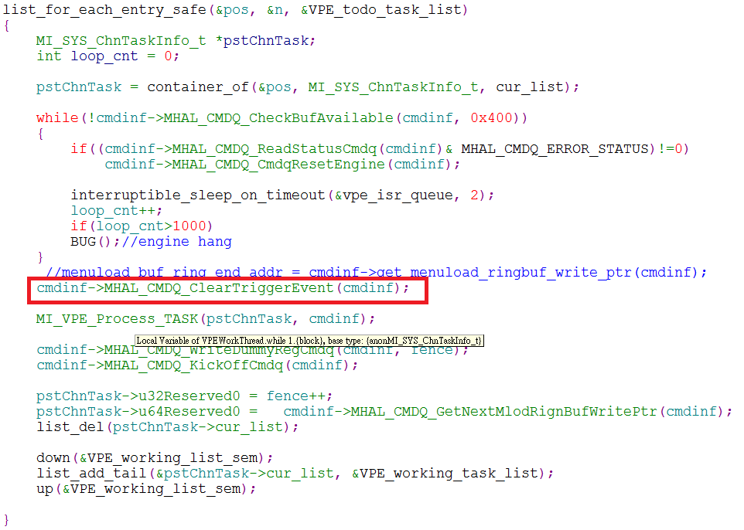

**Command Queue Process**

* How to control command queue service

1. 使用者首先需呼叫MHAL_CMDQ_GetSysCmdqService 去allocate cmdq buffer及menuload buffer , cmdq service會回傳 cmdq interface structure.
2. 每當要將command寫進command queue buffer之前，都需呼叫MHAL_CMDQ_CheckBufAvailable的callback function 來確定command queue buffer是否有足夠的空間來填寫command.
3. 如果有足夠的buffer空間，使用者會將cmdq interface structure所提供 MHAL_CMDQ_WriteRegCmdqMask、MHAL_CMDQ_WriteRegCmdq、MHAL_CMDQ_CmdqPollRegBits、MHAL_CMDQ_CmdqAddWaitEventCmd 的callback function 交由負責填寫command的模組來負責。
4. 確定完畢後，由使用者呼叫MHAL_CMDQ_KickOffCmdq的callback function 來進行command queue的kick off。

* Menuload callback function的使用

Command queue service只提供menuload的 buffer 管理，主要流程如下

1. 當使用者將cmdq interface structure中MHAL_CMDQ_MloadCopyBuf 的callback function交由負責填寫command的模組時，如要使用menuload功能，會先將內容先copy在command queue service的menuload buffer。
2. 如果copy成功，填寫command的模組處理後續驅動menuload IP的動作。
3. 處理完成後，使用者呼叫MHAL_CMDQ_GetNextMlodRignBufWritePtr 的callback function來取得menuload buffer write point 。
4. 當command queue執行完畢後，由使用者來呼叫MHAL_CMDQ_UpdateMloadRingBufReadPtr來更新menuload buffer的read point，以更新menuload buffer的空間。

* Pseudo code
  + To get command queue service interface

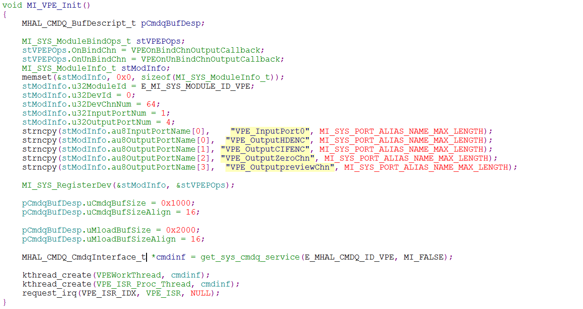

* Process command queue

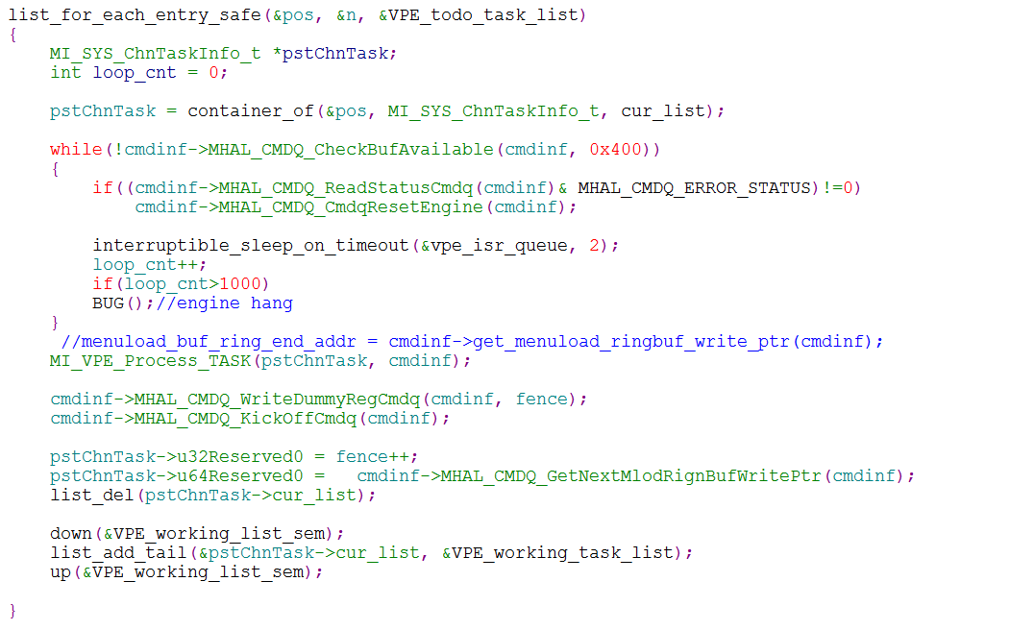

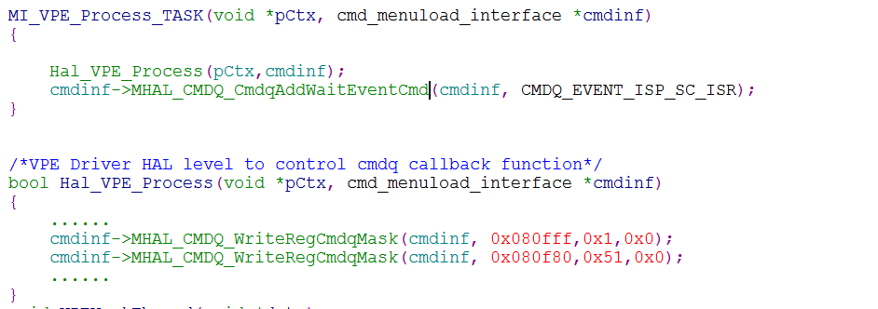

* ISR Thread to deal with command queue

