**Setup DS-5 on LinuxDB**

**Version 0.1**

**Prepared by <miff.lyn>**

**<2017-07-24>**

© 2017 MStar Semiconductor, Inc. All rights reserved.

MStar Semiconductor makes no representations or warranties including, for example but not limited to, warranties of merchantability, fitness for a particular purpose, infringement of any intellectual property right or the accuracy or completeness of this document, and reserves the right to make changes without further notice to any products herein to improve reliability, function or design. No responsibility is assumed by MStar Semiconductor arising out of the application or user of any product or circuit described herein; neither does it convey any license under its patent rights, nor the rights of others.

MStar is a trademark of MStar Semiconductor, Inc. Other trademarks or names herein are only for identification purposes only and owned by their respective owners.

REVISION HISTORY

|  |  |  |  |
| --- | --- | --- | --- |
| **Rev.** | **Description** | **Date** | **Author** |
| 0.1 | 添加 1 至6章节 | 2017/7/24 | Miff.lyn |
|  |  |  |  |
|  |  |  |  |
|  |  |  |  |
|  |  |  |  |
|  |  |  |  |
|  |  |  |  |

TABLE OF CONTENT

REVISION HISTORY i

TABLE OF CONTENT ii

LIST OF TABLES iii

LIST OF FIGURES iii

1. 安装DS5软件 1

2. 编译gator.ko & gatord（daemon） 2

2.1. Building the gator module 2

2.2. Building the gator daemon 3

3. 抓取开机状态 4

4. 抓取当前状态 5

5. 导入lib，并分析 6

6. 案例分析举例 9

6.1. [C_CN_Hisense_6586_DB] 关于开机时间优化问题 9

6.2. MiSysSrv占用CPU过高 9

LIST OF TABLES

LIST OF FIGURES

Table 1缩略语清单

|  |  |
| --- | --- |
| **缩略语** | **描述** |
| LinuxDB | Pure Linux Driver Base Platfrom（MI平台） |
|  |  |
|  |  |
|  |  |
|  |  |
|  |  |
|  |  |
|  |  |
|  |  |
|  |  |
|  |  |
|  |  |
|  |  |
|  |  |
|  |  |
|  |  |

# 安装DS5软件

下载路径：

<https://developer.arm.com/products/software-development-tools/ds-5-development-studio/downloads>

PS: 也可以参考，Mstar有社区授权服务器，否则只能使用试用版本30天。

* 导入 DS-5 License
  + Help -> ARM License Manager

license server: **alisvr03**，port: **8224**

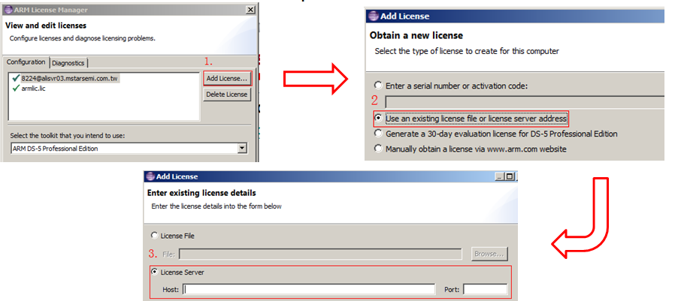

# 编译gator.ko & gatord（daemon）

到安装目录“C:\Program Files (x86)\DS-5 v5.21.1\arm\gator”拿出gator的源文件，启动文件和daemon文件

* 1. driver-src 是gator.ko的源码
  2. daemon-src 是gatord （daemon）的源码
  3. README_Streamline.txt介绍了上述两个源码的如何编译，并且要求Kernel需要打开的相关config。例如：macan Kernel需要CONFIG_PROFILING=y，但是LinuxDB的Maxim Kernel module已经包含gator.ko（很可能需要重新编译，毕竟DS5的版本不一样，Daemon与gator.ko 的通讯协议可能有变化）

（**这个文件很重要**）

## Building the gator module

以macan linuxdb 为例

1. ***linux-mstar-3.10.40-master/tegra/***
2. ***cp .config_macan_SMP_supernova .config***
3. ***make menuconfig打开***

***General setup ---> [*] Profiling support***

***Kernel hacking ---> [*] Tracers --->***

1. ***make clean && make uImage -j32***
2. To create the gator.ko module,

tar xzf /path/to/DS-5/arm/gator/driver-src/gator-driver.tar.gz

cd gator-driver

make -C <kernel_build_dir> M=`pwd` ARCH=arm CROSS_COMPILE=arm-none- modules

***make -C ~/linux-mstar-3.10.40-master/tegra/ M=`pwd` ARCH=arm CROSS_COMPILE=arm-none-linux-gnueabi- modules***

whenever possible, use the same toolchain the kernel was built with when building gator.ko

for example when using the linaro-toolchain-binaries

make -C /home/username/kernel_2.6.32/ M=`pwd` ARCH=arm CROSS_COMPILE=/home/username/gcc-linaro-arm-linux-gnueabihf-4.7-2013.01-20130125_linux/bin/arm-linux-gnueabihf- modules

If successful, a gator.ko module should be generated

It is also possible to integrate the gator.ko module into the kernel build system

cd /path/to/kernel/build/dir

cd drivers

mkdir gator

cp -r /path/to/gator/driver-src/* gator

Edit Makefile in the kernel drivers folder and add this to the end

obj-$(CONFIG_GATOR) += gator/

Edit Kconfig in the kernel drivers folder and add this before the last endmenu

source "drivers/gator/Kconfig"

You can now select gator when using menuconfig while configuring the kernel and rebuild as directed

*** Use the prebuilt gator daemon ***

A prebuilt gator daemon is provided at /path/to/DS-5/arm/gator/gatord. This gator daemon should work in most cases so building the gator daemon is only required if the prebuilt gator daemon doesn't work.

To improve portablility gatord is statically compiled against musl libc from http://www.musl-libc.org/releases/musl-1.0.2.tar.gz instead of glibc. The gator daemon will work correctly with either glibc or musl.

## Building the gator daemon

tar -xzf /path/to/DS-5/arm/gator/daemon-src/gator-daemon.tar.gz

For Linux targets,

cd gator-daemon

make CROSS_COMPILE=<...> # For ARMv7 targets

make -f Makefile_aarch64 CROSS_COMPILE=<...> # For ARMv8 targets

gatord should now be created

For Android targets (install the Android NDK appropriate for your target (ndk32 for 32-bit targets and ndk64 for 64-bit targets), see developer.android.com)

mv gator-daemon jni

ndk-build

or execute /path/to/ndk/ndk-build if the ndk is not on your path

gatord should now be created and located in libs/armeabi

If you get an error like the following, upgrade to a more recent version of the android ndk

jni/PerfGroup.cpp: In function 'int sys_perf_event_open(perf_event_attr*, pid_t, int, int, long unsigned int)':

jni/PerfGroup.cpp:36:17: error: '__NR_perf_event_open' was not declared in this scope

To build gatord for aarch64 edit jni/Application.mk and replace armeabi-v7a with arm64-v8a. To build for ARM11 jni/Application.mk and replace armeabi-v7a with armeabi.

**若Kernel需要打开相关config，则所有的KO也需要一并重新编译，否则KO在加载时会卡住不动。（若USB的驱动没有安装，那只能重新烧录镜像文件了）**

# 抓取开机状态

1. 修改mmap（若抓的时间不长，则无需修改）
   * + 1. 修改mmap将LX LEN 拉到到50M
       2. 同时将mboot地址做对应修改
       3. 查看板子 /tvservice/modules/ 下已有的ko ，在MI中将他们换成文件夹里 driverok/ 下的ko 编译
       4. 不需要 xhci-hcd.ko
       5. 修改后的MI和mboot烧进板
2. 将文件夹里的 configuration.xml session.xml 放到 /tvservice/modules/ 注意修改权限session.xml 里的 duration="20" 已预设录制20s，可自行修改。

 

1. 添加开机驱动加载: insmod /tvservice/modules/gator.ko (在daemon之前)
2. 添加开机启动gatord daemon. 添加到/etc/ini.d/rcS 或者 /applications/bin/autorun中。

/tvservice/modules/gatord -s /tvservice/modules/session.xml -c /tvservice/modules/configuration.xml -o /tvservice/modules/ds-5 &

-o /tvservice/modules/ds-5 就是指定存储路径和文件名。

# 抓取当前状态

1. 开机驱动加载: insmod /tvservice/modules/gator.ko
2. 确保ifconfig中的eth0 的IP可以正常看到。
3. 添加IP后点击Start Capture按钮（会要求输入本次抓取的名称，如XXX）就可以开始抓取当前状态

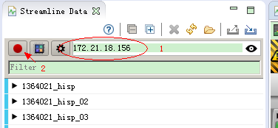

# 导入lib，并分析

抓取完毕的按钮也是一个红色按钮，随后在Streamline Data中会看到刚才抓取的XXX项目。在该项目上右键，选择Analyze… 所打开的界面可以进行lib导入。

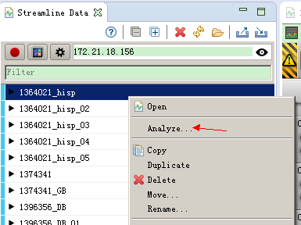

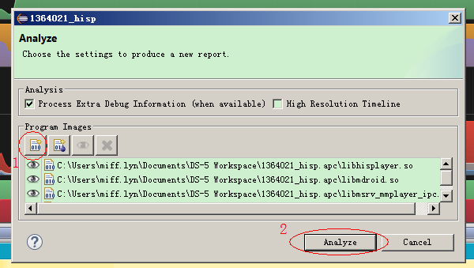

抓取到的状态显示如下：

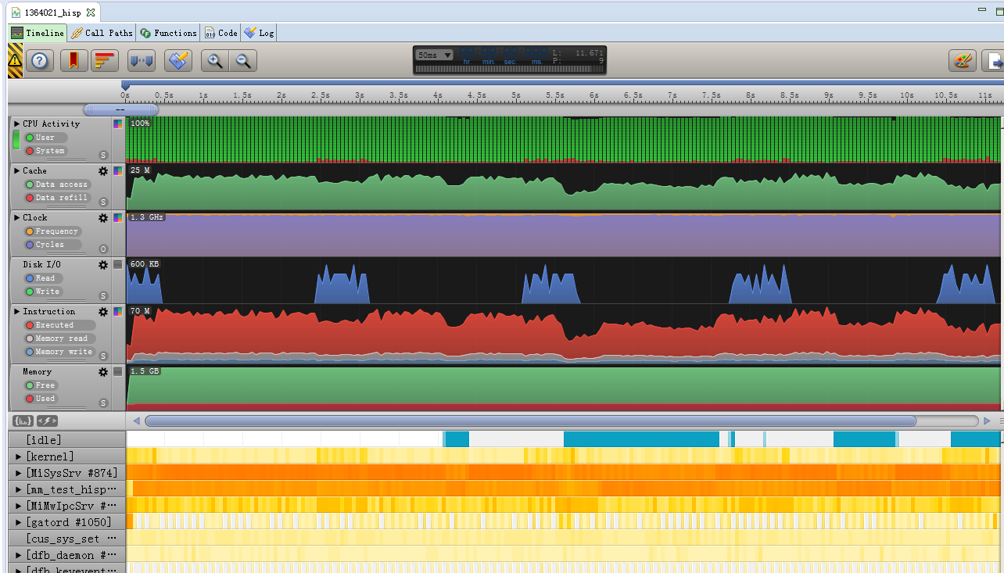

TimeLine：用图像显示各项主要指标。点击截图下半部的进程，可以看到该进程的状态图像，点击偶数下，就还原总体状况图像。实心三角形隐藏子项。另外留意下图的这些功能。

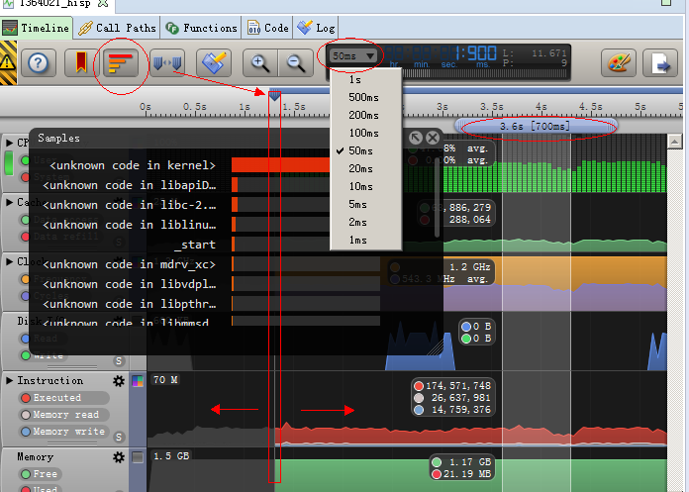

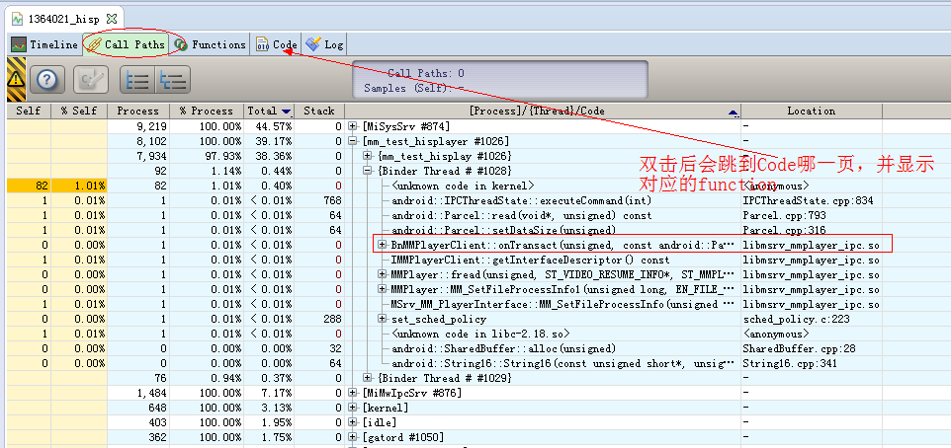

# 案例分析举例

## [C_CN_Hisense_6586_DB] 关于开机时间优化问题

请帮忙厘清fc-cache 开机高CPU耗费的问题. 连续3次开机都看类似下图1的状况。

His tvmain 高CPU耗费点如图2：

就图1 看来，8.5秒后的CPU未满载，是否可以做成满载来压缩开机时间？

Platform：usb_HU55N3050UW_0509_2.bin

+拿掉 bluetooth.ko & btmtk_usb.ko –>  for DS-5

+ 所提供的Wifi修改   -> 显示UI

|  |
| --- |
| cid:image003.jpg@01D2CB63.18B40EE0 |

## MiSysSrv占用CPU过高

1374341: [Hisense_6586][DB][ATSC][QD]播放商场模式下预制视频MiSysSrv占用CPU过高（40%以上）

1. 下图是我在海信的平台上直接跑local MM（mm_test）播放目标码流（带subtitle）所获得的结果。

海信的平台使用top 也可以看到MiSysSrv之IRQThread_208占比很高。所以直接用mm_test 分析.

另外应该也可以在MacanLinuxDB 的公版上直接看问题。

1. 该线程的CPU 使用情况如下。（drvTSP.c分析明天回公司我再贴出来）

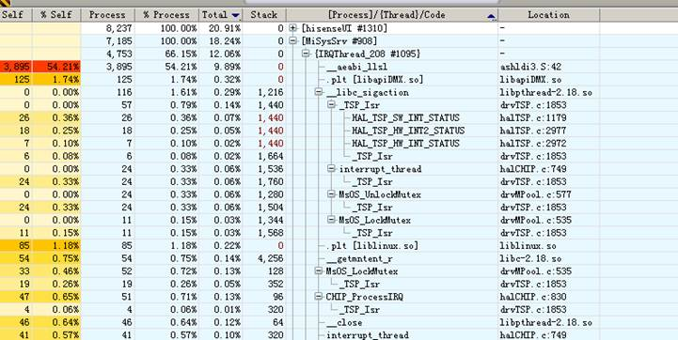

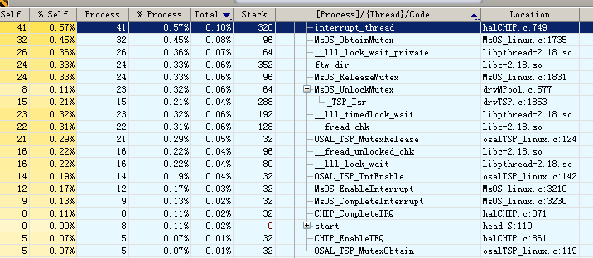

1. 从架构上看，Local MM 跟MiSysSrv没有交集，IRQThread_208为何开在MiSysSrv，原因如下：

