Some questions about DSA 3. Most of them arose after reading the
manuscript on DSAs by Vassallo et al, IEEE 2007-

1- Are there any documents specifically on the DSA 3 parameters, or
anything where to look for differences between DSA 1/2 and 3?

DS-3 will be very similar to DS-2. The attached file “Pages from ESTRACK_Facilities_Manual_issue1.1.pdf” report the publicly available information on both DS-1 and DS-2. The performance contained therein is the one to be used officially in defining interfaces with spacecraft, mission requests, general users, etc.

2- Regarding the transceivers that will be attached to DSA-3. a) Is it
already discarded to have an S-band one? b) The X- and Ka-band
transceivers will be operational from the beginning both receiving and
transmitting?

a) Yes
b) X-band both Tx and Rx, Ka-band Rx only

3- Is the mirror M4a dichroic or reflectant; observing at X and Ks
band can be done simultaneously?

Simultaneous observations at X-band and Ka-band are indeed possible.

4- Which will be the speed of the engine for tracking? And for re-location?

- Minimum speed during track is 1 mdeg/s (both Azimuth and Elevation axes)
- Maximum speed during track is 0.4 deg/s (both Azimuth and Elevation)
- Maximum speed for re-location is 1 deg/s (both Azimuth and Elevation)

5- Which will be the value of the effective area of the dish, and the
aperture efficiency?

Please refer to the figures provided in “Pages from ESTRACK_Facilities_Manual_issue1.1.pdf” for DS-2 to get a reference valid also for DS-3.
Final figures for DS-3 may slightly change.

6- a) Will the input bandwidth of DSA 3 be 100 MHz, or larger? b) Will
it have channels? If so, how wide?

Available Bandwidth (BW) depends on frequency band being recorded
X-band BW (in Rx) is 100 MHz
Ka-band BW (in Rx) is 220 MHz
These bands are not entirely recordable, but can be split in maximum 8 channels per receiver (max two receivers are available in parallel), each channel covering maximum 4MHz (at 1-bit quantization).
The width of each individual channel depends on the sample rate and on quantisation and is according to the formula:
SamplingRate*Quantisation < 36 Mbps
The station can be configured in such a way that the channels cover the entire available bandwidth at both X- and Ka- bands.

7- Which will be the maximum acquisition rate per record?

Maximum rate can be 4MHz (at 1 bit quantisation)

8- Where can I read on data acquisition (record, format, further
processing,...)?

Please refer to the attached file “gsy050042_05.pdf” for the native format ICD of our open loop receiver.
CCSDS is currently developing a “Raw Data Exchange Format” for this kind of open loop acquisitions. The draft version of this format is documented in the attached file “506x1r1.pdf”

9- Is it available a time table of developments/stages/module completition?

According to current schedule the station will be operational by mid-October 2012 in all its functionalities (i. e. including X- a Ka- band reception and Open Loop recording)

10- Which radio stars were used to determine the coefficients for the
SPEM corrections?

List 1 is the list of ICRF radio-sources that were considered for DS-1.
The attached file “Pages from 129226_rev1.pdf” is the preliminary list of candidate ICRF radio-sources that are considered for DS-3.
The final list for DS-3 is not yet available.

List 1
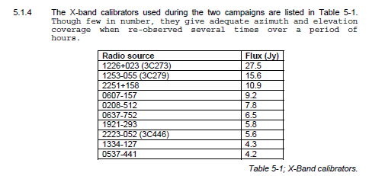

Paula Benaglia

