

Foundations of Programming
Assignment No. : 12

PROBLEM STATEMENT:
Write a program in C to accept two numbers from the user and compute:
- The smallest common divisor of the two numbers (other than 1, if any)
- The Greatest Common Divisor (GCD) of the two numbers

OBJECTIVE:
• To understand the use of mathematical operations in C.
• To implement loops and conditional statements
. • To perform number-based computations.
• To enhance logical thinking using menu-driven programs.

THEORY:
Divisors and the Greatest Common Divisor (GCD) are fundamental concepts in number theory. The smallest common divisor of two numbers is the smallest positive integer greater than 1 that divides both numbers. The GCD of two numbers is the largest positive integer that divides both numbers without leaving a remainder. In C programming, these operations can be efficiently implemented using loops and the Euclidean algorithm, which repeatedly applies the modulo operation until the remainder becomes zero.

PLATFORM:
V.S Code

ALGORITHM:
Smallest Common Divisor (other than 1)
- Start
- Input two numbers a, b
- Find the smaller of a and b → min = (a < b) ? a : b
- Initialize i = 2
- If i > min → no common divisor found, print "No common divisor other than 1", go to step 8
- If (a % i == 0) AND (b % i == 0) → print i as smallest common divisor, go to step 8
- i = i + 1, go to step 5
- Stop
GCD (Euclidean Method)
- Start
- Input two numbers a, b
- If b == 0 → GCD = a, go to step 5
- Set temp = b, b = a % b, a = temp → go to step 3
- Print GCD = a
- Stop

FLOWCHART:

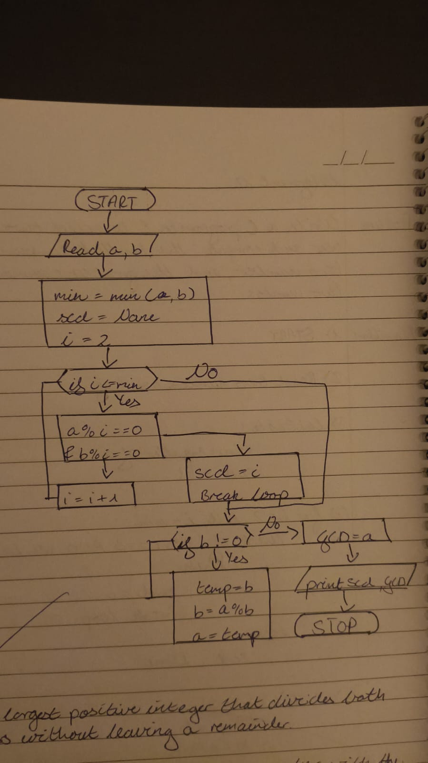

PROGRAM :
#include <stdio.h>

int main() {
int a, b, i, min, temp, x, y;

printf("Enter two numbers: ");
scanf("%d %d", &a, &b);

x = a; y = b;

// ── Part A: Smallest Common Divisor ──
min = (a < b) ? a : b;
int found = 0;
for (i = 2; i <= min; i++) {
if (a % i == 0 && b % i == 0) {
printf("Smallest common divisor (other than 1) = %d\n", i);
found = 1;
break;
}
}
if (!found)
printf("No common divisor other than 1\n");

// ── Part B: GCD (Euclidean) ──
while (y != 0) {
temp = y;
y = x % y;
x = temp;
}
printf("GCD = %d\n", x);

return 0;
}
INPUT:
The user enters two integer numbers.
Example Input: Number 1: 24 Number 2: 36

Paste Screen Shot of Input

OUTPUT:
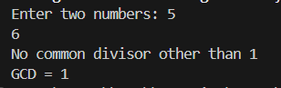

CONCLUSION:
Thus, the program to find the smallest common divisor and the Greatest Common Divisor of two numbers was successfully implemented using C programming. This program demonstrates the use of loops, conditional statements, and the Euclidean algorithm.

FAQs:
- What is meant by the Greatest Common Divisor (GCD)?
- Why does the Euclidean algorithm efficiently compute the GCD?
- How can this program be modified to handle negative numbers?
- What changes are required to compute the Least Common Multiple (LCM) using the GCD?
- How can this program be extended to find the LCM of two numbers?

