

Foundations of Programming

Lab Assignment No. : 03

PROBLEM STATEMENT:
Write a program in C to generate multiplication tables for a given number.
OBJECTIVES:
- To understand the use of looping statements in C.
- To generate multiplication tables using loops.
- To improve program logic and execution flow understanding.

THEORY:
Syntax for for loop example program
Syntax for while loop example program
Syntax for do while loop example program

ALGORITHM:
Algorithm

Start

Declare variables n and i

Ask the user to enter a number

Read the value of n

Initialize i = 1

Repeat until i ≤ 10

Calculate n * i

Display the result in the form n × i = result

Increment i by 1

Stop

Type Program :
#include <stdio.h>

int main() {
int num, i;

printf("Enter a number: ");
scanf("%d", &num);

for (i = 1; i <= 10; i++) {
printf("%d x %d = %d\n", num, i, num * i);
}

return 0;
}
Flowchart :
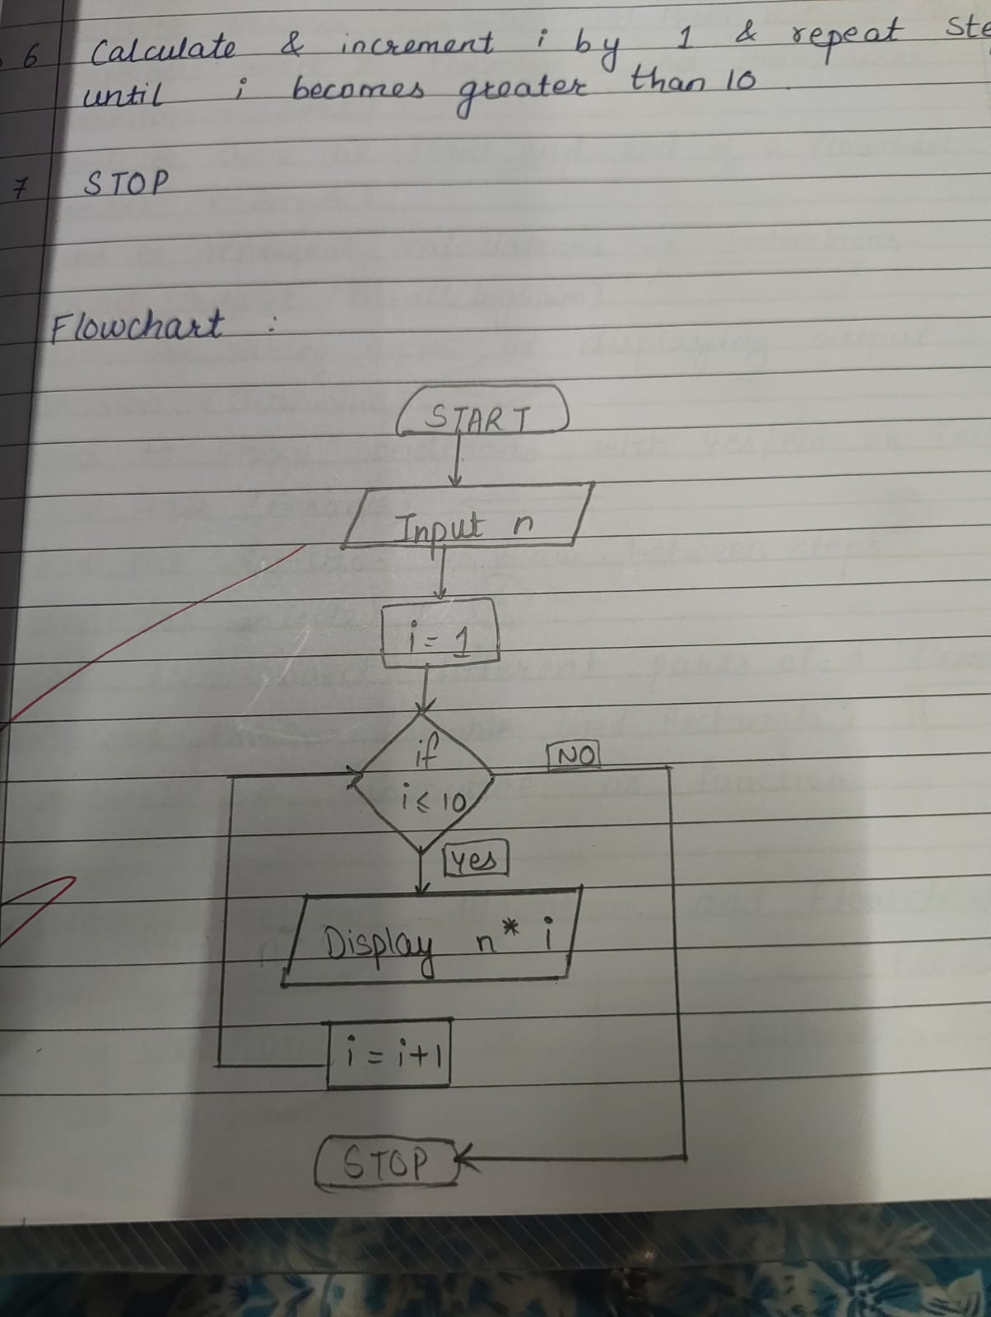

PLATFORM:
Linux

INPUT:
5

OUTPUT:
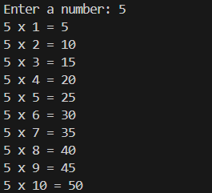
SAMPLE INPUT:
1
10 5

SAMPLE OUTPUT:
Addition = 15

CONCLUSION:
Thus, the menu driven program in C successfully performs basic arithmetic operations using switch–case statements.

FAQs:
- Which loop is best suited for generating multiplication tables?
- What is the role of loop initialization?
- Difference between for loop, while loop and do while loop?
- Can a do–while loop be used to generate multiplication tables? Explain.
- Why is the do–while loop called an exit-controlled loop?

