LAB221Assignment | Type: | Short Assignment
LAB221Assignment | Code: | J2.S.P0113
LAB221Assignment | LOC: | 70
LAB221Assignment | Slot(s): | 2

Title
Manage book
Background Context
NA

Program Specifications
Use swing library to create a program to manage books, basic information includes:
- Book code
- Book name
- Author
- Publisher
- Publish year
- For rent
Main functions described as below:

Function details:

- Create new book : tạo mới sách
- Update an existing book : cập nhật sách hiện có
- Remove an existing book : xóa sách hiện có
- Display an existing book information : hiển thị thông tin sách hiện có
Expectation of User interface:
The screen should be as:

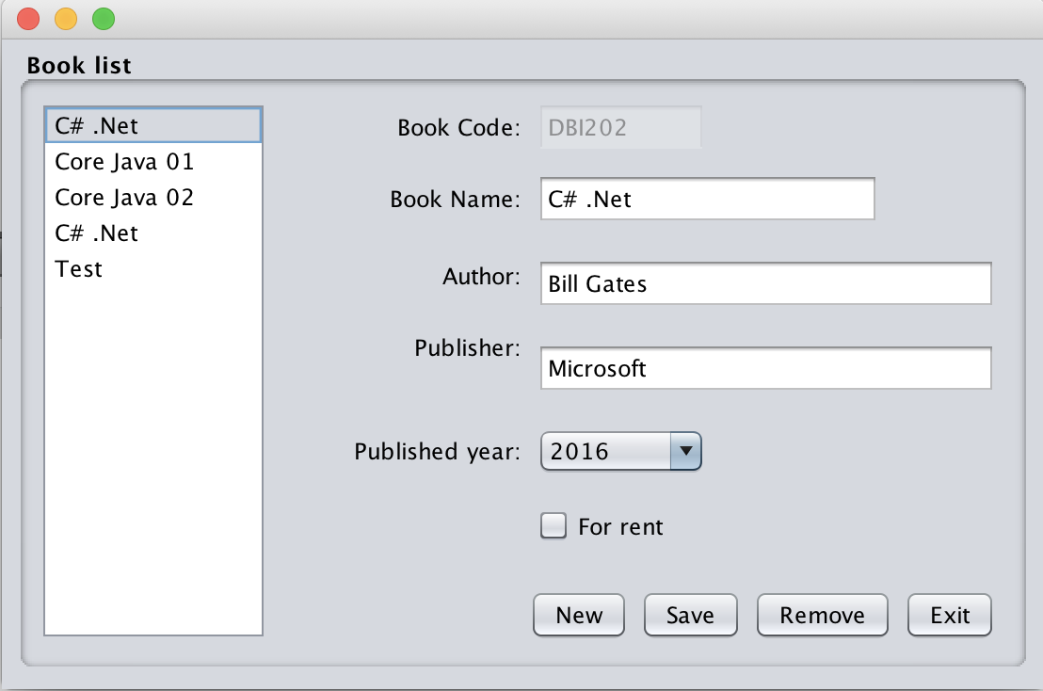

- Enter book information in controls on the form, click Save button, book information is stored and new item added in the Book list

  - Select one item in the Book list, book information displays on the screen, click Remove button, the item is removed from the Book list and the first item information in the Book list will be displayed.
- Click Exit button, the program is finish
- Click Exit button chương trình sẽ kết thúc.

Guidelines

