

YENEPOYA INSTITUTE OF ARTS, SCIENCE, COMMERCE AND MANAGEMENT
BALMATTA, MANGALORE
YENEPOYA (DEEMED TO BE UNIVERSITY)
Project – High Level Design
on
Healthcare

Student Name: Anusree s nair

Industry Mentor: | Shashank Korrem | Guided by: | Vikyath Shetty

Table of Contents

- Introduction. 3
  - Scope of the document. 3
  - Intended Audience 3
  - System overview. 3
- System Design. 4
  - Application Design 4
  - Process Flow. 6
  - Information Flow. 8
  - Components Design 8
  - Key Design Considerations 10
  - API Catalogue. 11
- Data Design. 14
  - Data Model 14
  - Data Access Mechanism 15
  - Data Retention Policies 16
  - Data Migration 17
- Interfaces 19
- State and Session Management 20
- Caching 23
- Non-Functional Requirements 10
  - Security Aspects 10
  - Performance Aspects 10
- References 11

1.INTRODUCTION

1.1 Scope of the document :
This document outlines the high-level design of the GuardianHealth system, focusing on its overall architecture, major components, and system interactions.
It covers key aspects such as authentication, role-based access control, security mechanisms, and data flow across the system. The scope includes frontend, backend, database, and security layers, providing a clear understanding of how the system operates at a high level without going into detailed implementation.

1.2 Intended Audience:
This document is intended for developers, system architects, project evaluators, and stakeholders who need a high-level understanding of the GuardianHealth system. It helps them understand the system architecture, components, and overall design without going into detailed implementation.

1.3 System Overview
GuardianHealth is a secure healthcare identity system that manages user access and protects sensitive data. It uses IAM for role-based access, MFA for secure login, and blockchain for audit logging. The system follows a Zero Trust approach to ensure every user and action is verified.

2. SYSTEM DESIGN

2.1 Application design:
The GuardianHealth application is designed as a secure and modular healthcare identity system.
- Follows Client-Server Architecture
- Divided into:
- Frontend(Vanilla JS UI)
- Backend (API &Business Logic)
- Database(Data Storage )
- Security Layer(IAM,MFA,SSO)
- Communication via REST APIs
- Designed for simplicity and performance

- Frontend Design :
- Built using:
- HTML(structure)
- CSS (styling)
- Vanilla JavaScript (logic)
- No frameworks used (lightweight design)

Features:
- Login & Registration pages
- MFA verification interface
- Role-based dashboards
- Role-based dashboards
Responsibilities:
- Handles user input and validation
- Sends API requests using Fetch/AJAX
- Dynamically updates UI using DOM manipulation
- Manages routing using simple navigation (no SPA framework)

- Backend Design
- Built using Python (FastAPI / Flask)
Responsibilities:
- Authentication & authorization
- MFA verification
- Role and permission management
- API handling
- Uses JWT tokens for secure sessions

- Database Design
- Uses SQL database (PostgreSQL/MySQL)
Stores :
- Users
- Roles and permissions
- Sessions
- Audit logs
- Ensures:
- Data Integrity
- Secure storage

- Security Design:
- Follows Zero Trust Model
Features:
- IAM (Role-Based Access Control)
- MFA (OTP verification)
- SSO (OAuth2/OIDC)
- Session and device management

- Blockchain Audit Design:
- Stores logs as immutable records
Includes:
- User action
- Timestamp
- Hash values
- Ensures:
- Tamper-proof logging
- Data integrity
- API Design:
- Uses REST APIs
Key Endpoints:
- /login
- /register
- /verify-mfa
- /users
- /audit-logs
- Ensures:
- Secure communication
- Data Validation

- User Flow Design:
- User accesses frontend (HTML/CSS/JS)
- Sends request to backend via API
- Backend validates credentials
- MFA is triggered (if required)
- User is authenticated and redirected
- Access granted based on role

- Design Principles:
- Lightweight frontend (Vanilla JS)
- Modular backend design
- High security
- Scalability
- Maintainability

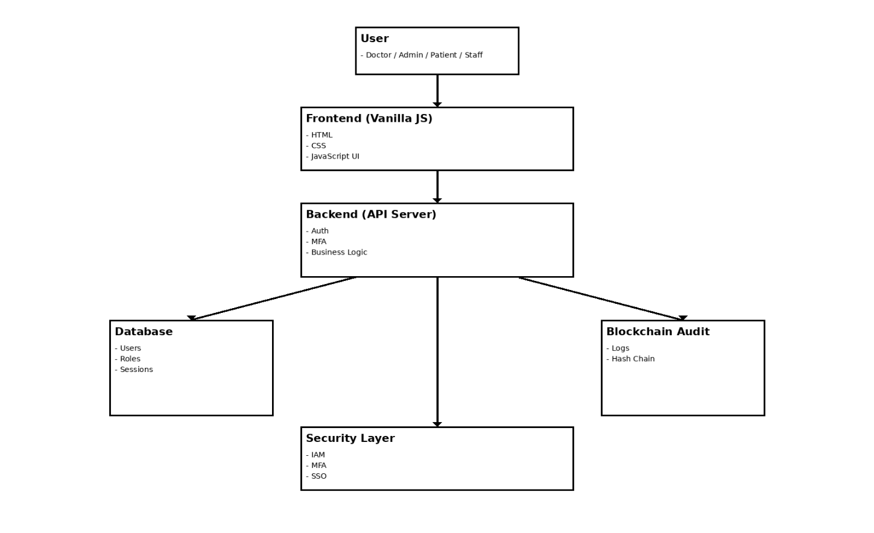

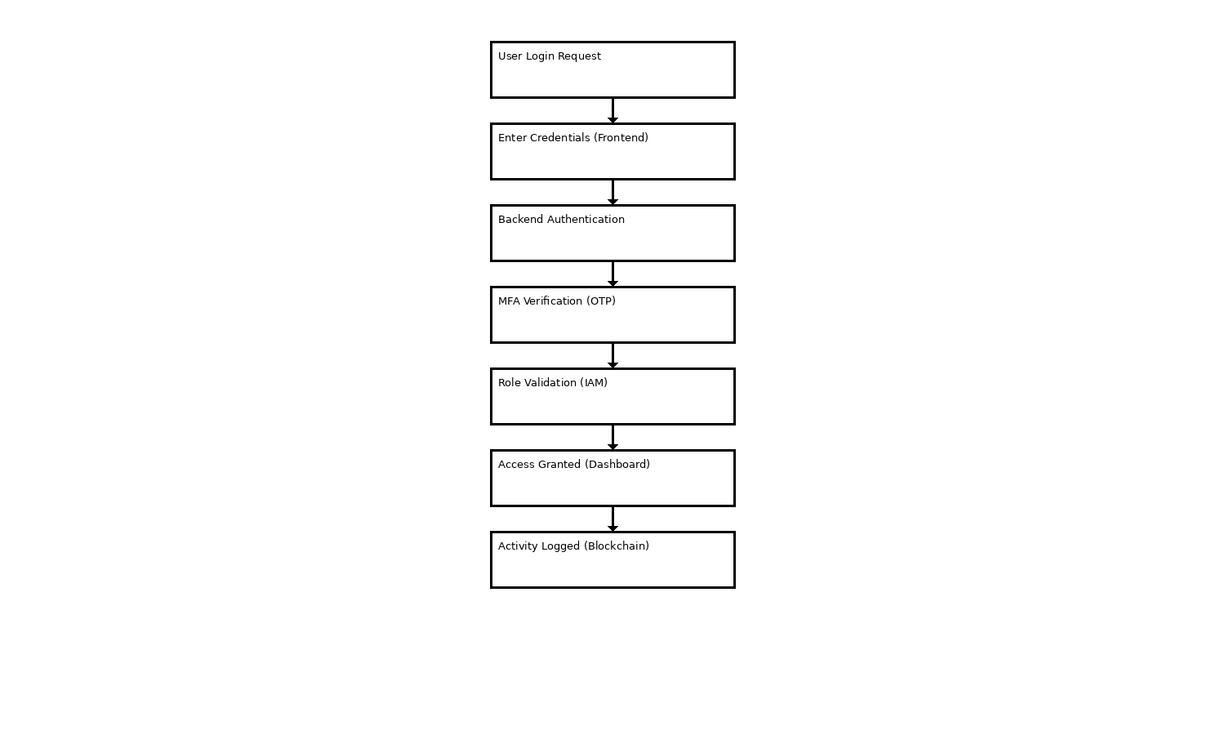
2.2 Process Flow:
2.3 Information Flow:
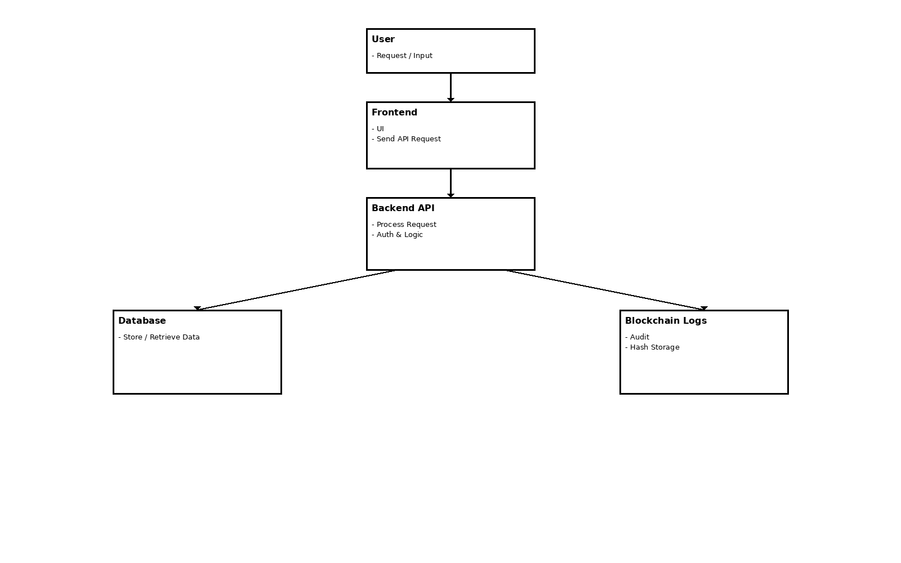

2.4 Component Design:
The GuardianHealth system is divided into multiple components, each responsible for a specific functionality such as authentication, access control, security, and monitoring.
Key Components:
- Authentication Component:
- Handles user login and registration
- Validates username/email and password
- Generates JWT tokens for sessions
- Supports Single Sign-On (SSO)

- Multi-Factor Authentication (MFA) Component:
- Provides additional security after login

- Uses OTP (Time-based One-Time Password)
- Verifies 6-digit codes
- Ensures secure access

- IAM (Identity and Access Management) Component:
- Manages users, roles, and permissions
- Implements Role-Based Access Control (RBAC)
- Assigns roles (Admin, Doctor, Patient, Staff)
- Controls access to system resources
- Dashboard Component:
      - Provides role-based dashboards
      - Displays relevant data for each user role
      - Restricts access based on permissions

- Security Monitoring Component:
      - Tracks login activity and user behavior
      - Detects suspicious activities
      - Displays alerts and notifications
      - Monitors active sessions

- Blockchain Audit Component:
      - Stores system activity logs securely
      - Uses hash chaining for integrity
      - Ensures tamper-proof logging
      - Supports audit and verification

- Session Management Components:
      - Manages user sessions using JWT
      - Tracks active sessions and devices
      - Allows logout from all devices
      - Detects unknown devices

- API Management Component:
      - Handles communication between frontend and backend
      - Provides REST API endpoints
      - Validates requests and responses
      - Ensures secure API access

2.5 Key Design Considerations:

- Security:
- Implements Zero Trust Model
- Uses MFA for strong authentication
- Applies IAM (Role-Based Access Control)
- Encrypts sensitive data
- Ensures secure API communication

- Sacalability:
- Designed to handle increasing users and data
- Modular architecture supports easy expansion
- Can scale backend and database independently

- Performance:
- Optimized API responses
- Efficient database queries
- Minimal frontend load using lightweight Vanilla JS
- Reliability:
- Ensures system availability and stability
- Handles errors and failures effectively
- Maintains consistent performance

- Data Integrity:
- Uses constraints (PK, FK, UNIQUE)
- Prevents data duplication and corruption
- Blockchain ensures tamper-proof logs

- Maintainability:
- Modular design for easy updates
- Clear separation of frontend, backend, and database
- Easy debugging and enhancements
- Usability:
- Simple and user-friendly interface
- Role-based dashboards
- Clear navigation and responsive design

2.6 API Catalogue:
The GuardianHealth system uses RESTful APIs to enable secure communication between the frontend and backend.
Key APIs:
- Login API
- Endpoint: /login
- Method: POST
- Description:
Authenticates user credentials and initiates login process
- Request:
- Email
- Password
- Response:
- JWT token
- MFA required flag

- Registration API:
- Endpoint: /register
- Method: POST
- Description:
Registers a new user in the system
- Request:
- Name
- Email
- Passsword
- Role
- Response:
- Success message
- User status (Pending/Active)

- MFA Verification API:
- Endpoint: /verify-mfa
- Method: POST
- Description:
Verifies OTP for multi-factor authentication
- Request:
- User_id
- OTP code
- Response:
- Authentication success
- Access token

- User Management API:
- Endpoint: /users
- Method: GET / POST / PUT / DELETE
- Description:
Manages user data and roles (Admin access)
Functions:
- Create user
- View user
- Update user
- Delete user

- Audit Logs API
- Endpoint: /audit-logs
- Method: GET
- Description:
Retrieves blockchain-based audit logs
- Response:
- User Actions
- Timestamp

- Security Features of APIs:
- Uses JWT-based authentication
- Secured using role-based access control
- Validates all inputs and requests
- Prevents unauthorized access
- Uses HTTPS for secure communication

3. DATA DESIGN:

3.1 Data modal:
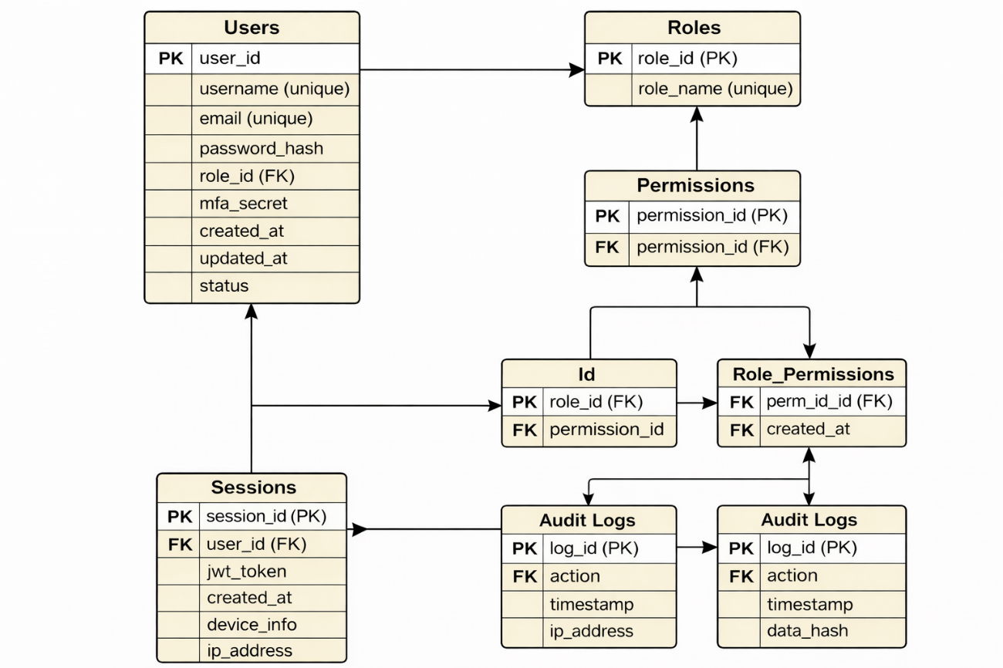

3.2 Data Access Mechanism :
The GuardianHealth system accesses and manages data through secure APIs and controlled database operations. It ensures that only authorized users can access or modify data based on their roles and permissions.

- API-Based Data Access:
- Data is accessed through REST APIs
- Frontend sends requests to backend
- Backend processes and interacts with database

- Role-Based Access Control (RBAC):
- Access is controlled using IAM roles
- Users can only access permitted data
- Roles include:
- Admin
- Doctor
- Patient
- Staff

- Secure Databse Access:
      - Backend handles all database queries
      - Direct database access is restricted
      - Uses:
- Parameterized queries
- ORM (optional)

- Authentication & Authorization:
- Uses JWT tokens for authentication
- Verifies user identity before data access
- Checks permissions before processing request

- Data Validation:
- Validates all input data before processing
- Prevents invalid or malicious data
- Ensures data consistency

- Logging & Monitoring:
- All data access activities are logged
- Stored in blockchain audit logs
- Helps in tracking and auditing

- Error Handling:
- Handles failed requests securely
- Returns proper error messages
- Prevents system crashes

3.3 Data Retention Policies:
The GuardianHealth system follows structured data retention policies to ensure secure storage, compliance, and efficient management of healthcare and security-related data. Data is retained only for necessary durations and handled securely.

- User data Retention:
- Stores user details (name, email, role, etc.)
- Retained as long as the account is active
- Deleted or anonymized after account deactivation

- Authentication & Session Data:
- Session data (JWT tokens, login sessions) stored temporarily
- Automatically expires after a defined time
- Old sessions are cleared regularly

- Audit Logs Retention:
- Stores all user activities for auditing
- Retained for a longer duration for security analysis
- Blockchain logs remain immutable (cannot be deleted)

- MFA Data Retention:
- Stores MFA secrets securely

- Retained while MFA is enabled
- Deleted when MFA is disabled

- Device & Access Data:
- Stores device information and IP addresses
- Used for monitoring and security
- Retained for a limited time

- Data Archiving:
- Older data is archived periodically
- Archived data stored securely
- Helps improve system performance

- Data Deletion Policy:
- Unused or expired data is removed
- Ensures minimal data storage
- Prevents unnecessary data accumulation

- Compliance & Security:
- Follows data protection standards
- Ensures confidentiality and integrity
- Prevents unauthorized data access
3.4 Data Migration:
Data migration in the GuardianHealth system refers to the process of transferring data between databases, systems, or versions while ensuring data integrity, security, and consistency.

- Purpose of Data Migration:
- Transfer existing data to a new system or database
- Support system upgrades or schema changes
- Ensure continuity of operations without data loss

- Types of Migration:
- Database upgrades (schema changes)
- System migration (old system → GuardianHealth)
- Data backup and restore

- Migration Process:
- Extract data from source system
- Transform data into required format
- Load data into target database (ETL process)

- Data Validation:
- Verify data accuracy after migration
- Check for missing or duplicate records
- Ensure data consistency

- Security Considerations:
      - Encrypt sensitive data during migration
      - Restrict access to migration process
      - Maintain confidentiality of user data

- Backup and Recovery:
      - Take full backup before migration
      - Enable rollback in case of failure
      - Prevent data loss
      - Downtime Management:
      - Perform migration during low-traffic periods
      - Minimize system downtime
      - Ensure smooth transition

- Tools and Techniques:
      - Use database migration tools (e.g., scripts, ETL tools)
      - Use version control for schema changes
      - Automate migration where possible

4. INTERFACE:

- Frontend ↔ Backend Interface
      - Uses REST APIs
      - Frontend sends user requests (login, register, etc.)
      - Backend processes and returns responses
      - Communication via HTTP/HTTPS

- Backend ↔ Database Interface
      - Backend interacts with database for:
        - Storing user data
        - Retrieving records
- Uses secure queries (SQL)
- No direct frontend access to database

- Backend ↔ Blockchain Interface
      - Backend logs all activities to blockchain
      - Stores:
        - User actions
        - Timestamp
        - Hash values
- Ensures tamper-proof logging

- Backend ↔ Security Layer Interface
      - Handles:
        - IAM (roles & permissions)
        - MFA verification
        - SSO authentication
- Ensures secure access control

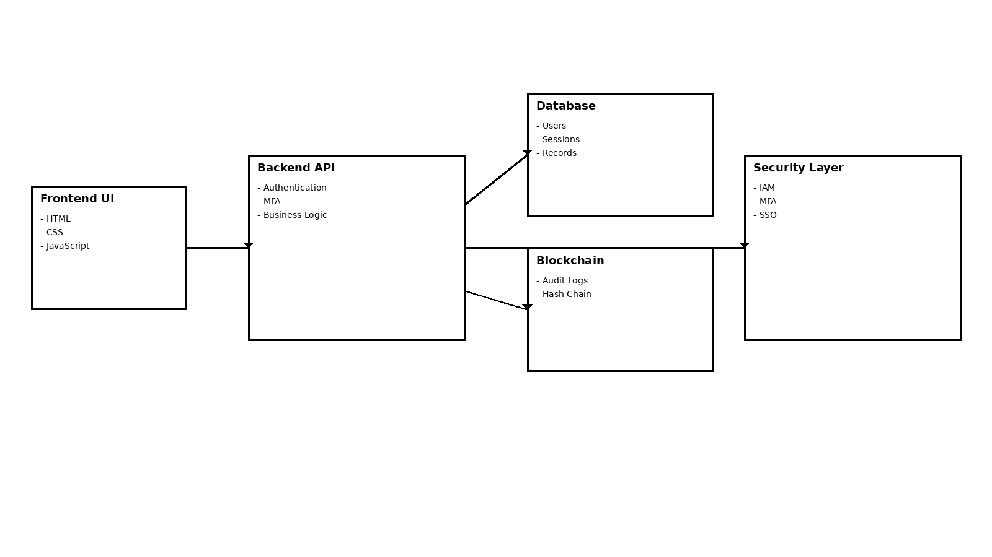

5.STATE AND SESSION MANAGEMENT
State and Session Management in the GuardianHealth system ensures that user authentication and activity are securely maintained across multiple

requests. It helps track user interactions, manage active sessions, and enforce security throughout the user’s access lifecycle.

- Session Management:

  - Session Creation

      - Created after successful login and MFA verification
      - Backend generates a JWT token
      - Token is sent to the frontend and stored securely

- Session Tracking
- Each session is linked to:
- User ID
- Device information
- IP address
- Enables monitoring of active user sessions
- Helps identify unusual login activity

- Session Expiry
  - Sessions expire after a predefined time
  - Prevents long-term unauthorized access
  - Requires re-authentication after expiry

- Session Termination
  - Users can manually logout
  - Admin can terminate sessions
  - Supports:
- Logout from all devices
- Forced session termination

- State Management
  - Authentication State
      - Maintains login status of the user
      - Determines whether user is authenticated or not
      - Controls access to protected routes

- Role-Based State
- Stores user role (Admin, Doctor, Patient, Staff)
- Determines accessible features and dashboards
- Ensures proper authorization

- UI State (Frontend)
- Tracks:
        - Current page
        - User actions
        - Form inputs
- Managed using JavaScript (Vanilla JS)

6.CACHING
- Stored in temporary memory (server-side caching)
- Can use in-memory storage (e.g., Redis - optional)
- Frontend may cache minimal UI data

- Cache Expiry:
      - Cached data expires after a defined time
      - Ensures updated and fresh data
      - Prevents stale data issues

- Security Considerations
      - Do not cache sensitive data (e.g., passwords)
      - Secure cached session data
      - Clear cache on logout

7. NON-FUNCTIONAL
- Authentication Security
- Uses secure login with username/email and password
- Passwords stored using hashing (bcrypt)
- Prevents unauthorized access

- Multi-Factor Authentication (MFA)
• Adds extra security layer after login
• Uses OTP (Time-based)

- Identity and Access Management (IAM)
      - Implements Role-Based Access Control (RBAC)
      - Assigns roles:
        - Admin
        - Doctor
        - Patient
        - Staff
- Restricts access based on permissions

- Session Security

- Uses JWT tokens for session management
- Sessions have expiry time
- Supports logout from all devices
- Detects suspicious sessions

- Data Security
      - Encrypts sensitive data
      - Uses secure database storage
      - Prevents data leakage

- API Security
      - Secured using authentication tokens
      - Validates all requests and inputs
      - Prevents unauthorized API access

- Blockchain Audit Security

      - Stores logs in tamper-proof format
      - Uses hash chaining
      - Ensures data integrity

- Network Security

      - Uses HTTPS for secure communication
      - Protects data during transmission

- Zero Trust Model
- Verifies every user and request
- No implicit trust within the system

7.2 PERFORMANCE ASPECTS

- Fast Response Time
      - Optimized API responses
      - Quick data retrieval from database
      - Ensures smooth user experience

- Efficient Database Queries
      - Uses optimized SQL queries
      - Indexing for faster data access
      - Reduces query execution time

- Lightweight Frontend
- Built using Vanilla JavaScript
- Minimal load on browser
- Faster page rendering

- Caching Mechanism
- Stores frequently accessed data
- Reduces repeated database calls Improves system speed

- Scalability
- Handles increasing number of users
- Supports system expansion without performance loss

- Load Management
- Distributes workload efficiently
- Prevents server overload
- Maintains system stability

- Asynchronous Processing
- Handles API requests asynchronously
- Improves system responsiveness

- Optimized Session Handling
- Efficient session tracking
- Prevents unnecessary resource usage

8.REFERENCES

- IAM (Identity & Access Management)
      - AWS IAM Documentation
      - IAM Concepts and Tools Overview
      - IAM helps manage user identities, authentication, and access control in systems

- Multi-Factor Authentication (MFA)
- MFA Documentation (Datadog)
- Adaptive MFA (Auth0 Docs)
- MFA requires multiple verification factors, improving security against attacks

- Cybersecurity & IAM Concepts
      - CISSP IAM Domain Explanation
      - Covers:
        - Authentication
        - Authorization
        - Access control models

