Trader Performance vs. Market Sentiment
An Analysis of Hyperliquid Trading Data and the Bitcoin Fear & Greed Index
Data Science Task Submission | Anything.ai / Primetrade.ai

1. Executive Summary
This analysis merges 211,218 individual trade executions from 32 Hyperliquid accounts (May 2023 - May 2025) with the daily Bitcoin Fear & Greed Index to test whether trader performance is systematically related to market-wide sentiment.
The headline finding is that raw profitability per trade is not meaningfully different between Fear and Greed regimes, but behavior is: traders are far more active and take larger positions during Fear, and win rates, coin selection, and individual account performance all shift with sentiment in ways that carry practical implications for strategy design.

Key Findings
- Average realized PnL per trade is statistically indistinguishable between Fear ($101.86) and Greed ($105.70) regimes (Welch's t-test, p = 0.69).
- Win rate is highest in Fear (84.4%) and lowest in Neutral sentiment (82.4%); the difference is small in magnitude but statistically significant (chi-square, p < 0.001) given the large sample.
- Traders are substantially more active during Fear: average trade size is 57% larger ($7,182 vs $4,574) and daily trade volume/count both correlate negatively with the sentiment index (r = -0.26 and r = -0.25), meaning more trading happens as the market gets fearful, not less.
- Performance is highly concentrated: the top 3 accounts generated over $3.6M of the $10.25M total realized PnL, and individual accounts vary widely in whether they do better in Fear or Greed.
- Sentiment sensitivity is coin-specific: @107 lost money in Fear but was the single largest Greed-regime winner ($2.71M), while TRUMP showed the opposite pattern, losing heavily in Greed.

2. Data & Methodology

2.1 Datasets
- Hyperliquid Trader History - 211,224 raw trade records across 32 accounts and 246 coins, including execution price, size, side, closed PnL, and fees.
- Bitcoin Fear & Greed Index - Daily sentiment score (0-100) and 5-way label (Extreme Fear, Fear, Neutral, Greed, Extreme Greed), Feb 2018 - May 2025.

2.2 Approach
- Parsed trade timestamps and joined each trade to the same-calendar-day sentiment reading (99.997% match rate; 6 unmatched rows dropped).
- Treated rows with non-zero Closed PnL as realized/closing trades (104,402 of 211,218) - PnL is booked at position close, so opening trades correctly show 0.
- Collapsed the 5-way sentiment label into a 3-way regime (Fear = Fear + Extreme Fear, Greed = Greed + Extreme Greed, Neutral) for higher-power statistical comparisons, while keeping the 5-way breakdown for descriptive detail.
- Tested differences using one-way ANOVA (5-class PnL), Welch's t-test (Fear vs Greed PnL), and a chi-square test of independence (win rate vs regime).

3. Performance by Sentiment Regime
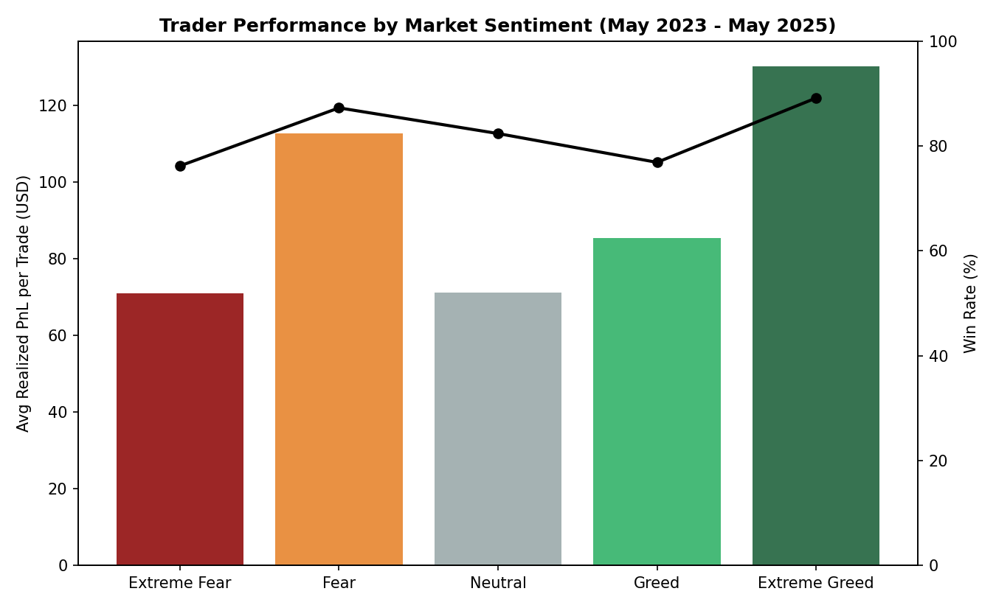
Figure 1. Average realized PnL per trade (bars) and win rate (line) across the five sentiment classes.
Average PnL per trade rises only modestly from Extreme Fear toward the middle of the distribution and does not show a clean monotonic trend with sentiment. The ANOVA across all five classes is significant (F = 7.74, p < 0.001), but this is driven mainly by Extreme Fear/Extreme Greed pulling away from the middle classes rather than a smooth Fear-to-Greed effect - the direct Fear-vs-Greed comparison is not significant. In practice, sentiment label alone is a weak predictor of per-trade profitability.

4. Trading Activity & Risk-Taking by Sentiment
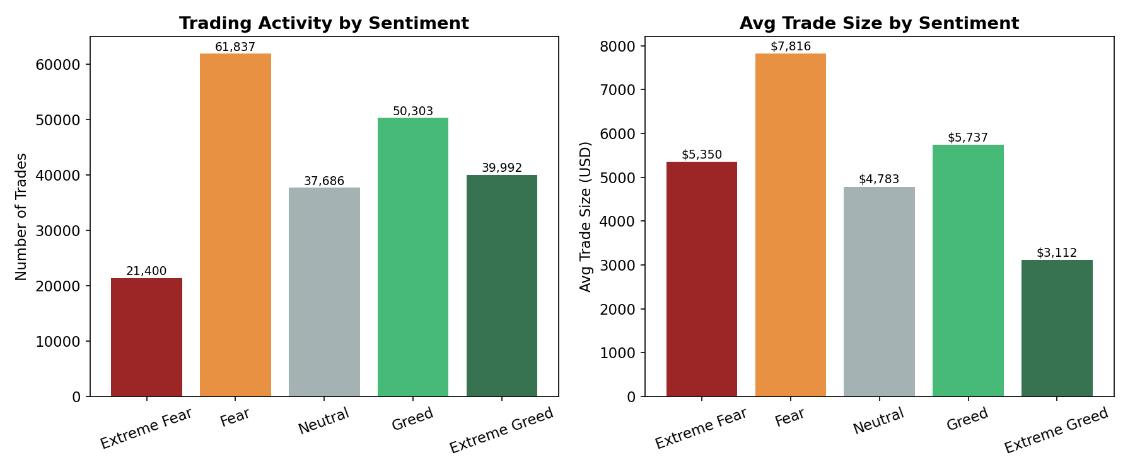
Figure 2. Trade count and average trade size by sentiment class.
The clearest and most actionable pattern in the data is behavioral rather than result-based. Fear days see the highest average trade size ($7,816 across all trades) - noticeably larger than Greed ($5,737) or Neutral ($4,783) - and overall trading volume is highest during Fear ($483M) versus Greed ($289M) despite Greed accounting for more individual trades in the simplified regime view. At the daily level, both trade count and total volume correlate negatively with the sentiment index value (r = -0.245 and r = -0.264 respectively): as the market gets more fearful, these traders don't retreat, they lean in with bigger size.
This is consistent with a contrarian or opportunistic trading style - treating market fear as a buying/positioning opportunity rather than a signal to de-risk - and is the single most useful insight for shaping a sentiment-aware strategy: position sizing and risk limits should account for this tendency to scale up exposure precisely when volatility (and drawdown risk) is typically highest.

5. Sentiment and PnL Over Time
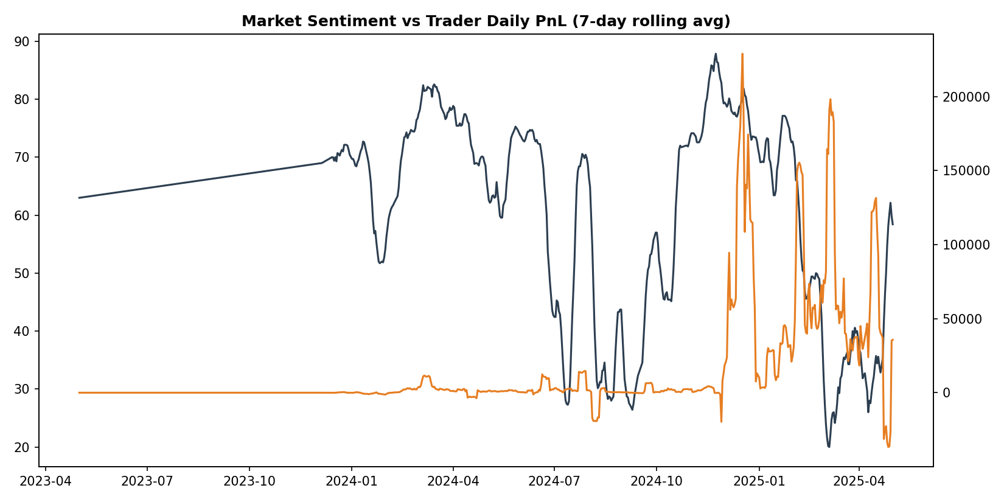
Figure 3. 7-day rolling average of the sentiment index versus 7-day rolling average of realized daily PnL.
The rolling time series shows PnL is noisy and does not visibly track the sentiment curve in a lagged or contemporaneous way; the overall daily correlation between sentiment value and PnL is weak and slightly negative (r = -0.083). Large PnL swings appear driven more by individual position sizing and specific coin moves than by the aggregate sentiment reading, reinforcing that sentiment here is better used as a risk/exposure signal than a direct profitability signal.

6. Concentration: Accounts and Coins

6.1 Account-level concentration
Performance is highly concentrated among a small subset of the 32 accounts. The table below shows the top accounts by total realized PnL, split by regime:
Account (truncated) | Fear PnL | Greed PnL | Total PnL
0xb1231a4a... | $102,710 | n/a in top-3 | $2,143,383
0x083384f8... | $1,238,143 | n/a in top-3 | $1,600,230
0xbaaaf657... | $882,790 | n/a in top-3 | $940,164
Table 1. Top 3 accounts by total realized PnL (full regime breakdown available in the accompanying code output).
The top 3 accounts alone account for roughly 46% of total realized PnL across all 32 accounts, and each shows a different sensitivity to sentiment - some concentrate their gains in Fear periods, others in Greed - suggesting distinct underlying strategies rather than a single shared sentiment-driven behavior across the trader base.

6.2 Coin-level sensitivity
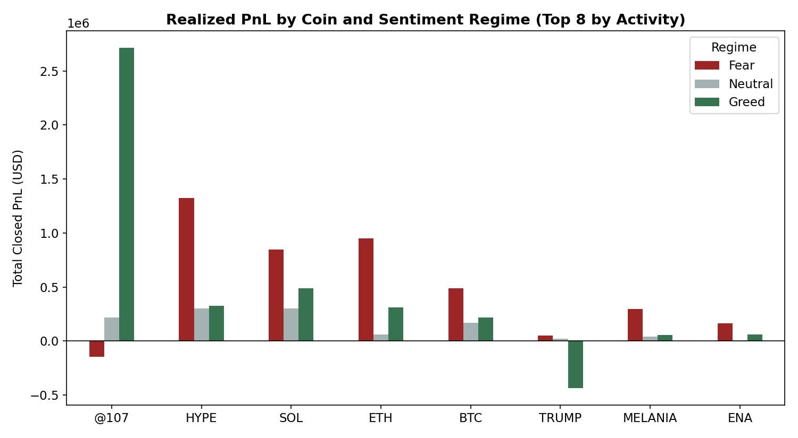
Figure 4. Realized PnL by coin and sentiment regime, for the 8 most-traded coins.
Sentiment sensitivity is highly coin-specific. @107 was the largest single source of Greed-regime profit ($2.71M) but was slightly negative during Fear, while TRUMP lost over $435K during Greed periods despite being profitable in Fear and Neutral conditions. This suggests any sentiment-aware strategy should be built and tuned per-asset rather than applied uniformly across the book.

7. Recommendations for Strategy Design
- Do not use the sentiment label alone as a profitability signal - its direct relationship with per-trade PnL is weak and not statistically robust between Fear and Greed.
- Do use sentiment as a risk-sizing signal: since traders empirically increase position size and activity during Fear, formalize a position-sizing rule (e.g., a volatility- or sentiment-adjusted cap) so exposure doesn't scale up exactly when tail risk is elevated.
- Build coin-specific sentiment overlays rather than a single portfolio-wide rule, given how differently individual assets (@107 vs TRUMP, for example) respond to Fear versus Greed.
- Investigate the top-performing accounts' strategies further (e.g., holding period, leverage, coin concentration) as a template, since a small number of accounts drive a disproportionate share of total profit.
- Extend the analysis with intraday sentiment proxies (e.g., funding rates, realized volatility) alongside the daily Fear & Greed Index, since the daily granularity may be masking shorter-term effects.

8. Appendix: Files Provided
- analysis.py - full reproducible Python script (load, merge, statistical tests, chart generation).
- This report (Trader_Sentiment_Analysis_Report.docx).

