1. **Introduction**
   1. **Dataset**

This data visualization analysis suicide rate between 1985 to 2016 for 101 different countries in the world. This dataset is divided group by 5 different age intervals and base on people’s divided into 6 different generations.

Population size: Number of people contained in each country at that year.

Number of Suicides: Number of suicides in each subsample

Suicides per 100k people: Number of suicides divided by the population size and multiplied by 100.000. This scales the number for better interpretation and allows you to make comparison between different subsamples.

This dataset also provide economical and development numerical index which GDP for yea, GDP(Gross Domestic Product) per capita and HDI (Human Development Index)for year that measures life expectancy, income and education.

This dataset also have incomplete or deficiency, such as the dataset not include all the countries in the world especially for many countries in Asia are not considered, some of

* 1. **Tasks**
     1. **Data Cleaning**

In order to improve the quality of data, data cleaning deals with detecting and removing errors and inconsistencies from data. Most of the data are reliable, each instance includes features in the data set. Because the dataset come from internet, which can’t avoid losing some importance values. Data cleaning need to modify or remove data according to requirements. One of the methods to solve it problem is using mean value from all the available data to substitute the losing value. But for some of the instances losing too much features which may misadvise final result, for this condition have to ignore instance.

* + 1. **Data Transform and integrate**

1. **Design and Approaches** 
   1. **Analysis**
      1. **Worldwide Analysis**

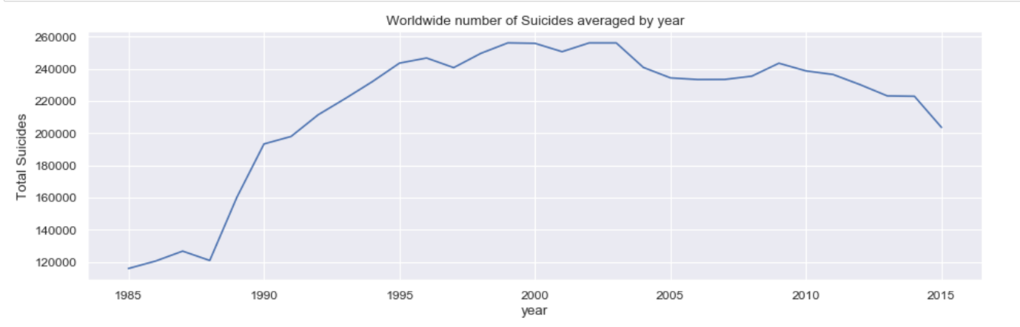

* + 1. **Region**
    2. **Age**

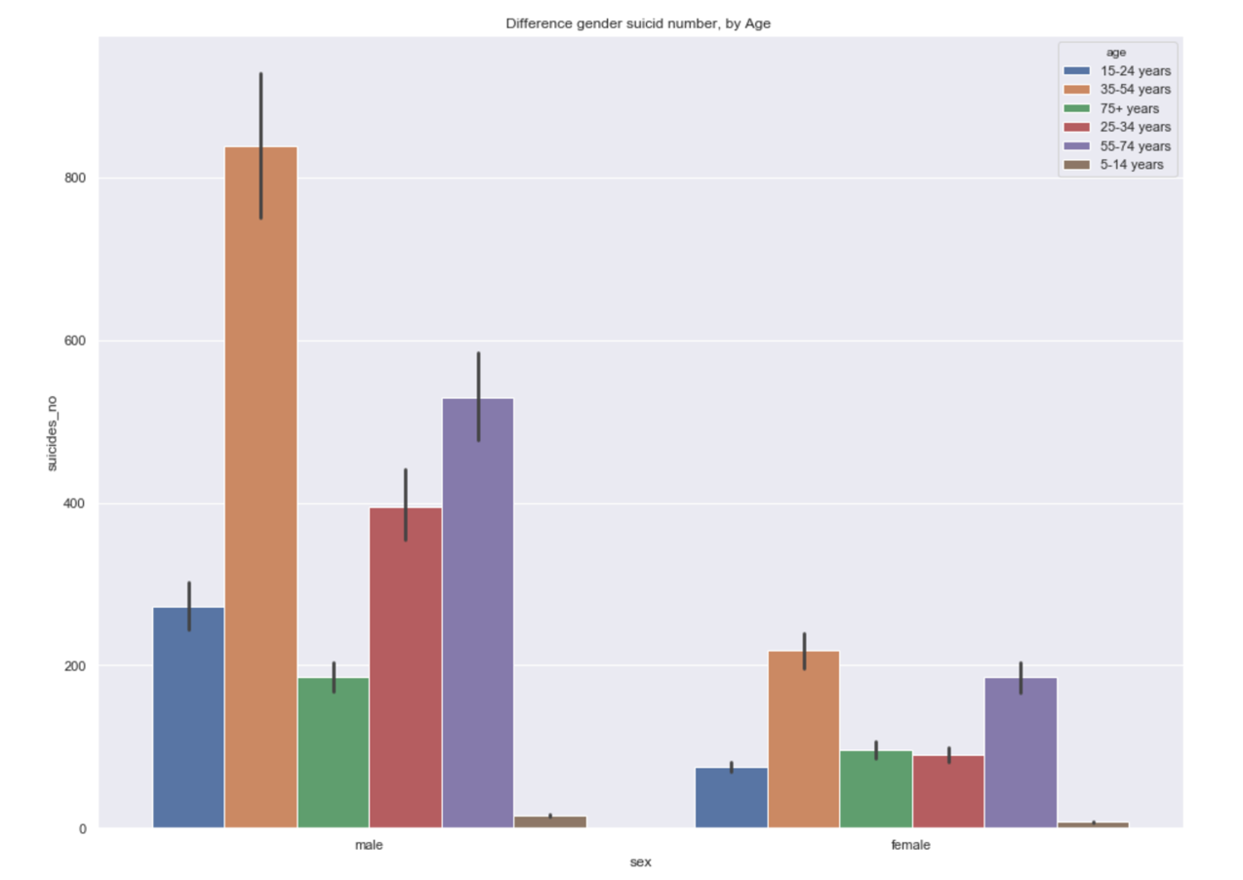

* + 1. **Generation**
    2. **Economy and Society Development**
  1. **Visualization**

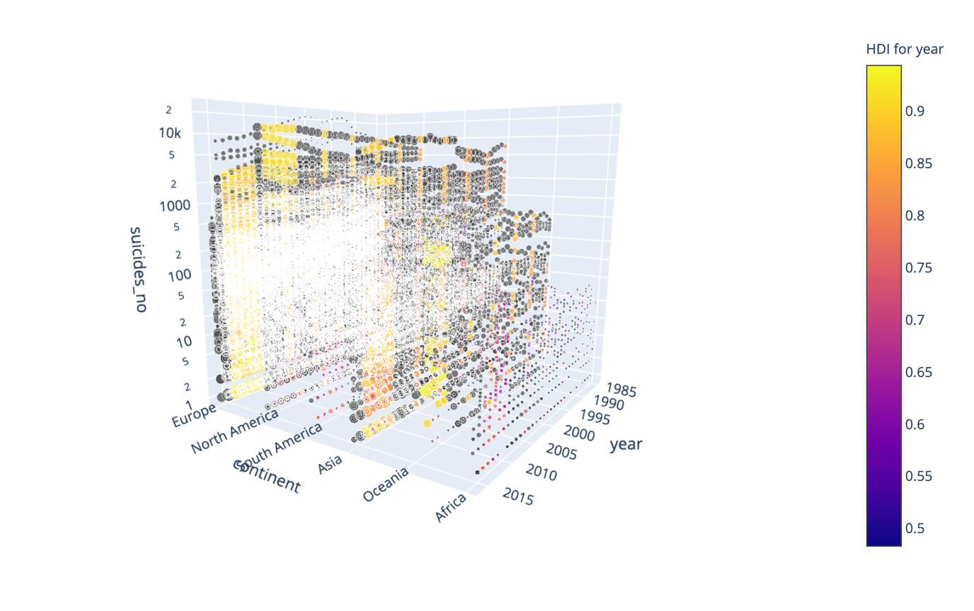

1. **Implementation**
   1. **Data Visualization Package**
2. **Evaluation**
3. **Planning**
4. **References**