Testing ‘Group Removal’
- Users are members
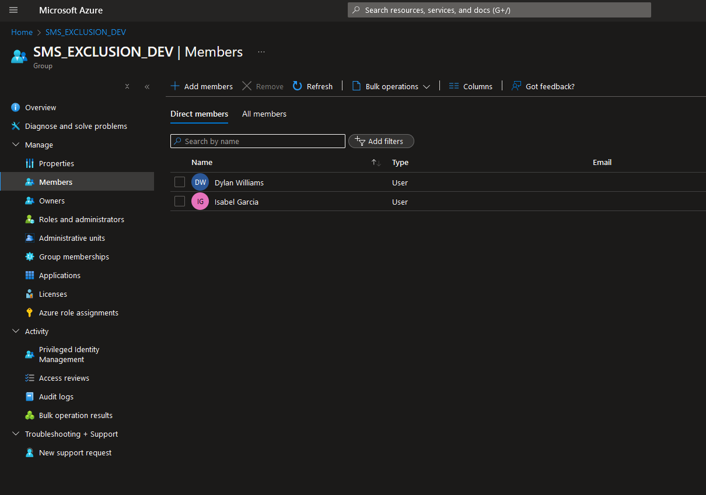
- Script expects input.csv as such
  - ‘fakeruser’ does not exist at all
  - ‘labuserprice’ exists in Entra but isn’t a group member
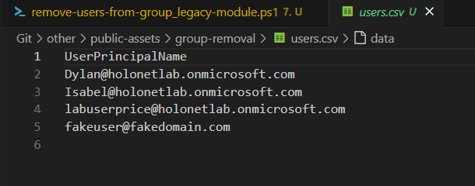
- Leverages interactive sign in
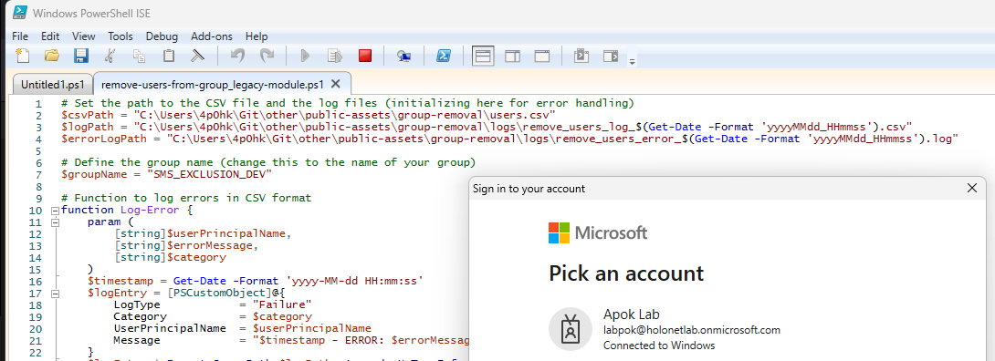
- Outputs to Console
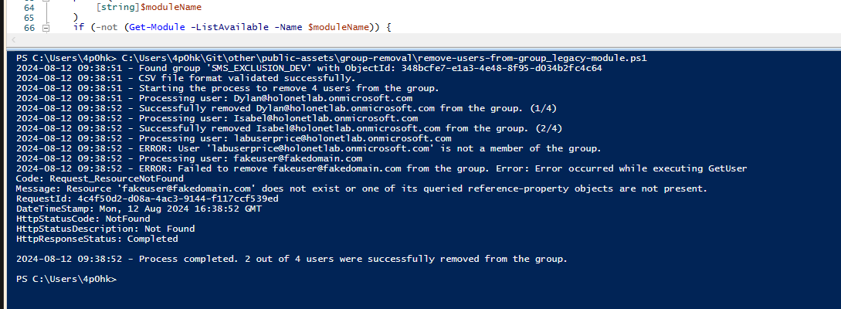
- Also outputs to a logfile, in CSV format for easy analysis at scale
- The log CSV implementation allows for Pivot Tables etc with Excel
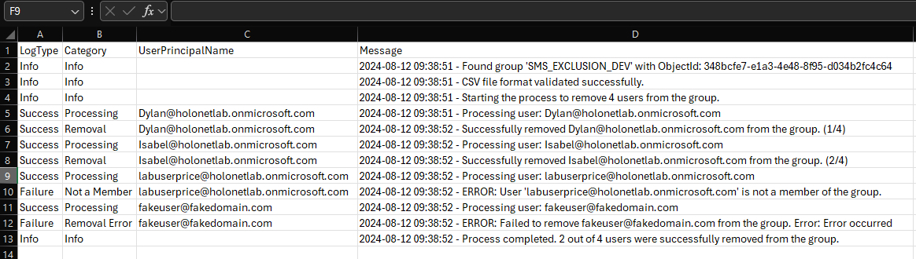

- Group membership after running script is empty as both users were removed


