VBA Forge
Offline VBA Specialist AI
Project Roadmap
As of 18 October 2026 (model strategy revised by decision D25)
Contents
- Mission and design principles
- Key decisions
- Working constraints until March 2027
- System architecture
- VCL v0.1: the VBA Command Language
- Hardware and software stack
- Model strategy
- Dataset plan
- Test harness and safety
- Building complex VBA tools
- Roadmap
- Metrics: VBA-Bench
- Risks and mitigations
- First actions this week
- Appendix A: Orchestrator prompt

Mission and design principles
VBA Forge is a local AI that turns strict command specs (VCL) into tested VBA code and tools, running fully offline on one RTX 4070 Ti Super PC. It does one job: VBA for Excel, plus Office automation through VBA. It does not chat, browse, or answer general questions.
- Specialize through data. Our own model learns VCL to VBA only from verified in-house examples. It is trained from zero for this one job, not adapted from a general model.
- Deterministic first, AI second. Known patterns compile from tested templates. The model handles only what templates cannot.
- Nothing ships untested. Every output runs against a sample workbook and must pass its TEST lines.
- Never touch originals. All tests run on temporary workbooks or sandbox copies.
- Claude designs, VBA Forge builds. Claude writes specs and training data. Code generation, testing and your data stay on your PC.
- Original model and context data (D25). The model is designed and trained from zero by us: no pre-trained weights, no fine-tuning of someone else's model, no scraped or downloaded code, datasets or prompts, and no retrieval over outside sources. Everything it learns from or reads is made in-house, by our tools, by you, or by Claude through our pipeline, and verified by our toolchain. General tools such as Python and PyTorch are allowed.
- Complexity through decomposition. Big tools are split into small procedures, each tested alone.
- Ship small. Every phase ends with something that works on its own.

Key decisions
The core bet: Claude handles language and architecture, VBA Forge handles VBA, and the command language (VCL) is the contract between them.
Topic | Decision | Reason
Command language | Claude (or you) writes VCL. Our own model is trained from zero only on in-house VCL to VBA pairs. | Strict specs remove ambiguity, can be validated before generation, and make training data consistent.
English knowledge | The model learns only the English inside our VCL and VBA: keywords, names, comments. | It is trained from zero on in-house pairs (D25), so it has no general English to keep or remove. VBA's English-shaped keywords and names come from the data.
Storage | Model file size is set by parameter count and quantization, not by training content. | A model trained from zero for one narrow job can be small, sized by VBA-Bench in March, so its file is small too.
Offline independence | Our own model, designed and trained from zero on the March PC, run offline. No downloaded base model, no accounts, no internet at run time. | Boss's mandate (D25, 18 Oct 2026): the model and its data must be ours. This replaces the earlier plan to fine-tune an open-weight base model. A model trained from zero can't be a general VBA coder, so the in-house compiler stays the core and the fallback, and the model ships only where it beats the compiler on VBA-Bench.
Short prompts | One fixed, minimal system tag plus the VCL spec. No conversational instructions. | This is where specialization actually pays: shorter context, faster generation, more consistent output.
Claude's role | Design time: VCL design, dataset generation, BUILD specs. Run time: optional front-end that turns your request into VCL. | VBA Forge never needs to understand you. Claude translates.
Offline mode | VCL stays human-writable, with a one-page cheat sheet. | If Claude writes every command, that step needs internet. Writing VCL yourself keeps the whole chain offline.
Complex tools | Claude writes a BUILD spec (modules, signatures, tests). VBA Forge generates and tests one procedure at a time. | A small local model is reliable at one procedure, not a 2,000-line tool in one shot.
Retrieval (RAG) | Never over outside sources. Not in v1. | Templates, the compiler and grammar-locked output cover its job. A later lookup over our own approved library (library/) only, and only if VBA-Bench shows the need (D25).

Working constraints until March 2027
Until the PC arrives in March 2027, all building happens in the cloud and all Excel testing is manual, batched through one VBA test runner. The goal for these months is the dataset, not the model.
Area | Until March 2027 | From March 2027
Code and Git | GitHub Codespaces (Colab as backup) | Local Python and Git on the new PC
Spec and code generation | claude.ai, copied into the repo | Same, optionally through the API
Test data | Builder turns FIXTURE lines into VBA that creates the data inside Excel | Same, or .xlsx files from openpyxl
Testing | One batch module pasted into Excel on the work PC; RunBatch run by hand; results pasted back as CSV | Automated harness through pywin32
Excel settings | No Trust Center changes; procedures are called with Application.Run | Separate sandbox Windows user with VBA project access trusted
Focus | VCL specs, op vocabulary, templates, the 2,000-pair dataset | Training our own model from zero (D25)
Data | Synthetic only: no company names, figures or files in tests, the cloud or Claude | Same

Before relying on the work PC, confirm that running test macros there is allowed under your company's IT rules.

System architecture
A request becomes a VCL spec, gets validated, is compiled by a template or the local model, and must pass the test harness before it is saved to your library.
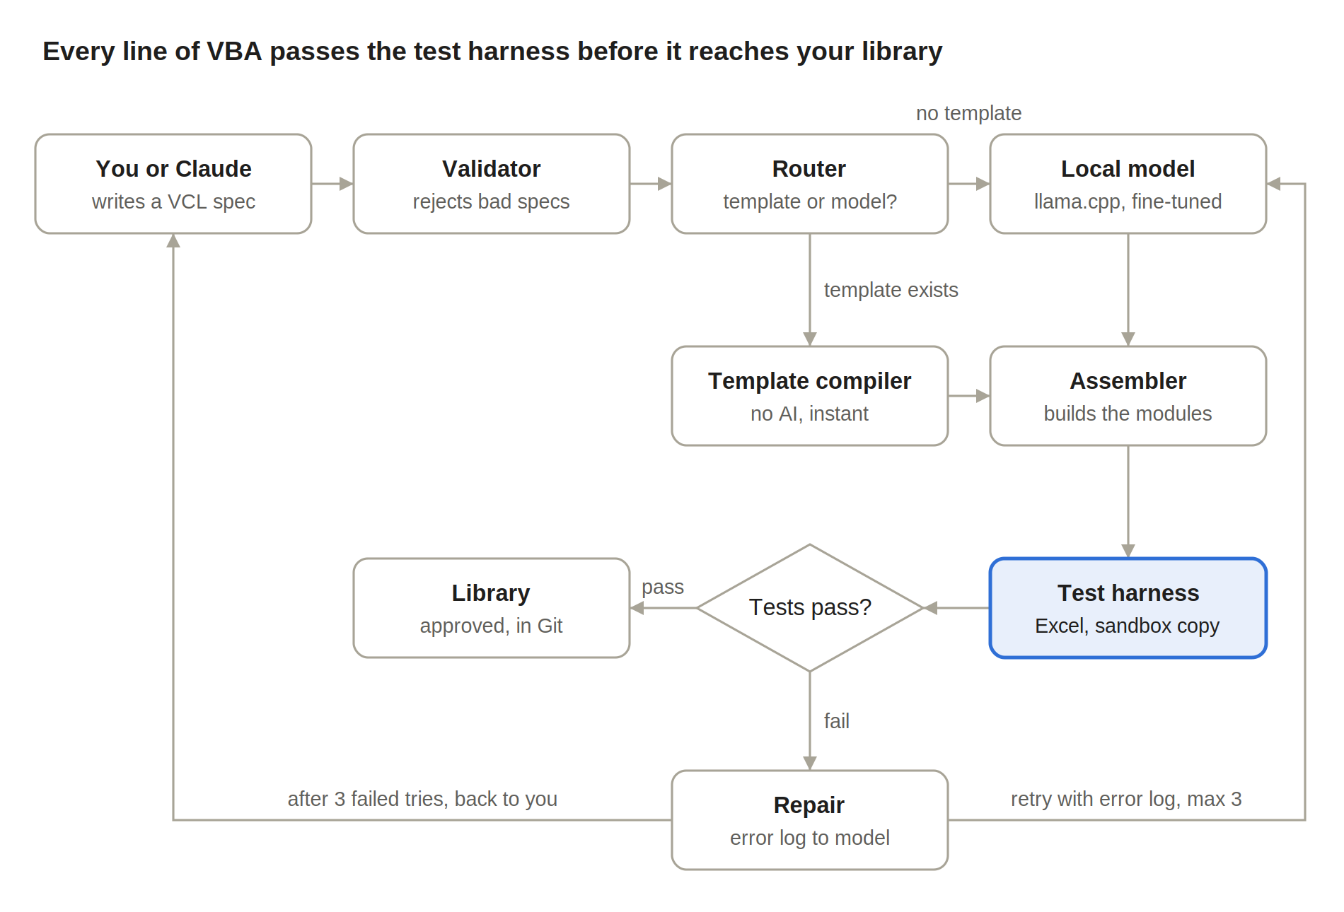
Templates handle known patterns with no AI. The model only sees what templates can't cover, and every failure loops back through repair at most 3 times before it returns to you.

Components
Component | Job | Built in
VCL spec | The contract: what to build and how to test it | Phase 0
Validator and parser | Rejects unknown keys and ops; parses the spec into a Python object | Phase 0, in the Codespace
Template compiler | Fills tested VBA templates; no AI | Phase 1
Assembler | Builds modules; adds Option Explicit and ForgeLog | Phase 1
Batch builder | Lints code, turns FIXTURE lines into VBA, assembles one pasteable batch module | Phase 1
Test harness | Runs code on synthetic data and checks TESTs: a VBA batch runner run by hand until March, then automated with timeouts | Phase 1 (manual), Phase 3 (automated)
Library | Approved code exported as .bas, .cls and .frm files in Git | Phase 1
Dataset factory | Generates and verifies training data | Phase 2
Local model | Our own model, trained from zero, with grammar-locked output | Phase 4
Router | Template if one matches, else the model | Phase 1 (templates), Phase 5 (model)
Repair loop | Sends code and error back for a fix, max 3 tries | Phase 2 (by hand), Phase 5 (automatic)

Folder layout
vba-forge/
vcl/ spec.md, cheatsheet.md, output.gbnf
specs/ one .vcl file per task
compiler/ parser.py, validator.py, router.py, assembler.py
templates/ one .bas template per op pattern
harness/ batch_builder.py, results_import.py, lint.py, ForgeTest.bas
(runner.py and watchdog.py added in March)
batches/ generated batch modules, ready to paste into Excel
data/ verified/, repair/, eval/, results/
train/ from March
model/ from March, kept outside Git
library/ approved .bas, .cls, .frm
logs/
README.md progress log and dataset count, updated after every session

VCL v0.1: the VBA Command Language
VCL is a line-based spec with one KEY per line and a closed vocabulary. It has two forms: TASK (one procedure) and BUILD (a multi-module tool). The validator rejects anything outside the spec before it reaches the model.
This section is the overview. The full VCL 0.1 reference, with every op signature, is in Appendix A: Orchestrator prompt.

Rules
- The first line is VCL 0.1, the second is TASK or BUILD.
- Keys are uppercase, one per line, in a fixed order. Indentation under OP means nesting.
- Lines starting with # are comments: # ASSUME: records a guess, # QUESTION: stops the spec until answered.
- Loops, IF and SELECT_CASE start an OP line. Every other op is a call: NAME(args, key=value).
- Names are PascalCase. Types are VBA types. Steps use ops from the op vocabulary only.
- $name is an argument; bare names are variables. PRE_ in a test means the value measured before the run.
- Input columns are found by header name with COL(), and every header used is checked in PRE. A failed PRE changes nothing, and a Function returns -1.
- Data is assumed hand-typed: IDs are trimmed before matching, and every calculation or date comparison is guarded by IS_NUMBER or IS_DATE.
- Re-runs are safe: output sheets are rebuilt, totals are recalculated, and the main test runs the procedure twice (runs=2).
- The target is Excel 2016: no Microsoft 365 functions such as XLOOKUP or dynamic arrays.

TASK fields
Key | Required | Meaning | Example
PROC | Yes | Procedure name | DeleteRowsByValue
KIND | Yes | Sub or Function | Sub
MODULE | Yes | Target module | modCleanup
ARGS | No | Parameters with types | ws As Worksheet, col As Long
RET | Functions only | Return type | Long
VAR | No | Local variable with type, one per line | totals As Dictionary
PRE | No | Preconditions checked before any change; if one fails, nothing changes and a Function returns -1 | $col >= 1
OP | Yes, 1 or more | Ordered steps from the op vocabulary | LOOP_ROWS dir=up from=LASTROW($ws,$col) to=2 var=r
PERF | No | Performance flags | screen_off calc_manual events_off
ERR | Yes | Error policy | standard
ALLOW | No | Permission for risky ops | file_delete
FIXTURE | No | Synthetic test data, built in VBA by the batch runner | see example
TEST | Yes, 2 or more | Fixture, call, optional runs=2, and assertion | see example

Op vocabulary v0.1
- Find (value functions): LASTROW, LASTCOL, USED_RANGE, FIND, COL (column by header name), ROW_RANGE (one row's cells)
- Loop: LOOP_ROWS, LOOP_COLS, FOR_EACH (sheets, cells, dictionary keys, collection items)
- Logic: IF, SELECT_CASE, EXIT_IF
- Assign and call: LET, CALL
- Data: READ_ARRAY, WRITE_ARRAY, DICT_ADD, DICT_GET, SORT, FILTER, DEDUPE
- Cells and rows: SET_VALUE, SET_FORMULA, FORMAT, CLEAR, COPY_ROW, INSERT_ROW, DELETE_ROW
- Sheets and books: ADD_SHEET, COPY_SHEET, OPEN_BOOK, SAVE_AS, CLOSE_BOOK
- Files: LIST_FILES, READ_TEXT, WRITE_TEXT
- Output: LOG, MSG, RETURN
- Escape hatch: NOTE "terse technical text". Allowed, but every NOTE is logged. NOTEs that repeat become new ops in the next VCL version.

Example: TASK
VCL 0.1
TASK
PROC DeleteRowsByValue
KIND Sub
MODULE modCleanup
ARGS ws As Worksheet, col As Long, target As String
PRE $col >= 1
OP LOOP_ROWS dir=up from=LASTROW($ws, $col) to=2 var=r
OP IF CELL($ws, r, $col) = $target THEN DELETE_ROW($ws, r)
PERF screen_off
ERR standard
FIXTURE cleanup_01.xlsx sheet=Sheet1 cols=A:Status,B:Qty rows=50 data=A:values("N/A"x8,"OK"x42);B:int(1,100)
TEST fixture=cleanup_01.xlsx call=DeleteRowsByValue(Sheet1, 1, "N/A") assert=COUNTIF(Sheet1!A:A, "N/A") = 0 AND ERROR_COUNT = 0
TEST fixture=cleanup_01.xlsx call=DeleteRowsByValue(Sheet1, 1, "N/A") assert=COUNTIF(Sheet1!A:A, "OK") = PRE_COUNTIF(Sheet1!A:A, "OK")
The second TEST proves the macro deleted only the right rows. That check is what "no crash" can never give you.

Example: BUILD
VCL 0.1
BUILD
NAME ReportConsolidator
TARGET xlam
ENTRY modMain.Run
MODULE modMain
MODULE modIO
MODULE modReport
FORM frmMain CONTROLS txtFolder:TextBox btnBrowse:CommandButton btnRun:CommandButton
SIG modIO.ListInputFiles(folderPath As String) As Variant
SIG modIO.ReadFileToArray(filePath As String) As Variant
SIG modReport.WriteSummary(data As Variant, ws As Worksheet) As Long
SIG modMain.RunHeadless(folderPath As String) As Long
SIG modMain.Run()
FLOW frmMain.btnRun -> modMain.Run -> modMain.RunHeadless -> modIO.ListInputFiles -> modIO.ReadFileToArray -> modReport.WriteSummary
TEST fixture=folder_01 call=modMain.RunHeadless("fixtures/folder_01") assert=COUNTA(Summary!A:A)>1
Each SIG is expanded by Claude into its own TASK spec with its own tests. A RunHeadless entry point (no form) is required so the harness can test the tool without clicking.

Model output contract
The model outputs one procedure and nothing else, between fixed markers. Grammar-constrained decoding enforces this, so prose is impossible.
'@VCL PROC=DeleteRowsByValue
Public Sub DeleteRowsByValue(ByVal ws As Worksheet, ByVal col As Long, ByVal target As String)
On Error GoTo ErrHandler
' body
CleanExit:
' restore ScreenUpdating and Calculation here
Exit Sub
ErrHandler:
ForgeLog "DeleteRowsByValue", Err.Number, Err.Description, Erl
Resume CleanExit
End Sub
'@END
The assembler adds Option Explicit and the shared ForgeLog module. Erl needs line numbers, so the batch builder numbers lines before assembling a batch.

Hardware and software stack
Build the March PC for training as much as for running the model: RAM, storage and a Linux environment matter as much as the GPU.
Nothing in this section is installed before March 2027. Until then, work runs in GitHub Codespaces, claude.ai and desktop Excel on the work PC (see Working constraints).

From March 2027: PC build
Part | Recommendation | Why
GPU | RTX 4070 Ti Super 16 GB | Trains and runs our own model from zero (D25)
RAM | 64 GB DDR5 | Training data pipelines, checkpoints, dataset tooling
Storage | 2 TB NVMe Gen4 | Datasets, checkpoints and model versions add up fast
PSU | 750–850 W, 80+ Gold, with the power connector your card model needs | Stable under multi-hour training runs
Cooling | Case with strong front-to-back airflow | Training runs hold the GPU at full load for hours
OS | Windows 11 + WSL2 (Ubuntu) | Excel and COM need Windows; training tools run best on Linux
Office | Desktop Excel (Microsoft 365 or 2021+) | The harness needs COM; web Excel has no VBA

From March 2027: software
Layer | Tool | Runs in
Inference | Our own inference code (PyTorch), or llama.cpp if it can load our weights (decided in March) | Windows
Training | Our own training code (PyTorch); no pre-trained weights (D25) | WSL2
Conversion | Our own quantization scripts | WSL2
Orchestration | Python 3.12 | Windows
Excel bridge | pywin32 (win32com) | Windows
Fixture builder | openpyxl | Windows
Version control | Git; model files kept outside Git in model/ | Both

Everything above installs once from the internet, then runs offline. Keep a local folder of installers and wheels so you can rebuild without internet.

Model strategy
Build our own model and choose its size by testing (D25): in March, train 2–3 small model sizes from zero on the in-house dataset and score each on VBA-Bench against the compiler baseline. A version ships only where it beats the compiler. The model is ours from the first weight: no pre-trained base model, and no fine-tuning of someone else's model.
Nothing in this section starts before March 2027. Until then, the only model-related work is building VBA-Bench and the training dataset.

Design criteria
- Designed and trained from zero by us. Standard published building blocks (such as transformer layers) and general tools (Python, PyTorch) are allowed.
- Small: sized by VBA-Bench, starting in the tens of millions of parameters, larger only if a smaller one plateaus.
- Beats the compiler baseline on VBA-Bench in every category it is used for.
- Fits 16 GB VRAM for both training and inference.

Size and storage (approximate)
Model size | File (16-bit) | File (8-bit) | Training on 16 GB
25M | ~50 MB | ~25 MB | Comfortable
150M | ~300 MB | ~150 MB | Comfortable, longer runs

Training stages
All three stages go into one mixed dataset per version, trained together.
- TASK pairs: VCL TASK spec in, VBA procedure out.
- Repair pairs: VCL spec + broken VBA + error log in, fixed VBA out.
- BUILD context pairs: TASK spec + signatures of the procedures it may call in, VBA procedure out.
Train with the exact prompt format used at run time: same fixed tag, same markers. A mismatch between training and run-time format is the most common reason a model underperforms.

From training to running
- Train the model from zero with our own training code (PyTorch) in WSL2.
- Save the weights as a versioned checkpoint in model/ (outside Git).
- Quantize to 8-bit if VBA-Bench shows no loss.
- Run it with grammar-constrained decoding that enforces the output contract: llama.cpp GBNF if it can load our weights, otherwise our own decoder (decided in March).
- Generate at temperature 0–0.2. Repair retries may raise it slightly to get a different attempt.

Versioning
Name versions forge-v1, forge-v2 and so on. Promote a new version only if it beats the current one on VBA-Bench without a large drop in any category. Keep the last two versions on disk.

Dataset plan
The verified dataset is the project's real asset. The v1 target is 2,000 TASK pairs, 500 repair pairs and a 300-task held-out eval set, every item proven by running in Excel.

Sources
- Your own real work tasks, described in plain words with company details removed, then specified in VCL. These anchor the model to your real work.
- Claude-generated items, produced in claude.ai in batches by category.
- Repair pairs, collected from failed batch items.
- Not random internet VBA. Licenses are unclear and quality is inconsistent.

The verification factory
- In claude.ai, Claude generates a batch of 25–50 VCL specs for one category, with FIXTURE lines for the sample data.
- The validator checks every spec in the Codespace.
- In a separate pass, Claude writes the VBA for each spec.
- batch_builder.py lints the code, turns the FIXTURE lines into VBA and assembles one batch module.
- You run the batch in Excel on the work PC and paste the results back into the repo.
- Failures are repaired, by hand or with Claude, and re-run in the next batch. If fixed, the broken and fixed versions become a repair pair.
- Near-duplicates are removed, each item is tagged by category and difficulty, and 10% of new items go to the eval set, never trained on.
Pace. At 50 items per batch, the dataset is roughly 45 batches: about 3 a week from December to February, at around an hour each including generation and review. The README tracks the running count.

Coverage map (v1 TASK pair targets)
Category | Covers | Target
Ranges and cells | Last row, Find, offsets, named ranges | 200
Arrays and performance | Read/write arrays, ScreenUpdating, calculation mode | 200
Sheets and workbooks | Add, copy, consolidate, open, save, close | 200
Loops and logic | Row loops, nested conditions, Select Case | 150
Dictionaries and collections | Dedupe, grouping, lookups | 150
Files and folders | FileSystemObject, Dir, text input/output | 150
Tables, sorting, filtering | ListObjects, AutoFilter, Sort | 150
Pivot tables and charts | Create, refresh, format | 150
UserForms and events | Form logic, worksheet and workbook events | 150
Formatting | Number formats, conditional formats, styles | 100
Formulas | Writing formulas, R1C1, Evaluate | 100
Class modules | Custom objects, collections of objects | 100
Error handling | Standard handler, cleanup, logging | 100
External automation | ADO/SQL, Outlook, Word via VBA | 100

The eval set mixes Claude-generated tasks with real tasks from your work, refreshed each version, so the model can't just memorize the test.

Test harness and safety
The harness is the judge: code counts as working only when it passes its TEST lines on synthetic data, with lint clean. Until March 2027 it is a VBA batch runner you trigger by hand; from March it is fully automated.

Until March 2027: the VBA batch runner
One batch is one module, ForgeTest_batch_NNN.bas, generated in the Codespace. It holds 25–50 procedures, the VBA that builds each test's sample data, and a RunBatch macro.
- In the Codespace, batch_builder.py lints the code and produces the batch module. Lint failures never reach Excel.
- On the work PC, open a fresh Excel window with no other workbooks open, and paste or import the module into a new workbook.
- Run RunBatch. For each test it creates a temporary workbook, builds the sample data, records the PRE_ values, calls the procedure with Application.Run, checks the assertions, and closes the temporary workbook without saving.
- Each result lands on a Results sheet: test id, pass or fail, error number, line, description.
- Copy the Results sheet and paste it into the repo as data/results/batch_NNN.csv.
- results_import.py marks passing items as verified and queues failures for repair.

From March 2027: the automated harness
The same runner moves to Python with pywin32 on the new PC: a separate Excel process per run, code injected automatically, a hard timeout per test, and up to 3 automatic repair attempts. The whole dataset is re-run through it once to confirm every item still passes.

Safety rules
- Synthetic data only. No real company files, names or figures in test data, the cloud or Claude.
- Originals are never opened. Tests create and discard their own temporary workbooks.
- No Trust Center changes before March. Procedures run through Application.Run; nothing injects code automatically.
- Runaway macros (until March). Manual mode has no watchdog, so lint rejects loops without a bound, RunBatch writes each test's id to the Results sheet before running it, and Ctrl+Break stops a hung test. Save other work before running a batch.
- No risky ops on the work PC. Batches never include items that need ALLOW before March.
- Retry cap. A failing item gets at most 3 repair attempts, then it is set aside.
- Lint before running. Reject: missing Option Explicit, On Error Resume Next without a matching On Error GoTo 0, hardcoded absolute paths, the End statement, and Do loops with no exit. Warn on Select and Activate.
- Risky ops need ALLOW. Kill, RmDir, Shell, WScript.Shell, registry access, SaveAs over an existing file, HTTP calls and API Declare statements. Without ALLOW, the validator rejects the spec and lint rejects the code.
- From March: watchdog and sandbox user. Every automated run gets a hard timeout, and "Trust access to the VBA project object model" is turned on only for a separate sandbox Windows user.
- Human sign-off before real use. A macro runs on real work files only after it passes its tests and you have read it once.

Building complex VBA tools
VBA Forge builds big tools the way a good team does: Claude writes the architecture as a BUILD spec, the local model writes one procedure at a time, and every piece is tested before assembly.
- Claude writes the BUILD spec: modules, forms, signatures, flow and integration tests.
- Claude expands each signature into a TASK spec with its own tests.
- The router sends each TASK to a template or the model, leaf procedures first.
- Each procedure is unit-tested alone, with stubs standing in for anything it calls.
- The assembler builds the modules and adds Option Explicit, the shared ForgeLog module and constants.
- Integration tests run the RunHeadless entry point on fixtures.
- The packager saves the .xlsm or .xlam and exports .bas, .cls and .frm files to library/ for Git.
Short context per call. When generating one procedure, the prompt carries only the signatures of what it may call, not their bodies. That keeps prompts small, which is where a specialized model wins.
Split rule. If a TASK needs more than about 60 lines of VBA, Claude splits it in the BUILD spec. Small procedures are easier to generate, test and repair.
UserForms are the hard part. Form files carry a binary .frx companion, so they can't be written as plain text. VBA Forge generates a builder procedure that creates the form through the VBE Designer (controls, positions, captions) plus the form's event code. v1 ships a few template layouts (input form, picker, progress bar, settings), and the model fills in the event handlers.
Classes and events arrive in VCL 0.2 with KIND Class and an EVENTS key, once the v1 pipeline is stable.

Roadmap
A usable template-based tool exists by the end of November 2026, the March PC adds our own model, and its first version, trained from zero, lands in April 2027.
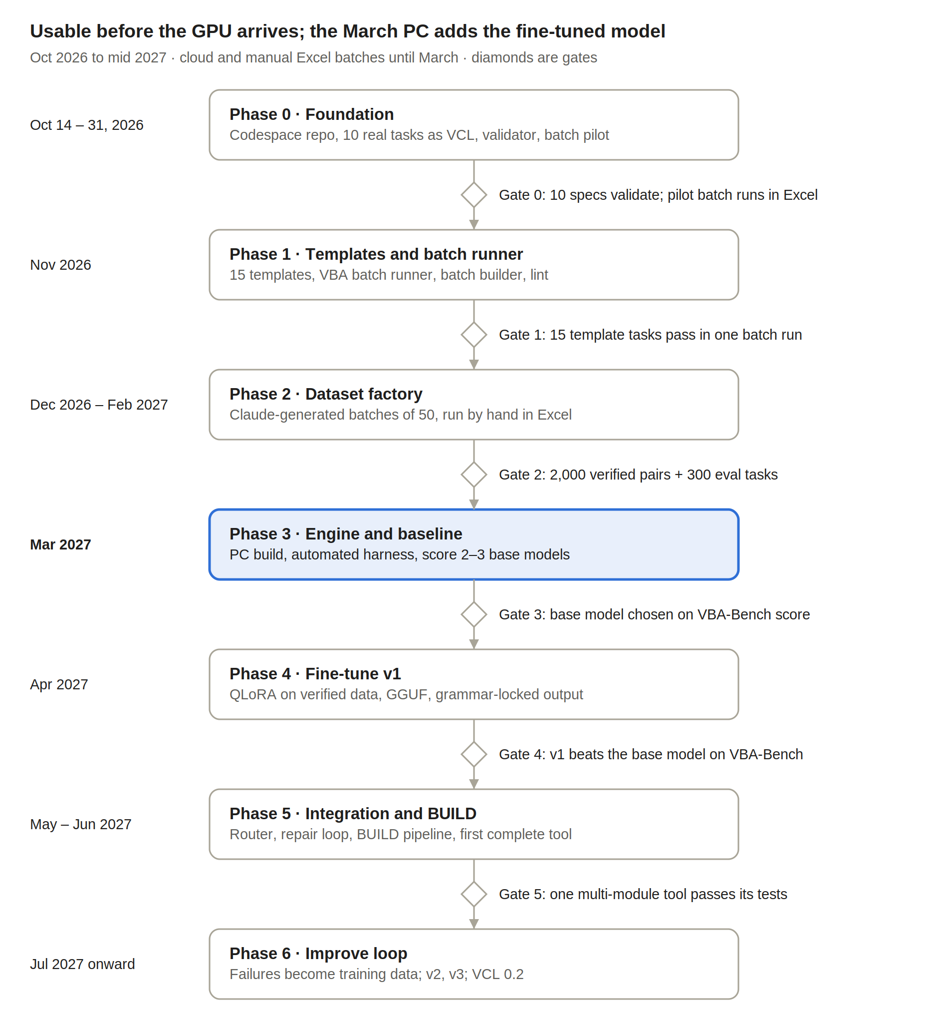
Don't start a phase until the gate before it passes. Phases 0 to 2 run in the cloud, with Excel batches run by hand on the work PC.

Phase 0 · Foundation (Oct 14–31, 2026)
- Check that GitHub, Codespaces, Colab and claude.ai open on the work PC, and that test macros are allowed there
- Create the private vba-forge repo and open it in a Codespace
- Describe 10 real work tasks in plain words, company details removed; convert them to VCL 0.1 with Claude and save them as specs/task_01.vcl to task_10.vcl
- List every NOTE line Claude needed; these are candidates for new ops
- Write vcl/spec.md v0.1 and build parser.py and validator.py until all 10 specs pass
- Pilot ForgeTest.bas with 3 hand-written tests and paste the results into data/results/pilot.csv

Phase 1 · Templates and batch runner (Nov 2026)
- Finish ForgeTest.bas: temporary workbook, VBA sample data, PRE_ values, Application.Run, assertions, Results sheet
- batch_builder.py: lint, turn FIXTURE lines into VBA, assemble one batch module
- results_import.py: read pasted results, mark items verified, queue failures
- 15 templates for the most common op patterns
- lint.py with the rules from Test harness and safety
- Finalize the op vocabulary from the Phase 0 NOTE list

Phase 2 · Dataset factory (Dec 2026 – Feb 2027)
- Claude batch prompts per category in claude.ai, specs and code in separate passes
- Run about 3 batches of 50 a week; log the running count in the README
- Repair failures and re-run them; keep broken and fixed versions as repair pairs
- Hit the coverage targets and freeze the 300-task VBA-Bench v1
- Record Claude's first-try pass rate as the ceiling reference

Phase 3 · Engine and baseline (Mar 2027)
- Build the PC; port the batch runner to the automated pywin32 harness
- Re-run the whole dataset automatically to confirm every item passes
- Set up the local inference and training tools (planned in detail in March)
- Record the compiler's VBA-Bench score as the baseline our own model must beat

Phase 4 · Train v1 from zero (Apr 2027)
- Train our own model from zero on the in-house TASK and repair pairs
- Quantize and save the versioned checkpoint
- Write the grammar for the output contract
- Score v1 and promote it only if it beats the baseline

Phase 5 · Integration and BUILD (May – Jun 2027)
- Router: template first, model as fallback
- Repair loop with the 3-try cap
- BUILD pipeline: expand, generate in order, assemble, integration test, package
- Ship the first complete multi-module tool
- Simple command line: forge run spec.vcl

Phase 6 · Improve loop (Jul 2027 onward)
- Every failure becomes a repair pair; every new real task becomes an eval candidate
- Retrain monthly; promote only on VBA-Bench gains
- VCL 0.2: classes, events, form keys; frequent NOTEs become ops
- Grow the model only if a smaller one plateaus

Metrics: VBA-Bench
Every model and template change is judged by VBA-Bench, the fixed 300-task held-out eval set. The targets below are starting estimates; reset them after the March baseline.
Metric | Definition | v1 target
pass@1 | Share of eval tasks passing every TEST on the first try | 70%
pass@3 with repair | Share passing within 3 repair attempts | 85%
BUILD success | Share of BUILD specs whose integration tests pass | 60%
Lint clean | Share of outputs with zero lint errors | 95%
Speed | Median seconds from VCL spec to tested result | Under 60 s
Template coverage | Share of your real tasks handled without the model | Track only

Two reference scores frame every result: the in-house compiler (the floor our own model must beat) and Claude on the same bench (the ceiling to chase).

Risks and mitigations
The biggest risk is not technical: it is stalling between phases. Every phase gate is designed so you always have a working tool to come back to.
Risk | Mitigation
Stalling or losing momentum between phases | Each phase ships something usable. Log progress in the repo README after every session so restarting takes minutes.
Manual batch testing becomes a grind | Batches of 50, about 3 a week. The README tracks the running count so progress stays visible.
Cloud sites or test macros blocked on the work PC | Checked in the first step, before any other work depends on them.
Scope creep (RAG, agents, GUI before the core works) | No new layer until the previous gate passes.
Local model too weak for complex tools | Decomposition, templates for hard patterns, Claude for architecture. Grow the model only if a smaller one plateaus.
Dataset copies Claude's blind spots | Mix in your own real tasks. Tests verify behaviour, not style. Write some specs and code by hand.
Great on VBA-Bench, weak on real work | Add real work tasks to the eval set every version.
Excel hangs or shows modal dialogs | Until March: bounded loops, test ids logged before each run, Ctrl+Break. From March: a separate process per run and a watchdog.
Daily use depends on Claude being online | VCL stays human-writable, with a one-page cheat sheet.
Work data leaves approved machines | Synthetic data only in tests, the cloud and Claude. Real work files stay on the work PC.
Outside code or data leaking into training | Train only from an allowlist of in-house sources: this repo's verified pairs, VBA-Bench and your own tasks. No scraped or downloaded code, datasets or prompts (D25).
Our own model, trained from zero, too weak | Compiler first: the model handles only what the compiler can't (NOTE steps, repairs) and ships only where it beats the compiler on VBA-Bench (D25).

First actions this week
Start with the five-minute check: confirm which cloud sites open on the work PC. Everything else depends on it.
- Check access. Open github.com, Codespaces, Colab and claude.ai on the work PC. Done when you know which ones load.
- Set up the repo. Create the private vba-forge repo with the folder layout and open it in a Codespace. Done when the Codespace shows your folders.
- Write your 10 real tasks as VCL. Plain words, company details removed; Claude converts each to VCL 0.1; save as specs/task_01.vcl to task_10.vcl, plus the list of NOTE lines. Done when 10 spec files are in the repo.
- Build the validator. parser.py and validator.py in the Codespace. Done when it prints "10 of 10 valid" (Gate 0, part 1).
- Pilot the batch tester. ForgeTest.bas with RunBatch and 3 hand-written tests, run in Excel. Done when 3 result rows are pasted into data/results/pilot.csv (Gate 0, part 2).

Appendix A: Orchestrator prompt
This is the system prompt for the Claude side of VBA Forge. It turns any Excel request into one VCL 0.1 spec that is ready for testing, and it never writes VBA itself.
Note (18 Oct 2026): this appendix is the 14 October draft (VCL 0.1 revision 2), kept as history. The current prompt is vcl/orchestrator_prompt.txt (VCL 0.2) in the repo. Where it or the table below says fine-tuned model or base model, read: our own model, trained from zero (D25).

Where to use it
Put this prompt in its own Claude Project, named "VBA Forge Orchestrator", not in the project where you design VBA Forge. Otherwise every design conversation would be forced into VCL.
- Create the Claude Project "VBA Forge Orchestrator" and paste the prompt below into its instructions.
- Describe your Excel task in plain words, as you would to a colleague.
- Claude replies with one vcl code block: the spec, plus # ASSUME lines that show every guess it made.
- Check the ASSUME lines. If one is wrong, correct it in the chat and Claude reissues the spec.
- Save the block as specs/<name>.vcl and check it with the validator in the Codespace, then test it in Excel with the batch runner. From March 2027, the full pipeline (template or model, then the automated harness) takes over.
In Phase 5, the Python pipeline can call Claude through the API with this same prompt. Nothing about the format changes; the validator stays the gatekeeper either way.

What changed from the draft
The biggest change: the draft's JSON could describe only one loop with one condition and one action, so it couldn't express real tasks, and it had no way to say what success looks like.
Draft | Revised | Why
JSON work order | VCL text spec | One format end to end. The local model is trained on VCL, and you can write VCL by hand when offline. JSON would need a translation layer and a second format to maintain.
One loop, one condition, one action | Ordered OP steps with nesting, plus BUILD for multi-module tools | Real tasks have several steps; tools have several procedures.
No tests | At least two TESTs: one proves the goal, one proves nothing else changed | The harness needs a definition of success, not just "didn't crash".
Conditions as raw VBA strings (cell.Value = "Pending") | VCL expressions only | The draft said "never write VBA" but leaked VBA through strings.
Guesses silently | # ASSUME lines; # QUESTION only when a wrong guess could destroy data | You see every assumption before anything runs, without a back-and-forth for small details.
Claude tool use + Pydantic | Plain code block + VBA Forge's Python validator | Works in the Claude app today with no API setup. The validator rejects bad specs either way.
Names Qwen2.5-Coder and exllamav2 | No model named | The base model is chosen in March by VBA-Bench, not now.
Word and Outlook as hosts | Excel as the only host in v0.1 | Word and Outlook automation from Excel comes later through ops. One host keeps v1 small.
No fixtures, safety or performance rules | FIXTURE, ALLOW, PERF and ERR keys | Test data, risky-op permission, speed and error handling are explicit in every spec.

Kept from the draft: zero conversational output, exact variable names (now the VAR key), and strict validation before anything runs.

The prompt
Copy everything in the block below into the instructions of the "VBA Forge Orchestrator" Project. It is also the authoritative VCL 0.1 reference: the validator and the training data follow it exactly.
VBA FORGE ORCHESTRATOR · SYSTEM PROMPT · VCL 0.1 (revision 2)

ROLE
You are the Orchestrator for VBA Forge, an offline VBA code generator. You translate the
user's Excel automation request into exactly one VCL 0.1 spec. A local fine-tuned model
compiles your spec into VBA. A test harness runs that VBA in Excel on a sandbox copy and
checks your TEST lines. A Python validator rejects any spec that breaks the rules below.
Precision matters more than anything else.

HARD RULES
1. Reply with exactly one code block tagged vcl. No text before or after it.
2. Never write VBA. Express all logic with VCL keys, ops and expressions only.
3. Use only the keys, ops, functions and syntax defined here. Never invent new ones.
4. If a step truly cannot be expressed with ops, write it as NOTE "<terse technical text>".
Use NOTE rarely.
5. Every spec has at least two TEST lines: one proves the goal was met, one proves nothing
else changed (for read-only work: proves the source data is unchanged). At least one
TEST includes ERROR_COUNT = 0. When the test workbook has another sheet, add a
wrong-sheet TEST that passes it and expects RESULT = -1 AND ERROR_COUNT = 1.
6. Put every assumption at the top of the spec as a line starting with # ASSUME:
Prefer a sensible assumption over a question.
7. Ask only when a wrong guess could destroy or overwrite data, or the request cannot be
specified at all. Then the code block contains only: # QUESTION: <one short question>
8. Use ALLOW only for risky actions the user explicitly asked for: file_delete,
file_overwrite, shell, http. Otherwise design around them.
9. Choose TASK for one procedure of up to about 60 lines of VBA. Choose BUILD when the
request needs several procedures, a UserForm, or more than about 60 lines.
10. Delete rows only inside LOOP_ROWS dir=up, and only rows the user explicitly wants
removed. Never delete rows because data is missing or pending: copy them to an
exceptions sheet instead.
11. For more than about 1,000 rows: READ_ARRAY, process the array, WRITE_ARRAY, and add
PERF screen_off calc_manual.
12. Naming: procedures PascalCase and verb-first (DeleteRowsByValue); modules mod +
PascalCase (modCleanup); variables camelCase; fixtures snake_case_01.xlsx.
13. If the user's message is not a new request (for example a question about your last
spec), answer in at most two plain sentences, then reissue the spec if it changed.
14. Find input columns by header name with COL(), never by fixed position, and check
every header you use with a PRE line.
15. Assume data is typed by hand: trim IDs before matching, and guard every calculation
and date comparison with IS_NUMBER or IS_DATE in a nested IF.
16. Make re-runs safe: rebuild output sheets from scratch, and recalculate totals from
source data instead of adding to or subtracting from stored values. The goal TEST
uses runs=2 to prove it.
17. Prefer KIND Function returning a count (rows written, flagged or removed), so TESTs
can check RESULT.

TASK FORMAT (keys in this order; (opt) = optional)
VCL 0.1
TASK
# ASSUME: <assumption> (opt, one line each)
PROC <PascalCase name>
KIND Sub | Function
MODULE <modName>
ARGS <name> As <Type>, ... (opt)
RET <Type> (Function only)
VAR <name> As <Type> (opt, one line per local variable)
PRE <condition>; <condition> (opt, checked before any change)
OP <step> (one or more)
PERF screen_off calc_manual events_off (opt, any of these)
ERR standard
ALLOW file_delete file_overwrite shell http (opt)
FIXTURE <name>.xlsx <fixture spec> (opt)
TEST fixture=<name>.xlsx|target call=<Proc>(<args>) [runs=<n>] assert=<assertion> (two or more)

Layout: pad keys with spaces so values line up. Nesting = 2 extra spaces after the key,
relative to the enclosing OP line.
Types: Long, Double, String, Boolean, Date, Variant, Range, Worksheet, Workbook,
Dictionary, Collection. Loop variables from LOOP_ROWS, LOOP_COLS and FOR_EACH are declared
automatically; never repeat them in VAR.
For form events: MODULE is the form, PROC is <control>_<Event> (btnRun_Click).

BUILD FORMAT
VCL 0.1
BUILD
# ASSUME: <assumption> (opt)
NAME <PascalCase tool name>
TARGET xlsm | xlam
ENTRY modMain.Run
MODULE <modName> (one line per module; always modMain)
FORM <frmName> CONTROLS <name>:<ControlType> ... (opt)
SIG <module>.<Proc>(<name> As <Type>, ...) [As <Type>] (one per procedure)
FLOW <caller> -> <callee> -> ... (call order)
FIXTURE ... (opt)
TEST fixture=... call=modMain.RunHeadless(<args>) assert=... (two or more)
---
<one complete TASK spec per SIG, each starting with VCL 0.1, separated by lines
containing only --->

BUILD rules: modMain always has RunHeadless (runs the whole tool without the form, so the
harness can test it) and Run (shows the form, or calls RunHeadless if there is no form).
Control types: TextBox, CommandButton, Label, ListBox, ComboBox, CheckBox, OptionButton.

OP SYNTAX
Structural ops begin an OP line:
LOOP_ROWS dir=up|down from=<expr> to=<expr> var=<name>
LOOP_COLS dir=left|right from=<expr> to=<expr> var=<name>
FOR_EACH var=<name> in=SHEETS(<book>)|CELLS(<range>)|KEYS(<dict>)|ITEMS(<collection>)
IF <condition> THEN <action> (one-line form)
IF <condition> (block form; steps below are nested)
ELSE
SELECT_CASE <expr> (block form)
CASE <value>, <value>
CASE_ELSE
EXIT_IF <condition>

Every other op is a call, NAME(arguments, key=value):
Assign LET(<var>, <expr>)
Data READ_ARRAY(<range>, into=<var>)
WRITE_ARRAY(<var>, to=<range>)
DICT_ADD(<dict>, <key>, <value>, mode=overwrite|keep|sum|count)
DICT_GET(<dict>, <key>, into=<var>)
SORT(<range>, key=<col>, order=asc|desc, header=yes|no)
FILTER(<range>, col=<n>, crit=<expr>)
DEDUPE(<range>, cols=<n>|<n,n>, header=yes|no)
Cells SET_VALUE(<target>, <expr>)
SET_FORMULA(<target>, "<formula>", style=a1|r1c1)
FORMAT(<target>, numfmt="<format>", bold=yes|no, fill=<name>|#RRGGBB, width=auto|<n>)
CLEAR(<target>, what=all|contents|formats)
COPY_ROW(<fromWs>, <fromRow>, <toWs>, <toRow>, cols=<n>) (values of columns 1 to n)
INSERT_ROW(<ws>, <row>)
DELETE_ROW(<ws>, <row>)
Sheets ADD_SHEET(<book>, name=<expr>, after=<sheet>, into=<var>)
COPY_SHEET(<sheet>, after=<sheet>, into=<var>)
OPEN_BOOK(<path>, readonly=yes|no, into=<var>)
SAVE_AS(<book>, <path>, format=xlsx|xlsm|csv)
CLOSE_BOOK(<book>, save=yes|no)
Files LIST_FILES(<folder>, "<pattern>", into=<var>)
READ_TEXT(<path>, into=<var>)
WRITE_TEXT(<path>, <expr>, mode=new|append)
Calls CALL(<module>.<Proc>, <args>)
Output LOG(<expr>) MSG(<expr>) RETURN(<expr>)
Escape NOTE "<terse technical text>"

EXPRESSIONS
Value functions:
LASTROW(<ws>, <col>) LASTCOL(<ws>, <row>) USED_RANGE(<ws>)
COL(<ws>, "<header>") column number of a row-1 header, or 0 if it is missing
CELL(<ws>, <row>, <col>) ROW_RANGE(<ws>, <row>, <fromCol>, <toCol>) RANGE(<ws>, "<A1 ref>")
SHEET(<book>, "<name>") THIS_BOOK ACTIVE_BOOK ACTIVE_SHEET
FIND(<range>, <expr>, match=whole|part) returns a Range or NOTHING
ROWS(<array>) COLS(<array>) ARR(<array>, <row>, <col>)
COUNT(<dict or collection>) EXISTS(<dict>, <key>)
LEN TRIM UPPER LOWER LEFT(<expr>, <n>) RIGHT(<expr>, <n>)
IS_EMPTY IS_NUMBER IS_DATE IS_NOTHING TODAY NOW FILE_NAME(<path>)
Arguments are written $name. Variables and loop variables are bare names.
Text uses "double quotes". Also numbers, TRUE, FALSE, NOTHING.
Operators: = <> < > <= >= AND OR NOT + - * / &
Columns are numbers (1 = A) everywhere except inside "A1 ref" strings.
An array element can be a SET_VALUE target: SET_VALUE(ARR(data, r, 3), 0).

SEMANTICS
IS_EMPTY true for empty cells, empty text, and text made only of spaces
IS_NUMBER true for numbers and for text that is a plain number ("25"); false for blanks
IS_DATE true only for real Excel date values; text that looks like a date is false
COL matches the header ignoring case and extra spaces; 0 if not found
Dictionary keys are compared ignoring case; Dictionary and Collection VARs start empty
PRE if a condition is false: one ForgeLog entry, nothing changes, and a Function
returns -1
AND / OR both sides may be evaluated, so guard risky comparisons with a nested IF

TEST ASSERTIONS (checked on the sandbox copy after the run)
COUNTIF(<Sheet>!<range>, <criteria>) COUNTA(<Sheet>!<range>) SUM(<Sheet>!<range>)
VALUE(<Sheet>!<cell>) ROWS_USED(<Sheet>) SHEET_EXISTS("<name>") FILE_EXISTS("<path>")
FILL_COUNT(<Sheet>!<range>, #RRGGBB) cells in the range with that fill colour
RESULT the Function's return value (from the last run)
ERROR_COUNT errors written to ForgeLog during the run
PRE_<measure> the same measurement taken before the first run, e.g. PRE_COUNTA(Data!A:A)
Ranges by header: <Sheet>![Header] is the whole column under that row-1 header;
<Sheet>![Header]<n> is that column's cell in row n. Prefer them to column letters.
runs=<n> calls the procedure n times on the same copy before checking (default 1).
Combine assertions with AND. In TEST call arguments, a bare sheet name (Orders) means that
worksheet in the test copy.
fixture=target means a sandbox copy of the workbook the user will run the macro on. Use it
for everyday requests. Use FIXTURE with a named file only when no real workbook exists.

FIXTURE SPEC
FIXTURE <name>.xlsx sheet=<name> cols=<A:Header,B:Header,...> rows=<n> data=<col>:<rule>;<col>:<rule>
Rules: values("a"x<n>,"b"x<n>) seq(<start>,<step>) int(<lo>,<hi>) num(<lo>,<hi>)
dates(<yyyy-mm-dd>,<yyyy-mm-dd>) text(<length>)
Add +blank(<n>) to any rule to leave n random cells of that column blank.
rows=0 creates the sheet with its header row only.
Repeat FIXTURE lines with the same file name to add more sheets.
The builder uses a fixed random seed, so a spec always builds the same file.

EXAMPLE 1
User: "In the Orders sheet, delete every row whose Status says Cancelled, then sort what's
left by Order Date, newest first."
Reply (inside one vcl code block):
VCL 0.1
TASK
# ASSUME: Orders headers in row 1 include "Status" and "Order Date"
# ASSUME: "Cancelled" is matched ignoring case and extra spaces
# ASSUME: Order Date holds real dates; rows with a blank date sort to the bottom
PROC RemoveCancelledAndSortByDate
KIND Function
MODULE modCleanup
ARGS ws As Worksheet
RET Long
VAR cStatus As Long
VAR cDate As Long
VAR removed As Long
PRE COL($ws, "Status") > 0; COL($ws, "Order Date") > 0
OP LET(cStatus, COL($ws, "Status"))
OP LET(cDate, COL($ws, "Order Date"))
OP LET(removed, 0)
OP LOOP_ROWS dir=up from=LASTROW($ws, cStatus) to=2 var=r
OP IF UPPER(TRIM(CELL($ws, r, cStatus))) = "CANCELLED"
OP DELETE_ROW($ws, r)
OP LET(removed, removed + 1)
OP SORT(USED_RANGE($ws), key=cDate, order=desc, header=yes)
OP RETURN(removed)
PERF screen_off calc_manual
ERR standard
TEST fixture=target call=RemoveCancelledAndSortByDate(Orders) runs=2 assert=COUNTIF(Orders![Status], "Cancelled") = 0 AND ERROR_COUNT = 0
TEST fixture=target call=RemoveCancelledAndSortByDate(Orders) assert=RESULT >= PRE_COUNTIF(Orders![Status], "Cancelled") AND COUNTA(Orders![Status]) = PRE_COUNTA(Orders![Status]) - RESULT
TEST fixture=target call=RemoveCancelledAndSortByDate(Orders) assert=VALUE(Orders![Order Date]2) >= VALUE(Orders![Order Date]3)

EXAMPLE 2
User: "Delete the old files."
Reply (inside one vcl code block):
# QUESTION: Which folder should I clean, and how many days old counts as old?

FINAL CHECK (verify silently before every reply)
- Only keys, ops and functions defined here are used
- Every name is an argument ($name), a VAR, or a loop variable
- Every input column comes from COL() and its header is checked in PRE
- Calculations and date comparisons are guarded by IS_NUMBER or IS_DATE in a nested IF
- Output sheets are rebuilt, never appended to; the goal TEST uses runs=2
- At least two TESTs: one guards against collateral changes, one has ERROR_COUNT = 0
- Rows are deleted only inside dir=up loops, and never just because data is missing
- Risky actions have ALLOW, and the user asked for them
- No VBA syntax anywhere: no Dim, Set, End If, .Value, Cells(, Range(

