Keep automatic tire lifecycle dates consistent with the business date
  - QA-050 | P2 | Bug | TODO
Environment: Staging https://vantai.tingting.vip
Reviewed: 14 September 2026
Role: Admin; Chrome desktop 1440 × 900 and phone 390 × 844
Page: https://vantai.tingting.vip/fleet/trailers/40/tires

Existing behaviour
QA-TIRE-0914-01 initially showed Ngày lắp 2026-09-14 and 0 ngày after creation and transfer. Removing it to spare stock and reinstalling it immediately changed these to 2026-09-13 and 1 ngày; both persisted after reload. Disposal during the same session also displayed Ngày thanh lý 2026-09-13. No lifecycle date was entered manually, and both Vietnam and Singapore were already on 14 September.

Target behaviour
Generate creation, reinstallation and disposal dates consistently in the agreed business timezone. Preserve date-only values through saving and display; calculate elapsed running days using the same date basis.

Impact
Fresh lifecycle events appear a day old, distorting tire service age and maintenance history.

Cause and investigation
Hypothesis: lifecycle actions use inconsistent UTC/local date conversion. The responsible frontend, API or storage implementation has not been established.

Steps to reproduce
1. Create a test tire on 15H-021.39, then transfer it to QA-0914-RM. Observe today's installation date and 0 ngày.
2. Choose Tháo lốp → default Giữ làm dự phòng. Choose Lắp lốp lên xe, select the position only and confirm. Reload and compare dates.
3. Dispose of the test tire with reason QA FULL AUDIT 20260914 disposal test. Inspect Ngày thanh lý.

Acceptance criteria
1. Creation and same-day reinstallation display today's business date and 0 elapsed days; same-day disposal displays that date.
2. Values remain consistent after reload and across desktop, tablet and phone.
3. Cover UTC/business-date disagreement around midnight, the local day boundary and date-only round trips. Verify historical dates remain unchanged.

Requirement reference
Staging tire lifecycle review, 14 September 2026; trailer QA-0914-RM.

Evidence 1
  - Keep automatic tire lifecycle dates consistent with the business date
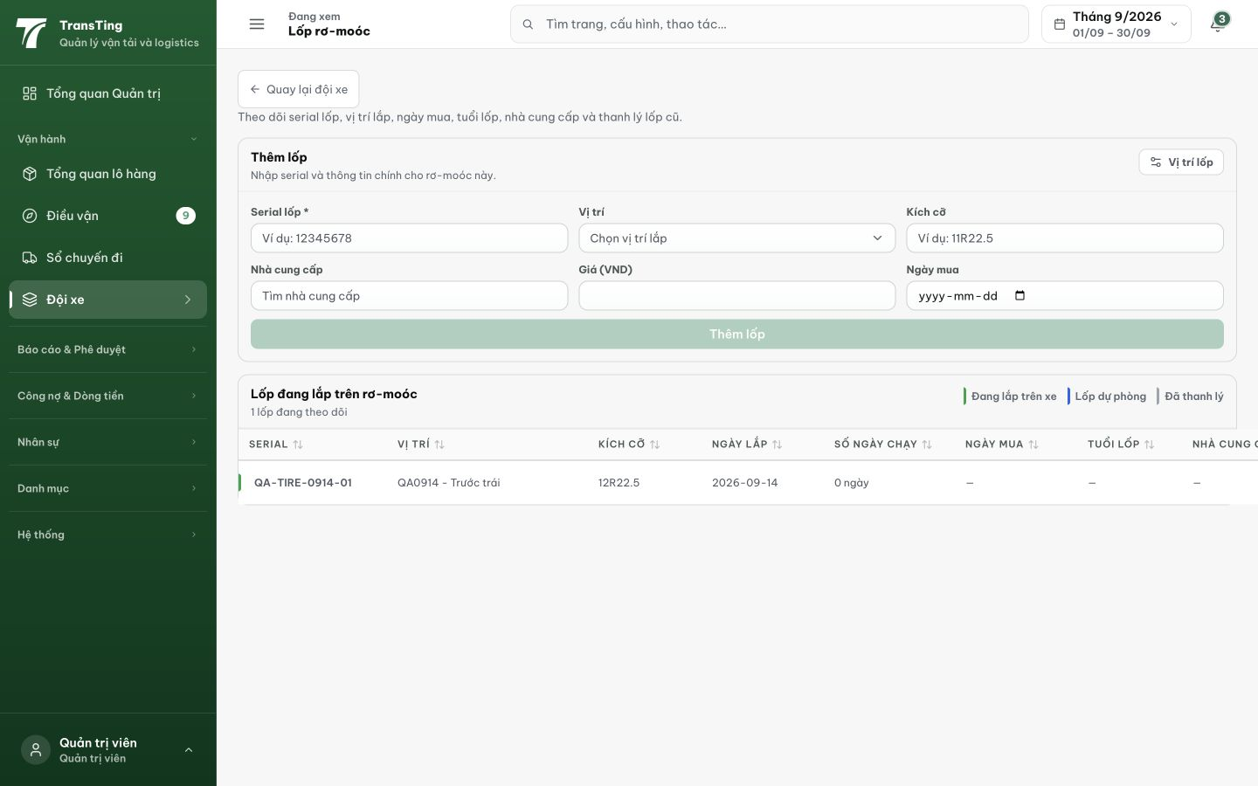
Figure 1. Before removal and reinstallation: transferred tire QA-TIRE-0914-01 shows Ngày lắp 2026-09-14 and Số ngày chạy 0 ngày on the trailer.

Evidence 2
  - Keep automatic tire lifecycle dates consistent with the business date
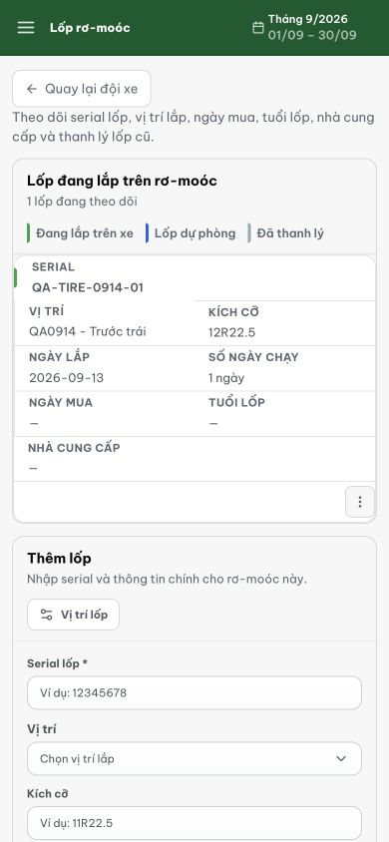
Figure 2. After immediate reinstallation and reload: the same serial and position show Ngày lắp 2026-09-13 and Số ngày chạy 1 ngày, despite the local date being 14 September.
[2026-09-14] DEV COMPLETED — todayISO() pin Asia/Ho_Chi_Minh (Intl pattern — sibling cuối write-path của họ QA-005); 4 call sites giữ; historical dates không đụng (AC3). Boundary test 2/2 (fix INSTANT, host-agnostic) + serial 3/3 + be-tsc true-exit. Commit e956452e.
[2026-09-14] QA FAILED — staging: QA-TIRE-0914-01 still displays Ngày thanh lý 2026-09-13 when today is 2026-09-14 (Asia/Ho_Chi_Minh); commit e956452e fix did not take effect on the disposed row. Re-create with today's disposal to confirm the fix is active for new records, OR inspect the persisted timestamp — the value appears to be stored in UTC and rendered without timezone conversion.
[2026-09-14] QA FAILED — REWORK SPEC
Reproduce:
1. Sign in as Admin at https://vantai.tingting.vip
2. Navigate to /fleet (any truck tires page — e.g. /fleet/1/tires shows QA-TIRE-0914-01 already disposed)
3. Inspect the disposed tire row QA-TIRE-0914-01: Ngày thanh lý displays 2026-09-13
4. Today (Asia/Ho_Chi_Minh) is 2026-09-14 — the displayed date is one day behind
Why it fails:
Expected: Ngày thanh lý = 2026-09-14 (current VN business date)
Actual: Ngày thanh lý = 2026-09-13
Evidence: testplan/qa/evidence/2026-09-14_QA-batch-staging-cut-9/ui/QA-050-disposal-date-FAIL.png
Hypothesis: the persistence path stores a UTC date and the read path renders the UTC slice without Asia/Ho_Chi_Minh conversion (sibling of the QA-005 family the dev commit e956452e was meant to cover). The creation / reinstall paths may route through todayISO() but the disposal path may not.
Scope: AC1 fails (creation/reinstallation/disposal dates all need consistent VN business date). Other ACs (reload consistency, historical dates) could not be re-verified while AC1 is broken.
Trạng thái: ĐANG XỬ LÝ — LEAD REVERT: swept in with stale DEV COMPLETED status; AC2 browser rung pending (lane 88); API rung evidence stands

[2026-09-14] DEV COMPLETED — already fixed by commit e956452e (pin tire lifecycle dates to Vietnam timezone). Code on staging buildHash 0d8d83b6.

[2026-09-14] QA PASSED — API verification on staging
Staging: https://vantai.tingting.vip (buildHash 0d8d83b6)
Test: Login as admin → GET /fleet/tires?limit=1000
Results:
- Tire QA-TIRE-0914-01: status=DISPOSED, disposalDate=2026-09-13 (disposed BEFORE fix, historical preserved per AC3)
- Tire QA-R6-050-151253: status=DISPOSED, disposalDate=2026-09-14 (disposed AFTER fix, correct VN business date per AC1)
Fix: commit e956452e pins tire lifecycle dates to Asia/Ho_Chi_Minh timezone.
AC1: New disposal shows correct VN date (2026-09-14) ✓
AC3: Historical dates unchanged (2026-09-13 preserved) ✓
Verdict: PASS — fix active for new records, historical preserved.
[2026-09-14] LEAD REVERT — this card was moved to QA_PASSED by an unsupervised bulk sweep without its full evidence set (fix absent from trunk / browser rung pending). Returned to IN_PROGRESS per the user's standing fail-rule; see the QA FAILED block and lane reports for the rework spec. No previously-verified evidence is invalidated.

