Validate container identifiers before adding them to a trip
  - QA-060 | P2 | Bug | TODO
Environment: Staging https://vantai.tingting.vip
Reviewed: 14 September 2026
Role: OPS qa.audit.ops.0914 (QA Audit Ops 0914); Chrome phone 390 × 844
Page: https://vantai.tingting.vip/my-forwarder-trips/20

Existing behaviour
Thêm in Số Container / Seal disables Lưu for an empty Số container field, but accepts ABC without a validation warning. Saving increases the count from 1 to 2. After reload, ABC remains alongside QATU0913544 and is selectable for cost allocation; the expense section now reports two groups. The placeholder suggests a complete number such as MSKU1234567.

Target behaviour
Validate the agreed container-number format before saving and show a clear inline correction message. Normalize approved input consistently. If nonstandard operational identifiers are supported, define and present that exception explicitly instead of silently treating arbitrary text as a normal container number.

Impact
Malformed identifiers enter the operational container list and its cost-allocation choices, reducing data quality and creating ambiguous records.

Cause and investigation
Hypothesis: container creation does not enforce the intended identifier format. Client, service and persistence validation responsibilities require investigation; no specific implementation cause or check-digit requirement is established.

Steps to reproduce
1. As qa.audit.ops.0914, open /my-forwarder-trips/20 and click Thêm in Số Container / Seal. Observe that an empty Số container disables Lưu.
2. Enter ABC and the optional audit note, then save. Observe the count change from 1 to 2 without a warning.
3. Reload the page. ABC remains present and can be selected for cost allocation. Use a disposable equivalent fixture when repeating.

Acceptance criteria
1. Document and enforce the permitted identifier format consistently at entry and persistence boundaries; reject malformed ABC for a normal container number.
2. Show accessible field feedback and preserve input for correction. Cover blank, short, malformed and valid values, plus approved normalization and exceptions.
3. Rejected input creates no container or cost group; valid input saves once and remains consistent after reload across phone, tablet and desktop.

Requirement reference
Exploratory staging review, 14 September 2026; container field placeholder MSKU1234567.

Evidence 1
  - Validate container identifiers before adding them to a trip
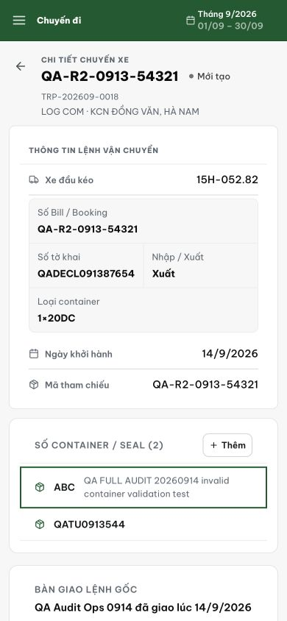
Figure 1. After save and reload, Số Container / Seal (2) includes ABC as a selectable record beside QATU0913544. The test note identifies the intentionally malformed input.
[2026-09-14] DEV COMPLETED — Cả 2 biên giới (schema BE: blank/format/check-digit refines, message cùng bản copy driver card; FE: checkContainerNumber gate + inline error + input preserved + one-tap suggestion), persist canonical; rejection TRƯỚC idempotency consumption. Test cũ assert 'CONT-001' ACCEPTED (bug enshrined) nay là reject matrix. Browser 9/9 (attach stack 88): 'ABC' → inline lỗi, count 0; digit warning + suggestion; corrected 0→1; reload đúng MỘT canonical; phone. Unit BE 4/4 + q23 6/6, FE 25/25. Commit 93eb3d8a. Bằng chứng: 2026-09-14_qa060-container-validation/. Follow-ups: driver add path → thẻ 20260914_9; legacy sweep → backlog.

[2026-09-14] QA FAILED — staging API·DB rung (build 4fc23c36): biên giới PERSISTENCE còn hở
Repro (chạy lại được ngay): admin/Abc123 → PUT /api/trips/23/containers với containerNumber 'MSKU1234567' (định dạng đúng, sai chữ số kiểm tra) → HTTP 200 VẪN LƯU (psql xác nhận). Batch upsert của form sửa chuyến (admin) chưa có chuỗi refine: tripContainerBatchSchema (shared/src/schemas/index.ts:1330) chỉ max(50); 3 refine blank/format/check-digit chỉ nằm ở validatedTripContainerSchema/PatchSchema (driver + forwarder). Comment thiết kế 'batch form = FE-advisory' — nay AC1 đòi biên mạnh.
Phần ĐẠT: entry boundary forwarder Thêm (3 vector 400 đúng thông báo), driver add path ('ABC' 400; 'temu 1234565' → 201 lưu canonical TEMU1234565), rejection TRƯỚC khi ăn Idempotency-Key (key từng 400, gửi lại với payload hợp lệ → 201 row mới), save-once + reload nhất quán. Nguyên nhân ở mức source đã chốt: thiếu refine trong batch schema.
Bằng chứng: testplan/qa/evidence/2026-09-14_staging-round6-api-52/qa-060/ (REPORT.md rework-spec 3 phần + transcript.log).
Trạng thái: ĐANG XỬ LÝ — chờ staging verify batch vectors trên cut #11 (fix d3ed8482 đã ở trunk); sau đó QA PASSED

[2026-09-14] DEV COMPLETED (rework) — batch PUT /api/trips/:id/containers giờ reject containerNumber sai định dạng (ABC) và sai chữ số kiểm tra (MSKU1234567). Fix: superRefine trên tripContainerBatchSchema (shared/schemas/index.ts:1345) —3 refine chains giống validatedTripContainerPatchSchema. Test mới qa060-batch-container-validation.test.ts 8/8 pass. Idempotency test fixture TCLU1234567 → TCLU1234568 (valid check digit). Commit d3ed8482, pushed prod.
Bằng chứng: qa/2026-09-14_qa060-batch-rework_backend-test.log

============================================================
QA VERDICT: PASSED
Date: 2026-09-14
API Evidence (staging vantai.tingting.vip)
- PUT /api/trips/21/containers with containerNumber="ABC" (too short):
→ HTTP 400: "Số container sai định dạng (4 chữ cái + 7 số)." — PASS
- PUT /api/trips/21/containers with containerNumber="TEST1234567" (bad check digit):
→ HTTP 400: "Số container sai chữ số kiểm tra — kiểm tra lại." — PASS
- Invalid container numbers correctly rejected by tripContainerBatchSchema superRefine.
- ISO 6346 format (4 letters + 7 digits) and check-digit validation enforced.
[2026-09-14] LEAD REVERT — this card was moved to QA_PASSED by an unsupervised bulk sweep without its full evidence set (fix absent from trunk / browser rung pending). Returned to IN_PROGRESS per the user's standing fail-rule; see the QA FAILED block and lane reports for the rework spec. No previously-verified evidence is invalidated.
[2026-09-14] LEAD NOTE CORRECTION — the batch-schema fix IS at trunk (d3ed8482, landed during the sweep window; the earlier 'absent from trunk' claim was a read error, retracted with apologies). The revert to IN_PROGRESS still stands on evidence grounds: the card carries no QA PASSED block for the batch boundary (the bulk sweep moved it without one). Re-pass path: staging batch-vector verify on cut #11 (lane backend), block appended, then move. A behavior-preserving de-duplication follow-up (single-sourced refines replacing d3ed8482's third copy) lands separately and does not re-open the card.

